Henry Oldroyd

A level computer science NEA

Chess Program

Candidate No: 7145

Centre No: 17535

# My Final Product:

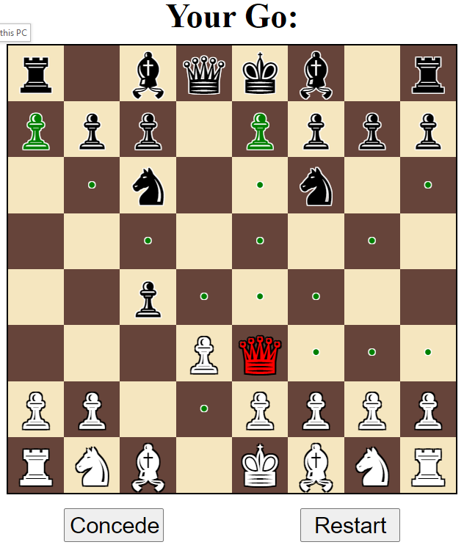

At the end of this project I was able to create a fully working chess game with a web based GUI and click interface. I created the interface and AI that the user plays against completely from scratch, without using any chess libraries. My chess AI can be told to look X many moves ahead to decide the best move. I implemented a database to allow the AI to learn from previous games it has played. I also added various difficulty level from easy to very hard. The pieces taken and move history are also displayed.

This project covers an implementation of the “minimax” search algorithm with alpha beta pruning. I also added my own optimisation including a caching function so that the engine doesn’t have to re-analyse positions that it has seen before. I also added a variable search depth (like the famous chess program Deep Blue). I even added a feature where multiple instances of he searching algorithm can run at once in different python processes in order to maximise use of a multi-core CPU.

See a demonstration of the program running here. This includes 3 games, and details the features of the program as well as demonstration the AI learning:

**Demo.mp4:** (The file size is large so if the resolution appears low try downloading it, it should be HD)

<https://drive.google.com/file/d/1wlnjgN2fKc8Nz8TxlrZsLWHNT9W8OttP/view?usp=sharing>

Contents

My Final Product: 2

Glossary of Key Terms: 8

Analysis Section 10

Problem definition: 10

What are the benefits to solving this problem with a computational approach? 10

My computational approach: 10

Thinking ahead: 11

Inputs: 11

Outputs: 12

Preconditions: 13

Thinking abstractly: 13

Thinking procedurally / decomposition 14

Thinking concurrently: 16

Stake Holders: 16

Research: 18

Interview with Roger: 23

Essential Features: 25

Limitations: 26

Solution Requirements: 27

Software Requirements: 27

Hardware Requirements: 28

Other External Services and Dependencies: 29

Success Criteria: 29

Design: 33

Initial Design for the system’s features and user interface: 33

Breaking down the problem into smaller components as well as explaining and justifying the structure of the solution. 34

The title / menu page: 47

The pregame config form page: 47

The chess game play page: 47

The game over pop-up: 47

Usability features to be used in the solution: 48

Effective 48

Efficient 49

Error tolerant: 50

Easy to learn 50

Engaging 51

Further Problem Analysis At a Technical Level: 52

Design Objectives: 54

Some changes to the design: 56

Usability Features to be Used in the Solution: 59

Effective 59

Efficient: 59

Error Tolerant: 59

Easy to Learn and Engaging: 59

Proposed Solution Description: 60

Front End: 60

Server Side API Connection and Webserver: 61

GUI to communicate. 61

Chess Computer: 62

Benefit of Decomposition: 62

Diagrams of propose solution: 63

Decomposition of Chess Computer (not algorithms just functions, classes and data structures) 66

Decomposition of GUI logic and API client server connection: 67

Chess Computer: All major algorithms 69

The Chess Engine / Chess Functions: 69

The Move Engine algorithm: 78

Game Manager: 83

GUI logic and API client server connection: 85

Describe database use (save games and minimax cache) and other persistent storage: 93

Variables and key data structures used in these key algorithms: 97

Complete trace tables and dry runs of key algorithms: 98

Validation: 107

Client side validation needed: 107

Server side validation: 109

Functionality that each prototype will have: 109

Prototype 1: 109

Prototype 2: 110

Prototype 3: 111

Test Plans 111

Test Plan for Prototype 1: 111

Test Plan for Prototype 2: 111

Test Plan for prototype 3: 115

Post development testing against development criteria (black box alpha testing): 117

Acceptance testing for success criteria (beta testing): 120

Iterative Development – Prototype 1 121

Aims for this iteration 121

The main aim is to create a working prototype for a system to solve a simpler problem that can be tackled in a similar way to chess. 121

Functionality that the prototype will have 122

Annotated code screenshots with description 123

Libraries, Languages and other assets: 125

The code: 125

Here are some screenshots of the final product: 139

Problems throughout and how I tackled them: 145

Test Plan for this version 154

Changes to code made after testing: 161

Validation: 164

Feedback from Stakeholder 164

Planned changes after stakeholder feedback 165

Evaluation 166

Iterative Development – Prototype 2 168

Aims for this iteration 168

Functionality that the prototype will have 168

Annotated code screenshots with description 169

Testing 250

Testing of Chess Engine and Move Engine: 250

Testing of Console Chess: 274

Validation: 277

Feedback from Stakeholders 278

Changes/Fixes that I now plan to make to the design or code as a result of testing and feedback 279

Evaluation 279

Iterative Development – Prototype 3: 281

Functionality that the prototype should have: 281

Annotated code screenshots with description: 281

Assorted Module: 286

General.py 286

chess_exceptions.py 287

Chess Functions Module (Chess Engine): 288

Move Engine: 289

Minimax_parallel.py 303

Game Manager 322

Database module: 338

Create_database.py 338

Models.py 340

handle_games.py 342

Schema Module: 343

Socket_shemas.py: 347

Website Module: 352

app.py 352

Chess_game.html: 366

Main.js 370

Demonstrating the end result 395

Example Play 402

Testing: 422

Automated unit tests: 422

Here are the main issues that were detected by the automated unit tests: 443

Timed Minimax not working: 443

Tests completed on final product: 446

Knights cannot take pieces 452

Pawns cannot move forward 2 places: 455

Concurrent workers not caching 457

Erroneous Results: 465

Demonstration video of the program working: 470

Stakeholder Feedback: 471

GUI: 471

Special Features: 471

Reliability (after the fixes from my testing): 471

Suggestions for improvement: 471

Evaluation (just of prototype 3): 471

Evaluation: Evaluative Testing: 473

Post-Development Testing 473

Usability Survey: 477

Usability Survey Results 479

Breakdown of success criteria (what has been achieved): 487

Limitations and Maintenance: 491

Limitations with the program itself include: 491

As part of maintenance, certain issues may arise: 491

Some of the key ways in which this chess program could be improved: 492

Appendix: 492

Sources: 492

Interview Transcript: Interview with Roger: 493

# Glossary of Key Terms:

I will use a variety of terms in my course work to describe my approach and I will aim to define them here for maximum clarity.

**Board state:** This is a general term that I am using to describe the details of the current chess board that are relevant to the game and making a decision about the next move. This is a set of information about which pieces are still on the board for each player and where they are. In addition other information including which player’s turn it is currently and the **utility score** for both sides given the current game state.

**Move engine:** This is a module that will be a component of my finished system and is responsible for making the best move given the current **board state**. It will be used to make the moves for the computer / AI opponent

**Chess engine:** This is a module that will be a component of my finished system and is responsible for making inferences such as the legal moves, check and is the game over? From the current **board state**.

**Chess computer:** This is the overarching term used to include all of the backend logic combined together. This includes the **chess engine** to analyse boards, the **move engine** to make moves and the **game manager** to keep track of a given chess game that the user is playing.

**Decision Tree:** This is a general term for a tree where each node represents a decision, and the child nodes are the possible options. In this context, by a decision tree I mean a tree that describes possible paths the board can take from the given **board state**. In this case the nodes are **board states** and the edges are moves. Each **board state** has many branches to show its many children. This idea of a decision tree is used by the **Move Engine.**

**British Museum Algorithm:** This is a variant of the minimax algorithm. Instead of using heuristics, this algorithm keeps exploring the **decision tree** until it reaches the terminal node where the game is over. With this fully explored tree, the best possible move can be calculated. This is feasible for a game like Tic Tac Toe but not for Chess.

**Utility score (for a given player):** This is a integer value that aims to evaluate and measure the total value of all the pieces on a given player’s **board state.** Using player white’s utility score and subtracting player black’s utility score will give a score that describes how advantageous the current board state is to player white. An example of how the utility score could be calculated could be giving each piece a value (e.g. a queen is worth 9, a castle 3 and a pawn 1) and then totalling these values. This score is useful to the **chess computer** as it can only look so many moves ahead. As such it will need to have a way to compare the **board states** that result from each move in order to determine the best move.

**AI and its use in the chess computer:** While the term AI is predominantly used to refer to neural network my planned approach of using the **Minimax** **algorithm** to recursively evaluate a tree in order to determine the best possible move is considered a type of symbolic AI. I aim to looks a few moves ahead be creating a tree where the current board state is the root node. Branching of the root node are many arcs that represent the many possible **legal moves.** The connect to nodes that represent the resulting game state after this move. This process will continue to some given depth and then the **chess computer** will use the **utility scores** to calculate how much the leaf node game state favours the computer in order to select the best possible move. More advanced implementations of the algorithm in late prototypes will use alpha beta pruning in order to improve time efficiency and search to a greater depth of moves.

# Analysis Section

## Problem definition:

605 million adults play chess regularly around the world according to the Un (<https://www.un.org/en/observances/world-chess-day>). While some play chess at a competitive level with the aim of improving their skills, many of those who play chess do so casually with the primary goal of entertainment and the secondary goal of getting better. Online chess programs are growing increasingly popular as a pastime. Chess.com is one such website that predominantly is used to play chess online against AI opponents and other users online. it has 77 million users.

My aim is to make a website that will allow users to play chess against an **AI** opponent. The program will be aimed at casual chess players and as such it will include features to help it specifically cater to this group of chess players. The website will have an interactive chess board that users will use to make their moves and see the computer’s move. When either the computer or the user wins the game will end.

## What are the benefits to solving this problem with a computational approach?

This approach allows users to play chess without a chess board. This enables users who don’t own a chess board to still play chess. A mobile device that can access my website is also more portable than a chess board. As such users will able to play chess on the go for example on a bus or train. In these scenarios it would not be practical to use a physical chess board as there may be limited space and If the journey is bumpy (for example when walking or using a buss) the physical pieces would fall off the board. Additionally, a computational solution like a website would allow users to play even when they cannot easily access another person to be their opponent. For example on the go, if they don’t know anyone that enjoys chess or at odd times of day like early in the morning. A chess game on a phone against the **AI** opponent can also be passed and picked up again at any time which would not be appropriate when playing against another human. This allow games to be played even when there is not a large enough consecutive block of time in which to play them.

For these reasons a computational approach would make playing chess more accessible to more people and allow more games to be played at the convenience of the user.

## My computational approach:

I order to determine if a computational solution is appropriate I have analysed the problem using a variety of computational approaches. This has helped me to imagine how a computer may be used to solve this problem even before the detailed planning stage

It is important to clarify that in this section I am considering the minimum viable prototype that only contains essential features. For example I may end up adding additional featured from my wish list. For example allowing users to login in order to earn trophies for winning and earn a place on a leader board or to load and continue games.

This would greatly increase the number of:

* inputs: details for login pages as well as new menus for user exclusive features
* outputs: for example the leader board or an email confirmation in order to make an account
* preconditions: some features will only work if a user is logged in, in order to manage this issue I may need to make user of sessions or cookies in order to keep track of whether or not a user is logged in

## Thinking ahead:

### Inputs:

One set of inputs needed will be the configurations for the game. These may include weather or not taking back moves is permitted. This could be implemented as a tick box in order to ensure that a Boolean value is given and to make validation simpler. These configurations may also include the difficulty setting for the chess match (this could for example affect how many moves ahead the chess computer looks affecting the quality of the selected move). This input could be collected with a set of radio buttons. This would ensure that only one options is selected. I could have the normal difficulty be selected by default to reduce the validation needed as this way exactly one choice will always be selected.

One of the important considerations here is that my target user will have likely already used a chess program before. It will make the transition to using my user interface and my chess program simpler if my user interface follows the conventions of other online menus and chess programs. This is because users are already likely to be familiar with radio buttons and tick boxes

Another important input is the users inputting there move. I intend to follow convention in how this is done (the benefits are discussed above). As part of my research I identified that how the user inputs are collected was similar across many chess programs. In many chess programs the user selects a move by first selecting a square and then selecting another square. Assuming the user gives valid input the square they select first should contain a piece that they own. At this point dots will show that possible squares that piece can move t to (the set of all possible moves is shown visually). The user then selects one of these marked squares to indicate that this is where they would like this piece to move to. The chess piece then moves to this new square

Chess board is presented and the user is told it is there turn:

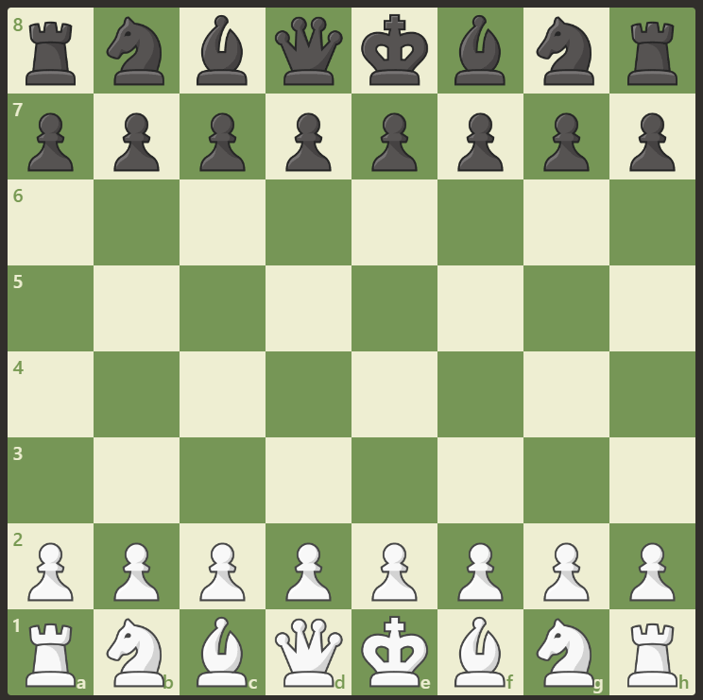

The user select one of their pieces:

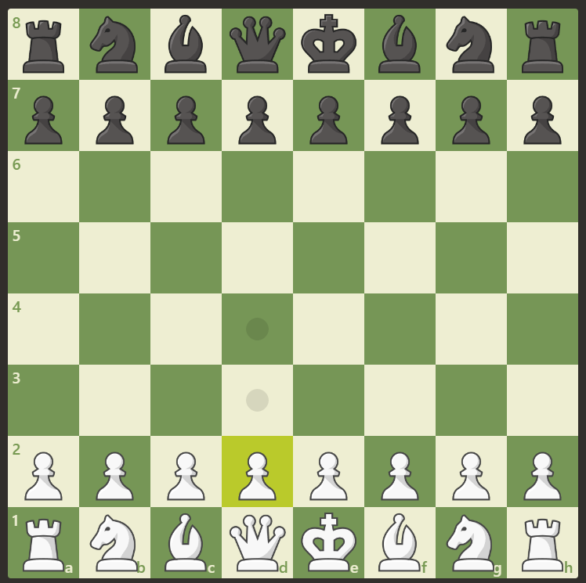

The use then selects the square for it to move to

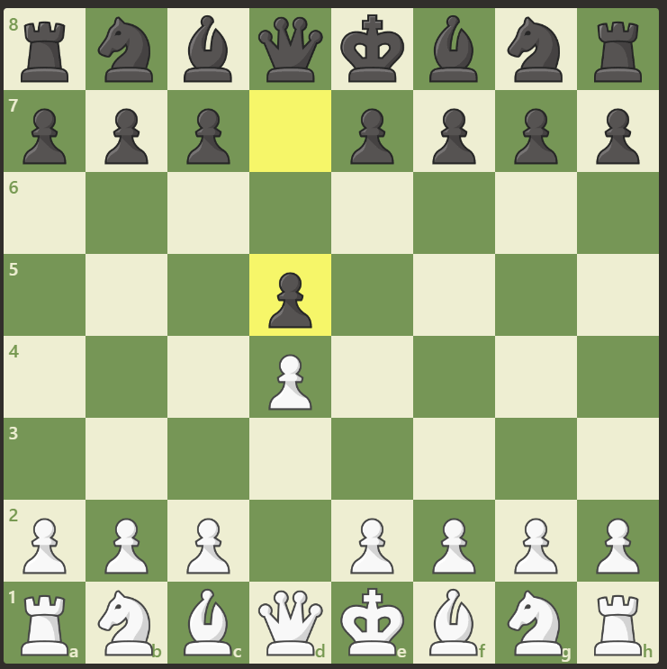

(computers move also shown but this is to be ignored for this explanation)

### Outputs:

The first important output is the computers moves in the game. This is to be shown to the user visually using the convention of lichess.org and chess.com by moving one of the computer’s pieces and highlighting the squares it have moved from and into. The move will also be added to a list of the moves in the game. This will be a displayed on the side and an example of how a move could be recorded could be “black bishop moves from F6 to G7”.

The other main output is who has won the game. It must be outputted once the game has finished. I will display that the game is over and who has won. It must also disable the chess board widget to prevent the user making any more moves. This information may be displayed with a popup window but it may be simpler to have a banner appear above the chess board that states who has won.

### Preconditions:

The main precondition is that all inputs must be valid. If this isn’t the case then the chess computer will not be able to function.

In order to solve this problem I will try to make many of the inputs forms on any menus feature limited options to reduce the chance of giving an invalid input. For example the user of radio buttons an checkboxes to ensure the only inputs that can be given are valid.

I also need to ensure that the users move is valid. In keeping with the conventions laid out by chess.com and lichess.org I will not display an error message if the user gives an invalid input. Instead nothing will happened and the program will continue to await the users move. This is detailed above in the inputs section. An example of an invalid input that may not be allows (and so ignored) is the user selecting an empty square or one with an opponent’s piece in when selecting one of there pieces to move. Another may be the user selecting an invalid square for one of their pieces to move to (the selected square is not one of the possible legal moves).

## Thinking abstractly:

Irrelevant details and properties of the chess board and chess pieces and abstracted and removed to reduce the complexity of the problem. The only details that will be kept will be those that are relevant to the object in game. I will use an objects to represent the abstracted chess board and pieces servers side. To clarify these details we be abstracted ‘under the hood’ in the server side chess computer and the client side validation. The user will still be able to see the colour and general shape of the pieces and the colours of the squares on the chess board when on the website

A chess piece will have these attributes abstracted:

* it’s specific shade and colour. Instead it will be assigned an owner to ensure the user’s and computer’s pieces are distinguished
* The exact physical dimensions of each piece e.g. height and width
* The exact physical shape / profile of the piece

Attributes that will be kept include:

* Which player owns the piece
* The set of possible ways in which the piece can be moves
* The relative value of each piece (to be used by the chess computer)
* Where is it on the board (which square) or is it off the board
* Is the piece a king? Due to handling check the king will be a special case with special properties

The ways in which a piece can move will be represented by a set of vectors.

The chess board will have these details abstracted:

* The colour of each square: it makes no difference in game if a square is black or white
* The physical dimensions of the board e.g. the width and height

The board will be represented server side as an 8*8 coordinate grid. Pieces that are knocked out may be stored in a separate list. Where the pieces are on the board is a detail that must also be stored

## Thinking procedurally / decomposition

I aim to break this problem down into subproblems that are more manageable and can be solved independently. The 2 main modules will be the chess computer and the front end website

The chess computer will be responsible for determining a good move to make given the current board state. I intend to implement it by analysing decision trees using the minimax algorithm and symbolic ai. I will go into more detail about this in the design section. An example of how the chess computer may be broken down into sub function is shown:

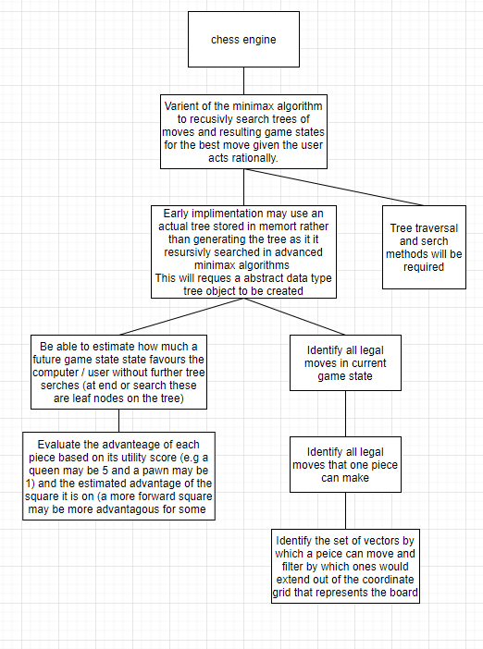

The chess computer will be written in python. The frontend website user interface will be created using HTML, CSS, JavaScript and Flask to act as a python webserver. The function of the website is to provide an interface to the user and validation of the user’s inputs. The frontend and backend will be connected vie with a type of API. This could be a REST API that users HTTP or a type of web sockets as appropriate. HTTP based connection as simpler but sockets allows for a full-duplex low latency connection which is advantageous.

The website will be broken down into pages each of which will serve a function. For example a home page, a user login page and a puzzle game page. Each page will be composed of multiple interactive and static widgets. Each of these will be made up of may HTML tags.

## Thinking concurrently:

The main component of this problem which can be solved with concurrent processed is the method of finding the adversarial AI’s move. This will involve using the Minimax algorithm to search a decision tree.

This will involve looking at each move from the current board state and recursively applying the minimax algorithm to score that board state. Then selecting the move that gives results in the board state with the best score. It would be possible to break up the legal moves that you need to recursively search (work to be done) into chunks. These chunks could then be processed concurrently to increase the algorithm’s speed.

For example, if the board state that must be searched has 24 legal moves I could break this array of legal moves into 4 subarrays of 6 moves. Then my I could make full use all 4 cores in my processor to execute the algorithm on these subarray concurrently and then select the best move once all the moves have been evaluated.

This would have the benefit of significantly increasing the speed at which I would be able to perform a deep search (many moves ahead) of the target board state.

A drawback of this approach is that the minimax algorithm is already complex and so programming it to work concurrently will be difficult. This will mean that this feature will take up a significant amount of time and so will have a significant opportunity cost in terms of other features not implemented.

I addition, there will be a significant overhead (time delay) in setting up the various threads and workers needed to run the algorithm concurrently. This means that this approach will only provide an improvement to performance for large minimax calls (searching to a high depth / looking many moves ahead).

This means that making use of concurrency in my project could give a significant benefit to performance of the minimax function if used in the right circumstances. As the minimax algorithm is the main algorithm needed to program the adversarial AI, this should mean that with the same amount of time, the AI would be able to make better moves. This should make chess games more challenging and enjoyable for the stakeholder.

## Stake Holders:

Stake holders are those who will be affected by the quality of chess program that is produced

The only stake holder for this game is the end user as its function is purely to provide entertainment. If the chess program doesn’t meet the end user’s needs or is not created then they will be affected as they will not have the opportunity to get the same level of enjoyment from playing with my chess program.

My target audience is a casual chess player who plays primarily for entertainment with the goal of improving at chess being secondary. For this reason the target user is someone who is already a casual chess player or is interested in giving chess a try. They should enjoy problem solving and be of age 8+ as chess is a highly complex game that involves high level strategy and problem solving that many younger children are unlikely to enjoy.

I have identified my parents as specific stake holders. Roger is a casual chess player who regularly plays chess against the computer on his phone at the start of the morning for entertainment. He is familiar with the rules of chess and has the technical knowledge to provide specific and useful feedback about which features he may require. My mum is interested in starting to play chess and doesn’t have a technical background. This allow her to represent the majority of my users and give feedback that is more focused on usability of the interface and features she would want. This makes my parents ideal to help with beta testing of prototypes. It is important to note that unlike other games there are likely to be many older adults (60+) who want to play chess. This demographic may not play other games like shooters but may enjoy games like chess, solitaire, backgammon for example.

As mentioned earlier I aim to ensure my chess program specifically caters to my stake holders (in this case my target audience) in the features that it offers.

I am aiming my program at casual chess players. I have tried to plan the features that I will use accordingly as shown. Further details about each feature will follow in later sections

Because my stake holder is a casual chess player (entertainment first / improvement in ability second) I have decided to implement these features:

* The chess games against the AI will be more casual and will allow you to backtrack and see the board state before the most recent moves to see what is done (a feature on chess.com and one Roger recommended as one he wishes for). A tick box could also be selected before hand to allow for moves to be reversed. This would obviously be an advantage but could be a feature that very new players who are learning may demand
* Puzzles will be made available that aim to be a challenge that can exercise problem solving skills. This challenge will be in the form of a board state that is 1 or 2 moves away from checkmate (the user winning) there goal is to find the path to winning. This should be entertaining and hopefully I will be able to create a variety of different challenges of different difficulty
* As the games are casual there will be no clock that limits how long the user has to play. This is standard in tournaments but I am trying to emulate casual chess that is played on a kitchen table between friends so these features server no purpose.
* The most important one as mentioned in interview: The user will be able to dictate the starting conditions of a match in order to have a fun off the wall match. For example where they have an unfair advantage over the hardest AI by starting with 1 king and 8 pawns as normal but all other 7 pieces are queens. This should be a fun and different game for the user to play.
* Casual chess players are less likely to be completely committed to chess in comparison to competitive players. This means that they may appreciate other games being made available that are similar. For example draughts. These games are similar to chess in terms of the board and pieces but may be a refreshing change for users.

My older stakeholders (e.g. 60+) may be less familiar with mobile devices and technology

In order to ensure my chess program is suitable for people of all ages I will ensure that the final product is distributed as a website and as a mobile app if possible. I believe that older people are less likely to own a smart phone or be familiar with touch screens. I know that my own grandfather plays solitaire on his PC computer on a website as he is more comfortable with this. This way older users should still be able to make use of the website. I aim to prioritise usability over aesthetics in the user interface design. I will also aim to ask my mum for feedback in detail about how the user interface can be improves to ensure the program is assessable to everyone.

## Research:

For my research I have:

* Looked into 2 online chess games to see their features and functionality: chess.com and lichess.org
* Interviewed Roger who is a casual chess player who plays chess daily on a mobile app

The first existing solution I researched was <https://www.chess.com/>

It is a more broad chess website that features a variety of chess content



I will specifically focus on the playing chess against a computer features of the website.

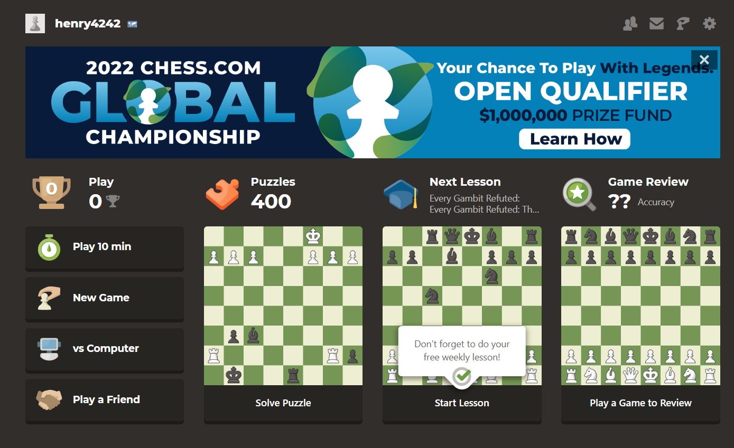

The user interface shows of the many features including the opportunity to play puzzles, collect trophies, review my gameplay or play another user. This site was clearly developed by a large team with lots of resources. While there are many sites where you can play chess this site seems to have a massive scope which make sense considering its 77 million users.

This site also allow for logging in which allow for users to access other features and upgrade to the premium mode. The login process was smooth as I could login with google preventing the need for an verification email.

Once I began to play a game I was asked to select a few pre-game configurations

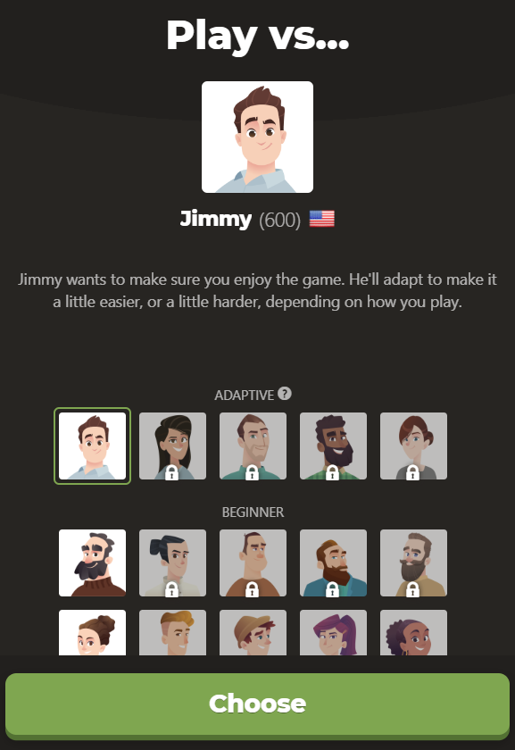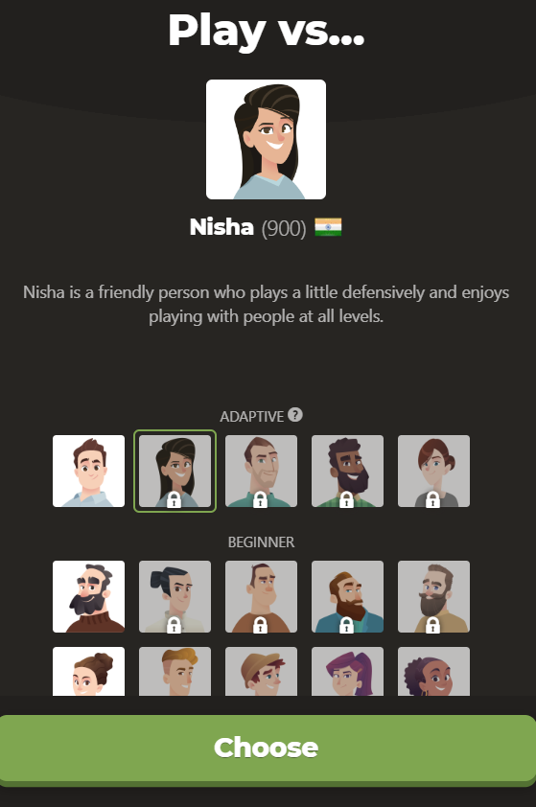

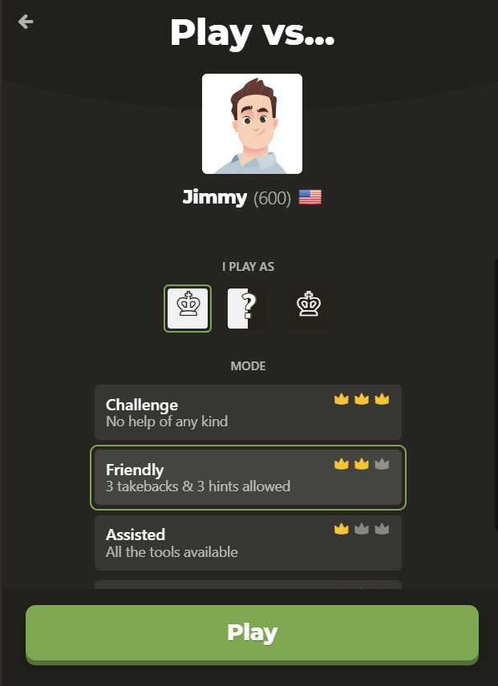

Interestingly they offered more than just different difficulty settings. They seemed to have different chess computer configurations represented by personas like Jimmy and Nisha with different skill levels. This seemed to dictate difficulty and the play style of the AI opponent.

The user then had the option to select how much help they wanted in the form of hints and takebacks.

Then the game begins and an interactive widget is used to represent the board visually to the user.



The user can then select a piece to move and the square to move it to. Then the computer will make its move. Selecting an invalid square or piece does nothing and the program still waits for you to make a valid move. One you do your computer opponent immediately makes their move. The move they made is highlighted by yellow squares to make it clear to the user what the computer has done.



For the users benefit there is a list of the moves made by each player

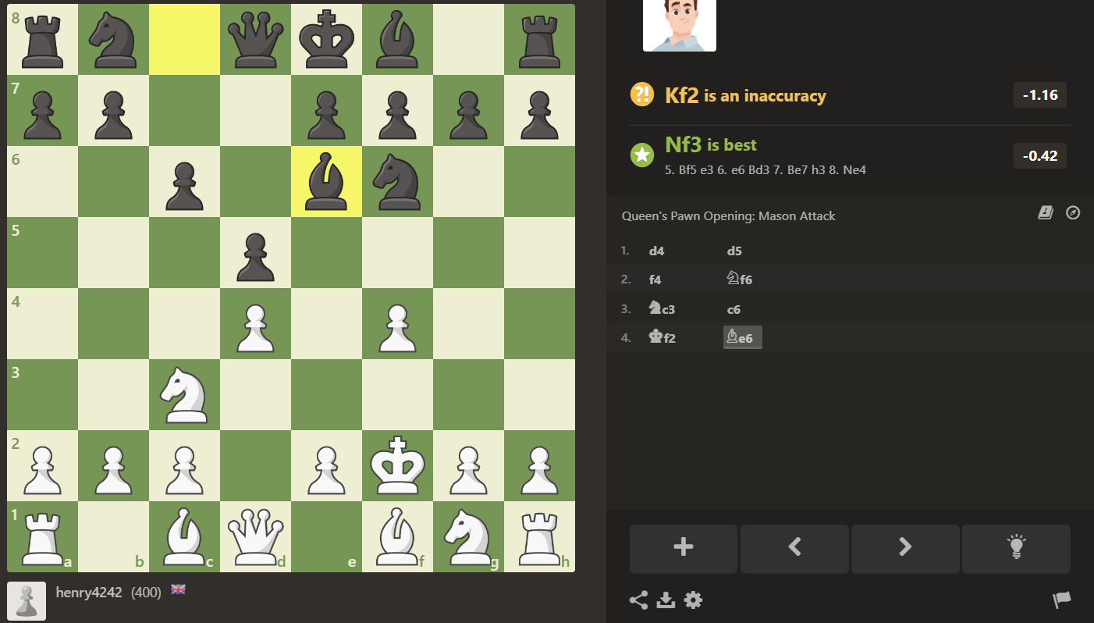

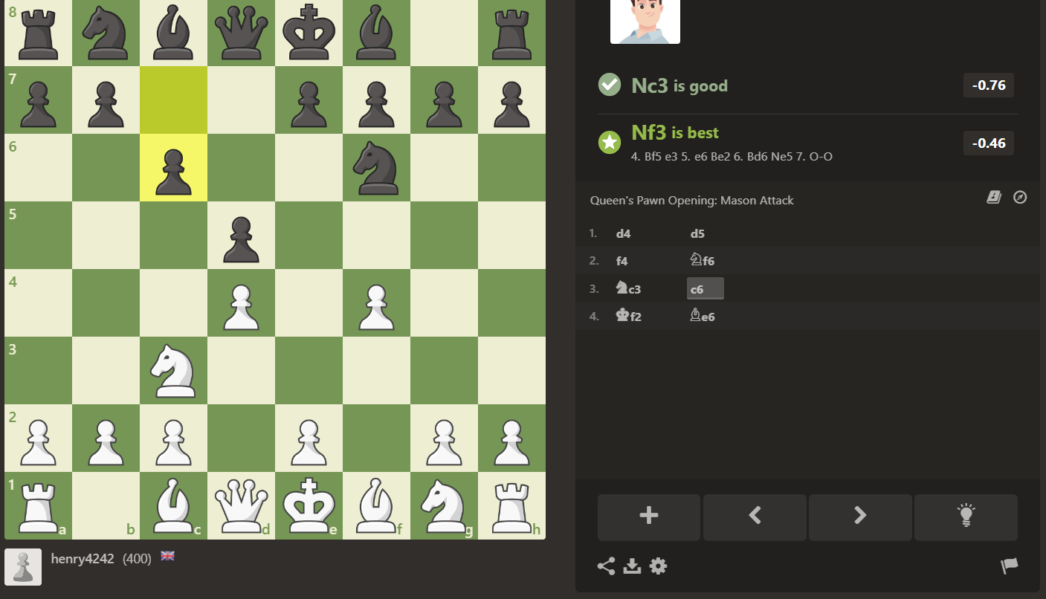

This list is interactive and clicking on a move will revert the board to the game state immediately after that move. This is shown above.

I ultimately find this list confusing and not descriptive without using the step back feature. Some moves have an icon next the square they moved into to show which piece moved but there is no icon for pawns. Additionally without stepping back through you cannot tell which square the piece came from originally.

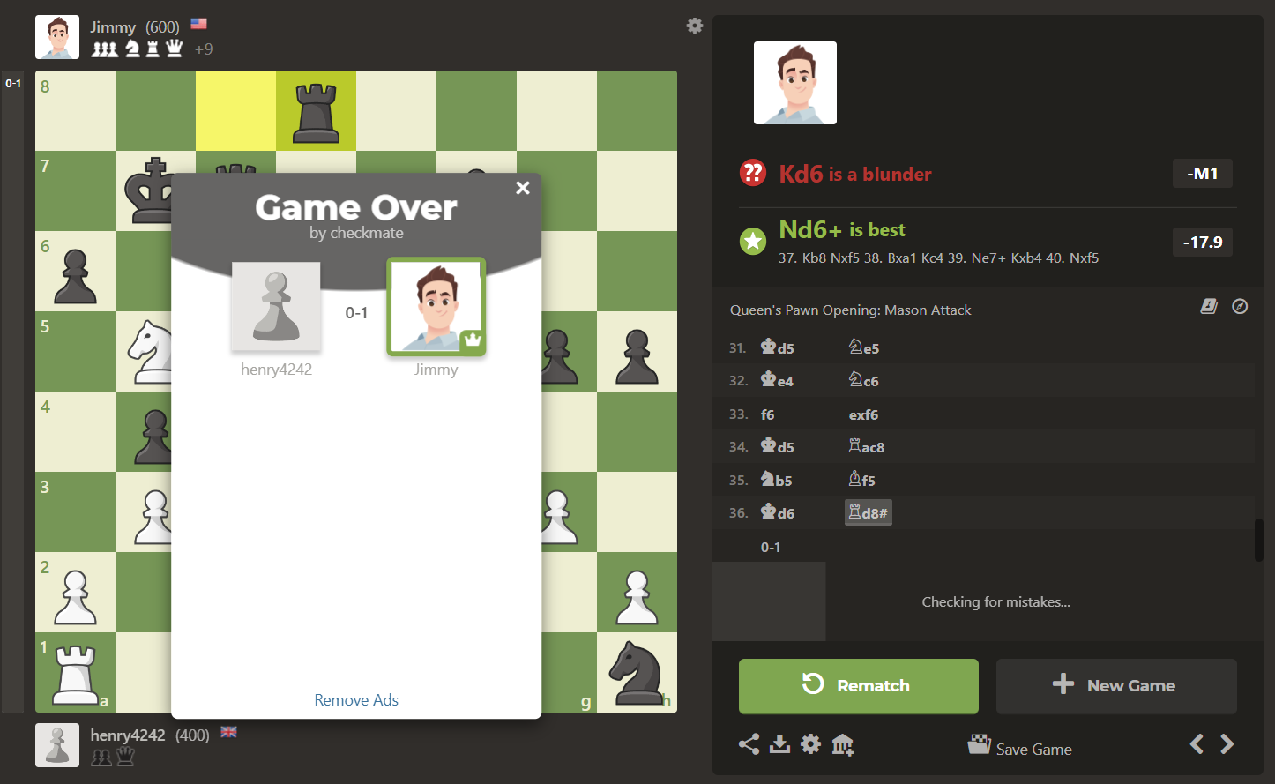

Once checkmate is reached the game ends as the chess board prevents new moves from being made. A popup window show that the game is over and who won. The rematch button is highlighted to attract the user’s eye. Taken pieces are shown next to the player along with name, picture and trophies.

Overall chess.com is a highly functional website with incredible scope and many other features including allowing 2 users to play chess against each other over the internet. I thought that for the most part the user interfaces were clear however sometimes there was information overload due to the amount of options and statistics on each page.

I likes how the difficulty setting and the help offered in game settings were distinct and different. I am likely to use this in my program.

I thought that some of the features may have been more suited to more competitive players. For example trophies and match feedback e.g. “Kd6 is a blunder”. In addition some functionality such as some of the puzzles and ai opponent personas were locked until you had played more on their website. I will not lock and features from logged in users based on trophies etc as such a feature seems wouldn’t meet the needs of my casual chess player stake holders who may not have time to play regularly.

## Interview with Roger:

The full transcript of this interview can be found in the appendix. See contents page.

Roger is a casual chess player who plays chess on a mobile app on his phone most days. The app he uses is called Lichess and is available both as a mobile app and as a website (<https://lichess.org/>).

He mostly uses Lichess to play games vs the ai (it like chess.com has many options of how to play)

I asked him about what he liked about Lichess:

* He liked the fact that he could choose a difficulty level. This makes sense as it will allow different players of different abilities to still play at the challenge level they want. It also allow one person to have an easier or harder game if they want
* He liked the interface as it was user friendly. He particularly likes how you can drag and drop or click to move pieces rather than type in what move you want to make. He found this easier to use and more intuitive
* He especially mentioned the satisfying sounds that this site uses as being an attractive feature, there is one sound for moving a piece and one for taking it
* He also likes how the moves are recoded and he can see the last move visually with highlighting and see a list of moves made in the game. It is also possible to step back through the moves like chess.com

I had a look myself at Lichess afterwards and noted how it’s interface seemed to be very similar in its features and design to chess.com suggesting that a convention is followed

Lichess also allows for 2 users to play against each other online but I am more interested in the chess vs a computer component

The same interface for getting the move input and stepping back through the games is used

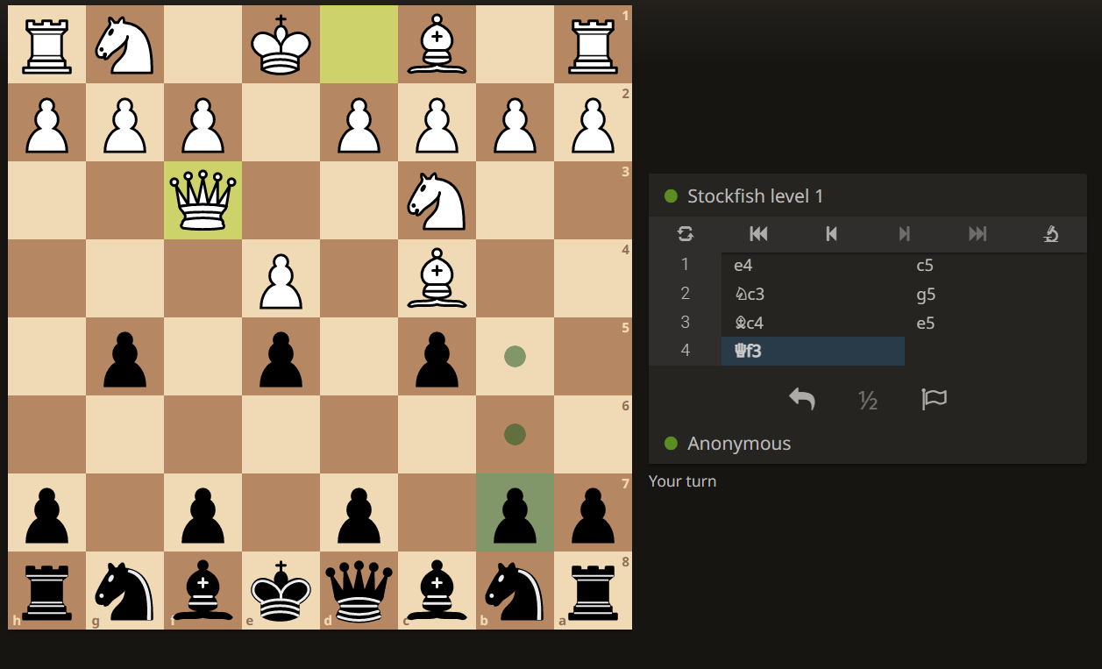

One of the feature he likes about li chess is how configurable a game is. This is perfect for a casual player as it allows for colours to be changed (for example to brown and cream) and the colour that the user plays as (white which goes first, or black). In addition the starting positions of the pieces can be configured. This has allowed him to play variations of chess against the strongest AI where he plays with an unfair advantage. For example him having extra pawns of the opponent having no queen.

The second feature he likes that chess.com doesn’t have and I am now considering adding is an undo button that allows the last move to be taken back. He is a casual player and uses is occasionally when he miss clicks and selects the wrong move. He pointed out that players know that it is a kind of cheat and can always chose not to use it.

The third feature he likes was the puzzles. Some of these puzzles are about finding the path to checkmate in 2 moves and others are about maximising your utility score over the computer by seeing the advantageous move. For example one of the challenges was to see how you could make 2 moves to sacrifice a knight in order to take a queen. He wasn’t told that this is what he was aiming to do. If he selected the wrong move then he was asked to try again and given the option to see the solution. Then the computer made it’s counter move and he was asked for a move for the second time. He said he enjoys this as even though he doesn’t take chess to seriously he still sometimes wants to improve. He also plays a puzzle when he doesn’t have time for a full game.

We then discussed some other features and he gave me his opinions.

He said that it would be really useful if the server would store the game as it is currently after each of the users moves. This way if the website was closed or Wi-Fi is lost then the game can be continues when the user logs back in to the website. He said that this wasn’t a feature that he was aware of on Lichess.

He said that he wouldn’t be interested in a trophy reward system for winning matches or a leader board for ranking players this way.

He also said that he thought that if I add in a move clock / timer is should be optional. He said that while some players may enjoy the tension it creates, he enjoys having the time to fully consider each move. He viewed this as more of a feature for competitive players (who are not the target audience).

He also said it is important that difficulty settings are discrete not continuous (e.g. not a slider) so users can ensure they are playing on the same difficult.

## Essential Features:

One of the desirable properties of this project was how simple the most basic chess program could be. For this reason the essential features are relatively basic. The goal is to then add in features form the success criteria on top of this.

How I aim to implement this is described in decomposition section

**The essential features are:**

* The user interface must have a menu where the user can select the difficult of the game that they would like to play.
* It must then present them with a fully functional chess board widget as is discussed at length in the research and thinking ahead section to allow the user to enter moves and see the computers move
* Proper validation must be in place in client order to ensure that the new game state resulting from the user’s move is only sent to the backend chess computer once a valid move is inputted
* The client side JavaScript must be able to recognise when the game is won, stopping the game and announcing the winner accordingly.
* The server must be able to keep track of the current board state by representing the chess board with an instance of a dedicated class or with a data structure such as a 2 dimensional array
* The server must be able to determine a good move given the current board state. The goal it to use the minimax algorithm in later versions. At its most basic looking one move ahead and picking the one that gives the greatest utility score advantage over the user will suffice (so a move that takes a piece for example)
* The chess computer must be able to pick moves that give it a overall utility score advantage over an opponent in the early and mid-game
* In the late game the chess computer must aim to get to checkmate over taking other pieces to ensure that it is able to actually win the game

## Limitations:

Here are some of the possible limitation of my current approach and how I aim to overcome them.

Firstly, if I am not careful, the graphical user interface may not be intuitive to older users. As mentioned some of the stake holders will be older (60+) and it is important to try to make the solution as accessible to them as possible. Older users may be less confident using a touch screen as an input device and may not have access to a smart phone. For this reason I think it is important that the website can also be accesses through traditional laptops and PCs. Older users may find it easier to use a mouse and or keyboard. However it is clear that this solution will not be suitable for some older people who enjoy chess if they lack basic computer skills (which I not uncommon).

Secondly, it would be difficult to add in specialist moves like castling and En Passant. This is because these moves are special cases and so are more than just a possible vector that a piece can move. As such they will be difficult to implement if I do indeed decide to use a vector space and set of vectors to determine the legal moves of a piece. Perhaps later versions of my program could include specialised code to add these moves as a feature but this will not be present in earlier versions. While this means that the program will fail to meet the needs of competitive players who need these moves in their repertoire, I hope that this will be less of an issue for the casual players at which this chess program is aimed.

The third potential limitation of the full stack website approach is to do with the use of server side code that includes my chess computer. The work load of my server program will be proportional to the number of users as they will all use my server side chess computer. As a result costs will be proportional to the number or users and will not be recouped as there is no current plan to monetise the application. Hopefully this will not be an issue as the it is unlikely that the program will have may users but in a real life issue this would be an issue. In addition having a web application as opposed to a downloadable executable file creates complexity in the form of webhosting. For example I may need to host with a cloud provider like AWS. This would mean paying for computation and storage space used by the database. It would also mean that I would need to purchase a domain name for the site. I would need to ensure my server was secure against attack (for example sql injection or stealing users data). I may also require specialist API services such as an email api to allow me to verify the emails of new users that sign up.

The forth issue is that I will have to ensure that I comply with all relevant laws and regulation if I decide to allow users to login. This could be complex to check I am following as I don’t have access to a legal expert. For an example, I would need to ensure the minimal amount of personal data I store on each user is in compliant with the data protection act. For example this means I would need their permission. One possible solution to both this problem and the email API problem is to use a login with google feature. This would allow google to handle obtaining the users details in advance and asking for their consent for this site to use them. However this would be highly complex to implement.

## Solution Requirements:

In order to implement my solution I will have requirements for both hardware and software. I will discuss the theoretical requirements necessary if this project were to be deployed.

### Software Requirements:

|  |  |
| --- | --- |
| Requirement description | Justification |
| Database manager software | This software will implement my SQL commands allowing me to read and write data to the database. It will also manage efficient lookups and storage of the normalised tables in a way that is abstracted from me so I won’t need to do additional work. |
| HTTPS WSGI webserver software | This software will be essential in deploying my app. My webserver program will be written in high level language but will not manually interact with ports etc to make requests. This is because it will use the Web Server Gateway Interface standard. This means that I will be able to run a functioning webserver so long as I have software capable of running a WSGI webserver. |
| Interpreter for python on server and a client browser capable of running JavaScript | This utility software will be needed to allow me to run my high level source code. Without this I will not be able to run the relevant part of the application server side or client side. This will prevent a user from being able to access the website and play chess. |
| Libraries various. I will use both inbuilt and external python libraries as well as linking to some external JavaScript libraries. This will mean this I will need to install pip as a package manager to install some of the new python libraries | This will be necessary to allow me to make use of prewritten code and subroutines in the project. This will save me time and will allow me to produce to complex full stack final product in the given time frame. |
| Webserver framework to allow me to program the WSGI webserver | This framework will be accessed through a library and will be essential in allowing me to create my webserver and restful API or web sockets API. Without this it will no be possible to create a webserver to host the website. One possible framework I could use is the python framework Flask. |
| Automated testing framework | This will allow me to create and run automated tests in the console or my editor. This will enable me to write a white box test once and then execute it regularly. This will allow me to safeguard finished functions that work against future bugs by allowing them to be detected immediately after each change made to the source code. |

### Hardware Requirements:

The following hardware requirements could all be accomplished with the use of a specialist server (physical hardware) that meets these requirements. Alternatively the more modern approach would be to use a virtual machine via cloud computing services like AWS. This would reduce startup costs and make the site more scalable to sudden peaks in traffic.

|  |  |
| --- | --- |
| Requirement description | Justification |
| A webserver capable of hosting the files relevant to the website (HTML, CSS, JavaScript and images). | This is essential to allow for an operating public website. Without this, client browsers will not be able to access the files needed to load the website. |
| A database server with sufficient secondary storage capacity to mange a database of saved games and cached chess moves. | Without this additional users will not be able to save and restore their games, additionally the chess AI will stop learning as it has no more space for its cached moves. |
| A server with sufficient RAM to run my application. This will need to cover overheads from the use of frameworks and libraries as well as small cache from the chess computer and session data stored for the many users accessing the sight at once. | Without this I will be unable to run the application or unable to deploy some of its features as scale as my number of possible users will be limited. Future modifications as part of scaling up the project could help reduce how RAM intensive the program is for many users. |
| A server with a sufficiently powerful processor to run the application including the CPU intensive chess computer. This processor will need multiple cores to allow for optimal performance due to the use of concurrent programming in the chess engine (minimax algorithm implementation). | Without a sufficiently powerful CPU I will be unable to generate computer moves for users if many users try to access the sight at once. This will limit scalability and could cause lag that would negatively affect the usability of the final product. |
| The client device that accesses the website must have a browser that is capable of executing all my HTML, CSS and JS to load the fully functional website. | This requirement is beyond my control but is important to acknowledge. It this requirement is not met, then a user may not be able to access the website at all of may not be able to access any of its functionality if JavaScript is not supported. |
| Network infrastructure will be needed to allow the client device to connect to the server. This means that a router will be needed as well as a high bandwidth connection between the server and the internet. | This is needed as many client devices will use the internet to try to connect to the server and access the website. This means that a router will be needed to connect the local LAN the server it in to the internet. The connection should have sufficient bandwidth to allow scalability in user traffic to the website. |

### Other External Services and Dependencies:

|  |  |
| --- | --- |
| Requirement description | Justification |
| Domain Name. This can be purchased for an annual fee | This will be needed as the final product that the user sees is a website. To make the website public a domain name will be needed. |

## Success Criteria:

|  |  |  |  |  |
| --- | --- | --- | --- | --- |
| **Number** | **Feature name** | **Importance** | **Description** | **Justification** |
| 1 | Difficulty settings | essential | The user is able to select from at least 2 different difficulty settings before the game | Interview, this allows a greater range of casual players to play. |
| 2 | Validation client side | Essential | The program must continue to await the users move until they use the devised system to input a valid to and from square | is needed for chess program to function at all |
| 3 | Validation client side | Essential | When it isn’t the user’s turn, appropriate validation should be able to decide to ignore any of the user’s square clicks | is needed for chess program to function at all |
| 4 | Validation client side | Essential | When in check the user must not be able to make a move that results in them still being in check. This is a difficult part of the chess rules but essential to replicating a proper game. | is needed for chess program to function at all |
| 5 | Intuitive Move Input with dot markings | High priority | When the user clicks on a square that contains a piece they own, this should be registered in software and in the visuals of the GUI they see. They have completed the first part of the move by selecting the form square. Invalid from squares will be ignored. Once the user selects a piece to move, dots should indicate the legal moves that piece can make. Once a marked square is clicked the piece should move into it | Interview and research |
| 6 | Graphically show the move | Essential | Once the user has successfully inputted a from and to square, they should see the piece they tried to move complete the desired move. This includes the piece moving and any taken piece being removed form the board. In essence, the board must be visually updated after both the computer’s and user’s move |  |
| 7 | Computer Move output | Essential | Following each move by the user the computer must make a move shown by their piece moving | is needed for chess program to function at all |
| 8 | Highlighting | High priority | After the computer makes a move the squares that this piece moved form and to should be highlighted for a short time. This will help show the user what is happening by catching their eye. This should ensure that they don’t miss the computer’s move by | Research of chess programs |
| 9 | Chess computer mid game | Essential | To at least some extent, the chess computer should be able to select moves in the mid and early game that take the opponents pieces and provide a utility advantage. This means that even though none of the board states n moves ahead (where n is search depth) involve the game being over, it should still produce a good move. | is needed for chess program to function at all |
| 10 | Chess computer late game | Essential | In the late game, when given the opportunity, the chess computer must at least aim to win by checkmate in order to ensure it can close out the game | is needed for chess program to function at all |
| 11 | Alert after each move for check | Essential | When the user or the computer are in check, some kind of alert should be produced to show this. This will explain to the user why their legal moves are reduced (it is important information to convey) | Needed to create an adequate user interface (it is a necessary output) |
| 12 | Proper recognition of game over and its properties | Essential | The chess game that the user plays should end when the game is over. Additionally, it should be displayed to the user why the game is over. By this I mean the main outcomes such as “stalemate” and “checkmate”. Additionally, the program should be able to identify 2 different kinds of stalemate: No legal moves and not in check, and the game state has been repeated 3 times.  It must be recognised when the game is won and, the game must end (no more moves), it must be outputted who has won the game. | Needed to properly handle when a game is over (essential part of the user experience with my chess game) |
| 13 | Chess computer aware of different game over outcomes | Essential | The chess computer should be able to see when games are over as it looks ahead, it should be able to recognise wins and losses due to checkmate as well as both kinds of stalemate. It should give each one a score to appropriate guide its behaviour (e.g. aim for checkmate, avoid stalemate unless loosing etc) | This is needed to ensure that the move engine models a human opponent in order to avoid irrational moves and to create the best chess games for the user |
| 14 | Undo button for last user move | Low priority | The user should be able to undo their last move and make a different one, then continue playing the game | Interview |
| 15 | Log of history of moves in game | Ideal / desirable | When a move is made it should be added to a list of the moves in the game for later reference by the user: e.g. “white bishop from F4 to G5” | Interview and research of online chess programs |
| 16 | Step back through log | Low priority | The ability to see the board state before a certain move was made in order to see what has happened in the last few turns | Interview and research of online chess programs |
| 17 | Fast and reliable connection between front and backend | Essential | The API interface between the frontend and backend must be robust and it must be efficient in order to not compromise the websites performance or cause functionality to fail | Essential in order for a web interface to work |
| 18 | Allowing users to login & sign up | Low priority | Allow users to create an account to allow access to other features | Research into other chess sites |
| 19 | Reloading unfinished game | Ideal / Desirable | Allow a logged in user to continue a game from where they left of it they login again | Interview |
| 20 | Puzzles | Low priority | Allow users to engage in puzzles to try to see the best moves in some preloaded game state | Interview |
| 21 | Draughts | Last add, very low priority | Allow users to play draughts vs the computer | N/A low importance |
| 22 | Allow users to start with a custom game layout | Low priority | For example users could start a game with a second queen or deprive the ai opponent of a queen | interview |
| 23 | Leader board and trophy system | **After interview I no longer want to implement this (lowest possible priority)** | Logged in users can earn trophies by winning games and completing challenges. Players are on a public leader board by trophies.  The justification for not doing this is that is has a high cost due to its complexity (I must have a user management and database system as well as a multipage website). Additionally this feature is less likely to be appreciated by casual chess players as they are less competitive. This means that it is not the most suitable feature considering my users. |  |
| 24 | Accessibility through website | Essential | This will make the end product more user friendly to older users.  I would define this a factor which leads to decisions to maximise usability for those who are not “tech savvy” or are differently abled. This includes making that all the text and widgets are readable (appropriate colours and sizes) | Thinking about stakeholders needs |
| 25 | Mobile access | Desirable | I could make the website work on the aspect ratio of a phone. This makes the program more accessible for those on the go | Thinking about stakeholders needs (e.g. the use of an IPAD) |
| 26 | Efficient adversarial AI | Highly desirable | The AI which the user plays against should use efficient algorithms so that a reasonable quality of move can be produced in a reasonable response time (minimise he user waiting) | Needed to create a positive user experience when playing against the AI and to differentiate the different difficulty levels. |
| 27 | The AI adversary feels as organic and real as possible | Highly desirable | It should change or learn over time or make purposeful mistakes in order to remain unpredictable and keep games fresh and challenging | Needed to create a positive user experience when playing against the AI |
| 28 | Validation of users move | Essential | The user should not be able to input an invalid move (an illegal move) | Essential to have a proper chess game |
| 29 | Valid computer move | Essential | The computers move should not be able to make an invalid move | Essential to have a proper chess game |
| 30 | Pieces Taken output | Desirable | The use should be able to see at a glance which pieces have been taken from both black and white to allow them to see who it winning. | My research of similar sites showed that this was standard practice |
| 31 | Restart game button | Essential | A button should allow the user to reset the chess game in order to play a new game from scratch or play again after the game has ended | My research of similar sites showed that this was standard practice |
| 32 | Concede game button | Essential | There should be a button for conceding the game. This will allow the user to still see all the information relating to the game (piece layout, pieces taken, move history) without the game continuing | My research of similar sites showed that this was standard practice |

## Design:

Following my analysis where I identified the stakeholder and their needs, I will begin my design process by looking at the final product that users will interact with.

This means that I will start by designing the user interface and determining the core features that the program will have. Then once I have done this I will create a set of design objectives. These design objectives will closely follow the high priority item in the success criteria. They should act a specific and achievable technical goals that, if achieved, will ensure that I meet the essential, high priority and desirable elements of the success criteria. If I have more time at the end of the project, I may go on to implement lower priority items form the success criteria

I will then laydown a concrete plan of how I will structure and implement the proposed solution and clearly define the subcomponents and algorithms within each component. I will then determine the functionality that each of my 3 prototypes should have.

I will then create a test plan for the whole system including testing during development as well as alpha and beta testing post development.

## Initial Design for the system’s features and user interface:

I would like to note that I have decided not to include the login system initially in my plan. This was because I determined that the number of features that required a user to be logged in was low. Therefore the benefit is small when considering the significant added complexity. So I have decided that my initial plan will not include a login. I will then add detail about the potential structure of a login system later.

## Breaking down the problem into smaller components as well as explaining and justifying the structure of the solution.

Due to the lack of a login system the initial proposed user interface is rather simplistic. This is an advantage as it will be easier to program and easier for the user to use. I can potentially add to it later.

The problem that this simplified version of my solution is trying to tackle: is to simply and easily allow my users to play chess.

In order to allow the user to play chess I have decomposed the problem in this way.

The problem consist of:

* Getting the users input for the pregame configurations
* Providing a way to get input moves and give output moves in order to facilitate a chess game
* Infirming the user when a game ends and how it has ended.

Here is a mind map of how I decomposed this problem into separate pages and decomposed each page into a set of different inputs and outputs that had to be gathered. This method aims to use decomposition to break the problem into a collection of pages and widgets and thinking ahead to determine the nature and requirements of each of these widgets / subcomponents.

Pages needed:

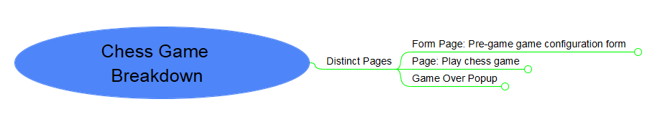

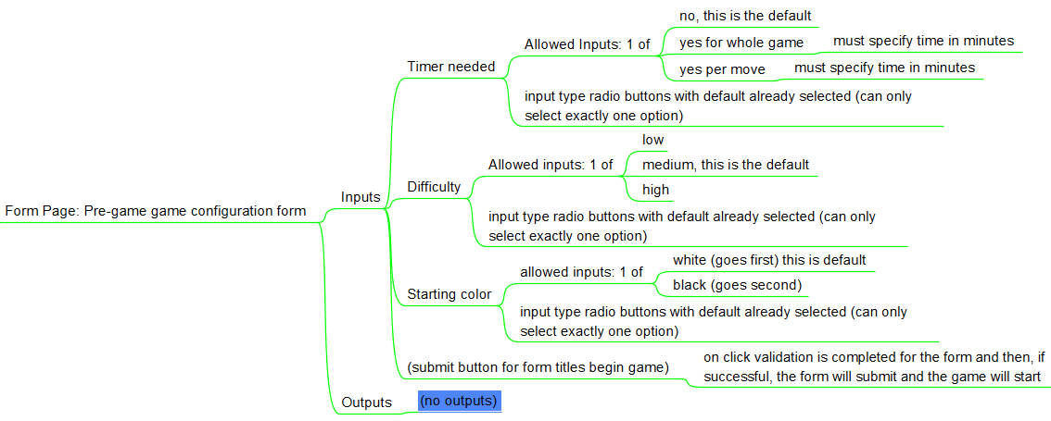Breakdown of each page (decomposed by the various inputs and outputs that the page is responsible for).

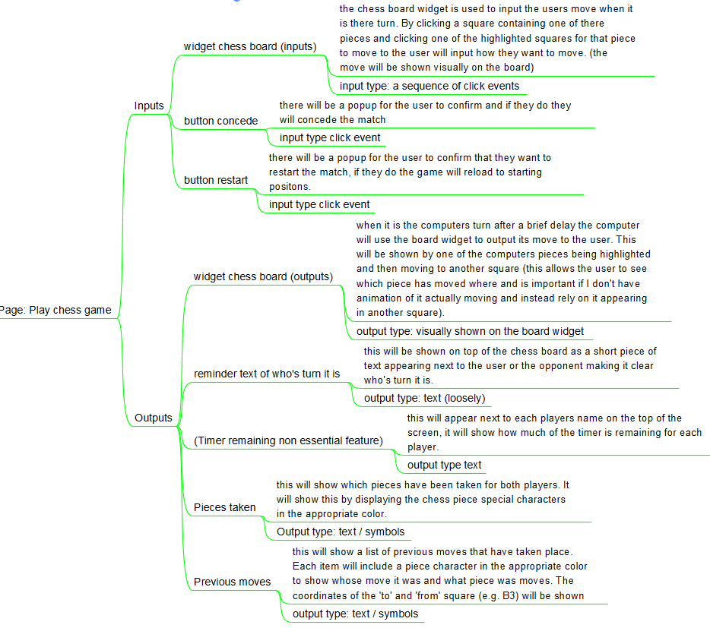

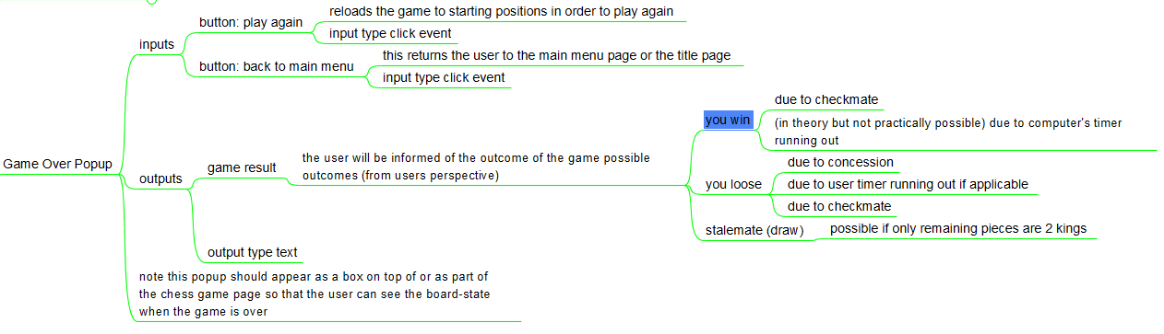

Many decisions were in the decomposition of the problem into various inputs and outputs. here are my justifications:

* For one I decided to reduce the initial problem size by removing the login and user part form my design. This could be added in later but I would first like to complete this design without. This greatly reduced complexity and reduced the number of webpages needed.
* For another I decided that I should include default options for many inputs in the pre-game form to ensure that no matter what the user does a valid input will be given (e.g. using radio buttons). This will reduce work needed for validation and make my program more error resistant.
* I also decided to approach receiving input moves and giving output moves in the way I did as this is a standard among chess apps and websites. Ensuring my program meets the convention will makes it feel more intuitive to those who have used other similar programs before and will reduce the learning curve. This was inspired by the research completed in my analysis step on websites such as chess.com.

I have also included a breakdown of the modules that will be needed in the client side JavaScript

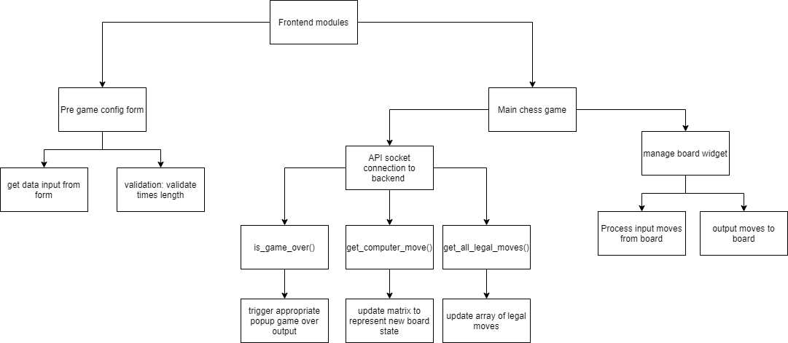

I should explain why the frontend has so few modules and why it doesn’t need a way to understand a chess game such as where a bishop can move or if a given game state is check mate.

The reason for this is that I intend to process all that information on the backend and leave only validation to the frontend.

API socket connection to backend is a module that connects to the backend and request information using methods such as is_game_over(). It then uses another module to handle the response, in this case a small submodule responsible for causing the appropriate popup to occur to notify the user that the game is over and to state the result.

Here is a diagram of the API connection between my frontend and backend

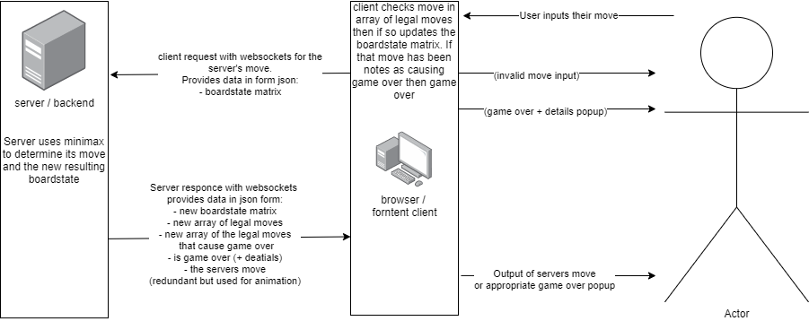

It shows how the front end client will be equipped with an array of moves that are legal and an array of moves that are legal and end the game + how the game ends.

Here is a flow chart to act as another way to show the logical flow of handling input to produce output in the frontend

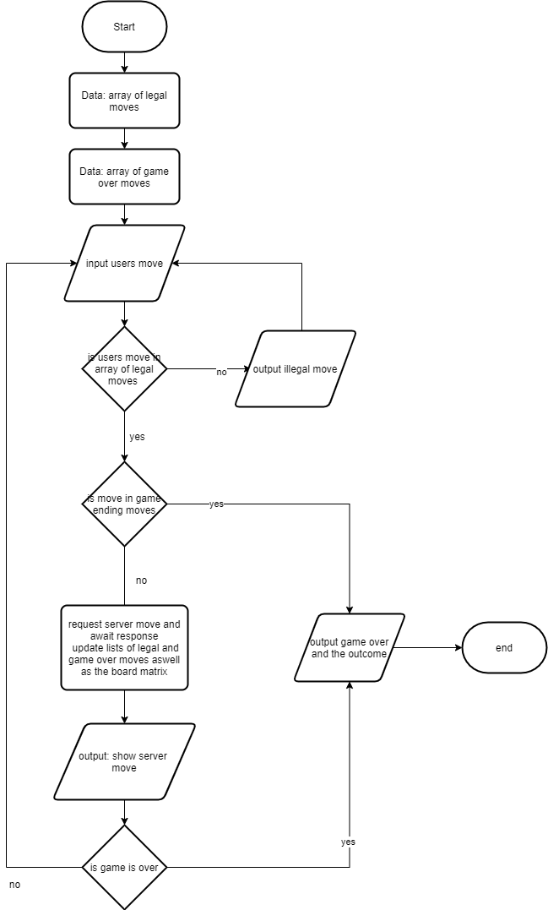

The point of this is to explain that the frontend is relatively dumb as it is unable to make inferences about the game ion its own. However by using one request per user move the server can send the client all the data it needs to validate the users next move. This is done by sending a new array of all the legal moves the user can make for future validation along with the server’s move.

This means that the main responsibility of the frontend (and therefore the purpose of most of its modules) is to validate the users move and process it into a request for the server as well as to process the servers move and turn it into the appropriate output for the user (e.g. know when to display game over) This reduces the complexity of the frontend greatly as it reduces the number of methods and classes needed. For instance no method is needed to determine if a game is over and no class is needed to represent the moving patterns of a knight.

I have used decomposition and thinking ahead to identify the various pages needed and the inputs and outputs that each should provide. Using this I have created on paper some designs for the various pages that would make up the user interface

The scans include arrows with annotations of the various features, some features in brackets are there to show where such a feature could fit if implemented in future.

My user interface will be made up of these pages:

* A menu page / title page
* A pre-game configurations form
* The main page in which a chess game is played
* A popup menu providing information about how the user has won.

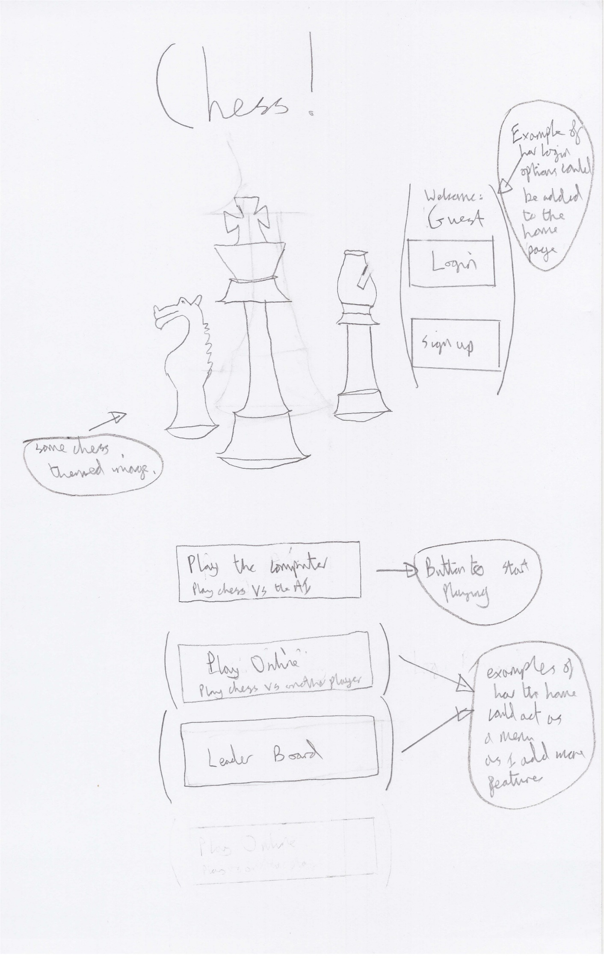 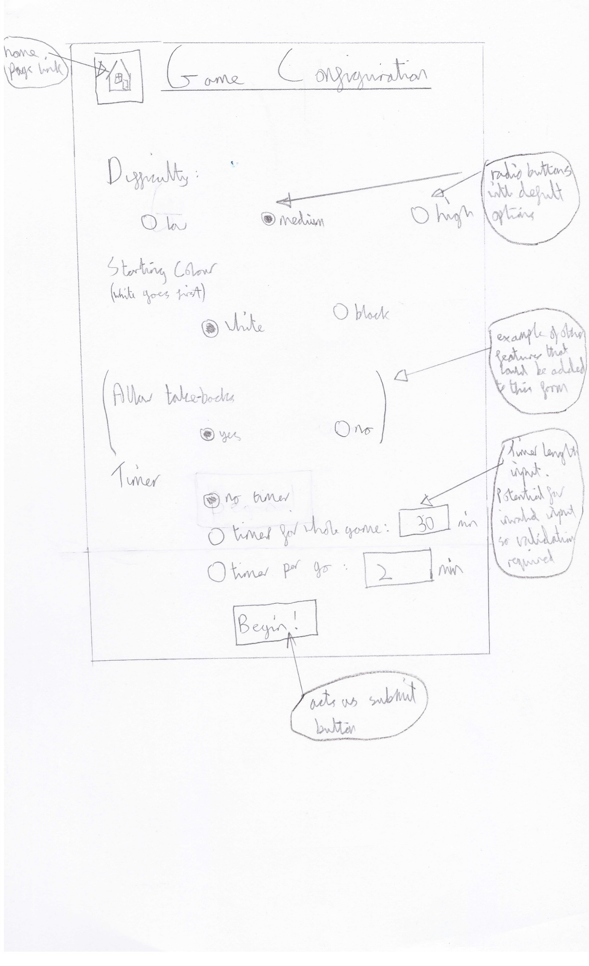 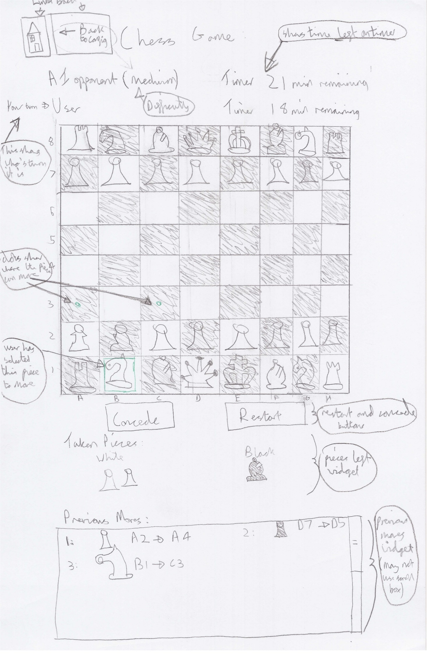 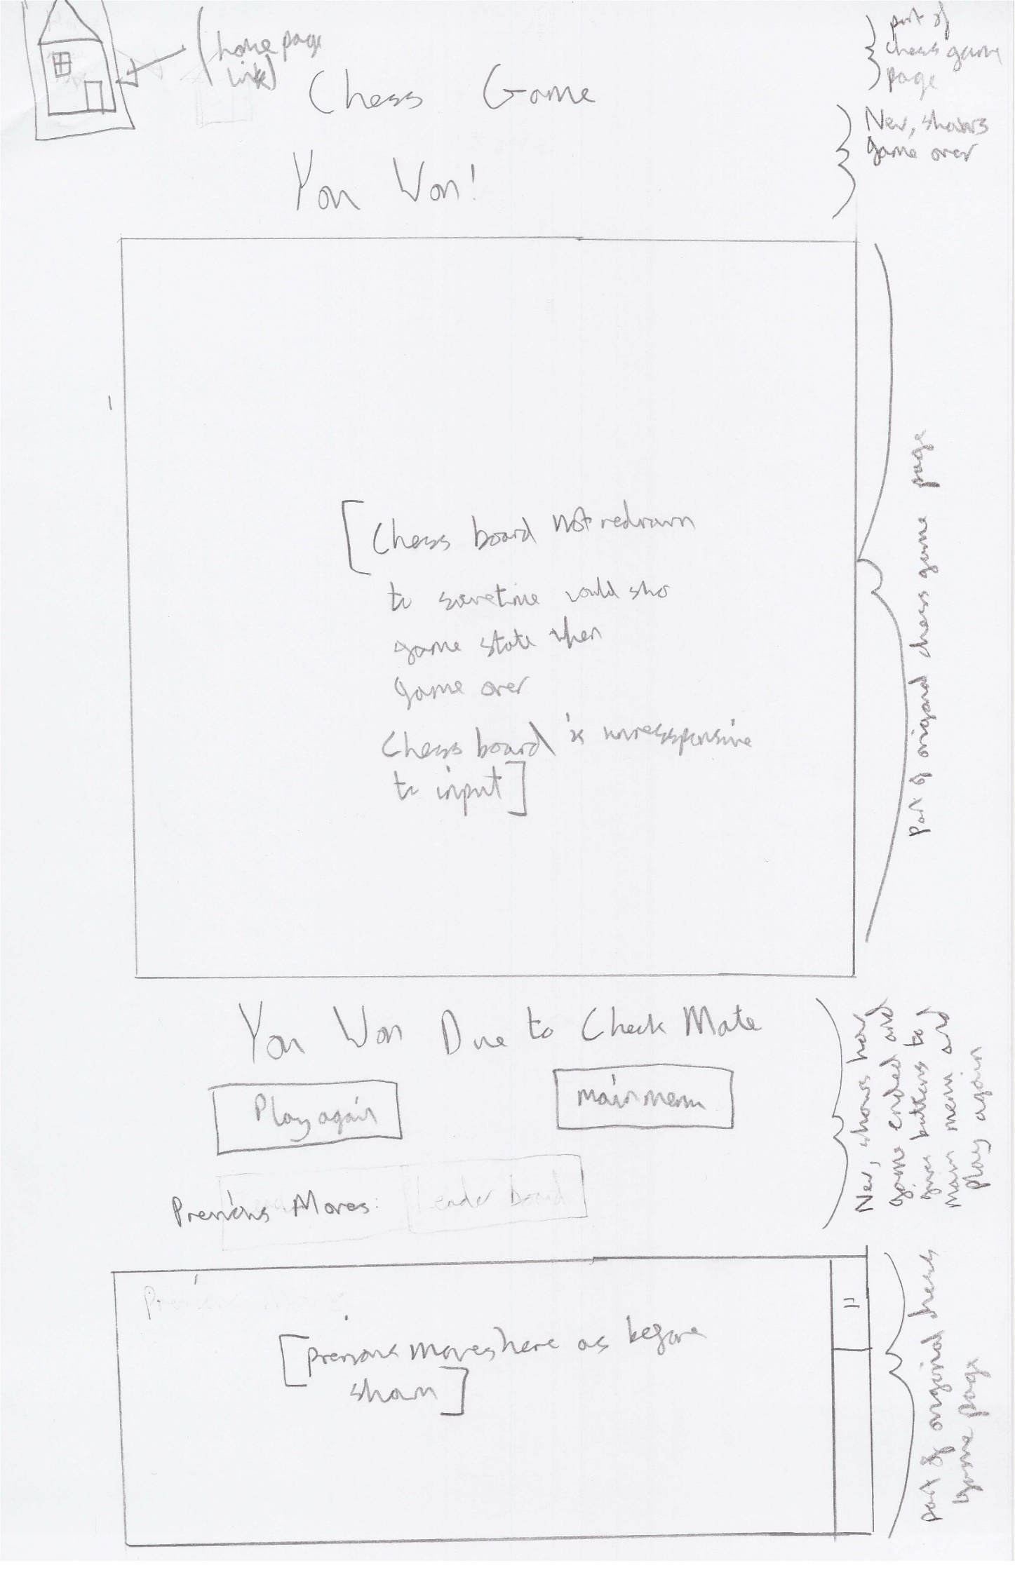

I will outline and explain some of the key features and decisions made when creating each page.

Note the aesthetics such as the background have been abstracted in order to reduce the problem. Implementations of these user interfaces will not have plain monochrome backgrounds and features.

I also choose to centre align all my pages in order to catch the users attention (they are most likely to look in the centre)

I would also like to mention here that while I intend to make my website work for multiple resolutions, these sketches are for the 820x1180 resolution of an iPad Air in portrait

## The title / menu page:

This page will initially be a simply page with only a title, a chess related image and a button to begin playing vs the computer. As more features are added it will be expanded to become a home page and menu for the website. Examples are included.

## The pregame config form page:

This page will be what the user sees after they click to begin a game vs the computer. I will use radio buttons with default options to ensure that the user cannot provide an invalid input for fields like difficulty and starting colour. I will need to add validation to the times length inputs (as an example). This would likely include a presence check, type check (integer) and a range check (e.g. 15<= time <120).

## The chess game play page:

As earlier stated the method of inputting and outputting is standardised to make the program easier to use.

Outputs like previous moves and pieces taken will auto update after each move. How the timer works will depend on implementation. It will only appear in the top corner if requested in the game configuration.

## The game over pop-up:

The main decision here was how the information should be conveyed. I decided against a different webpage or a popup square that obscures the chess game. This was because I thought that users would appreciate still being able to see the state of the current chess board. The current implementation will work by using the same webpage as the chess game play page. When the game is over some components like timers, whose turn and the pieces taken will be hidden and another widget that announces that the game is over unhidden. I may have the pieces taken component not disappear but this would mean that all of the widgets would not fit on a mobile phone screen without scrolling down. This may not be a bad thing if there is enough space left as users may not mind scrolling down to see all the previous moves. This decision depends on how the widgets fit together once the GUI is created and what feels natural.

Here is a menu flow diagram to show how the website is composed of these webpages to form the website.

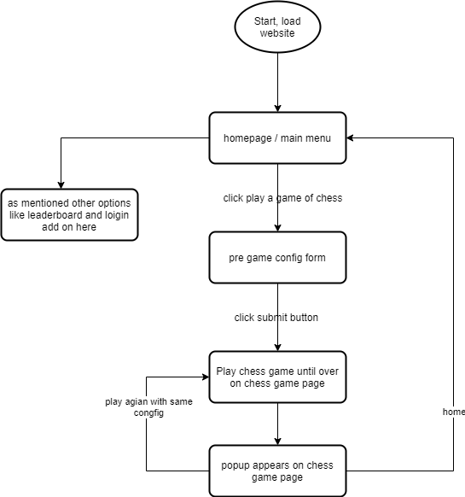

## Usability features to be used in the solution:

I have fully read this article which introduced me to the breakdown of usability into these components. I have integrated its tips with my project.

<http://www.wqusability.com/articles/more-than-ease-of-use.html>

### Effective

For a user interface (UI) to be effective it must meet the expectations of its users with regard to the utility it offers and also how effectively an average user could use this site to meet their goals.

I have determined in my analysis step that my target users are casual chess players of all ages. As such I have tried to meet their needs specifically be adding features like take backs (if implemented) and an easy difficulty.

To help meet users of all ages I intend to utilise my discussions with my grandparents and my research. I realised that many older people enjoy playing games like scrabble and chess on an app or website. They also commonly use iPads and tablets as they are bigger and so require less finger dexterity. Here is a breakdown of hardware usage by age: (<https://www.statista.com/statistics>)

Proportion of people in different age brackets who use a tablet to go online:

<https://www.statista.com/statistics/300257/tablet-pc-usage-to-go-online-by-age-uk/>

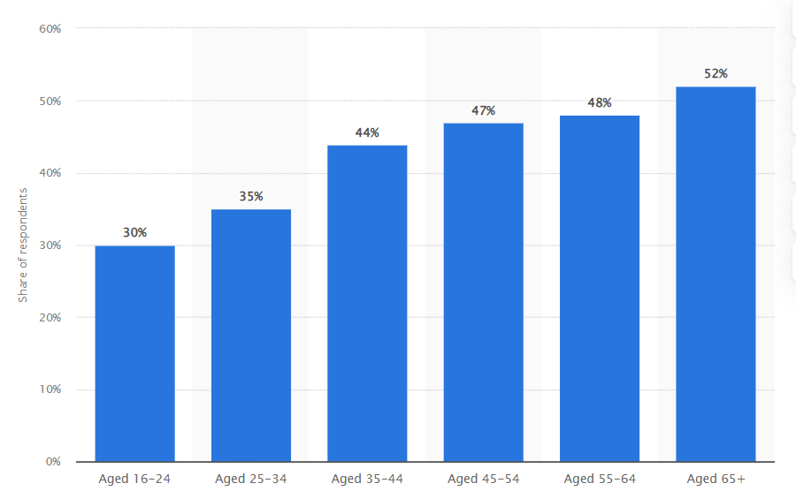

52% of people aged 65+ have a tablet that they use to access the internet. I found this surprising and useful. For this reason one of the other ways in which I aim to ensure that all my target users are able to effectively make use of this product is by ensuring that it has specialist layout that are compatible with large resolutions of laptops and PCs (resolutions vary) as well as tablets (baseline could be iPad Air which is 820px * 1180px) and mobile phones (a baseline could be the iPhone SE with a resolution of 375px * 667px). (My source for resolutions is the chrome web browser in its dev-tools section). This way I can ensure that my website can be accessed by commuters on a mobile, and by people of all ages at home with laptops, PCs and tablets.

Due to the target users I am prioritising some features over others. For one example I am prioritising crating a range of difficulty settings over making a mobile chess clock component in order to best meet my casual user’s needs.

### Efficient

I would like to divide efficiency into two distinct parts: user interface efficiency and overall program time efficiency.

I aim to make the user interface efficient as I believe that this goes hand in hand with being easy to learn. For example I have minimised the number of clicks that the user will need to make in order to begin playing chess. They can click play, change 1 or 2 configurations by clicking radio buttons and begin the game unhindered. They only need to make 2 intuitive clicks in order to move a piece. Additionally conformation popups are kept to a minimum.

The program has also had multiple considerations factored in to maximise efficiency. For instance I am using web sockets for the super-low latency (as well as the highly practical full duplex connection and ability to implement user vs user games is needed). I am also factoring in time complexity with all of the algorithms I employ. For instance I am using pruning and caching to improve the efficiency of my minimax variant algorithm. Additionally the computer is only given a limited time to think (for example 5 seconds max, if needed, difficulty dependant) as the user may become bored if the computer took as long as an average user to make a move. This allows the user to always be playing the game.

I may in future add keyboard shortcuts but I don’t currently deem it necessary or a priority.

### Error tolerant:

With regard to error tolerance I have used some of the tips provided in the article to passively improve my application error tolerance without more validation and input sanitation. For example I decided to implement the difficulty input field in the program config form using radio buttons with medium as a default. This means that it is impossible to select an invalid difficulty or not provide a difficulty. I also took the tip of making everything easily reversible by adding a ‘back to config’ hyperlink in the chess game page so that difficulty etc. can be easily changed without going back to the main menu and restarting.

With some fields like the duration of the timer if a timer is preferred by the user I will need validation as mentioned earlier. I will use a presence check, a type check to ensure the input is of type integer and a range check such as timer in range 15<= t<= 120. When the submit button on the form is clicked, if this validation fails I will use the industry standard and give the box with invalid input a red outline along with red text to indicate the input requirements.

With regards to moves made by the user on my chess widget. I will talk about it in more depth later but validation is needed. For instance I must ensure that the first square that the user clicks on contains one of their pieces, then I must ensure that the second square is one that the user could move to. I will highlight the legal squares a piece, one selected, can move to with a green dot to eliminate ambiguity.

This validation will be quiet failing as if the user clicks on an invalid first square nothing will happen and if the user clicks on an invalid second square then the piece will only become unselected. No error messages will be used as I believe that this way is most intuitive due to convention.

### Easy to learn

One of the reasons that this user interface is easy to learn is that is follows the convention of other chess programs with regards to how the user inputs a move. For example the same method, including highlighting legal moves, is used on Lichess and chess.com which I examined as part of my research. I was impressed by how intuitive it felt when I experimented with these websites.

Additionally by using a chess program convention in my interface design I will reduce the learning curve for new users that wish to start using my program. In this way I am providing an interface in the way that the user expects it. This interface also maps well onto both PC and mobile touch screen device.

### Engaging

I have aimed to make my user interface pleasant and satisfying to use by not making it too complicated. I have tried to reduce the level of noise and needless complexity on the screen and aimed to logically block together information for the user. For instance I put the submit button at the end of the form as users complete forms top to bottom and are less likely to read them properly if the button is at the top. I also used this principle of distinct blocks on information in my chess game play page as information such as previous moves and pieces left was grouped together with clearly allocated, non-overlapping space. They were also at the bottom as they are less important than the chess board and the concede button which should catch the users full attention.

I also plan to make my website visually appealing. I have already in the plan included an image in the home page and centred all the content to look appealing. In the final version I intend to have a different background colours for the webpages (this detail was abstracted away in my plans and so left white). I also want to give the chess board more of a wooden look or even better give the user the ability to alter the look in the pre-game configuration or their account setting. Here is an example of the wooden look I would like to add.

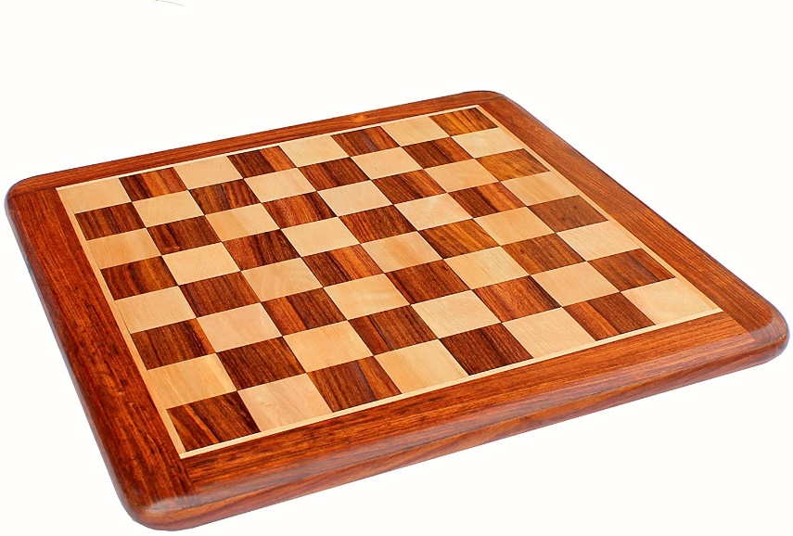

Future plans to maximise how engaging the website is include:

* Adding sound effects for moving a piece and taking an opponents piece (inspired by interview and Lichess research)
* Adding proper animation to show the piece actually moving from one square to another rather than just appearing in the selected square. This would help make the computer’s move more clear as it would show what piece had moves and where as a moving object is more catching to the eye.
* The image on the title slide could be replaced with a chess board showing a rapid replay of a series of example matches on loop.

## Further Problem Analysis At a Technical Level:

I thought it would be prudent to investigate the technical aspects and details of the problem of making a computer that can play chess. Without doing this I will struggle to decide the appropriate algorithms to use as well as the limitations of my solution.

Chess is a game with complete information as there are no hidden zones (e.g. hands in poker). This is important as it means that both players can use game theory and assume that the opponent is rational in order to try to predict how the opponent will react to each of the moves that they are considering. This thinking ahead is what human players do to identify the best move.

Chess is a game that uses 6 types of pieces:

* Pawn
* Rook,
* Knight
* Bishop
* King
* Queen

Each of these pieces come in 2 varieties: black and white. I will need to incorporate this into my program, both to mark which player owns and controls each piece as well as to properly display the chess board to the end user.

A game of chess is played on a board that is 8*8 and starts with each player having 16 pieces.

Most chess moves obey a set of rules that can be effectively modelled with vectors. Each chess piece can be attributed a position vector and then a series of movement vector if the chess board is treaded as a vector space. This is a useful abstraction as it provides a mathematical and easy to program way of describing how a piece can move from wherever they are.

Each piece has a set of movement vectors by which it can move. Ignoring the effect of check on legal the legal moves of a given piece for now, each piece can make usually perform each of these moves so long as the square that the piece would move to is empty or contains an enemy piece and so long as this vector doesn’t cause the piece to jump over an allied piece. ­­­­

This is not always true as there are exceptions. For instance the knight can jump over pieces, in addition the pawn if able to move forward 2 places on its first move only and takes pieces in a different direction to how it moves.

It is a useful generalisation to say that a chess move causes the square where the moving piece was to be empty and the square which it is moving to, to now contain the new piece. Assuming that every move has this simple structure and that no other squares are affected is an oversimplification but makes the problem easier to tackle

As such I don’t aim to add some more complex moves which violate this general idea of a move. These include:

* En passant
* Castling
* Ascension (a pawn becoming a queen)

In addition to analysing the problem of representing a chess game, I must try to investigate how a computer could play chess. In 1913 a man named Ernst Zermelo said: “As long as we are able to describe a game as a finite tree, we can find the optimal play”. Describing a game as a tree is a useful abstraction for an algorithm as the current game state can be

A game like tic tac toe can easily be described as a finite tree, if the user goes first then then this narrows down the number of possible games form 9! (360,000) to 8! (40,000).

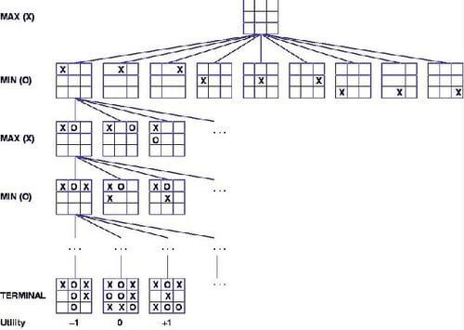

**(diagram source:** [**https://www.hackerearth.com/blog/developers/minimax-algorithm-alpha-beta-pruning/**](https://www.hackerearth.com/blog/developers/minimax-algorithm-alpha-beta-pruning/) **)**

This means that all the possible games that could result from a tic tac toe game can be described as a small finite tree that can easily be searched in its entirety by the computer. This process is a recursive and involves exploring the decision tree down to the terminal nodes (games that are won, lost or drawn). These nodes are then given a utility and the algorithm propagates back up the tree. By assuming that the user will act rationally it can take the move that maximises the best outcome that it can guarantee even if the user plays optimally. This brute force process which explores all the paths a game could take in its entirety is called the British Museum Algorithm

This will not work for chess. There are around 10123 possible games of chess. This number is far to large for any super computer to apply the British Museum Algorithm. For context there are only 1080 atoms in the universe. This means that if every atom in the universe acted as a chess computer and processes chess board states at a rate of 1 per millisecond since the Big Bang, only 1 100 trillionth of the work (10-14) would have been completed today. This highlights the issue with the exponential nature of possible chess games. Due to this combinatorial explosion, the problem is in intractable.

As a result of this, I will discuss a more feasible algorithm that can tackle this problem later in this document called the minimax algorithm.

## Design Objectives:

Here are my design objectives. These are based on my success criteria and should serve as a series of specific technical requirements for my solution in order to meet the success criteria.

As the size of the problem is significant, I have focused on the aspects of the success criteria that are of a high priority or are essential. This should ensure that a high quality product is produced at the end of the iterative development process that is realistic considering time constraints.

|  |  |  |  |
| --- | --- | --- | --- |
| Number: | Name | Description | Success Criteria Link |
| 1 | GUI: Chess board | I need a graphical user interface that includes a visual representation of a chess board | 2-8 inclusive |
| 2 | GUI: Chess Board | This chess board should be able to register click events and run a handler function in order to allow the user input their move | 2-8 inclusive |
| 3 | GUI: Chess Board | The square click handler function should be able to keep track of the state of the chess board with some key variables in order to decide how to action the users click input | 2-8 inclusive |
| 4 | GUI: chess board | The program should do nothing when an invalid square is clicked. Relevant validation should decide to disregard the click event rather than raise an error. | 2-8 inclusive |
| 5 | GUI: Chess Board | The chess board should be able to respond to inputs as appropriate by visually changing how it appears to the user to add highlighting and move pieces. I will aim to ensure that ever click causes a reaction (visual feedback) | 2-8 inclusive |
| 6 | GUI: Chess Board | The chess board should be able to display any layout of pieces overlayed onto the squares using either characters or images to show the pieces | 2-8 inclusive |
| 7 | GUI: Chess Board | The chess board and the pieces must be sufficiently different in color so that white pieces can be seen on a black background | 2-8 inclusive |
| 8 | GUI: Chess Board | The chess board should be able to show the computers move but adding highlighting and then moving the pieces. | 2-8 inclusive |
| 9 | GUI: Difficulty Radio Buttons | Radio buttons should be used for the difficulty with the medium button already selected. This will ensure that only valid inputs for the difficulty are given. It will also ensure that at all times, at least one input is given. | 1 |
| 10 | Difficulty Of AI | The move engine (AI adversary) should be able to be limited in how well it can explore the board (measured in either depth or time) to create different difficulty levels. | 1 |
| 11 | Move Engine AI | The move engine should be able to perform a type of tree search to determine scores of child board states and use these scores to decide and return both a move and a score | 9, 10 |
| 12 | Move Engine AI | The move engine should feature some optimisations to allow it produce the same quality of move faster or produce a better move in the same time. The new optimisations should not change the output of a given search (this is deterministic) but should just improve speed | 26 |
| 13 | Move Engine AI | The move engine should be able to learn from its past games in order to improve its decisions and select new moves. | 27 |
| 14 | Move Engine AI | Persistent data storage should be used to enable the AI to retain calculations and cache results from previous games in order to improve and learn. | 27 |
| 15 | Move Engine AI | The move engine should be able to make a good move decision even if none of the terminal nodes are game which are over by using heuristics. | 9 |
| 16 | Move Engine AI | The move engine should be able to understand when a given node represents a board state where the game is over and value this node accordingly. In the late game it should aim to try to steer towards outcomes where it wins. | 10 |
| 17 | GUI: Main Title | Above the chess board there should be a main title which displays a message which changes over time. This should be in large font. It will indicate whose go it is and whether or not a given player is in check. This should also act as the prompt for users to input another move, to make moving a clearer process.  This title will also be used to explain when the game is over and who has won. | 5, 11, 12 |
| 18 | Board State Analysis | The chess computer should be able to determine is a given player is in check. This will affect legal moves and therefore the move engine as well as validation of the users move | 11, 28, 29 |
| 19 | Board State Analysis | The chess computer should be able to determine if the game is over, and the nature of the end to the game (e.g. is it a stalemate or who the winner is) | 12, 28, 29 |
| 20 | Board State Analysis | The chess computer should also be able to accurately determine all the legal moves available to a player for a given board state. This functionality will be relied on to validate the user’s move input and for the move engine’s search of the decision tree. | 28, 29 |
| 21 | Move engine can access board state analysis | The move engine (adversarial AI) should be able to able to access functions to recognise the legal moves of a given board state or whether or not the game is over in order to properly construct and traverse it’s the decision tree. | 9, 10, 26, 29 |
| 22 | Chess game: A data structure should be used to display previous moves | An array should be used to hold as vectors all the previous moves made in the game. | 15 |
| 23 | GUI: A widget to output previous moves | A table should be used to display the previous moves in plain English an using chess squares (not vectors). | 15 |
| 24 | GUI: buttons | I will need buttons on my user interface to concede and restart the game as well as functions to facilitate this | 31, 32 |
| 25 | GUI: Pieces taken function and widget | A function should be able to use the piece layout for a chess board state in order to determine which piece are missing (have been taken). There should be a widget in the user interface to provide this as a graphical output to the user. | 30 |
| 26 | API connection | I should have a fast and efficient way to convey data between the server and the client to allow for real time inputs and outputs and to prevent lags. The connection structure should also allow all the relevant data to be exchanged while not being too complex. | 17 |
| 27 | GUI: Reloading unfinished chess games | I have decided that this feature can be completed without a login system. When loading up, the website should make a request to the server for the up to data chess game rather than load data for a starting chess game. This should allow the user to continue a chess game where they left off if they close and then reopen the tab | 19 |
| 28 | Reloading unfinished chess games | The server should be able to read the cookies within a browser when client server session starts. If a unfinished game exists in the cookie (or the cookie contains an id to lookup in a database) then this game will be loaded into memory for the duration of the client and servers session.  When the session ends, a cookie should be created in the users browser that contains or links to the unfinished game for future use by the server. | 19 |
| 29 | GUI: Mobile device access | The GUI should be designed so that the core components (main title and chess board) can be correctly displayed in a variety of aspect ratios and orientations to allow for the use of tablets and phones (maximise accessibility and convenience) | 25 |
| 30 | GUI Accessibility | The website will aim to practise clarity and accessibility of the content over visual appeal when deciding colour schemes and layouts.  This means that there should be sufficient color contrast to identify individual widgets and text from the background as well as highlighting and pieces on the board. This includes ensuring that the colours used for highlight are not a common color pair for color blindness. | ­­24 |
| 31 | Move Engine Heuristics | The move engine (adversarial AI) should be able to perform a fast heuristic analysis of the board. This will provide a score that one player aims to minimise and the other maximise. It should be based on pieces remaining and piece layout. It will be used by the move engine to play chess in the early and mid-game. | 9 |
|  |  |  |  |

## Some changes to the design:

After deciding my technical design goals to achieve the high priority part of the success criteria I have made some changes to my design for the proposed solution.

I found the initial attempt to design the program very productive as it help me understand how the problem was trackable by computational techniques. My initial attempt to break down the problem helped me see which components would be needed to tackle the problem.

I will now use the new ideas from my design objectives to revise to structure of the proposed solution and how it will be implemented. One reason for doing this is that laying out all the design goals in a table has helped me see that there are more feature to implement than I fist thought. In order to achieve the most important components of the success criteria and deliver a working final prototype that meet the stakeholder needs I must be realistic about the time available.

For example, my first design iteration included a multi webpage user interface that included login capabilities. This was not a high priority feature in the success criteria and so it is not realistic to implement in the limited time frame.

However, the process of determining how the problem was solvable by computational techniques and designing the user interface has been useful. For instance I have decided that I will use the minimax function to implement the chess AI. I have also decided that of all my drawings of the user interface, I like the following design the most. As a result I will model my single webpage user interface on it:

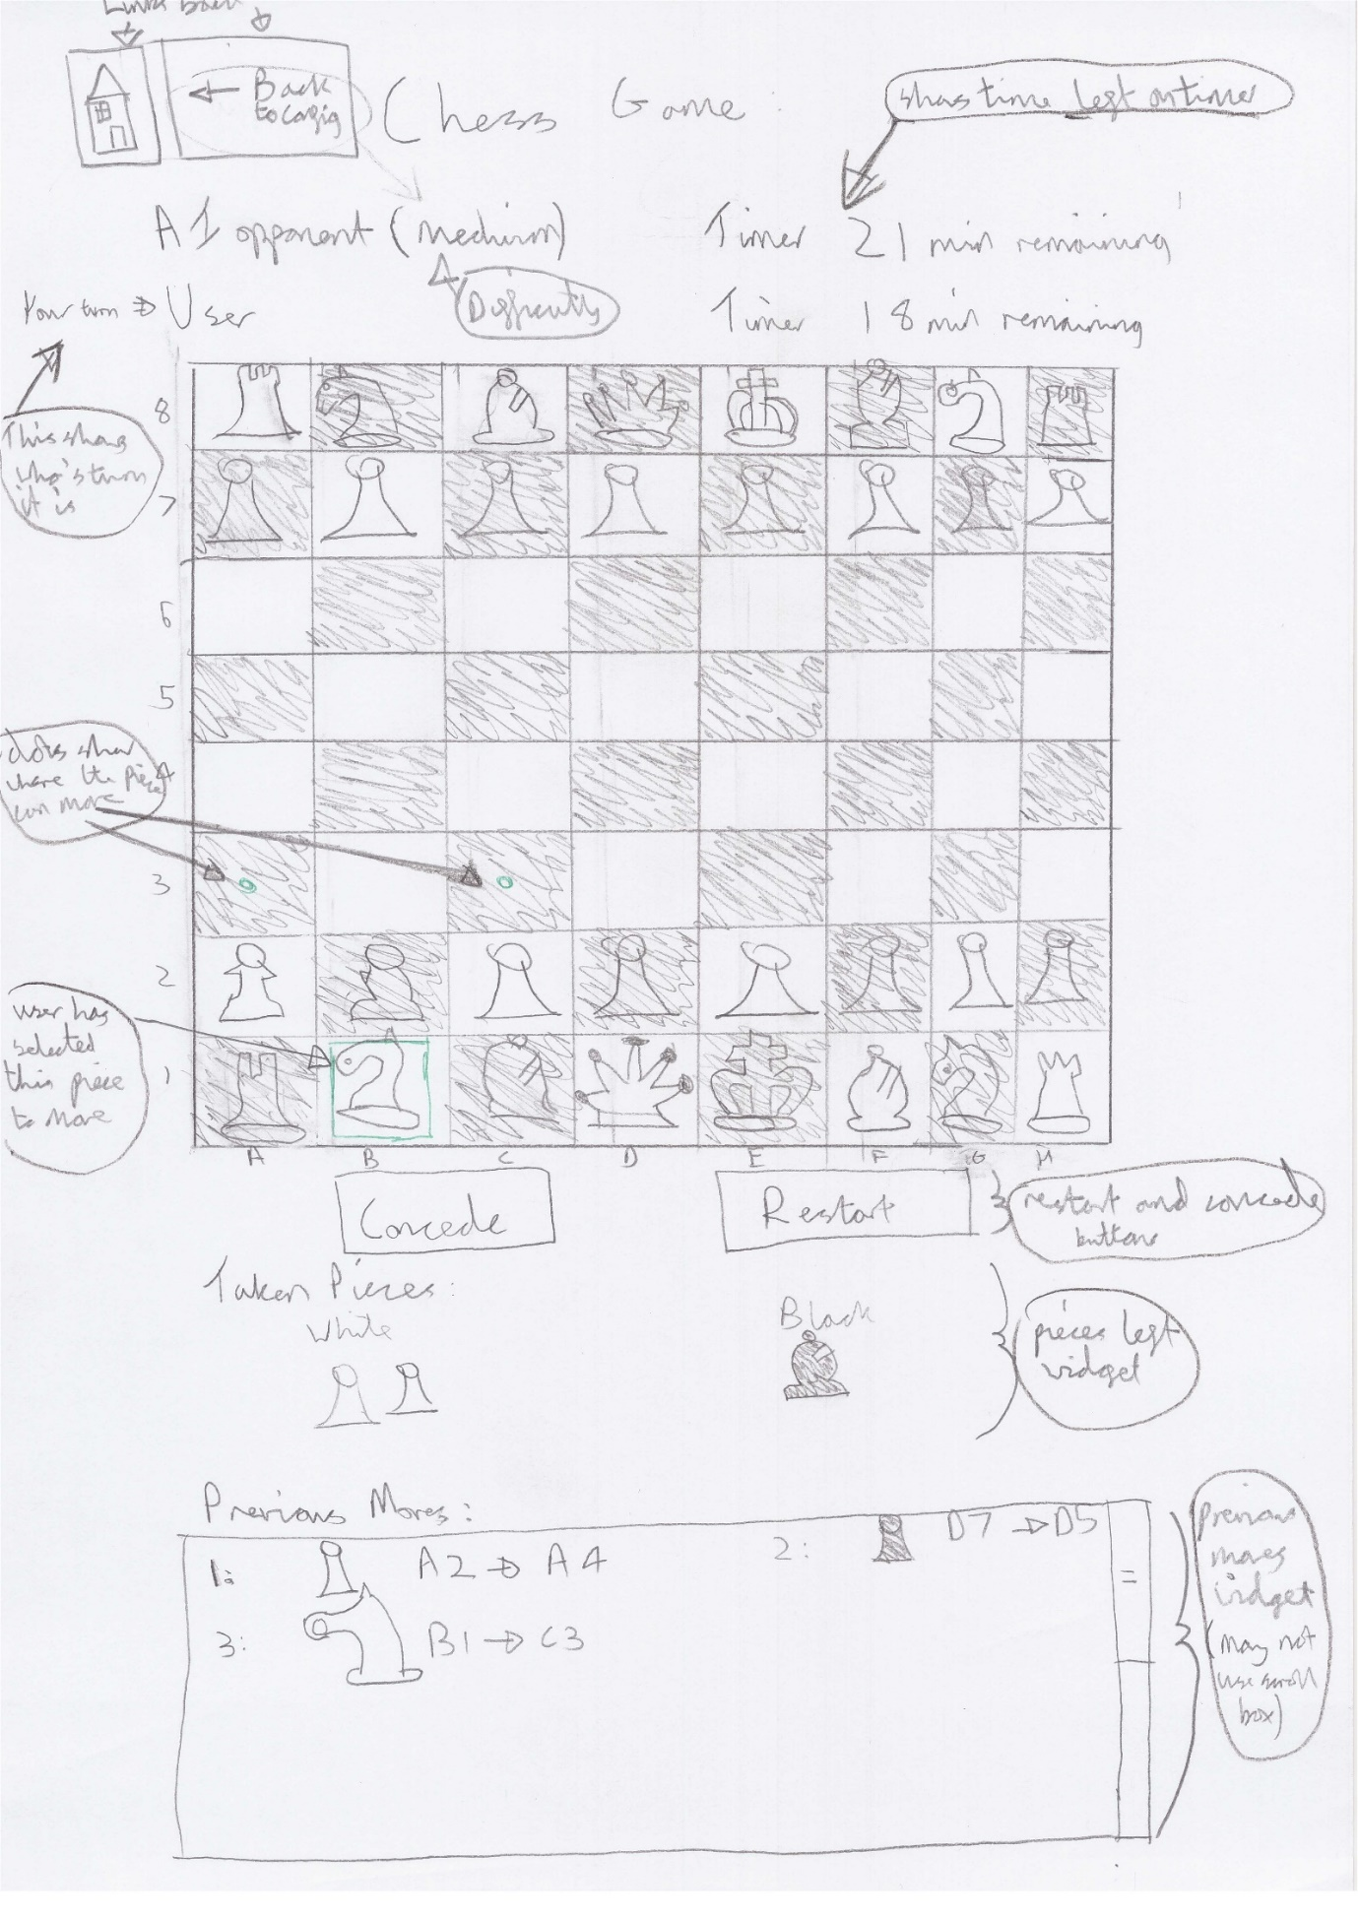

## Usability Features to be Used in the Solution:

I made use of my research into usability and how to ensure that it is maximised within my program within the first part of my design. I liked these ideas and will not change them. I have integrated them into my design objectives.

### Effective

I have aimed to make my proposed solution effective by trying to maximise the range of aspect ratios that the final website will work with. This will include tablets as my research shows that they are more popular among older stakeholders. I will aim to make the final product work on phones. This will allow me to meet the needs of stakeholders who are on the go or otherwise play chess on their phones.

This links to design objective 29 and 30

### Efficient:

I will maximise the efficiency of my program by using a fast API connection and by making improvements to the minimax function. This should help avoid symptoms of inefficiency like lag which could negatively effect the user experience.

This corresponds to design objectives 26 and 12

### Error Tolerant:

I will ensure that my final product is error tolerant by adding validation to avoid invalid inputs causing invalid outputs. I will also use automated unit tests to ensure that the final product is robust and has as few logic errors as possible.

This corresponds to design objective 4

### Easy to Learn and Engaging:

I have used my research from the analysis section and decided that I will try to emulate the highlighting feature as well from competitor websites like chess.com. This should make the program easier to use and more intuitive as it should allow me to show the user visually the legal moves that are available to them. I will also use the highlighting to show the computer’s move.

This should make the program easier to learn and use for both new player (who may not know where all the pieces can move) and players who are used to the user interfaces of competitors like chess.com. Features such as the game being saved for later should also provide convenience and make the game easier to use.

I believe that if I can make the sight easy to use, then there should be nothing to get in the user’s way of enjoying and engaging with the chess game. Addition different difficulty setting to allow user to set the write level of challenge should also make the chess games more engaging.

This corresponds to design criteria items:

* 1, 10, and 12-16 for different difficulties and AI challenge
* 5, 23-25 for highlighting as well as other features common to many chess sites
* 27 and 28 for reloading chess games

## Proposed Solution Description:

My proposed solution will be a full stack web application. It will have this overall structure:

­­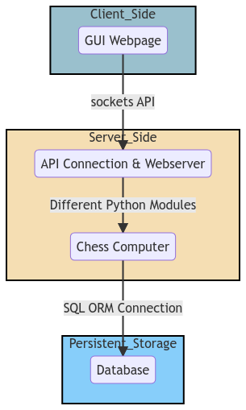

As shown in the above diagram, the solution is a full stack web application. This means that it includes code and logic at both the client and server side.

## Front End:

The front end or client side component of the solution will be a combination of HTML, CSS and JavaScript. It will be responsible taking in user inputs and providing outputs. This should be done through a purely graphical user interface (GUI). The client side JavaScript should also perform client side validation of the users inputs in order to ensure that only legal moves are made. The client side JavaScript should also use asynchronous programming by using JavaScript promises to connect to the server and exchange data. The client side JavaScript code is intended to be “dumb”. By this I mean that it won’t have any algorithms that can help it understand what is happening in this game of chess (e.g. if the game is over or what the legal moves are). Instead it will request act only as a wrapper around the logic already created in the chess computer, providing a User Interface on top of this.

## Server Side API Connection and Webserver:

The next layer in my application is the server’s webserver and API gateway. This server side code will setup the HTTP webserver that will send the relevant HTML, CSS and JS files to the browser. In addition, appropriate WebSocket routes will be created to allow the server and the client side chess

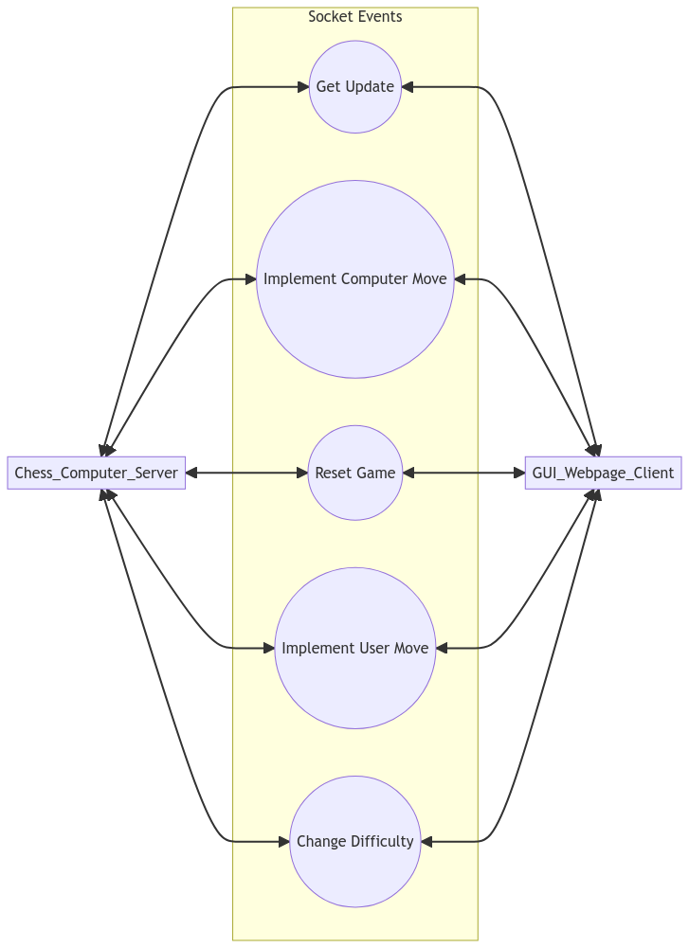

## GUI to communicate.

The webserver and API gateway should act as an intermediary between the client side JavaScript and the functions of the chess computer. It should include server side validation to ensure that the data sent to the server by the client is valid (so for instance the user move must be valid). As part of defensive design to minimise unexpected behaviour and validation needed I will aim to minimise he amount of data that the client and server exchange.

## Chess Computer:

The chess computer will take the form of a server side python program that is able to keep track of a chess game, provide the legal moves, and recognise check and game over as well as determine the adversarial AI’s move. This will be completed by dividing the chess computer into various sub programs.

## Benefit of Decomposition:

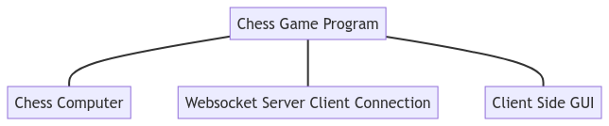

The benefit of this decomposition of these main parts is that each part can be tackled separately and using different means.

The chess computer can be tackled with pure python

The client side user interface can be tackled with HTML and JavaScript

The API connection and webserver can be tackled using the Flask and WebSocket frameworks

Dividing up the program into these parts allows for specialist languages and frameworks to be used to tackle the sub-problem. Additionally different people could work on different sub problems independently if this was a professional project. Because of this, the above decomposition makes the final product easier to implement and should improve its quality in terms of how well it meets the design goals.

## Diagrams of propose solution:

Here is a flowchart to describe how the user will input a move and play chess against the computer.

This will all take place on the same page as the application is only a single web page (reduces complex menus that the elderly can struggle to navigate):

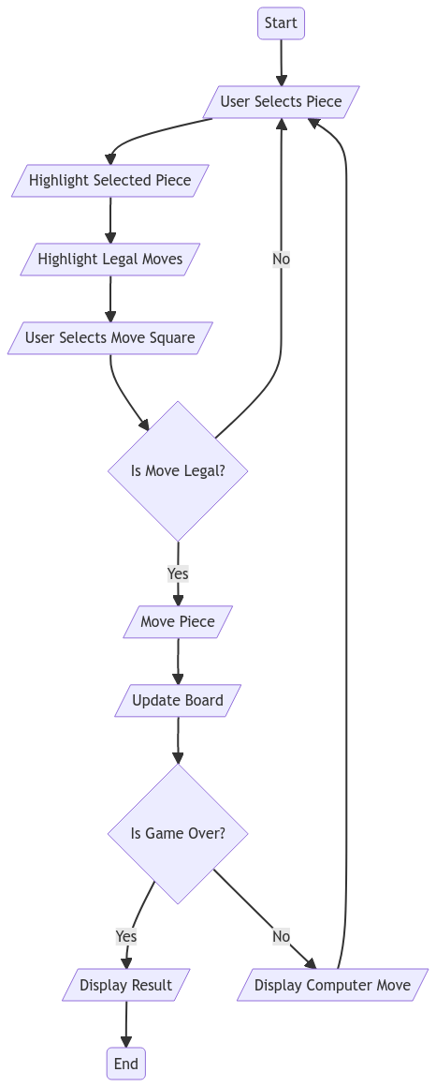

And here is a data flow diagram to describe the flow of data within the program when making a move. It shows the layers of the application that sit between the GUI and the database. It shows how a user move input is processed and then a computer move output is produced.

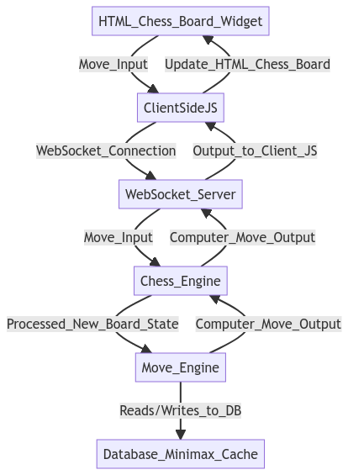

I will use the interface design from my first design iteration as I believe it addresses the various usability requirements that I identified in the first part of my design:

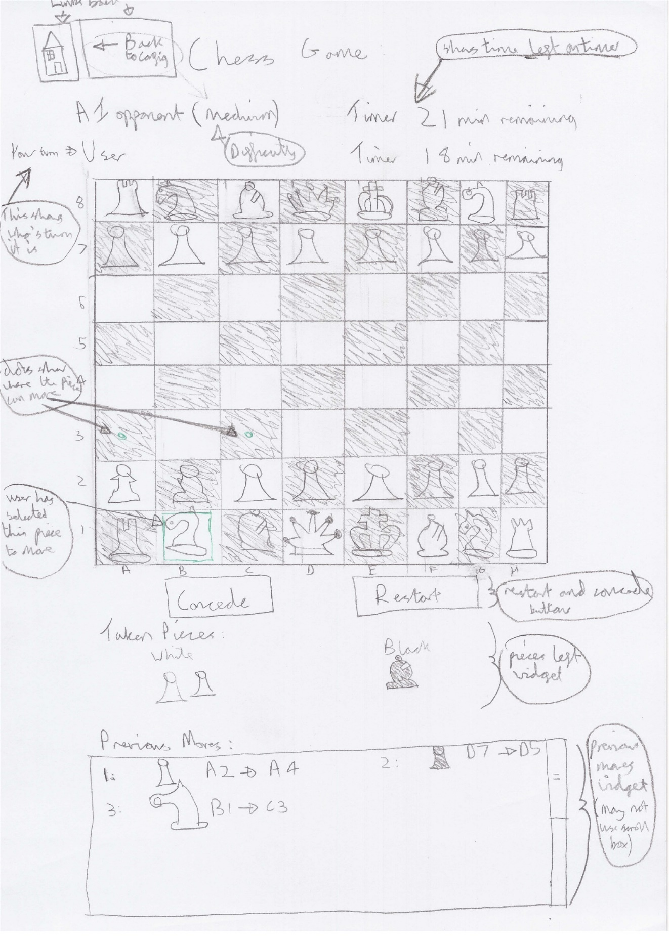

## Decomposition of Chess Computer (not algorithms just functions, classes and data structures)

The chess computer is a broad term that I am using to describe the backend logic that runs on the server to allow it to manage a game of chess, including generating the computer’s moves.

The chess engine is a large program that can be further decomposed into multiple modules.

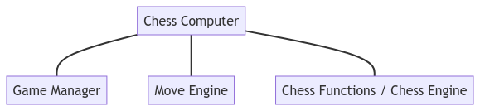

The Chess Functions Library or Chess Engine us used to analyse a given chess board state. It will contain functions to use a given board state to determine the possible legal moves, or if the game is over.

The Move Engine component will be responsible for performing a minimax search of a given board state in order to determine a suitable move for the computer to make. As part of this it may interact with the database in order to make use of caching to improve efficiency.

The Game Manager module will act as a wrapper around all of the logic and functionality of the other 2 modules. It will be able to keep track of a whole chess game where as the chess engine can only keep track of a single board state which is a snapshot of a whole game. It will be able to keep track of which players go it is as well as implement moves. It will include validation to ensure that only the right player is able to move on their turn and that they can only make a legal move.

It will make use of the Chess Engine module to keep track of the board state throughout the game. It will use the Move Engine module to decide the move of the adversarial AI that the user will play against. It may also make use of a database in order to save and restore games for the user.

This means that:

* The Chess Engine module has no dependency on the other modules
* The Move Engine module is dependent on only the chess engine module
* The Game Manager module is dependent on both of these modules. It is the way in which the functionality of the other modules is accessed and choreographed together to produce useful functionality.

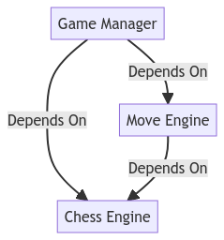

This decomposition should allow me to more easily achieve my design objectives as a big problem is being tackled with multiple separate sub components with their own responsibilities.

Additionally, the use of a Game Manager module should provide abstraction as it allows other components that facilitate a chess game to access shared logic rather than each interacting with board states and keeping track of turns individually. This should make other components such as the Server Side API Handlers easier to implement as less logic will need to be repeated. In addition the Game Manager module can be tested to show that it is reliable whereas lots of different instances of similar code to facilitate a chess game cannot be easily tested.

Each section should be able to achieve the following design criteria (by numbers):

* Chess Engine: 18, 19, 20
* Move Engine: 10, 11, 12, 13, 14, 15, 16, 21, 31
* Game Manager: 22, 18. Also ties in with requirements around game: (part of objectives 4, 5, 6, 7, 80

## Decomposition of GUI logic and API client server connection:

This component will include some logic on both the server and client side. Logic on the sever side will facilitate the API connection between the client and the server. Relevant handler function will call the appropriate functions of the Game Manager module when events are received from the client.

The majority of the code will be client side. It will include HTML and CSS to define the relevant components (tags) and there layout / style on the webpage.

JavaScript will also be used to provide interactivity, logic and connect to the server:

* It will include logic to affect the DOM object. The Document Object Model is an object in JavaScript that allows for the HML content that the browser renders to be interacted with. This will allow inputs to be received and outputs to be graphically displayed.
* JavaScript will also be used to create a class to represent all the data and logic from a given board state. This will include all the logic to decide how user inputs will be processed, when server requests will be made and how the returned value will be outputted.
* JavaScript will also be used to request data from the server. For example this could allow for a user move to be implemented and the new board data to be used to update the board object and the front end. This will involve the use of a framework like WebSocket that will provide an API: Application Program Interface with which the client and server can exchange data.

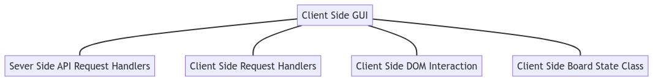

Each component should be integrated together to achieve the specified design objectives.

For instance, when a user clicks a piece, the DOM interaction components should register the square click and then send he data about which square is clicked to the Board State Class. This will decide what output are appropriate.

For example it could decide to change the highlighting in response. The DOM interaction components would then use a corresponding function to update the visual highlighting colours that the user sees.

Alternatively that Board State class could decide that the user has inputted a valid move. If so both client and server side API handlers would be used to communicate this input to the Game Manager module in the Chess Computer. Then the new board state and all its relevant data would be sent back to the client side Board State class vie both client and server side API handlers. The new data contained within the Board State class (e.g. a moved piece) would the be provided as a visual output to the user using the DOM interaction component to affect the HTML.

HTML and CSS will be used to dictate the content of the webpage (the tags that JavaScript will interact with) and its layout. I will keep styling to a minimum and focus instead on the interfaces usability. I will also use CSS to ensure that all the text is big enough and clear to read. The layout of the webpage, as defined by CSS, should also be such that it should be compatible with PCs, tablets and mobile phones.

Each module will be used together to achieve the design objectives that are relevant to the GUI. Here are the design objectives that this component should be able to achieve:

1, 2, 3, 4, 5, 6, 7, 8, 9, 17, 23, 24, 25, 26, 27, 29, 30.

## Chess Computer: All major algorithms

## The Chess Engine / Chess Functions:

The Chess Engine component should be able to make various inference to determine information about a chess board. It should also be possible to implement moves to get a new resultant board state. This will be needed in the minimax search completed by the Move Engine as well as to implement user’s moves.

Here is a further decomposition of the Chess Engine to identify its functionality and properties.

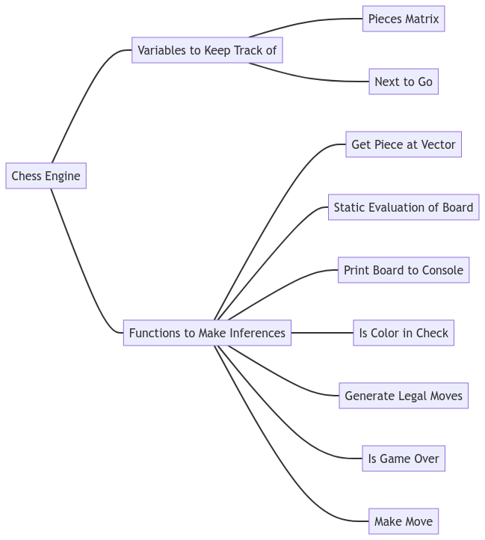

Due to the nature of the problem, there are various reasons why OOP (object oriented programming) is needed. These include:

* I need to keep track of many different board states at once in a minimax search
* I have already grouped the responsibilities of the module into variables and function that use these variables. This can be easily translated to properties of a Board_State class and method that reference these properties
* The module will be easier to develop and test if OOP is used as variables and methods form different board states will be grouped withing self-contained objects and so will not interfere with each other (as global variables might).

So here is the design for a class that will possess this functionality:

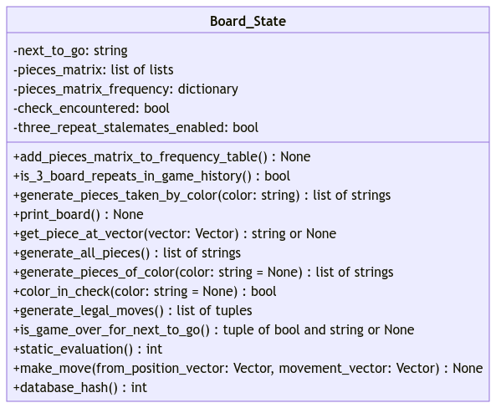

Due to the fact that I need to keep track of multiple different board states and child board states at once when performing a minimax search, I decided that it would be best to make the objects produces by the Board_State class immutable. This means that the make_move will return a new child board state object rather than mutate the existing object. This prevents me needing to make copies of the board state before making moves whenever I want to preserve the original board state. It also prevents any properties being set erroneously so long as the make_move and constructor methods are used correctly.

The pieces_matrix variable will be a 2 dimensional array of pieces to represent the board layout. It can be accessed by a position vector by converting the position vector to a row and column in the 2d array:

Row = 7- vector.j

Column = vector.i

Piece = pieces_matrix[row][column]

The most important function in this module is the generate legal moves function which is essential for determining if the game is over (no legal moves) as well as performing the minimax search and validating the users move.

It returns an array of moves. Each move is encoded as a position vector (for the piece moving) and a movement vector (the direction is moves in).

In order to represent these vectors, I will create a vector class which will include both the vector’s data: integers for the i and j components as well as functions relevant to vectors.

Here is the pseudocode and UML diagram for my vector class:

FUNCTION sqrt(x):

    RETURN x**(1/2)

END FUNCTOIN

FUNCTION square(x):

    RETURN x**2

END FUNCTOIN

CLASS Vector():

    // 2d vector has properties i and j

    i: int

    j: int

    // code to allow for  +  -  and  *  operators to be used with vectors

    FUNCTION add_vectors(self, other):

        ASSERT isinstance(other, Vector), "both objects must be instances of the Vector class"

        RETURN Vector(

            i=self.i + other.i,

            j=self.j + other.j

        )

    END FUNCTOIN

    FUNCTION subtract_vectors(self, other):

        ASSERT isinstance(other, Vector), "both objects must be instances of the Vector class"

        RETURN Vector(

            i=self.i - other.i,

            j=self.j - other.j

        )

    END FUNCTOIN

    FUNCTION multiply_vectors(self, multiplier: int | float):

        RETURN Vector(

            i=int(self.i * multiplier),

            j=int(self.j * multiplier)

        )

    END FUNCTOIN

    // check if a vector is in board

    FUNCTION in_board(self):

        // Assumes that the current represented vector is a position vector

        // checks if it points to a square that isn't in the chess board

        RETURN self.i in range(8) and self.j in range(8)

    END FUNCTOIN

    // alternative way to create instance, construct from chess square

    @classmethod

    FUNCTION construct_from_square(This_Class, to_sqr):

        // Example from and to squares are A3 -> v(0, 2) and to B4 -> v(1, 3)

        to_sqr = to_sqr.upper()

        letter, number = to_sqr

        // map letters and numbers to 0 to 7 and create new vector object

        RETURN This_Class(

            i=ord(letter.upper()) - ord("A"),

            j=int(number)-1

        )

    END FUNCTOIN

    // this function is the reverse and converts a position vector to a square

    FUNCTION to_square(self) -> str:

        letter = chr(self.i + ord("A"))

        number = self.j+1

        RETURN f"{letter}{number}"

    END FUNCTOIN

    FUNCTION magnitude_and_unit_vector(self):

        magnitude: float = sqrt(square(self.i) + square(self.j))

        // unit_vector: Vector = self.__mul__(1/magnitude)

        // RETURN magnitude, unit_vector

        RETURN magnitude

    END FUNCTOIN

END CLASS

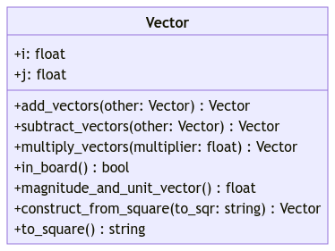

I will use Vector objects to describe the position of each piece and how it is moving. These objects are used as parameters for some methods like make_move and as return values for generate_legal_moves.

In order to implement the static_evaluation and generate_legal_moves functions I am going to further decompose the problem by using a pieces class.

I will aim to make a class for each chess piece. The resulting objects will be able to represent both black and white pieces. Each object will have 2 main responsibilities:

* Given where it is on the board, determine its own utility
* Given where it is on the board, ignoring check, determine the movement vectors by which it can move.

Each piece object will contain a starting utility and a 8*8 matrix of additional utility. Depending on where it is on the board, the value matrix may increase or decrease the pieces utility. The value matrix is meant to describe how some pieces are move valuable if they are in a certain area of the board (e.g. knight near the centre of the board). The sum of all these utility values will be used by the board state class to find the static evaluation of the board as a whole.

In addition each piece will contain a function that will return a list of movement vectors. Each piece will use the pieces matrix (board positions) and its position vector (where it is) to identify where it can move to. All the different piece will have different ways of doing this:

* For instance the knight will simply need to check the contents of the square it would move to for each of its 8 possible vectors. The king is similar
* The pawn needs to use rules around the contents of its neighbouring squares (e.g. are they empty of do they contain an enemy) to decide if it can move forward or diagonally. It additionally may need to overload the constructor of the pieces class to include a flag to determine if it has moved yet. This will affect it can move forward 2
* Pieces like the rook, bishop and queen must iteratively test increasing length vectors in a given direction until a non-empty square is hit. Then they cannot go any further in that direction and should start iteratively checking vectors in other directions.

Due to the fact that each piece contains some logic that is different (where it can move) and some logic that is shared (calculating its utility score) I have decided to use parent classes. All logic that is generic and shared will be implemented in a parent Piece class. In addition, an abstract class called Abstract_Piece_Interface will be used to ensure that every child piece has the relevant methods and properties.

By having the Piece class Inherit from the Abstract_Piece_Interface class and by having each individual piece class (e.g. Pawn) inherit form Piece I will ensure that:

* I keep repeated logic to a minimum
* Every piece class has the same external interface and so can be used in the same way.

Here the whole UML diagram for these classes:

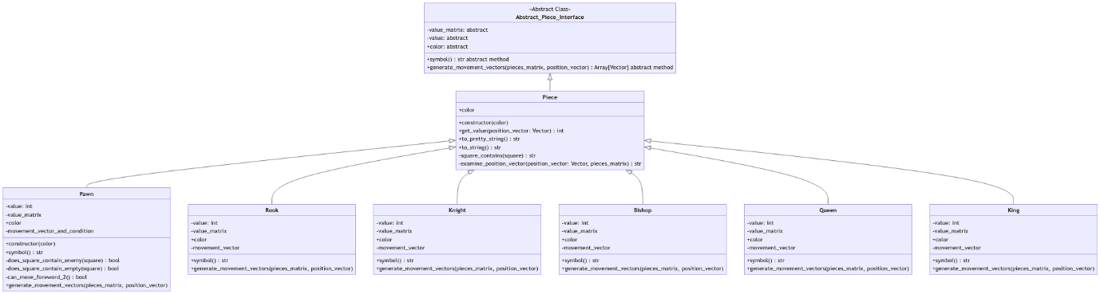

This is too small to see but should illustrate the structure I am trying to show. I will now show 3 sub-diagrams to make the details easier to read:

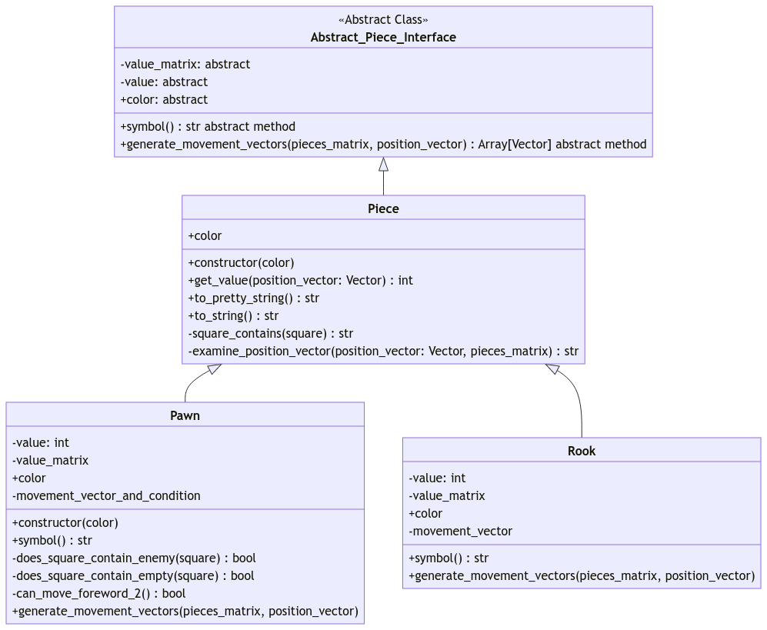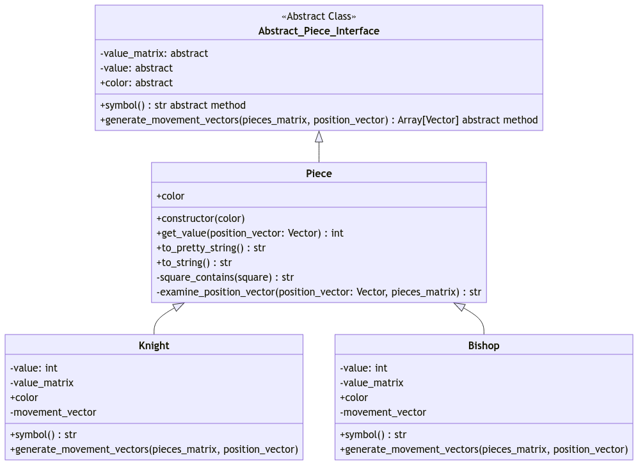

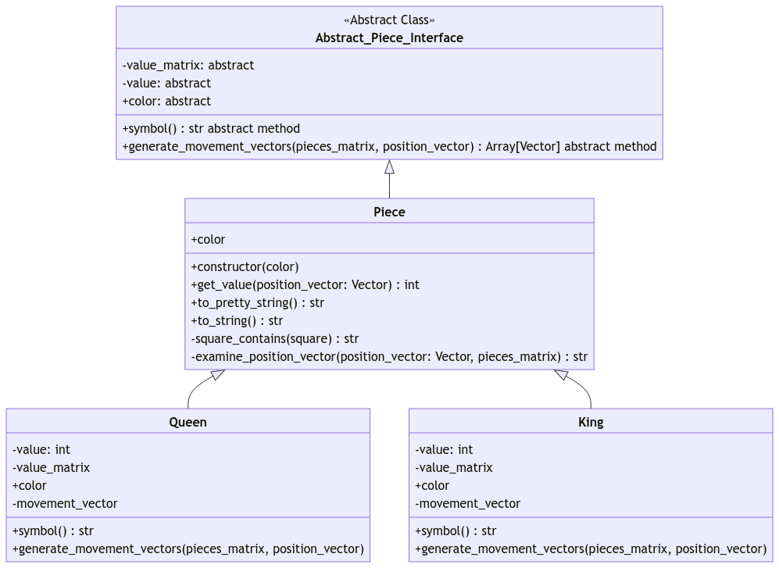

Using the abstract base class will mean that an error will be raised if any child class is initialised without all the necessary attributes and methods. This should ensure that the interface between the classes is that same and should help prevent logic errors later.

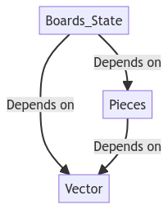

In addition, the use of the pieces an vector sub components allows me to further break down the problem through layer of abstraction. At the bottom is the Vector class, this is at the lowest level and is performing individual vector calculations. This module can be tested to ensure it is robust. Then the Pieces component can abstract all that logic and simple deal with vectors to try to determine the moves a given piece can make. Then at the highest level, all of the previous detail is abstracted. All the board state class needs to do is collate all of these individual pieces moves together into a big array and filter it to remove child board states that cause check. This reduces the complexity of a function like generate legal moves within the board state class. This is because the details for each which way each piece can move are abstracted as decomposition has been used to create a subcomponent to solve this issue.

This should make writing the otherwise tricky legal moves and static evaluation functions easy. All the other functions in the Board_State class should either be easy to write (e.g. get piece at vector) or should able to make use of the generate legal moves function (e.g. the is_game_over function).

### The Move Engine algorithm:

The move engine should act as a large and complex function that is composed of many sub functions. It takes as input a board state and returns as output a best move and a score for how good that move is estimated to be.

As discussed earlier, I cannot perform the British Museum Algorithm on a chess decision tree as the number of computations needed is so high that the problem is intractable. Instead I will use a recursive function called the minimax function to explore the decision tree to a given depth, use heuristics to estimate each players advantage at the terminal nodes and then back propagate to find the best move. I am calling the tree that I am using to represent the possible chess games form a given board state a decision tree as each node represents the decision of which move to pick.

Here is an example of this process. I have here a decision tree which I created to represent the problem with all the details of chess abstracted. The tree has been explored to a given depth using the legal moves of parent board states. Then the terminal nodes have been given a score:

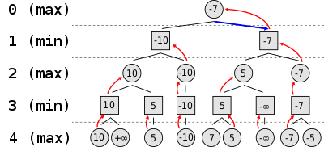

(source: <https://en.wikipedia.org/wiki/Minimax>)

We can see that in the above decision tree we have simplified the problem by illustrating each node as only having 2 children.

The terminal nodes are given a score, this could be infinity is the game is over or a number estimating how favourable the game is using a heuristic. One player aims to maximise this score and the other aims to minimise it. In this way, chess is a zero-sum game as one players gains are another players losses. We can see that all chess board where the maximising player can decide a move are represented with circular nodes and the minimisers moves are represented with square nodes.

As complete information is assumed, the idea of picking a move instead becomes deciding which of the child board states is most favourable for you to create. Because of this, we can see that at depth 3, the values assigned to the rectangular nodes are the lowest scores of the child nodes. This is because these are the moves that are best for the maximiser.

Because the assumption is made that each player is rational and as there is complete information, the maximising player can anticipate that when presented with these board states, the minimising player will act in these ways. As a result, the maximising player at depth 2 can attribute nodes at depth 3 with the value that the minimising player will rationally pick. Then the maximising player picks the highest score among these nodes.

In doing this, the final score and move is the best that can be guaranteed, assuming the opponent plays optimally. This means that a when a player makes a sub optimal play, this leads to a better outcome than expected for the opponent.

In my program, the static evaluation function from the Chess Engine module will be used to provide the heuristic that will evaluate the terminal nodes. The computer will be the minimiser and the user will be the maximiser.

This algorithm will allow me to tackle the game of chess as it provide a heuristic solution that is good enough. The algorithms is still slow as it has an exponential time complexity. We can define the branching factor at a given stage in the game to be the number of legal moves available from a given board state and the depth to be the number of moves ahead that we look. Now the number of static evaluation of terminal nodes is proportional to the branching factor to the power of depth. This means that the function has an exponential time complexity O(2^n). This means that the solution algorithm cannot be used to a high depth as it has a non-polynomial time complexity.

I will add a series of optimisation to my program. The simplest of optimisation to add. It works to reduce redundant calculations by “pruning” parts of the tree to prevent unnecessary computation.

Here is a screenshot from the following video that illustrates this concept well: <https://www.youtube.com/watch?v=l-hh51ncgDI>

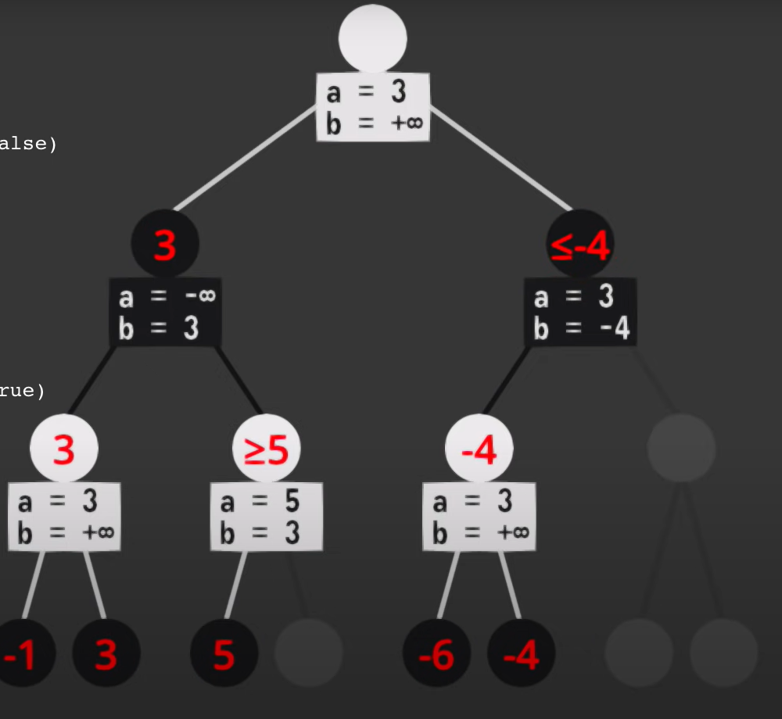

The minimax function now uses 2 additional arguments that are passes on to recursive calls. Alpha represents the best that the maximiser can already achieve and beta represents the best that the minimiser can already achieve. Another way of looking at this is to say that alpha is what the maximising player can achieve without further exploration and beta is the best that the minimiser has to allow the maximiser to achieve. Because of this, if alpha is greater than or equal to beta, it means that further exploration of child nodes is not needed as the opponent minimiser would never let you the maximiser get to this path as it is already too good for them to allow.

This is shown in the above diagram. Nodes are ladled with their alpha and beta values. In this case, white is the maximiser and black is the minimiser. We can see from the inequalities on some nodes how the alpha beta pruning indicated that a certain branch of the tree can be “pruned” and no longer explored.

I also intend to add caching to improve the efficiency of my minimax algorithm. To do this I will store the parameters and return value of each minimax function call as an entry in a database (structure explained later). This will allow me to prevent redundant searches in future. Cached results could be retrieved from the database if they match the search being performed exactly or if they match a recursive function call within a search (e.g. cached depth 1 results could be used as part of a depth 2 search later).

To maximise efficiency I will not store the whole board state in my database, instead I will store its SHA256 hash as a hexadecimal string. Due the size of 2­­­­256­ I can make the safe assumption that there is a 0 chance of collision. Therefore each board state can be encoded as a small binary sting.

To write the result of a minmax search to the cache I will delete all previous cached results that are at a lesser depth and then add the new search to the database.

To retrieve data form the cache (for a search of a given board state at a given depth) I will hash the board state and then query the table for matching hashes. This will be efficient as the table will be indexed by hash. The depth of any stored records will then be checked, if it is insufficient then it will be ignored. Otherwise, if the cached search has a depth greater than or equal to the needed depth, the database entry will be returned.

Further optimisation that I intend to add to the algorithm to improve efficiency or efficacy include:

* Variable depth search. This would model the variable depth feature of Deep Blue by allowing certain parts of the tree to be searched to an additional depth if check is encountered. These branches are likely to be more important to search at they could help to cause or avoid checkmate.
* Pre-sorting the moves best to worst (using a heuristic or a recursive depth n-2 search) before performing a recursive minimax search of each move to improve pruning
* Concurrency: The minimax function can be made concurrent by breaking up the legal moves to examine into sub arrays. Then many threads could be used to concurrently perform minimax searches of these segments of the legal moves at once.
* Insurance policy + self-interrupting: This is the idea that a minimax call at a lesser depth takes exponentially less work. This means that it only takes around 1/30th more work to do a depth 1 then 2 then 3 search of a board state than to just start with a depth 3 search. This means that the algorithm could be structured to keep searching for a given amount of time and then stop itself and return the best result. Unfinished searches could be added to the cache allowing for additional search time in future to improve the quality of the result.

The implementation of the self-interpreting feature will allow me to create a minimax function that will search the decision tree for a given amount of time.

* This will allow for more than 2 difficulty settings: depth 1 and depth 2 as a greater depth will likely be infeasible in the context of the limited thinking time of a chess AI.
* This will remove the inconsistent thinking time of setting the AI to a given depth. This problem arises as the number of legal moves can vary greatly form 1 to 50. This can cause great variation in how long an minimax search to a given depth can take
* This idea of a certain amount of time to explore will also allow me to achieve my design objective (13 and 14) of making a learning adversarial AI. This will be possible by combining caching with a set exploration time. This will allow the AI to continue where it left of when it encounters a bord state again (like the opening positions) and search in greater depth to improve the quality of its move.

Here is the pseudocode for a basic minimax function. It will be able to calculate the computers best move from a given board state. It featured alpha beta pruning to improve its efficiency.

// default arguments allow for the function to be provided only the board state and be able to find the computer move

FUNCTION minimax_search(board_state: Board_State, depth: 2, alpha=-infinity, beta=+infinity, is_maximizer=False)

    // base case

    over, winner = board_state.is_game_over_for_next_to_go()

    IF depth == 0 or over THEN

        // use static_evaluation for score

        best_score = board_state.static_evaluation()

        best_move = None

        RETURN best_score, best_move

    END IF

    // recursive case

    // set initial variables

    best_move = None

    IF is_maximizer:

        best_score = - infinity

    ELSE:

        best_score = + infinity

    END IF

    // iterate through legal moves and get child board states

    legal_moves = board_state.generate_legal_moves()

    FOR EACH move in legal_moves

        // get child board state

        from_v, move_v = move

        child_board_state = board_state.make_move(from_v, move_v)

        // recursive call to evaluate child board state

        child_score, child_move = minimax_search(child, depth - 1, alpha, beta, not is_maximizer)

        // depending on if player is maximiser affect if a lower or higher score is better

        // update alpha / beta and update best score and move variables as necessary

        IF is_maximizer:

            alpha = max(alpha, child_score)

            IF child_score > best_score:

                best_score = child_score

                best_move = child_move

            END IF

        ELSE:

            beta = min(beta, child_score)

            IF child_score < best_score:

                best_score = child_score

                best_move = child_move

            END IF

        END IF

        // pruning, stop exploring more legal moves

        if beta <= alpha:

            break

    END FOR

    // return the score and move corresponding to the best child

    RETURN best_score, best_move

END FUNCTION

## Game Manager:

This module is to be in charge of managing a chess game. It should be able to keep track of whose turn it is and include validation to ensure that only valid moves are made.

Due to the fact that a web server may have may sessions with clients at once, I will need to be able to store the data for multiple games at once. Additionally I want to be able to save all data relevant to the game as binary to be restored later. These factors mean that using global variables, that can be accessed by all function in the game manager module, to keep track of the game is not feasible. Instead I will again use OOP.

Here the game class that I will use when creating my console chess prototype:

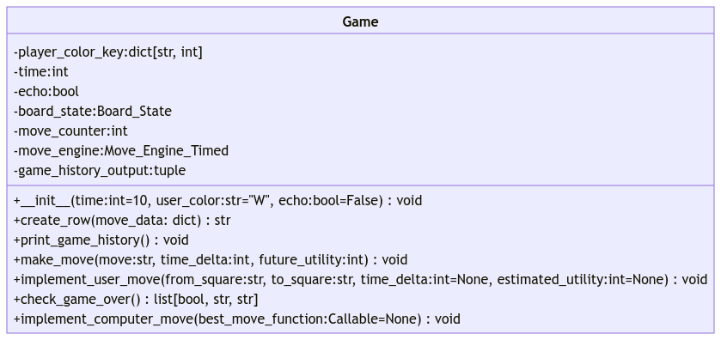

And here is the game class that I will use to facilitate the chess games that are played on my webpage:

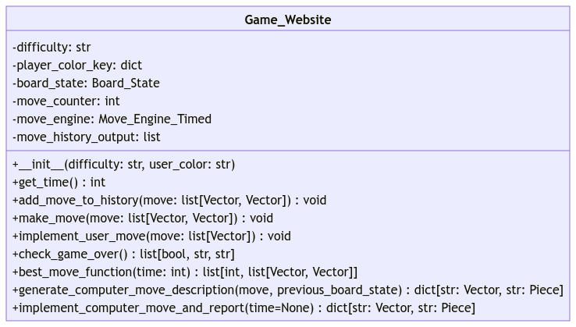

The main difference between them is that the website game class has the capacity to play at different difficulties. In addition it doesn’t need to build a table of data to give running commentary of the game in the console. Instead it creates a dictionary of data about the computers move that is sent to the webpage to allow for the computer’s move to be displayed.

The implement user move and computer move methods in both classes contain validation to ensure that it is that player’s turn to go. In addition, the user move is checked to ensure that it is a valid move.

It is also important that this object can be pickled as this will allow it to be serialized to binary data which can be stored in a database. The game object’s binary can then be read form the database and deserialized in order to reload the game for the user to finish.

## GUI logic and API client server connection:

As previously mentioned, I will use a system where data is exchanged between the client and server using the WebSocket framework.



There will be 5 main WebSocket events that will be used to exchange data between the client and the server.

After the server updates it python Game_Website object, a standardised block of JSON data will be sent to the client to provide the client all the data needed to update the GUI.

Here is an example of this json data for the start of a chess game (opening positions):

{"difficulty": "medium", "next_to_go": "W", "game_over_data": {"over": false, "winning_player": null, "victory_classification": null}, "legal_moves": [[[0, 1], [0, 1]], [[0, 1], [0, 2]], [[1, 0], [-1, 2]], [[1, 0], [1, 2]], [[1, 1], [0, 1]], [[1, 1], [0, 2]], [[2, 1], [0, 1]], [[2, 1], [0, 2]], [[3, 1], [0, 1]], [[3, 1], [0, 2]], [[4, 1], [0, 1]], [[4, 1], [0, 2]], [[5, 1], [0, 1]], [[5, 1], [0, 2]], [[6, 0], [-1, 2]], [[6, 0], [1, 2]], [[6, 1], [0, 1]], [[6, 1], [0, 2]], [[7, 1], [0, 1]], [[7, 1], [0, 2]]], "pieces_matrix": [[["B", "\u265c"], ["B", "\u265e"], ["B", "\u265d"], ["B", "\u265b"], ["B", "\u265a"], ["B", "\u265d"], ["B", "\u265e"], ["B", "\u265c"]], [["B", "\u265f\ufe0e"], ["B", "\u265f\ufe0e"], ["B", "\u265f\ufe0e"], ["B", "\u265f\ufe0e"], ["B", "\u265f\ufe0e"], ["B", "\u265f\ufe0e"], ["B", "\u265f\ufe0e"], ["B", "\u265f\ufe0e"]], [[null, null], [null, null], [null, null], [null, null], [null, null], [null, null], [null, null], [null, null]], [[null, null], [null, null], [null, null], [null, null], [null, null], [null, null], [null, null], [null, null]], [[null, null], [null, null], [null, null], [null, null], [null, null], [null, null], [null, null], [null, null]], [[null, null], [null, null], [null, null], [null, null], [null, null], [null, null], [null, null], [null, null]], [["W", "\u265f\ufe0e"], ["W", "\u265f\ufe0e"], ["W", "\u265f\ufe0e"], ["W", "\u265f\ufe0e"], ["W", "\u265f\ufe0e"], ["W", "\u265f\ufe0e"], ["W", "\u265f\ufe0e"], ["W", "\u265f\ufe0e"]], [["W", "\u265c"], ["W", "\u265e"], ["W", "\u265d"], ["W", "\u265b"], ["W", "\u265a"], ["W", "\u265d"], ["W", "\u265e"], ["W", "\u265c"]]], "check": false, "pieces_taken": {"B": [], "W": []}, "move_history": []}

Here we can see that many data points have been pre-calculated and provided to the client UI. This includes an array of legal moves as vector pairs and an 8*8 2d array of the pieces matrix. Sub strings like this "\u265f\ufe0e" correspond to a chess pieces character that is not in the standard ASCII character set but instead in the larger UTF-8. To ensure compatibility, it has been encoded by the python json module so that the JSON is ASCII compatible as it is sent between the client and the server. JSON is a useful abstract data structure to use as modules exist to convert python objects to JSON and JSON to JavaScript objects. This means that this standard makes transferring data between the client and the server easier.

On the server side I will need the following functions handler functions to process data receives on each of these 5 events. These handler functions will cause some mutation to the game object held within the server client session and then return JSON data to update the client side about the game.

Here is the pseudocode for this:

FUNCTION generate_game_update_data()

    game = get_game_in_session()

    next_to_go = game.board_state.next_to_go

    difficulty = game.difficulty

    legal_moves = list(game.board_state.generate_legal_moves())

    legal_moves_serialised = serialize_legal_moves(legal_moves)

    pieces_matrix = game.board_state.pieces_matrix

    pieces_matrix_serialised = serialize_pieces_matrix(pieces_matrix)

    next_to_go_in_check = game.board_state.color_in_check()

    over, winning_player, victory_classification = game.check_game_over()

    game_over_data =  {

        "over": over,

        "winning_player": winning_player,

        "victory_classification": victory_classification,

    }

    pieces_missing = {}

    FOR EACH color IN ("B", "W")

        pieces_missing[color] = list(map(

            serialize_piece,

            game.board_state.generate_pieces_taken_by_color(color)

        ))

    END FOR

    move_history = game.move_history_output

    payload = {

        "difficulty": difficulty,

        "next_to_go":  next_to_go,

        "game_over_data":  game_over_data,

        "legal_moves":  legal_moves_serialised,

        "pieces_matrix": pieces_matrix_serialised,

        "check": next_to_go_in_check,

        "pieces_taken": pieces_missing,

        "move_history": move_history,

    }

    RETURN payload

END FUNCTION

@bind_socket_handler("get_update")

FUNCTION get_update()

    result = generate_game_update_data()

    RETURN result

END FUNCTION

@bind_socket_handler("implement_computer_move")

FUNCTION implement_computer_move()

    game = get_game_in_session()

    assert game.board_state.next_to_go == "B"

    assert not game.board_state.is_game_over_for_next_to_go()[0]

    move_description = game.implement_computer_move_and_report()

    set_game_in_session(game)

    outgoing_payload = generate_game_update_data()

    outgoing_payload["computer_move_description"] = move_description

    RETURN outgoing_payload

END FUNCTION

@bind_socket_handler("reset_game", respond=False)

FUNCTION reset_game()

    old_game = get_game_in_session()

    difficulty = old_game.difficulty

    new_game = Game_Website(difficulty=difficulty)

    set_game_in_session(new_game)

END FUNCTION

@bind_socket_handler("implement_user_move")

FUNCTION implement_user_move(incoming_payload)

    game = get_game_in_session()

    assert game.board_state.next_to_go == "W"

    assert not game.board_state.is_game_over_for_next_to_go()[0]

    user_move = tuple(

        deserialize_move(

            incoming_payload["user_move"]

        )

    )

    game.implement_user_move(user_move)

    set_game_in_session(game)

    RETURN generate_game_update_data()

END FUNCTION

@bind_socket_handler("change_difficulty", respond=False)

FUNCTION change_difficulty(incoming_payload)

    game = get_game_in_session()

    new_difficulty = incoming_payload["new_difficulty"]

    game.difficulty = new_difficulty

    set_game_in_session(game)

END FUNCTION



(diagram repeated)

The client side JavaScript need 3 main sets of functions. As preciously discussed, these are:

* Client side request handlers, these functions should handle making requests to the sever and receiving the servers response to return.
* Client side DOM interaction, these functions will affect the DOM (HTML displayed) to display outputs
* Client side board state class, this will contain all the data from the server about the current bord state and will manage the logic or receiving user inputs and making the relevant requests to the server vie the handlers

The Client side request handler will consist of the following functions:

ASYNC FUNCTION external_get_update()

    PASS

END FUNCTION

ASYNC FUNCTION external_implement_computer_move_and_update()

    PASS

END FUNCTION

ASYNC FUNCTION external_reset_game()

    PASS

END FUNCTION

ASYNC FUNCTION external_implement_user_move_and_update(from_vector, to_vector)()

    PASS

END FUNCTION

ASYNC FUNCTION external_change_difficulty(new_difficulty)

    PASS

END FUNCTION

Each of these asynchronous functions will send the relevant data to the server and then wait for a response which will then be returned. The functions will be asynchronous as this allows other code to be executed while this function is idle (waiting for server response).

I will need the following functions to affect the DOM and display outputs to the user:

FUNCTION create_board_widget()

    PASS

END FUNCTION

FUNCTION get_square_at_vector(v)

    PASS

END FUNCTION

FUNCTION add_pieces(board)

    PASS

END FUNCTION

FUNCTION add_highlighting(board)

    PASS

END FUNCTION

FUNCTION clear_board()

    PASS

END FUNCTION

FUNCTION update_main_title(board)

    PASS

END FUNCTION

FUNCTION update_pieces_taken(board)

    PASS

END FUNCTION

FUNCTION set_selected_difficulty(board)

    PASS

END FUNCTION

FUNCTION set_widget_move_history(board)

    PASS

END FUNCTION

FUNCTION update_board_widget(board)

    update_main_title(board)

    add_pieces(board)

    add_highlighting(board)

    set_selected_difficulty(board)

    update_pieces_taken(board)

    set_widget_move_history(board)

END FUNCTION

create_board_widget()

let board = new Chess_Board(

    update_board_widget,

    update_main_title

)

FUNCTION handle_radio_button_click(radio_button)

    PASS

END FUNCTION

FUNCTION handle_square_click(i, j)

    board.handle_square_click([i, j])

    update_board_widget(board)

END FUNCTION

FUNCTION reset_button_click()

    board.reset_game()

END FUNCTION

FUNCTION concede_button_click()

    // update_main_title(null, "You Conceded The Game")

    board.concede_game()

END FUNCTION

The chess class will have the following methods. It must be able to handle each of the 4 inputs. These include board square click, difficulty radio button click, reset button click and concede button click. It must make the appropriate decisions of how to handle these inputs. This may involve affecting the DOM using or making a request to the server using the above function.

Here is the UML diagram for the client side Chess_Board class

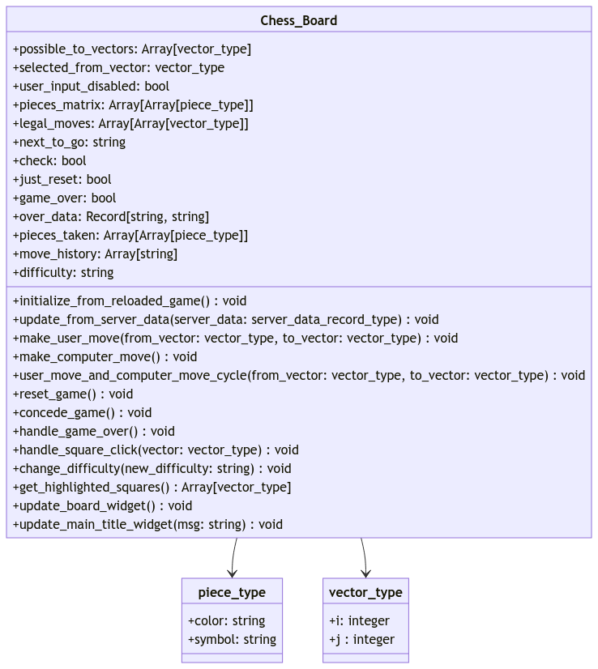

This UML diagram shows only one class. This it’s the Chess_Board class that will be used to represent data about the current board state client side. The properties and methods given have appropriate types included. Some of the types are piece types or vector types. The will in practice be implemented as a standardised format of array containing 2 values. A vector will an array of 2 integers and a piece will be an array of 2 strings. I have names these types in the UML diagram to make it clearer.

## Describe database use (save games and minimax cache) and other persistent storage:

In my programs, most of the data stored will be contained within objects. I will make use of some key data structures in addition to these objects. These will be highlighted below.

In the client side JavaScript I will use a dictionary data structure which uses string keys and contains a list for each value. This list will contain a hexadecimal hash and a function.

Here is the pseudocode:

previous_data_hashes = {

    "pieces_taken": [None, (board) => get_hash_of_data(board.pieces_taken)],

    "move_history": [None, (board) => get_hash_of_data(board.move_history)],

    "piece_layout": [None, (board) => get_hash_of_data([board.pieces_matrix, board.possible_to_vectors, board.selected_from_vector])],

    "highlighting": [None, (board) => get_hash_of_data([board.possible_to_vectors, board.selected_from_vector])],

    "difficulty": [None, (board) => get_hash_of_data(board.difficulty, stringify=False)]

};

FUNCTION update_as_necessary(board, update_function, hashes_table_key)

    old_hash, compute_hash = previous_data_hashes[hashes_table_key];

    let new_hash = compute_hash(board);

    IF new_hash != old_hash THEN

        // hashes are different, updating table

        previous_data_hashes[hashes_table_key][0] = new_hash

        update_function(board)

    END IF

    // ELSE hashes are the same so don't update

END FUNCTION

FUNCTION update_board_widget(board)

    update_main_title(board);

    update_as_necessary(board, add_pieces, "piece_layout")

    update_as_necessary(board, add_highlighting, "highlighting")

    update_as_necessary(board, set_selected_difficulty, "difficulty")

    update_as_necessary(board, update_pieces_taken, "pieces_taken")

    update_as_necessary(board, set_widget_move_history, "move_history")

END FUNCTION

The function get_hash_of_data represents a generic SHA2 hash function.

Each entry contains a hash of the data relevant to a certain widget on the board and a function to generate the updated hash.

The function update as necessary checks the hash of the current data against the old hash in order to decide if the relevant DOM update function must be run. If the hashes are the same, the function is not run which improves performance. If the hashes are different, the function is run and the hashes are updated.

I felt that this table is necessary as some of the DOM update methods can be visually noticeable to the user and so I don’t want to be recreating my HTML widgets every time if there is not change in output to display.

I used a dictionary data structure to organise the hashed and functions into the widget / data category that they corresponded to. I used a list as the 2 items that I wanted to store were of different types.

In my program I also used a 2 dimensional array of pieces. This was useful as it allowed me to very naturally represent that tabular layout to the chess board in an 8*8 array. I will use a 2 dimensional array called pieces matrix in both the frontend and the backend.

The backend 2d array may contain values that are either None or a Piece object. The classes that will represent pieces were defined above.

Here is an example of how the pieces matrix would in the backend, using pieces objects (showing starting positions):

STARTING_POSITIONS: array[array[Piece | None]] = [

    [

        Rook(color="B"),

        Knight(color="B"),

        Bishop(color="B"),

        Queen(color="B"),

        King(color="B"),

        Bishop(color="B"),

        Knight(color="B"),

        Rook(color="B")

    ],

    [Pawn(color="B"),]*8,

    [None,]*8,

    [None,]*8,

    [None,]*8,

    [None,]*8,

    [Pawn(color="W"),]*8,

    [

        Rook(color="W"),

        Knight(color="W"),

        Bishop(color="W"),

        Queen(color="W"),

        King(color="W"),

        Bishop(color="W"),

        Knight(color="W"),

        Rook(color="W")

    ]

]

The frontend pieces matrix will use an array of 2 characters to represent a piece. These character would correspond to the piece’s color and its symbol / type. This array pair of characters will likely be the easiest way to represent the chess board and will definitely be used in JavaScript and JSON data representations of the board. This would means that the pieces matrix will use a 3 dimensional 8*8*2 array of characters as appose to the 2 dimensional 8*8 array of Piece objects

Here are some examples of describing pieces in this way:

['B', '♜']

['W', '♟︎']

And here is how I would then use this principle to describe a whole chess board (starting positions shown):

[[["B","♜"],["B","♞"],["B","♝"],["B","♛"],["B","♚"],["B","♝"],["B","♞"],["B","♜"]],[["B","♟︎"],["B","♟︎"],["B","♟︎"],["B","♟︎"],["B","♟︎"],["B","♟︎"],["B","♟︎"],["B","♟︎"]],[[null,null],[null,null],[null,null],[null,null],[null,null],[null,null],[null,null],[null,null]],[[null,null],[null,null],[null,null],[null,null],[null,null],[null,null],[null,null],[null,null]],[[null,null],[null,null],[null,null],[null,null],[null,null],[null,null],[null,null],[null,null]],[[null,null],[null,null],[null,null],[null,null],[null,null],[null,null],[null,null],[null,null]],[["W","♟︎"],["W","♟︎"],["W","♟︎"],["W","♟︎"],["W","♟︎"],["W","♟︎"],["W","♟︎"],["W","♟︎"]],[["W","♜"],["W","♞"],["W","♝"],["W","♛"],["W","♚"],["W","♝"],["W","♞"],["W","♜"]]]

I will also make use of a database in my program. This database will have 2 main uses:

* It will use entries in a table to store cached minimax function results for reuse
* It will use an entries in a different table to store saves games and a corresponding cookie ID contained withing the user’s browser

I will aim to make use of an external library like SQL-Alchemy of SQLite3 to implement my database. This will allow me to defend my program against accidentally running malicious SQL queries as a result of SQL injections attack. This is needed as the value held in a cookie in the users browser will be used to reference the saves chess game binary in the database. If this value were to be manually altered to be a harmful SQL query, I want to ensure that no deletion of data can be allowed.

Using a library should also make the process of saving and reading data to and from the database earlier. If I use SQL-Alchemy I can make use if an ORM (Object Relational Mapper) to directly describe how my objects can be converted to and entries in my database.

I will be able to create my 2 tables and the 2 indexes I want with the following SQL commands:

CREATE TABLE "Minimax_Cache" (

        primary_key INTEGER NOT NULL,

        board_state_hash VARCHAR,

        depth INTEGER,

        score INTEGER,

        move VARCHAR,

        PRIMARY KEY (primary_key)

);

CREATE TABLE "Saved_Games" (

        primary_key INTEGER NOT NULL,

        cookie_key VARCHAR,

        raw_game_data BINARY,

        PRIMARY KEY (primary_key)

);

CREATE INDEX board_state_hash ON "Minimax_Cache" (board_state_hash);

CREATE INDEX cookie_key ON "Saved_Games" (cookie_key);

This should result in a database with the following structure being created:

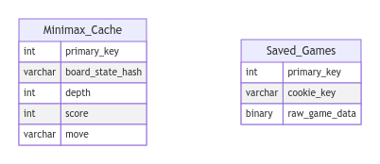

The above entity relationship diagram shows that database structure that I aim to create. There is not relationship between the tables.

In addition, It could be argued that the use of integer primary keys is unnecessary as I am effectively using the board state hash and cookie key as primary keys. This is because I intend to use these values to search for rows in each table, this is why I have created indexes by these values. In many ways I think it would make sense to make these columns the primary keys, however many ORM libraries (including SQL-Alchemy) do not allow custom primary keys. This means that I must have an incrementing integer primary key, even if it isn’t used, due to the limitations of the framework with which I intend to implement my database.

Due to the exponential nature of the minimax algorithm. A single depth 2 search will cause around 900 depth 0 searches (static evaluation) to be completed, assuming a branching factor of 30. This will increase exponentially at a greater depth and could pose scalability problems for the database. In addition, depth 0 cache (stored depth 0 searches in the minimax cache table) is the least valuable of cached minimax results. This is because it can be calculated the quickest and so the cached item prevents the least computation. If the depth 0 cache was stored in a database in secondary storage, the slow read times (relative to time to compute) and large space requirement could result in no overall efficiency gain from the cache.

As a result I intend to implement the above database structure in both a local “.db” file in secondary storage and in separate logical database that will exist in RAM. This will allow me to store depth 0 cache in the volatile database. This will improve read write speed and prevent the persistent database form becoming overfull. This should still present efficiency gains as static evaluation are likely to be reduced within a game. It is not necessary to store these permanently as the chance of encountering the same chess board again is sufficiently low that only high value cache is worth storing.

With this explained redundancy aside, I believe that my database design is already normalised. This is because my 2 tables have no relationship and store no duplicated data. Therefore, there is no redundancy and so this design is already in third normal form due to its simplicity.

The use of indexes will increase the amount of space needed to store each entry, as well as increasing write times. However, the reduction in retrieval times should make indexes on certain columns a worthwhile trade of as I interned to query the tables by these columns every time.

Going forward, if further tables needed to be added to the database (e.g. containing user data) then normalisation would need to take place again to ensure that the database remained as efficient as possible.

## Variables and key data structures used in these key algorithms:

Do to the heavy use of OOP in my prosed design, global variable will be rare. I outlined the properties of each of my classes using UML diagrams earlier. I have also outlined key data structures that were used earlier.

In addition to this, I intend to use a variable to keep track of the client server session on the server side. This should be able to contain the serialised binary for the specific game object being used in each of the browsers games, while the user has the website open. There is already a way of achieving this within the Flask framework using a flask session object. This uses temporary cookies on the client’s browser to store some data (the Game object) while the tab is open.

I intend to read the cookies of the client browser, when the session is first created. If a cookie has already been created by this website then I will query the database for the relevant game object and restore it into the session.

When the session closes I will save the game object to the database and create a cookie on the clients browser containing the cookie key of that saved game’s database entry. This will allow the game to be reloaded if the user visits the website.

## Complete trace tables and dry runs of key algorithms:

I will now aim to trace though some of my main algorithms. As this system uses layers of abstraction, high level functions such as the minimax function would be very difficult for a human to trace in its entirety. This is because a single minimax search needs to run many board state functions, even move pieces functions and a huge volume of vector calculations. As such I will aim to simplify where appropriate.

In the case of the minimax function, I will use a general decision tree and abstract away the process of determining static evaluations. I will focus on traversing the tree and then picking the appropriate score.

I will use a diagram of a tree that I have created to trace though the minimax algorithm. I have traced the algorithm though by annotating the diagram at various points.

Firstly I traced though a standard minimax function without any pruning.

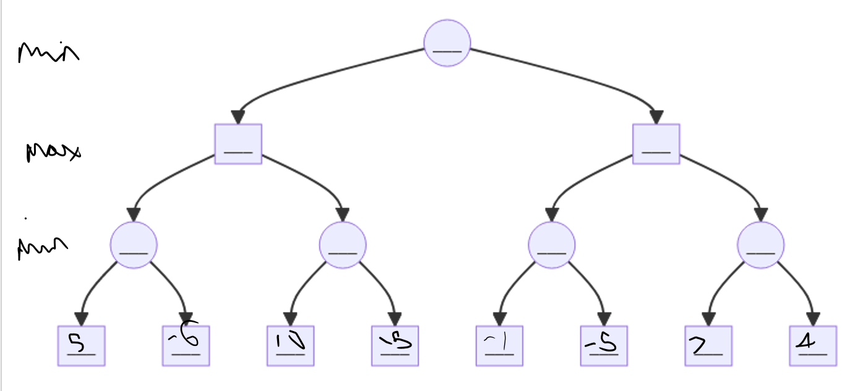

Here we can see a simplified illustration of a depth 3 search by the minimiser. The tree has been simplified by only showing 2 of the children of each node. The static evaluations of the terminal nodes are written at the bottom. Circular nodes represent a decision by the minimiser whereas rectangles are for the maximiser.

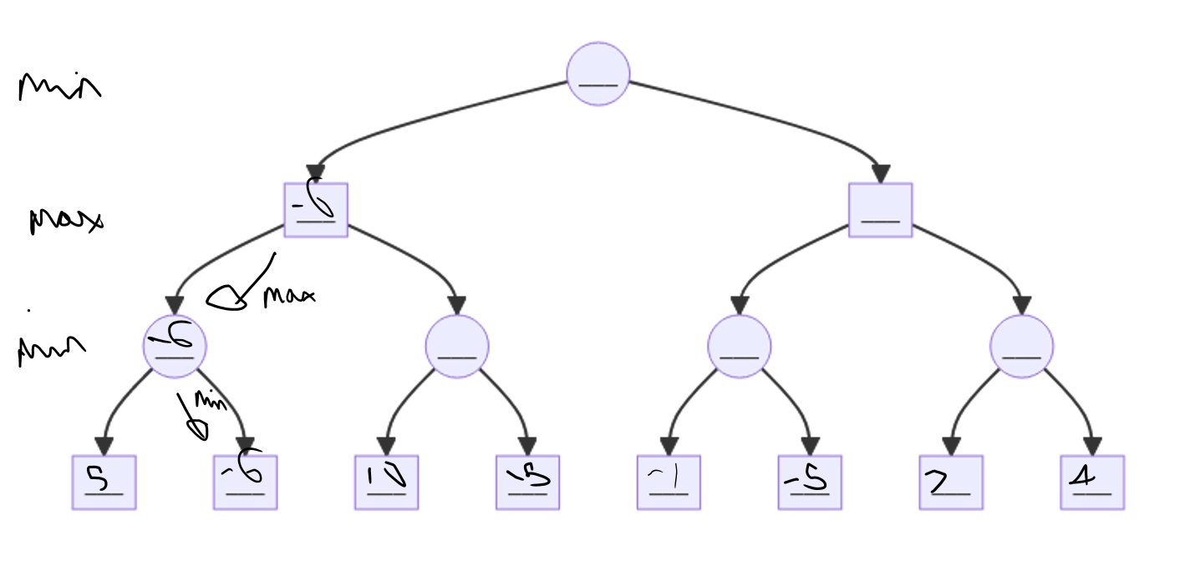

Here we can see that -6 is the lowest score among 5 and -6 and so the minimiser choose -6. As a result, the current best score of the parent maximiser move is also now -6.

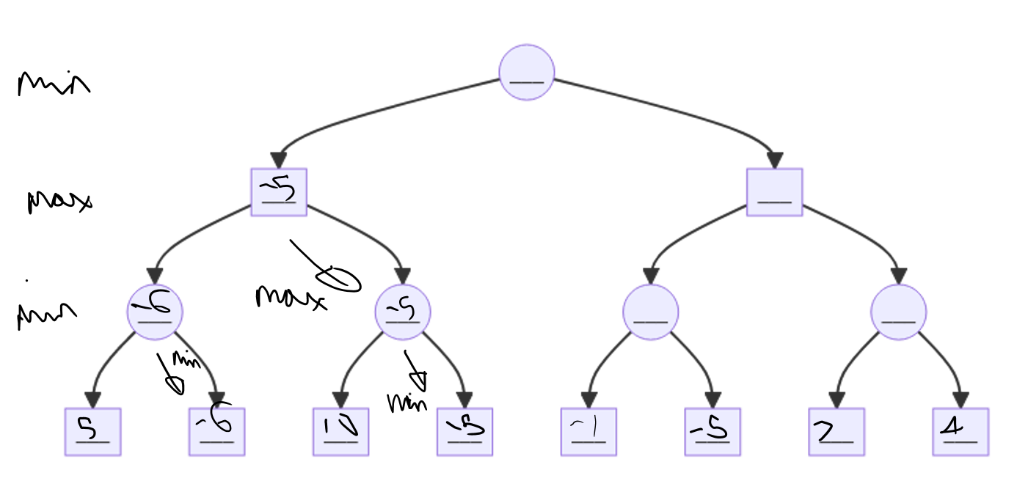

We can see that this process is repeated with the minimiser picking -5. As there is complete information and the maximiser anticipates that the 2 child nodes, the minimiser can get a score of -6 and -5 respectively, therefore to maximise its score, the maximiser picks the second child with a current best score of -5.

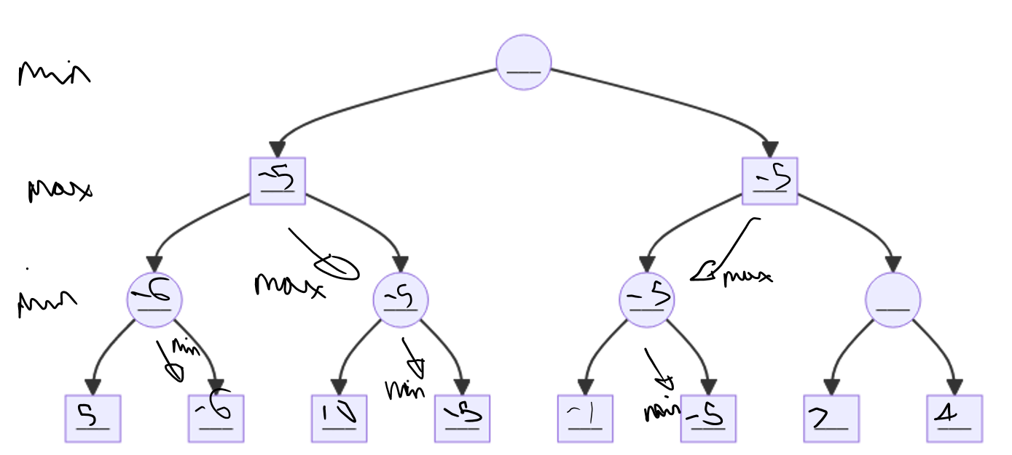

This process repeats again.

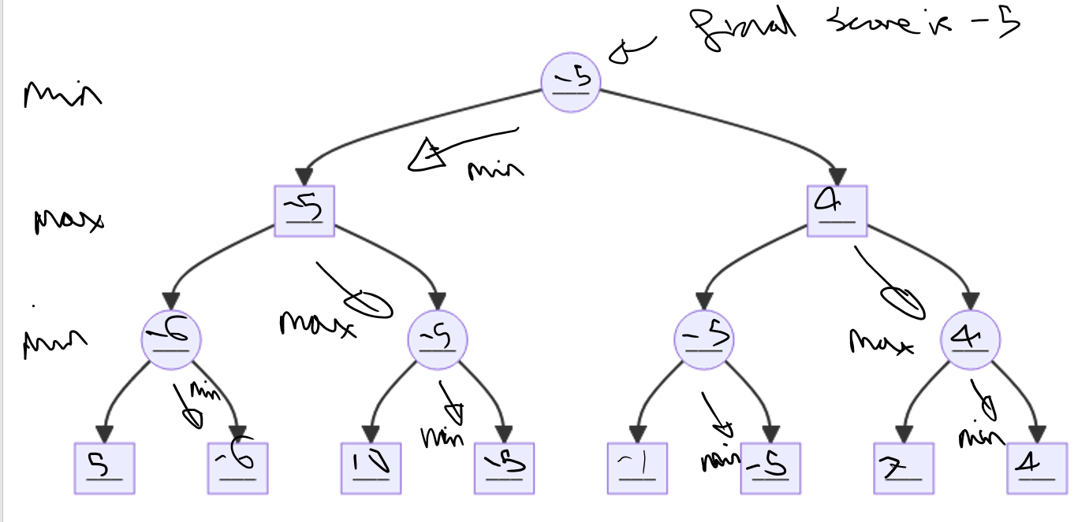then finally, all parts of the tree have been searched and the minimiser decides that the best score that they can guarantee is -5 (at a depth of 3).

Now I will trace though the minimax function more slowly to show its method when using alpha beta pruning.

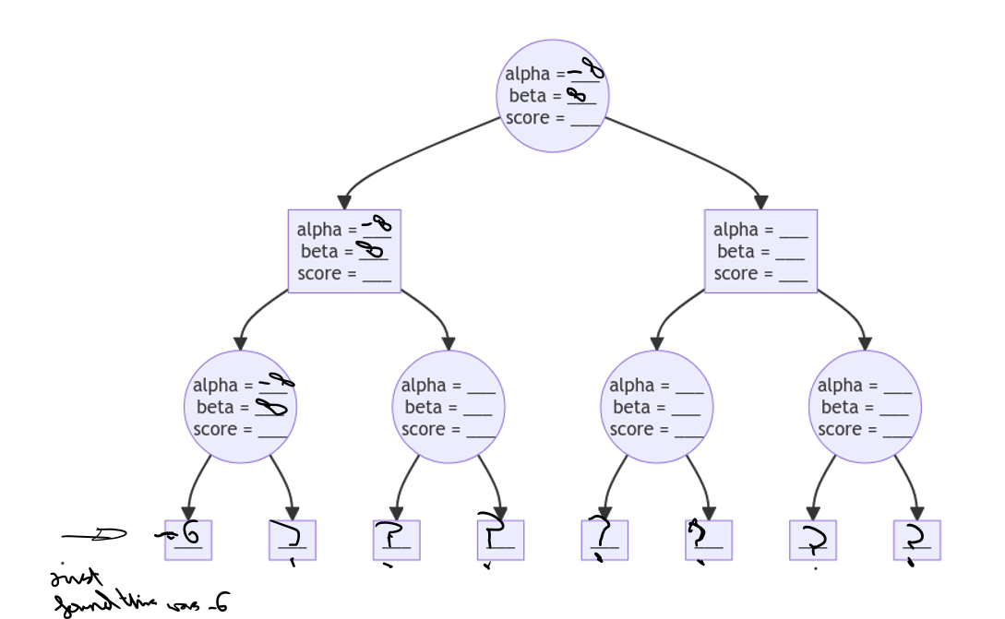

Here we see again a recursive search of depth 3 by the minimiser. I have only filled in the values of nodes once they are reached by the algorithm. Above we see the recursive call has passed its starting values of

alpha = -infinity

beta = infinity

down in all its recursive calls until the base case is reaches and a static evaluation is performed to get a value of -6.

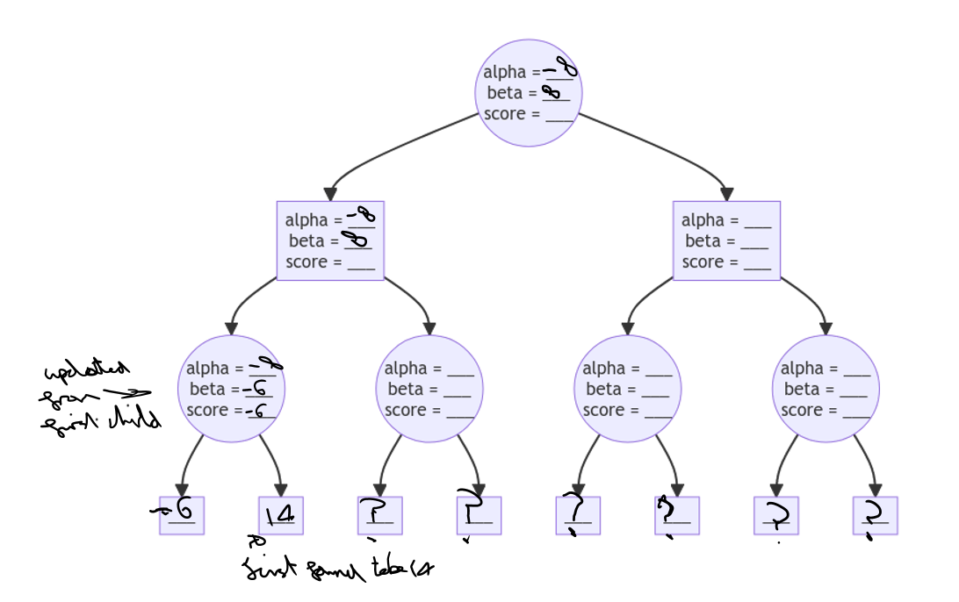

We then see how after examining the first child, the indicated minimiser node (minimisers are circles and maximisers are rectangles) has updated it beta value and its current best score to -6. It then continues to search the children and the next static evaluation is 14.

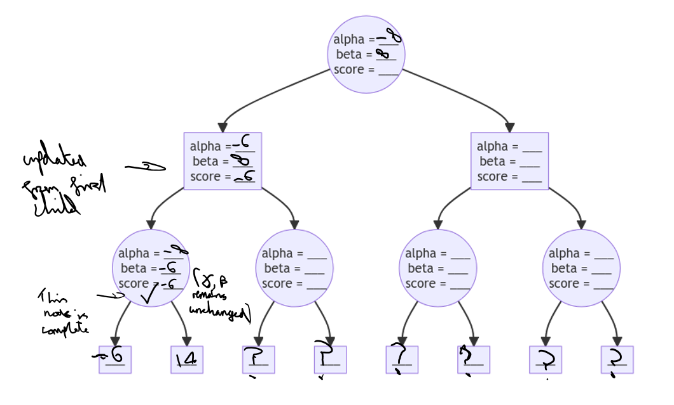

We see how, because the previous value of -6 is better than 14 for the maximiser, the values of beta and best score remain unchanged in the minimiser node (indicated with a tick). It parent maximiser node has not successfully searched its first child and so updates its alpha and best score values to -6.

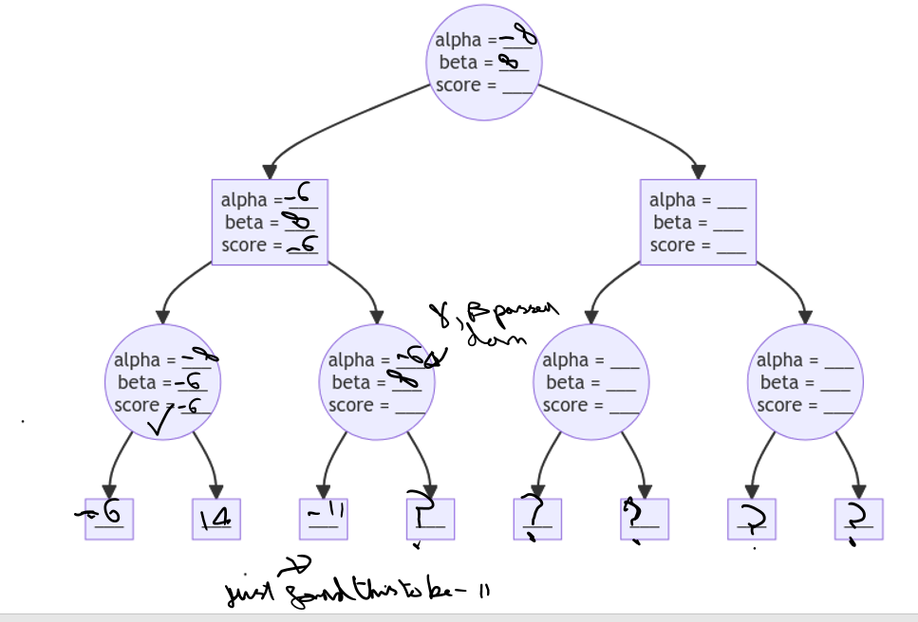

We then see this process repeat recursively. Each time, the alpha and beta values form the parent node are passed down to the search at a lesser depth. (they are never returned up the tree)

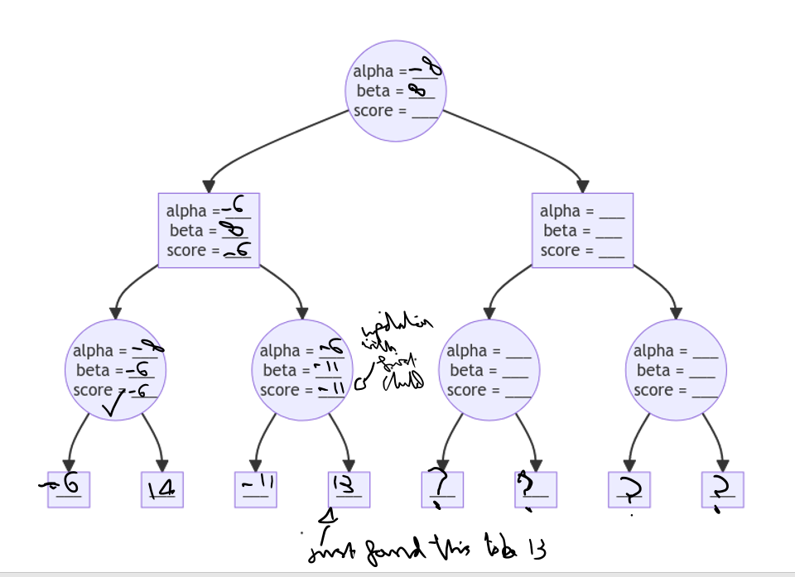

The minimiser node is updated with a new beta and best score value of -11. It should be noted at this point that the pruning condition: alpha >= beta has been met. This is not relevant in this example, but if the minimiser node had more than 2 children, it could stop examining them now.

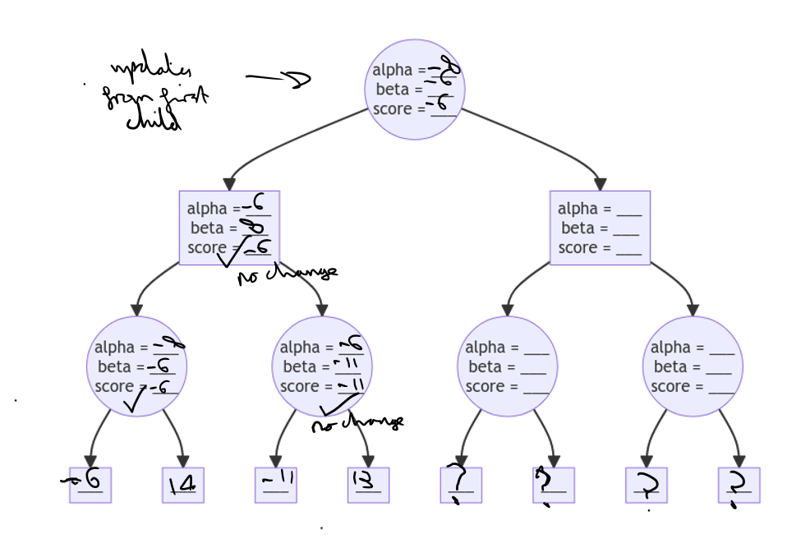

We then see that the minimiser 2nd minimiser node on the third level has finished its search. This means that the 1st maximiser node on the 2nd level has also finished its search with no change to its variables. This causes the variables of the root node to update as its first child has been searched.

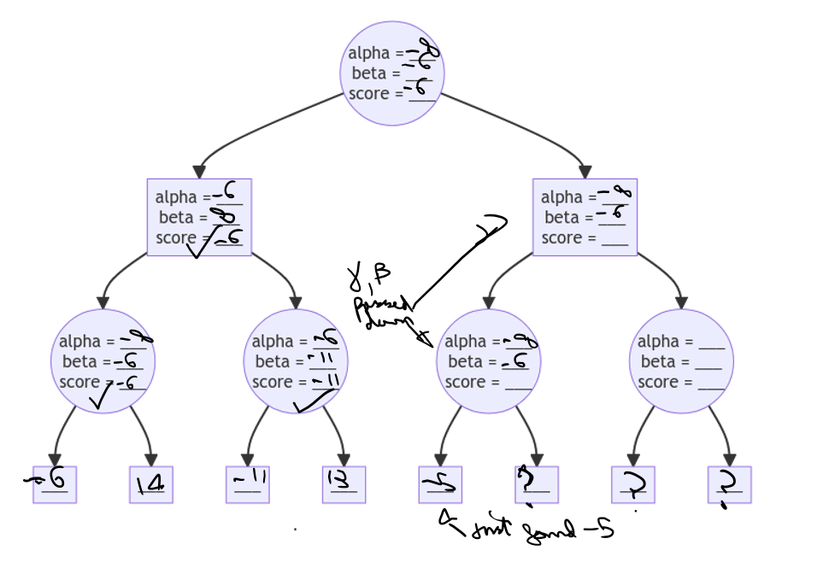

We then see the right side of the tree get recursively searched with alpha and beta values passed down by the root.

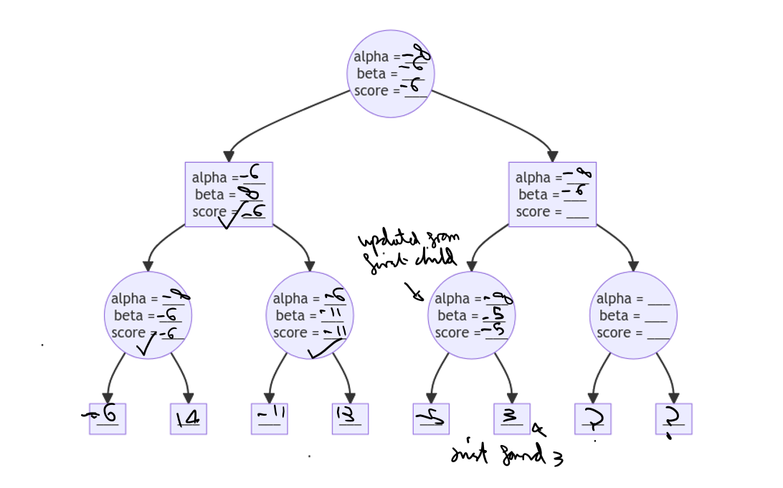

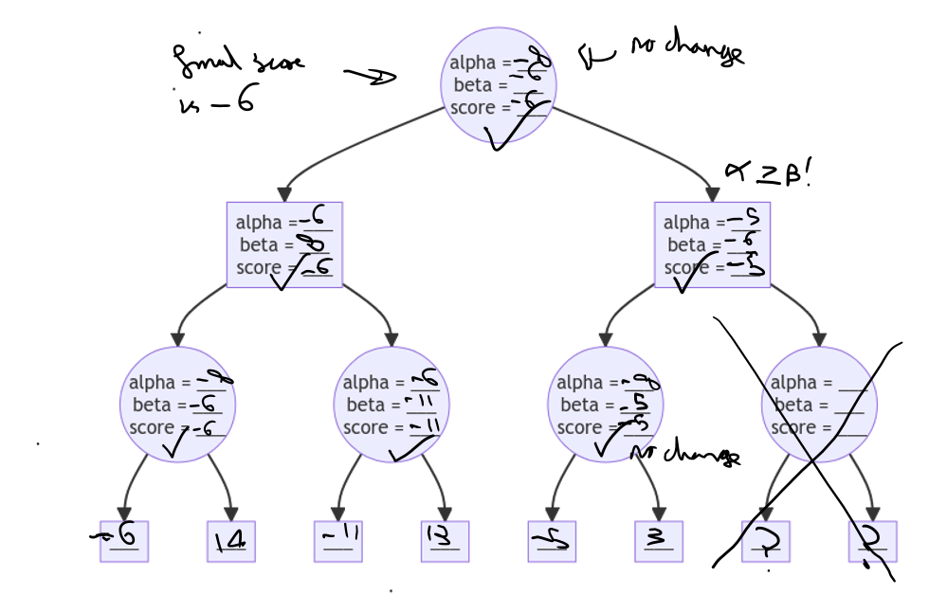

The 3rd minimiser node on the 3rd layer has now been completed. The alpha and best score values of the 2nd maximising node of the 2nd layer are now updated.

Again we see that alpha >= beta. This means that the 2 static evaluations on the right were prevented as they were not necessary. This can be logically explained as the minimiser at the root node has to decide which of the 2 maximising nodes on the 2nd layer are the worst for the maximiser. Without exploring the last part of the tree, we can see that the alpha value for the right maximiser node is -5 which is already higher that the -6 alpha value of the left node. This means that no matter what the scores are in the unexplored part of the tree, the right half of the tree is already better for the maximiser and so the minimiser at the root node will always pick the left maximising child node.

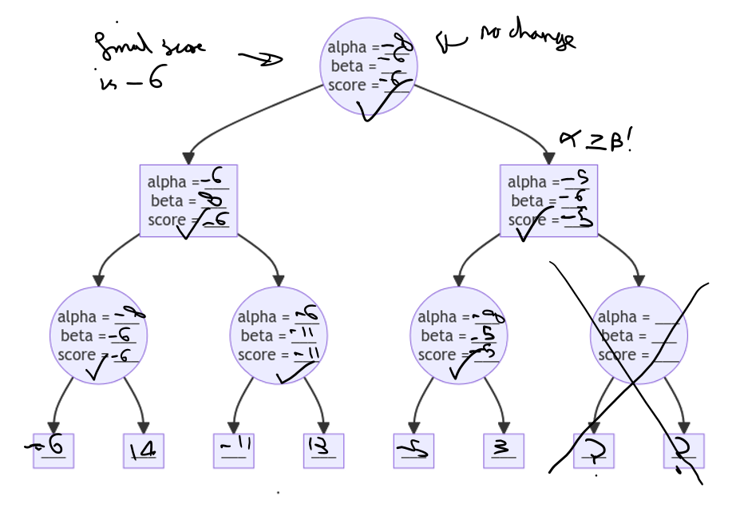

This means that the depth 3 search is completed with a final score of -6. If no pruning was used, the final score would still remain the same.

I have now accurately traced the minimax algorithm through in a graphical manner. This traceback exemplified the order in which it searches nodes. It also shows how the values of alpha and beta are updated and passed to child nodes. With the previously defined pseudocode, I can apply this searching method to chess. The use of a best move variable in the pseudocode will also ensure that the move is returned and not just the score.

## Validation:

The final program would feature both client side and server side validation. This should allow invalid inputs to be detected so that they do not cause invalid outputs.

My final program will have 4 main inputs:

* The user can click any square on the chess board
* The user can click the reset button
* The user can click the concede button
* The user can click the radio buttons that control difficulty

### Client side validation needed:

It should not be possible for the user to provide an invalid input to the concede and reset buttons. The button should be able to be used as any time. This includes when the game is over but also during both the user and computer’s go. The only input the user should be able to provide is a Boolean, did they click the button? yes or no? Both of these inputs (pressing and not pressing the button at any given stage in the game) are valid.

It should also be impossible for the user to select an invalid difficulty. The difficulty settings will be changed using radio buttons. This means that when the user select one option, all previous options should be unselected. Using radio buttons (e.g. as opposed to a text input) will also reduce the range of inputs that can be given as only valid difficulties can be selected. I will make the program automatically select one of the radio buttons (e.g. default of medium) when the page loads. This should ensure that at all points in the program, exactly one of the possible difficulties will be selected.

I will also use client side validation to decide when the client should ignore erroneous and invalid click events from the user. To input a move the user will click 2 squares on the chessboard: a move from square and a move to square. I will use highlighting to make this intuitive.

The client side Chess_Board class should contain an array of legal moves that the user can make at any one point. After the user move these should be updated by the server. The Chess_Board class will use an additional 2 properties to allow the user to input their move and add validation in the process:

* Selected_from_vector: This variable will contain none of a position vector in the form [i, j] where i and j are integers
* possible_to_vectors: This variable will be an array that will contain position vectors (in the form [i, j] where i and j are integers)

Before the user first clicks a square, the selected_form_vector will be set to None and the possible_to_vectors will contain an empty array.

When the user clicks a square, the position vector of that square will be checked to see if it is an item in the possible_to_vectors variable. It the clicked square’s position vector is a in the possible_to_vectors property then the user move will be made. If not then the user has not selected a valid to square.

I will then check if the clicked square contains a white piece. If It does then it will be treated as the user’s input for their move from square (which piece they want to move). The position vector for the clicked square will be stored in the property selected_from_vector. The possible_to_vectors will then be updated by iterating through the array of legal moves and adding all possible legal moves that start by moving the selected piece.

This method will allow me to:

* Ensure that the user cannot move the opponent’s pieces. This is because only clicking one of the users own pieces will allow them to input a from square. Clicking other squares will cause the selected vector property to be set to none.
* Ensures that the once the user has selected one of their pieces to move, the cannot the select an invalid movement square move to. Only squares in the position vector array possible_to_vectors (a subset of legal moves for where the selected piece can move) can be selected as a to square

All invalid square click events will be ignored.

### Server side validation:

I will also add server side validation to prevent invalid inputs.

If the user tries to bypass the JavaScript and make a move that they should be able to an error will be caused on the server. Due to the use of the Flask framework, this error will be caught. While it will be logged to the console and it may prevent that client from continuing with their chess game, it will not cause the server to crash or disrupt other users.

My server side validation should only be used when users deliberately bypass of tamper with the client JavaScript. As a result I will focus on preventing these invalid inputs from causing unexpected behaviour. I will not produce an error message that will be sent to the client to explain the issue as it will have been caused deliberately.

Below is a list of the various exceptions that should be raised on the server to top it and the relevant invalid input they represent. I will validate the input and then deliberately raise and exception to prevent the server using the invalid input which could result in unexpected behaviour. I will create the custom exceptions below myself by creating a python class that inherits form Exception.

|  |  |
| --- | --- |
| Invalid input to server | Resulting Exception |
| Invalid difficulty provided to the change difficulty handler | ValueError(“difficulty not recognised”) |
| Not the user’s turn, and yet the client has tried to implement a user move | NotUserTurn() |
| Not the computer’s turn and yet the client has tried to implement a computer move. | NotComputerTurn() |
| Illegal move: it is the users turn but the provided move isn’t legal | InvalidMove() |
|  |  |

## Functionality that each prototype will have:

### Prototype 1:

The aim for this prototype is to successfully tackle a simpler problem with a similar approach. I will aim to create a website that will allow uses to play tic tac toe against the computer.

The users will have access to a 3 by 3 board with which to play the game. A title will declare that it is their turn to move first. The board’s squares will respond to their mouse clicks, allowing them to put a cross in any of the 9 squares. There will also be a reset button to allow for the game to be restarted.

I will create an API connection between the server and the client using either WebSocket HTTP. This will allow the client to request the user’s move. The server will then respond with a move which the client will implement on the board. The game will continue until the computer wins or the game is a draw.

The computer will use alpha beta pruning and the minimax algorithm to use a decide the computer move. The approach will be to use the British Museum algorithm to look ahead and search the whole decision tree, through to the 9th turn where all games end. This will allow the computer to perform a search and decide the best move to use.

This prototype will help me work towards chess and will help me partially achieve a variety of success criteria. These include:

* Working towards items 2, 3, and 4 by adding client side validation to ignore clicks when it is not the user’s turn
* Working towards items 6 and 7 as I will need to graphically show the computer and user move
* Working towards items 9, 10 and 26 as I will create a first iteration of a working minimax algorithm that can then be later adapted to play chess.
* Working towards item 17 as I will need to create a similar client server API connection for this simpler program
* Working towards item 31 as I will need to create a reset button in this game

### Prototype 2:

This prototype should begin to address the complexities of chess. It will include a working version of the 3 main components of the chess computer:

* It will include a fully finished Chess Engine / Chess Functions module that can make inferences about a chess board. This must include detecting if the game is over and identifying all legal moves
* I will have created a working prototype of the Move Engine Component. This version of the minimax function will include heuristics and search to a given depth instead of using the approach of the British Museum Algorithm. The move engine should also feature some more optimisation including variable depth checking and pre-sorting moves
* I will also create a working prototype of the Game Manager module that is able to keep track of and manage an individual chess game

I will also aim to create a console based chess game what uses my game manager module. It should provide a text based interface with which the user can play chess against the computer

I will also aim to begin exploring how best to implement final chess webpage GUI. I will attempt to use a framework called VUE to achieve this. I will then build upon my progress with the user interface in prototype 3.

Prototype 2 will aim to achieve the following items form the success criteria:

* Implement validation what will be used in the final GUI to achieve success criteria items 2, 3, 4, 28, 29
* Implement a working and more efficient move engine to achieve success criteria items 9, 10, 11, 12
* Implement a working game manager to keep track of an manage the chess game:

14

* Woking towards efficiency with the minimax algorithm: item 26

### Prototype 3:

This will be the final prototype of my iterative development cycle. It will aim to create a program that meets all the design criteria. Doing this will enable me to create a solution that meets all essential, high priority and desirable success criteria items. I can then add more featured from the success criteria if I have move time later.

This means that the third prototype should feature a webpage GUI that the user can access to play a game of chess.

The Move Engine should be fully optimised to maximise efficiency and efficacy.

The Game Manager should be fully implemented and include multiple different difficulty setting.

This prototype will aim to achieve all the essential, desirable and high priority items in the success criteria by meeting all of the design goals. This should result in this prototype achieving all the following success criteria items:

1-13, 15, 17, 19, 24-32.

## Test Plans

Functional white box testing during development:

### Test Plan for Prototype 1:

For this iteration, I will test a variety of aspects of the final webpage and game to ensure that the chess AI, validation and GUI behave as anticipated.

To do this I will perform the following tests:

* Valid: Try clicking a square when the game loads and see that it now contains an “X” and I should see that another square fills with a “O”.
* Invalid: I will then test what when I click the 2 filled squares, nothing happens.
* Valid: I will test that when I click another square, I am able to make my second move and put an “X” there
* Valid: The game should be able to successful identify when the user has lost. It should freeze the board and display this
* Valid: The game should be able to successfully identify when the game is a draw and produce the appropriate output.
* Valid Extreme: The game should be able to successfully identify when the user wins and handle this. The chess AI should prevent this ever happening so I will perform the test by loading a board state into the board so that the user is a move away form winning.
* Valid: The reset button should work in resetting the board in all 3 game states: the user’s move, the computer’s move and when the game is over.

### Test Plan for Prototype 2:

The testing for this prototype will come in 2 main parts:

Firstly, I will create automated test for the Chess Engine and Move Engine to ensure that these components are working correctly.

To test the Chess Engine I will test the various functions that I have created for a variety of inputs and expected outputs. I will store the test data in external files and use the python unit test library to complete the tests.

It is important that the functions in the Chess Engine are robust as they will be used by many of the other modules. For instance the Move Engine Module and Client Side validation rely on the generate legal moves and is game over functions. If these have logic errors, this could produce knock on logic errors in the wider program.

I will create automated tests to test the following functions for a variety of inputs and expected outputs:

I will test the method of the Vector class:

* Vectors are equal
* Add vectors
* Subtract Vectors
* Multiply Vectors
* Check position vector in chess board
* Check the vector can be converted to a square (e.g. F5 or A2)

I will then test the generate movement vectors method of the piece class for each pieces.

To do this I will check that the piece can move where I expect on an empty chess board.

I will the create a populated chess board that is filled with other pieces. This will allow me to test the vectors by which a piece can move are affected by the pieces around it, resulting in the expected legal moves (ignoring check).

I will then test various methods of the Board State class:

* I will test the generate all piece method for various piece layouts
* I will test the get piece at vector method for various pieces at different places in various boards
* I will then test that the generate pieces of a specific color method works. I will do this by checking that it can give me all the black and white pieces for a variety of chess board states.
* I will then test that the is color in check method works for a variety of board states and edge cases (including checkmate).
* I will test that the game over function is able to correctly recognise then the game is over in a variety of board states as well as say the nature: “checkmate / stalemate” an winner “none / w / b”
* I will test that the generate legal moves function is able to correctly identify all the legal moves available to a given player for a variety of board states. This will include testing extreme data such as game over situation where there aren’t any legal moves.

I will then test the Move Engine’s Minimax function.

To do this I will create a variety of tests where 2 different computer bots play against each other. All my test will have a “good bot” that I expect to win and a “bad bot” that should in loose. I will use my Game class to have the 2 bots play against each other. I will output the moves that they made and the running score to a file. By ensuring that the good bot beats the bad bot and by checking the graph of the game to see that the win was progressive (gradually took pieces then won, not was losing and the bad bot then made a mistake) I can test that the good bot is better.

Being able to create a test like this where I can confirm that one bot is better than another will enable me to:

* Confirm that my minimax algorithm is making intelligent moves by having it beat a randomly moving bot
* Confirm that a minimax search at a greater depth gives me a better move by testing that bots with a greater depth beet bots with a lesser depth.
* Confirm that variable depth checking produce better moves. To do this I will test 2 depth n bots against each other to see that the good bot with a variable depth of 1 beats the bad bot.

I will create the following test to test my minmax algorithm: (good bot on the left, bad bot on the right)

* Depth 1 vs random mover
* Depth 2 vs random mover
* Depth 3 vs random mover
* Depth 2 vs depth 1
* Depth 3 vs depth 1
* Depth 3 vs depth 2
* Depth 1 + 1 variable depth vs depth 1
* Depth 2 + 1 variable depth vs depth 2

The focus of this prototype is on the Chess Engine and Move Engine not the console chess program. I created it to allow users to give feedback on the system. The focus of this iteration (and therefore also the focus of the testing) was to test that the chess engine module is robust. I did decide to test the console chess program anyway. Here are the tests that I will complete:

|  |  |  |  |  |  |
| --- | --- | --- | --- | --- | --- |
| **Test No.** | **Aspect Being Tested** | | **Type of test** | **Test Data Used** | **Expected Result** |
| 1 | When I input a correct move, the right piece is moved and the board is shown to me | | valid | Starting positions, then moving a pawn from A2 to A4 | The move will be accepted and the pawn will move |
| **Actual Result** | **Evidence** | | | **Success?** |
|  |  | | |  |

|  |  |  |  |  |  |
| --- | --- | --- | --- | --- | --- |
| **Test No.** | **Aspect Being Tested** | | **Type of test** | **Test Data Used** | **Expected Result** |
| 2 | When I input an invalid move (wrong format), the program asks me to input it again. | | Erroneous | Inputting “x”, “5”, “A8”, “” and “00” | The program should reject these erroneous inputs and force me to provide anther input |
| **Actual Result** | **Evidence** | | | **Success?** |
|  |  | | |  |

|  |  |  |  |  |  |
| --- | --- | --- | --- | --- | --- |
| **Test No.** | **Aspect Being Tested** | | **Type of test** | **Test Data Used** | **Expected Result** |
| 3 | When I input an invalid move the program gives me the valid moves and asks me to try again. | | Invalid | Try to make invalid moves from stating positions. “A1” to A2”, “A2 to A5” “D4, D5”, “C2 to C2”. “B6 to B4” | The program will print out the legal moves and ask me to give a different input. |
| **Actual Result** | **Evidence** | | | **Success?** |
|  |  | | |  |

|  |  |  |  |  |  |
| --- | --- | --- | --- | --- | --- |
| **Test No.** | **Aspect Being Tested** | | **Type of test** | **Test Data Used** | **Expected Result** |
| 4 | The program can handle losing to checkmate | | valid | I used a board state one move form checkmate where white wins. | The program should output that the game has ended, who has won and not allow me to continue to move. |
| **Actual Result** | **Evidence** | | | **Success?** |
|  |  | | |  |

|  |  |  |  |  |  |
| --- | --- | --- | --- | --- | --- |
| **Test No.** | **Aspect Being Tested** | | **Type of test** | **Test Data Used** | **Expected Result** |
| 5 | The program tries to win by checkmate | | valid | I used a board state one move form checkmate where black wins. | The program should make the move to win by checkmate. It should then prevent the game form continuing and give the appropriate output. |
| **Actual Result** | **Evidence** | | | **Success?** |
|  |  | | |  |

### Test Plan for prototype 3:

To test this module I will use some automated testing:

* I will add to the “bot vs bot” test of prototype 2 to test that bots that are given more time to explore the decision tree do better. I will perform multiple tests where a bot with X seconds of time should be beaten by a bot with 1.4X seconds of time. I will perform these tests for the following values of X
  + 2
  + 5
  + 10
  + 15
  + 20
* I will create a test to verify that the output of the parallel minimax algorithm is the same as the output of the standard minimax algorithm for a variety of board states
* I will create a test to check that the cache enabled minimax function performs much faster when performing a search on a board state that it has already seen and searched before
* I will test that my game object can be serialised to binary and then restored without any properties being overwritten

I will then manually perform the below test using the website:

|  |  |  |  |  |  |
| --- | --- | --- | --- | --- | --- |
| **Test No.** | **Aspect Being Tested** | | **Type of test** | **Test Data Used** | **Expected Result** |
| 1 | The chess board and website renders correctly | | Valid | I loaded the page in my browser | The webpage load and the chess board is drawn |
| **Actual Result** | **Evidence** | | | **Success?** |
|  |  | | |  |

|  |  |  |  |  |  |
| --- | --- | --- | --- | --- | --- |
| **Test No.** | **Aspect Being Tested** | | **Type of test** | **Test Data Used** | **Expected Result** |
| 2 | I can, the user can move my pieces and will the computer respond with a move | | Valid | I clicked a piece to move it forward | I should be able to move my pieces and I should see the computer move its pieces |
| **Actual Result** | **Evidence** | | | **Success?** |
|  |  | | |  |

|  |  |  |  |  |  |
| --- | --- | --- | --- | --- | --- |
| **Test No.** | **Aspect Being Tested** | | **Type of test** | **Test Data Used** | **Expected Result** |
| 3 | I should be able to make all legal move and shouldn’t be able to make and illegal moves | | Valid (I can make legal moves) and then Invalid (I can’t make illegal moves) | I will try to move various pieces | I should be able to try to move a variety of pieces and they should move as expected, no missing legal moves and not extra legal moves. |
| **Actual Result** | **Evidence** | | | **Success?** |
|  |  | | |  |

|  |  |  |  |  |  |
| --- | --- | --- | --- | --- | --- |
| **Test No.** | **Aspect Being Tested** | | **Type of test** | **Test Data Used** | **Expected Result** |
| 4 |  | | Valid extreme | I tried to loose and then I tried to win | When the game is over (for both winners), the board should be disabled and the title message should explain that the game is over. |
| **Actual Result** | **Evidence** | | | **Success?** |
|  |  | | |  |

|  |  |  |  |  |  |
| --- | --- | --- | --- | --- | --- |
| **Test No.** | **Aspect Being Tested** | | **Type of test** | **Test Data Used** | **Expected Result** |
| 5 | The database cache is being build up after each minimax search the computer completes | | Valid | I played the AI on various difficulties and checked that database as I did | I should add a small amount of depth 1 cache to the database on a low difficulty. It should produce a large amount of depth 1 cache with come depth 2 cache at a high difficulty |
| **Actual Result** | **Evidence** | | | **Success?** |
|  |  | | |  |

## Post development testing against development criteria (black box alpha testing):

I will then perform the following tests in post development. These test will check the functionality of the final program. Each test will be justified with a link to the success criteria

|  |  |  |  |  |  |
| --- | --- | --- | --- | --- | --- |
| **Test No.** | **Aspect Being Tested** | **Justification of test** | **Type of test** | **Test Data Used** | **Expected Result** |
| 1 | Different Difficulty Settings | Needed for stakeholder (casual chess player). Success criteria item 1 | Valid | Clicked radio buttons then looked for a change in response time for the computer move | The response time should change so that it is approximately the same as the listed time (e.g. medium is 5 seconds) plus an extra second delay. |
|  | **Actual Result** | **Evidence** | | | **Success?** |
|  |  |  | | |  |

|  |  |  |  |  |  |
| --- | --- | --- | --- | --- | --- |
| **Test No.** | **Aspect Being Tested** | **Justification of test** | **Type of test** | **Test Data Used** | **Expected Result** |
| 2 | Client Side Validation | Test that I cannot input an invalid move or move the opponents pieces on my turn.: Success Criteria items: 2 and 28 | Invalid | Clicked on my piece than an invalid square, then tried to click and move the opponent’s pieces | The invalid click events are ignored, they will only affect the highlighting. |
|  | **Actual Result** | **Evidence** | | | **Success?** |
|  |  |  | | |  |

|  |  |  |  |  |  |
| --- | --- | --- | --- | --- | --- |
| **Test No.** | **Aspect Being Tested** | **Justification of test** | **Type of test** | **Test Data Used** | **Expected Result** |
| 3 | Client Side Validation | To meet success criteria items 3 and 29, the user cannot move when it is not the user’s turn. The move that the computer produces should then be valid | Invalid | Set difficulty to high and then try to move while it is the opponents turn.  The computer then made a move which was valid | These clicks will be ignored and there will be no corresponding output.  The computer’s move should be a valid legal move |
|  | **Actual Result** | **Evidence** | | | **Success?** |
|  |  |  | | |  |

|  |  |  |  |  |  |
| --- | --- | --- | --- | --- | --- |
| **Test No.** | **Aspect Being Tested** | **Justification of test** | **Type of test** | **Test Data Used** | **Expected Result** |
| 4 | Check: testing that a message is used to show check and testing that the user cannot input invalid moves that cause their king to be in check | To meet success criteria items 4 and 11 and to ensure that the program has the relevant and does not allow invalid inputs | Valid (for message)  And  Invalid (try to make invalid move | I play the game until I had moved my king into check | The computer should make use of the main title to show that it is my go and I am in check. It should show with highlighting that I cannot make moves that violate the rules of check. When I try to make these moves anyway, they should be ignored |
|  | **Actual Result** | **Evidence** | | | **Success?** |
|  |  |  | | |  |

|  |  |  |  |  |  |
| --- | --- | --- | --- | --- | --- |
| **Test No.** | **Aspect Being Tested** | **Justification of test** | **Type of test** | **Test Data Used** | **Expected Result** |
| 5 | All aspects of highlighting in both the user and computer move.  As well as checking that the user and computer can move | This will indicate if my usability feature to show the moves and legal moves with highlighting is working. I will also see it the computer can make a move and if it shown with highlighting  This corresponds to items: 5,6,7,8 from the success criteria | Valid | I implemented user moves step by step to see the highlighting at each part of the process. | I can click one of my pieces, it will be highlighted red and everywhere it can move to will be highlighted green. The computer move will be highlighted before it happens. The moving piece will be red and the square it move to will be green. |
|  | **Actual Result** | **Evidence** | | | **Success?** |
|  | Exactly as expected | **See clip 5** | | | Full success |

|  |  |  |  |  |  |  |
| --- | --- | --- | --- | --- | --- | --- |
| **Test No.** | **Aspect Being Tested** | **Justification of test** | **Type of test** | | **Test Data Used** | **Expected Result** |
| 6 | The Chess AI should be capable of making smart moves, it should also be able to learn over time.  I will also try to show that I have improved the algorithms efficiency by using multiple codes | Tests success criteria item 9,26, 27 | Valid | I will make a series of moves to lay a trap where it trades a knight for a pawn | | on trivial difficulty it should fall for the trap. Then on extreme difficulty and all later games it should avoid the trap. I should be able to show this with the database. |
|  | **Actual Result** | **Evidence** | | | | **Success?** |
|  |  |  | | | |  |

|  |  |  |  |  |  |
| --- | --- | --- | --- | --- | --- |
| **Test No.** | **Aspect Being Tested** | **Justification of test** | **Type of test** | **Test Data Used** | **Expected Result** |
| 7 | Computer’s ability to put me in checkmate. And the appropriate game over output | This will test that the AI is trying to actually win and will test how the program uses outputs to clearly show when the game is over. This corresponds to success criteria items 10, 12, 13 | valid | I will try to put myself in checkmate | The computer should be able to put my king in checkmate. The main title should then show that I am in check mate. The board should then be disabled |
|  | **Actual Result** | **Evidence** | | | **Success?** |
|  |  |  | | |  |

|  |  |  |  |  |  |
| --- | --- | --- | --- | --- | --- |
| **Test No.** | **Aspect Being Tested** | **Justification of test** | **Type of test** | **Test Data Used** | **Expected Result** |
| 8 | Bulk testing of many features. I will test:  The move history and pieces lost tables work; the reset and concede buttons work and that reloading the webpage restores the game. I will also check that the server connection is fast enough | This will test various features are working as intended. It will test that the program meets success criteria item:  15, 30, 31, 32 | Valid | Checking the contents of the tables and clicking the buttons | The tables should be able to accurately keep track of the chess game (moves and pieces taken) as I make moves. The buttons should be able to end the game and then reset it. This includes resetting the move and pieces tables |
|  | **Actual Result** | **Evidence** | | | **Success?** |
|  |  |  | | |  |

|  |  |  |  |  |  |
| --- | --- | --- | --- | --- | --- |
| **Test No.** | **Aspect Being Tested** | **Justification of test** | **Type of test** | **Test Data Used** | **Expected Result** |
| 9 | Bulk testing of many features. I will test:  that reloading the webpage restores the game. I will also check that the server connection is fast enough. I will also verify that the program works in different aspect ratios. | This will test various features are working as intended. It will test that the program meets success criteria item:  17, 19, 25 | Valid | I started a new game, reloaded the tab. Then show the response speed and then different aspect ratios | I expect the response speed to be fast. The game should be reloaded when the tab is reopened.  The website should work on:   * PC / Laptop * Tablet Landscape * Phone portrait |
|  | **Actual Result** | **Evidence** | | | **Success?** |
|  |  |  | | |  |

## Acceptance testing for success criteria (beta testing):

For each item in the success criteria I will justify whether I believe that I have or have not met that item. I will reference specific post development tests as evidence when I believe that I have achieved a success criteria item. I will also provide evidence for and success criteria items that I feel I met with partial success.

I will add a comment for each item of the success criteria to comment on how important I thought that criteria was, how I met it or why I didn’t meet it.

I will also perform a questionnaire of my stakeholders to try to determine how well they think I met the success criteria. I will focus on usability features and ease of use.

# Iterative Development – Prototype 1

## Aims for this iteration

The main aim is to create a working prototype for a system to solve a simpler problem that can be tackled in a similar way to chess.

I intend to create some code to run as a server and some code to run in the user's browser. They must be able to communicate using some form of API.

This prototype should act as a stepping stone to help me tackle the larger problem of chess.

It should use a simple version of minimax with alpha beta pruning to determine the best move in tic tac toe. This is over-engineering for tic tac toe as a simple set of ‘if-then’ rules would suffice. However if I use the approach of  the British Museum Algorithm to make a working version of minimax, then this will help me with chess in future.

Another main aim is to create a simple skeleton architecture that can be built upon. This involves:

* using python to write the code for the webserver
* writing the JavaScript code to validate input and manage the game client side
* Using a REST API or WebSocket to create a connection between the frontend and the server.

In terms of the aims of the prototype from general perspective:

The prototype will have only one page/window and will allow the user to play tic tac toe vs the computer. This is a simpler problem to tackle as tic tac toe is a solvable game. This means that there is a best strategy that leads to a draw or a win and it can be determined. I will go into more specifics on why I have chosen tic tac toe and why it is a simpler problem to tackle in the research section.

The primary goal of this prototype is not to perfect the frontend or to perfect the backend for my final chess program. Instead It will focus on developing the backend and the connection between the frontend and backend. Multiple prototypes will provide a stepping stone toward the completion of each element of the project. In this case the primary goal will be met so long as the user can play noughts and crosses, even if the user interface is not the most easy to use. This should be a test that I have successfully implemented the webserver, minimax algorithms and the connection between the frontend and backend.

This means that I am aiming to achieve / work towards the following success criteria item:

* Working towards items 2, 3, and 4 by adding client side validation to ignore clicks when it is not the user’s turn
* Working towards items 6 and 7 as I will need to graphically show the computer and user move
* Working towards items 9, 10 and 26 as I will create a first iteration of a working minimax algorithm that can then be later adapted to play chess.
* Working towards item 17 as I will need to create a similar client server API connection for this simpler program
* Working towards item 31 as I will need to create a reset button in this game

## Functionality that the prototype will have

In terms of the prototypes functionality:

* It should be a single webpage that consists of a tic tac toe board, a reset button as well as a title and some text.
* Text should prompt the user that it is there go
* The user should then be able to click a square to put a cross ‘X’ there.
* The computer should then respond (near instantaneously) by putting a naught ‘O’ in another square
* The user should then be able to play the game out until a draw or loss (or in theory win).
* Then an alert should appear to explain how the game has ended
* The user should be able to reset the game at any point to play again

I recognise that either I will fail to correctly implement the minimax function, in which case I will not meet all my technical goals for this prototype, or the user will never be able to win. This shouldn’t be a problem with chess as the computer cannot play perfectly and there will be different difficulty settings available.

I believe that the added difficulty of making the computer play sub optimally is greater than the benefit to the user experience in this prototype if the user can win. This is after all only a prototype and the user experience is not its primary goal. This sounds silly but my end product isn’t tic tac toe so refinement of the user experience would experience diminished returns.

Due to the simplicity of this game compared with chess, not all of the modules, in my plan for the final product, are needed / applicable. I have only in a loose sense, created a portion of my modules for the front and backend. Instead tic tac toe has some different modules that are simpler.

From by overall plan this iteration includes the following functionality



The API connection is similar. The main difference is that the frontend determines if a move is legal on its own



Of the frontend module plan, I have created the get computer move function and the board widget (a simpler version) but not the rest. The API connection has been simplified and the menu wasn’t needed for this prototype

However the functions developed on the backend (including the api connection) are the bulk of this project. I have created:

* simpler version of the minimax function (no static evaluation)
* a simple game state class with child generator and other methods
* I have created a WSGI webserver that host the webpage (simpler as only one webpage)
* I have created the socket connection (simpler as less data transmitted between)

## Annotated code screenshots with description

**First I will show screenshots of the code with explanation beyond comments when relevant (but comments are extensive). Then I will show screenshots of it working**

**Code Editor:**

I used visual studio code for the editor and IDE. I didn’t ‘set it up’ as I used my normal programming configuration. The relevant extensions I am using in vs code include:

* Microsoft IntelliCode
* Microsoft Jupyter
* Microsoft Python
* Sourcery
* Ventur
* VUE language features

These extensions are mostly for syntax highlighting, ‘intelli-sence’ and jupyter notebook compatibility.

I used the console to run my program mostly but made some use of breakpoints for debugging.

My main tool in debugging was jupyter notebook which allowed me to import the function from a python file I was developing and see how the functions behaved with sample inputs.

The reason I used Visual Studio Code is that it was the editor I was familiar with and had already configured. Over time I had tried other editors like ‘Notepad ++’ and ‘Atom’ but I preferred VS code. This was for the following reasons:

* It provides easy navigation of a folder full of files by allowing you to access them with the keyboard only and have multiple windows at once
* It allow you to run your code using the integrated PowerShell terminal (which I rely on as I later discover that I need to use the terminal to run my code successfully)
* It has integration with git which I will try to setup for version 2 to have some version control
* It has a myriad of different available extensions to help with language syntax
* It has direct support for python and jupyter notebooks unlike other editors.
* All settings and keyboard shortcuts can be changed.

Below are some screenshot examples of me using VS Code.

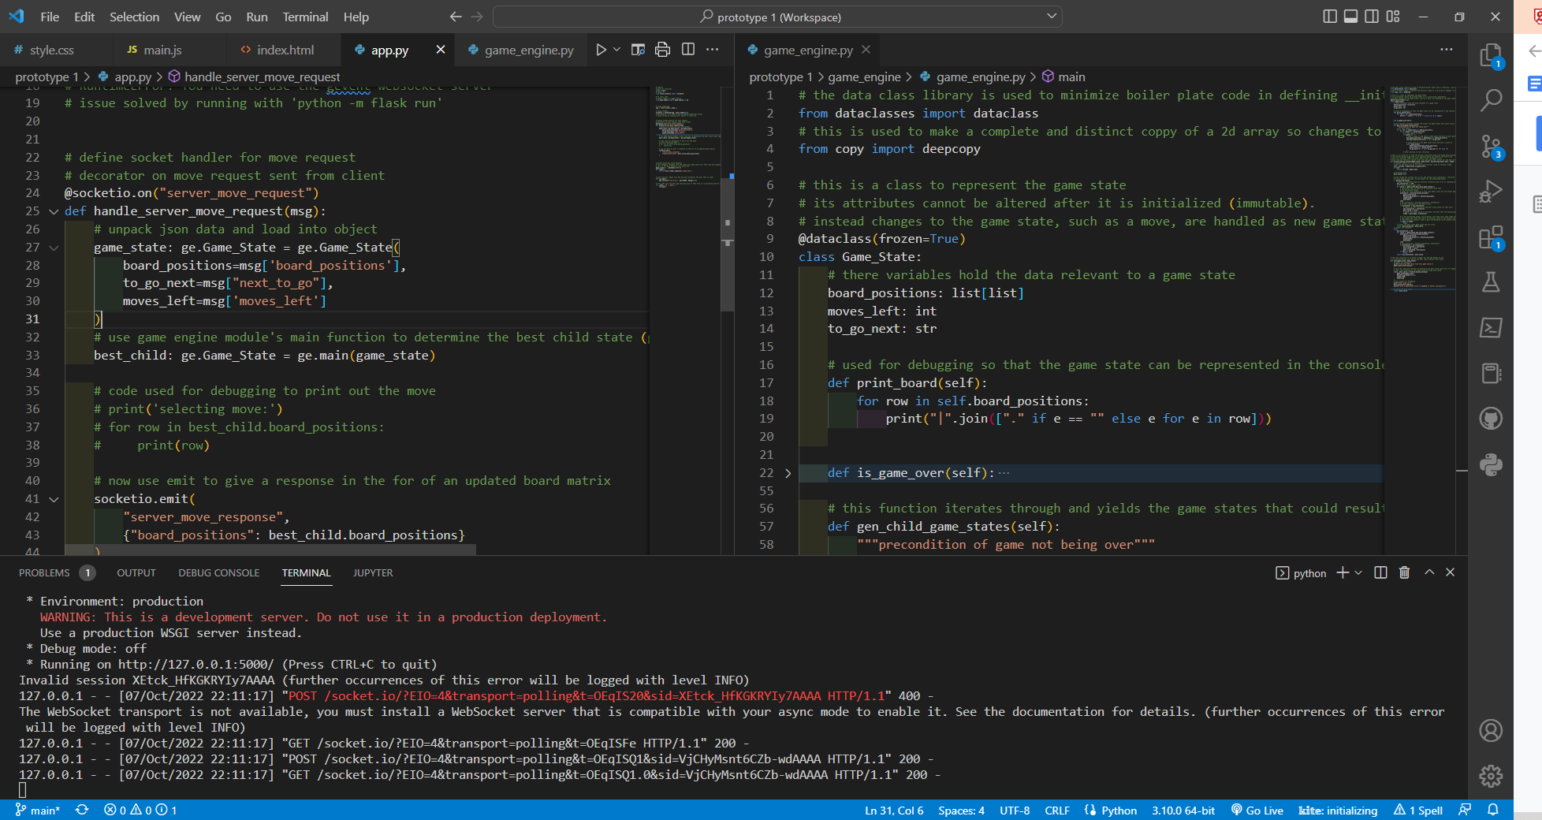

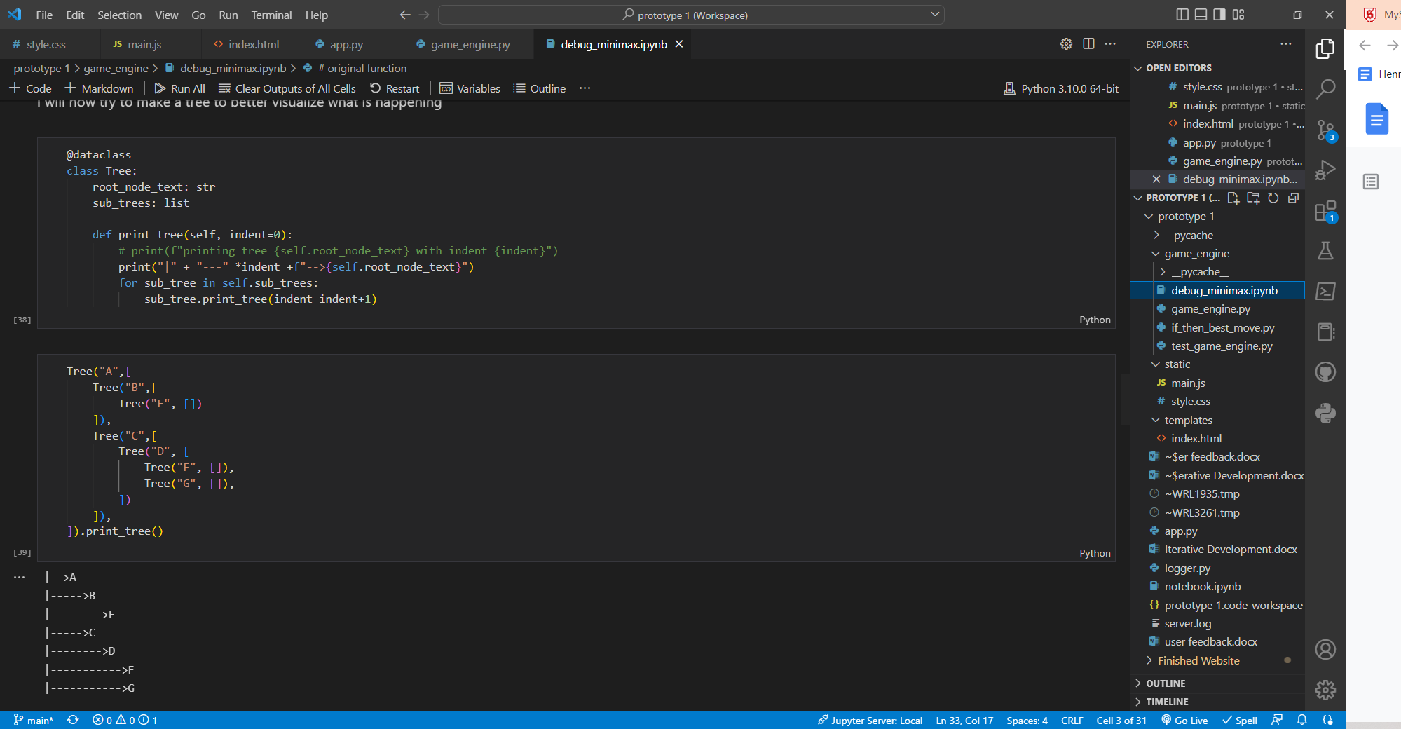

### Libraries, Languages and other assets:

I decided to use python and JavaScript for this project as I am already familiar with both. I know how to code many more complex technical tasks in python that I will need to complete in later prototypes. For example maintaining a SQL database. I also think that there is no real alternative to JavaScript for client side logic and validation. Therefore these languages were familiar and a good fit for the project, so I choose to use them.

For this iteration I use very few libraries and external assets. I only used VS Code for the editor and only used code I had written. No elements of my solution (including the html and UI) were produced using a forms designer.

I used libraries minimally, here are all the libraries I used:

Python:

* Flask: used to create a WSGI HTTP web server
* Flask_socketio: used to create a WebSocket server to connect the front and backend
* Data classes: used to avoid boiler plate code (which can be quite a lot) in class definitions for the __init__ and __eq__ (comparison) method. It also easily allowed me to make my classes immutable
* Copy: I used the deepcopy method to make a duplicate copy of a 2 dimensional array in python. Without it changes to the original array change the new copy as they use the same memory location

JavaScript:

* Socket.io.js: used to allow the client side JavaScript to connect and communicate with the socket.io server

WSGI stands for Web Sever Gateway Interface. It allow the python framework that I am using (flask) to give instructions in a standardised way specialist webserver software like waitress. I can still run the program locally for debugging without this software in development mode. When I am finished I will need to use Waitress as an additional piece of necessary software to deploy my project.

I decided to use WebSocket to make my API over a traditional REST approach using HTTP. This is because WebSocket creates a full duplex TCP/IP connection. This leads to lower latency (allowing for more complex validation to be server side without delays for the user) and it allows for messages to be ‘broadcast’ to all clients or just ‘emitted’ to one. This is important if I want to allow for a leader board or player vs player matches in future.

### The code:

Starting with the HTML

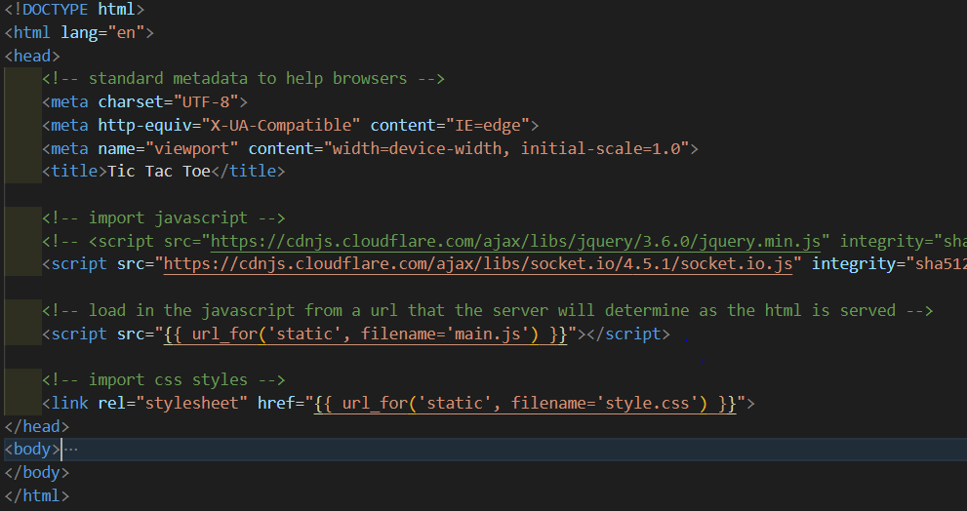

Here is my head tag. It contains boilerplate code to provide browsers with basic metadata. It also fetches the WebSocket library which is how the frontend and the backend will communicate. A CSS file and JavaScript file are also loaded in from the server.

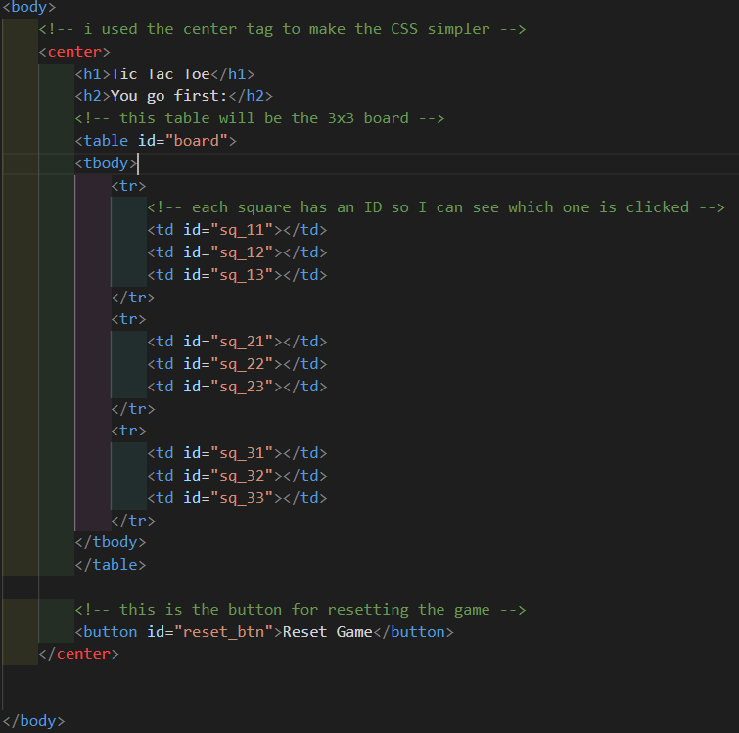

Here is the body tag and its contents. The individual squares of the board and the reset button are given ids so that I can give then a click event in JavaScript later.

The JavaScript then consists of one file with many functions which I will add screenshots of here. I will only add explanation on top of the comments if I think it is necessary. I am not necessarily explaining the JavaScript in which it appears in the file as the order how the functions are defined is not relevant or the best way to explain it.

Here I define my global variables and setup WebSocket. I initially tried to make a class to represent the noughts and crosses game that contained attributes and methods that used and changes these attributes. I then realised that the class would be all the code and that it didn’t make sense as I would only ever have one instance. Due to the small size of the code, this lead me to decide to use global variables to contain the data about the current game.

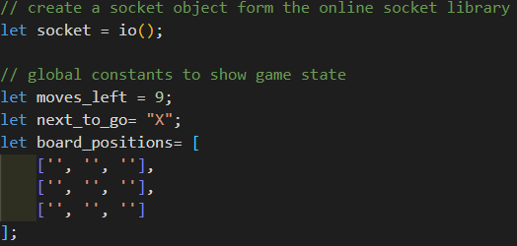

I then I add click events to the squares and the reset button

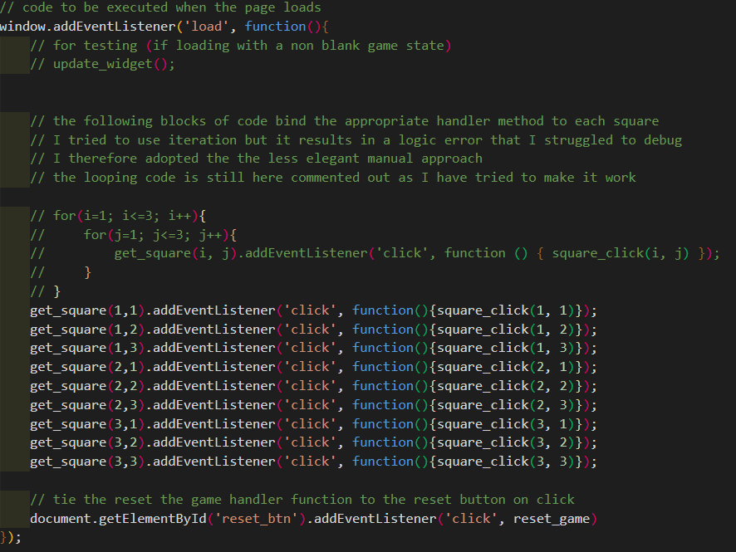

I will not show you the functions that I defined. In theory many of then are actually procedures as they don’t return anything. However they behave in a similar way as they use global variables.

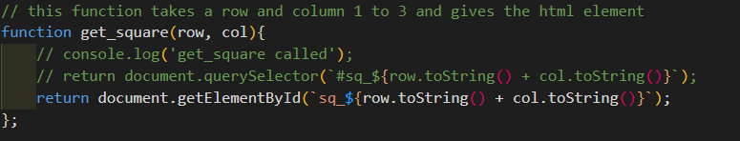

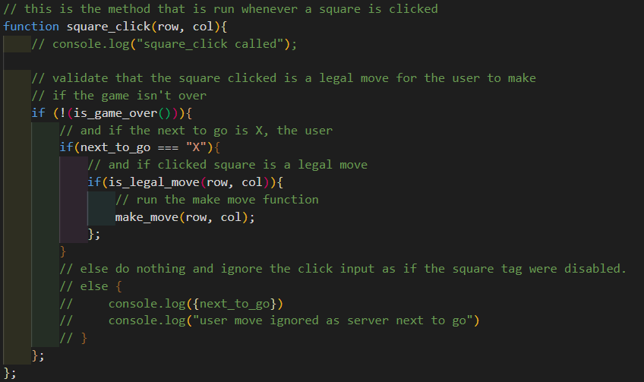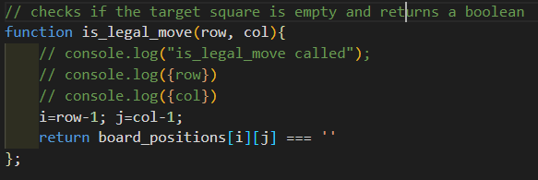

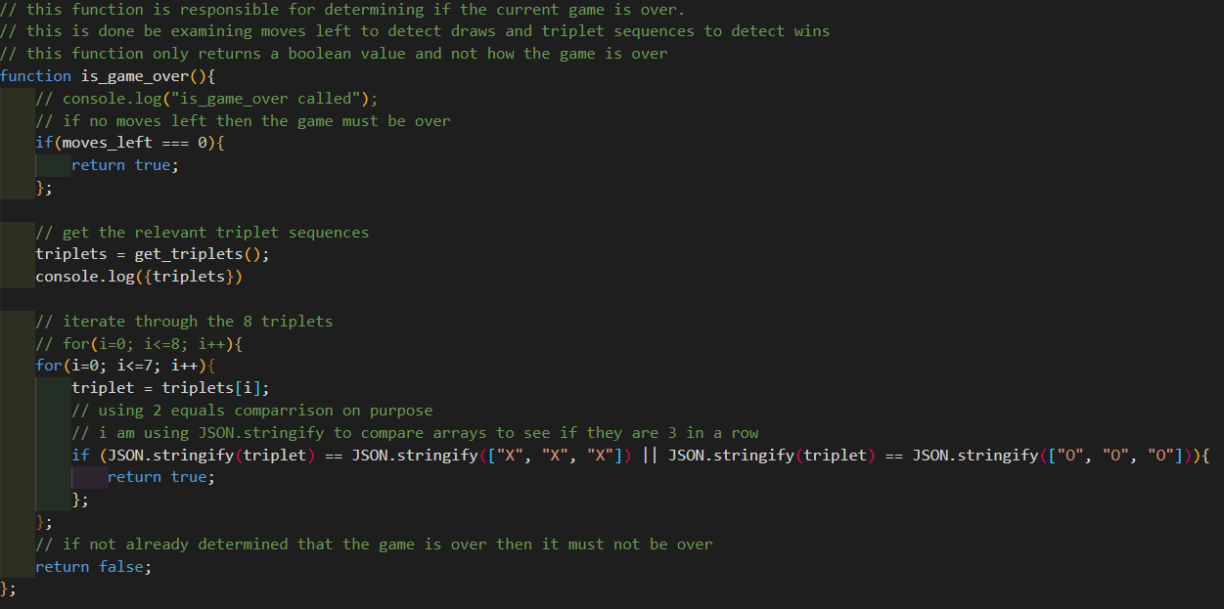

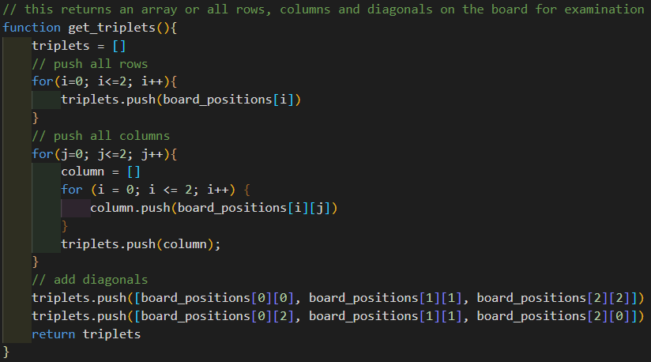

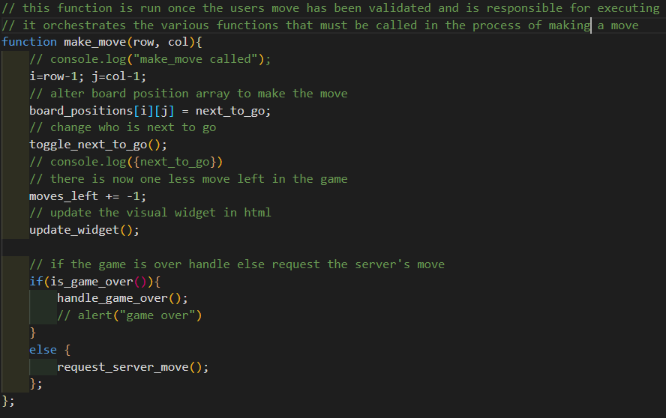

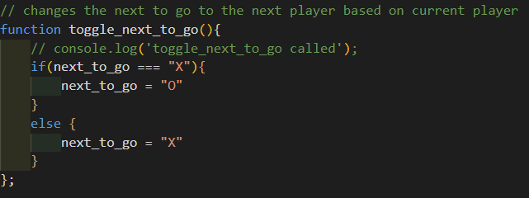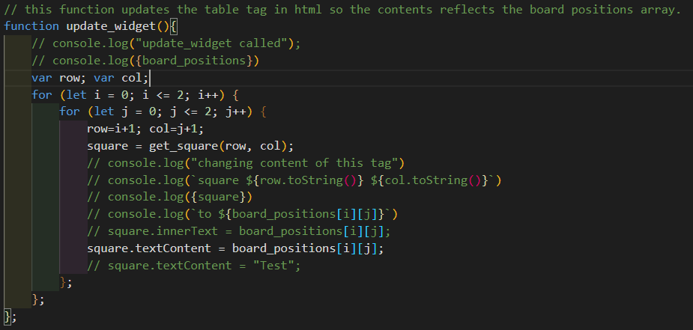

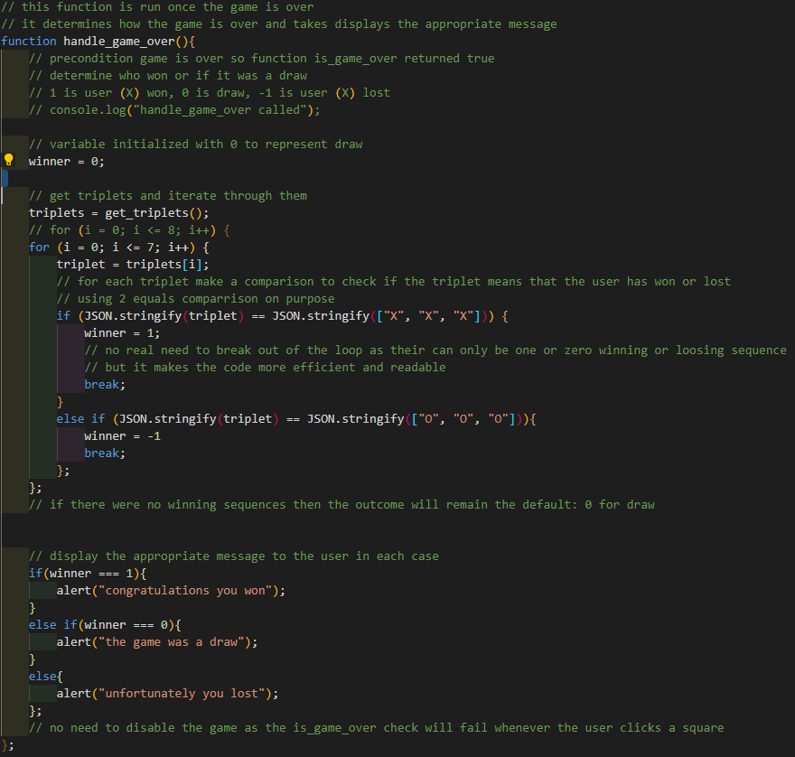

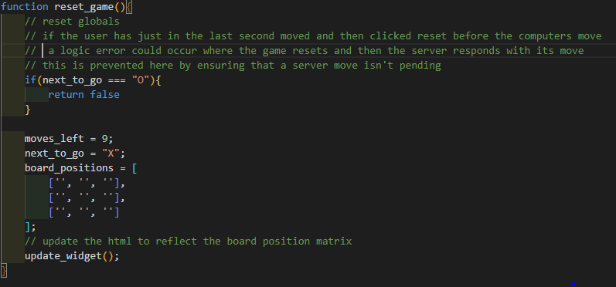

The following functions are used to request and handle the server’s move.

They require a little more explanation

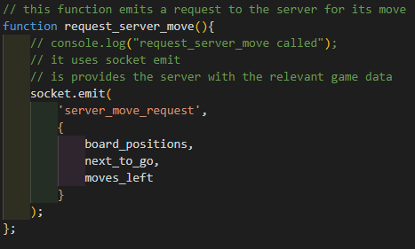

This function sends a request to the server for its move using the socket.emit function. The server will process the request and then respond with a new game state, that is where its move is added.

The following event handler ties ques a relevant handler function to run when this happens.

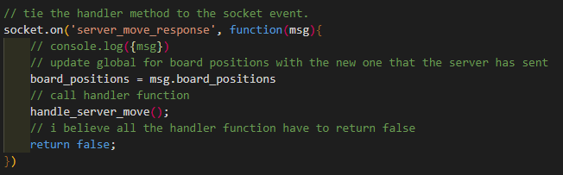  
Here is the handle_server_move function

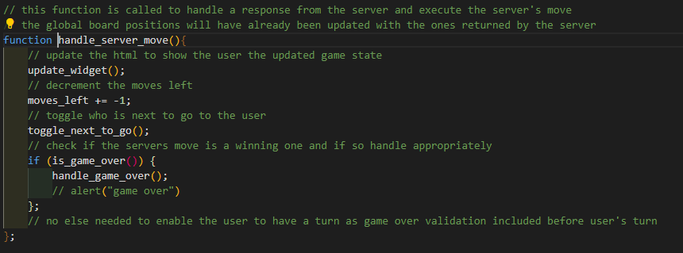

This is all the client side JavaScript that I used to make the interface work. The rest of the program is python bas­­­ed. It is responsible for hosting the website and determining the best move.

**Here is the code for app.py:**

This is a python program that acts as the webserver and socket server for the frontend website. It is a relatively small program

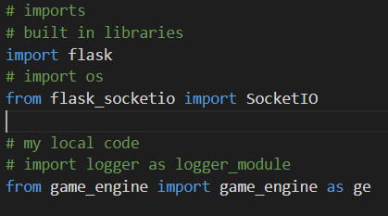

To start with I Imported 2 libraries to help provide the WSGI and WebSocket server functionality. I also imported the functions from a program I write called game_engine. This contains the code for my minimax function.

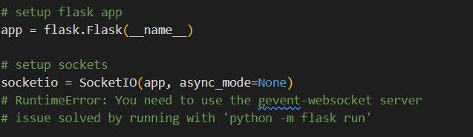

I then setup my app object and socketio object. This is boilerplate code to use the relevant libraries and setup my WSGI and socket server.

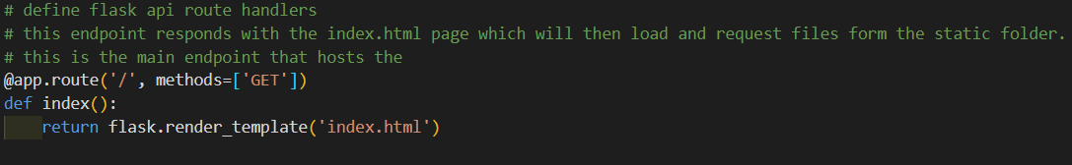

I then used my app object to setup a handler for what happens if a HTTP get request is made to the root. This method returns the html page. I use the flask render template method so that URLS to external CSS and JS files are substituted into the html code where {{ }} double curly brackets are used.

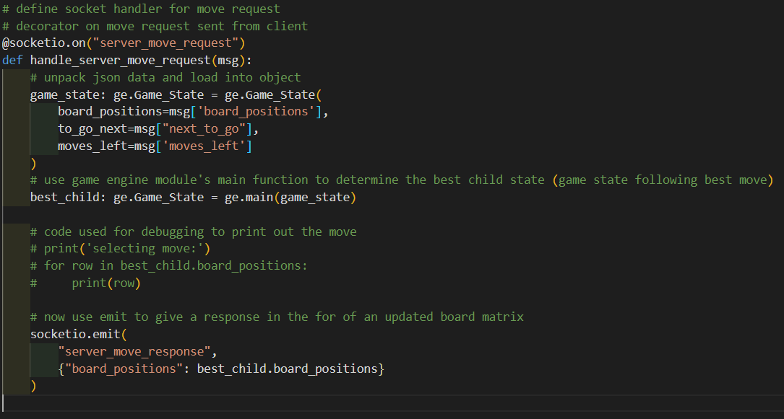

I then used my socketio object to define a handler function for the server_move_request.

It unpacks data provided into a Game_State class form the game_engine module. It then gets the best child game state using the minimax function. This represents the game state after the server has made the best possible move. The resulting board positions matrix is then sent back to the client my making an emit with the name ‘server_move_response’.

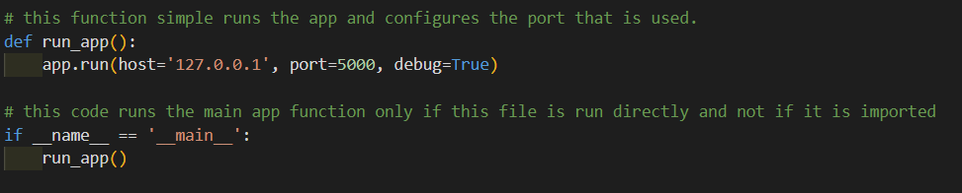

The above code is then responsible for starting the server when this python file is run directly. It used port 5000 on the local host.

**Game engine file**

This file contains code that is used to determine the server’s best move.



Here is imported external libraries and gave the reasons for why

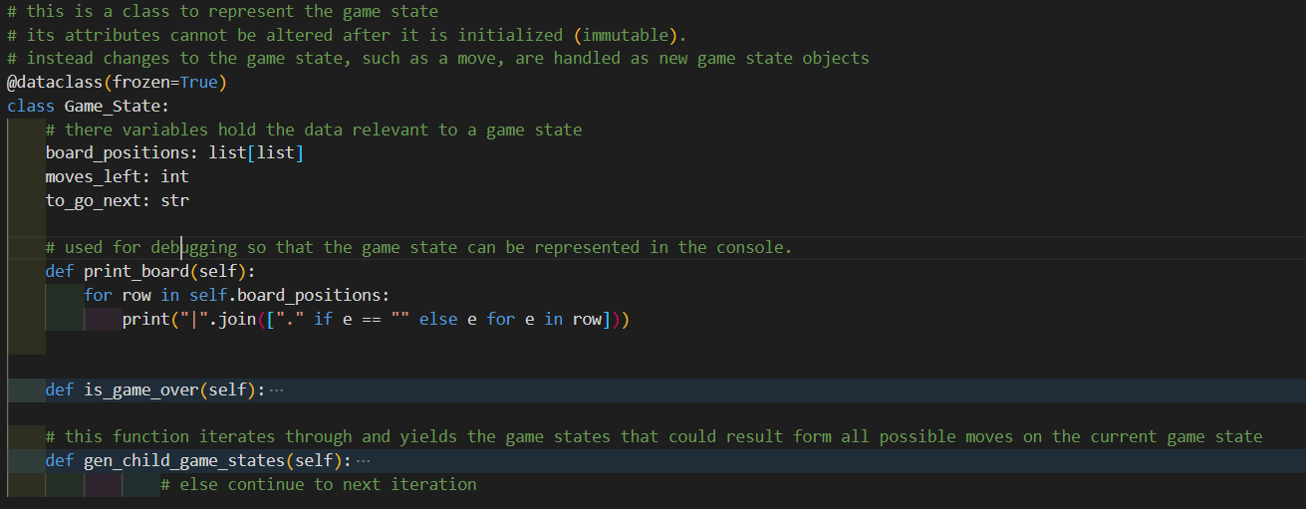

I then use a class to represent a tix tac toe game in a specific state.

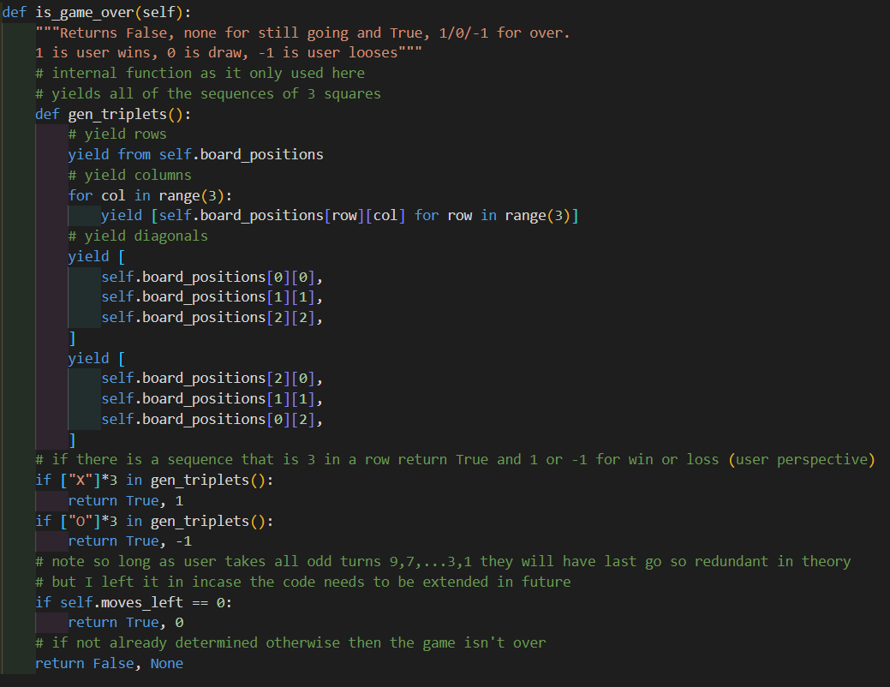

I then produced a function to determine if the game is over and if so what the state is

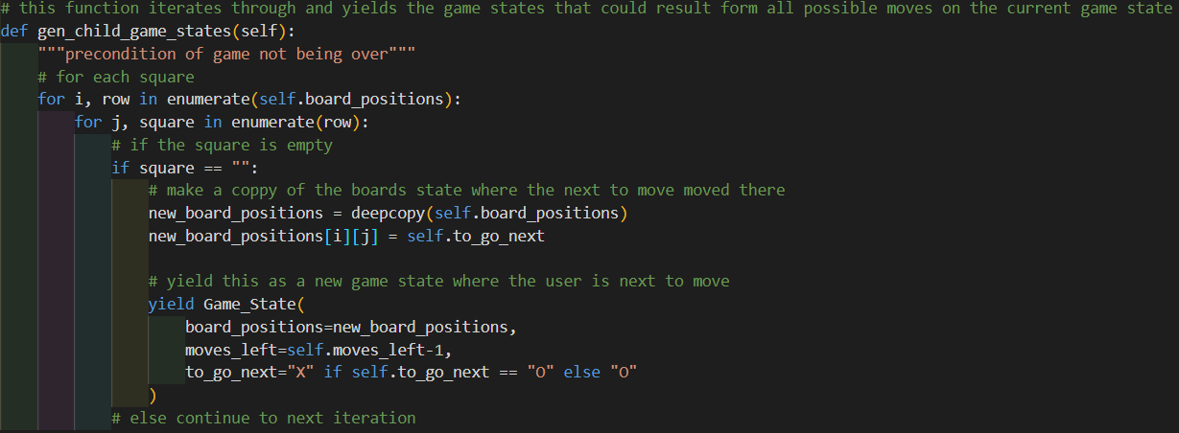

I then produced a function to iterate through all empty squares on the board and yield the resulting game state if the server had moved there. This function returned an iterator of child Game_State objects

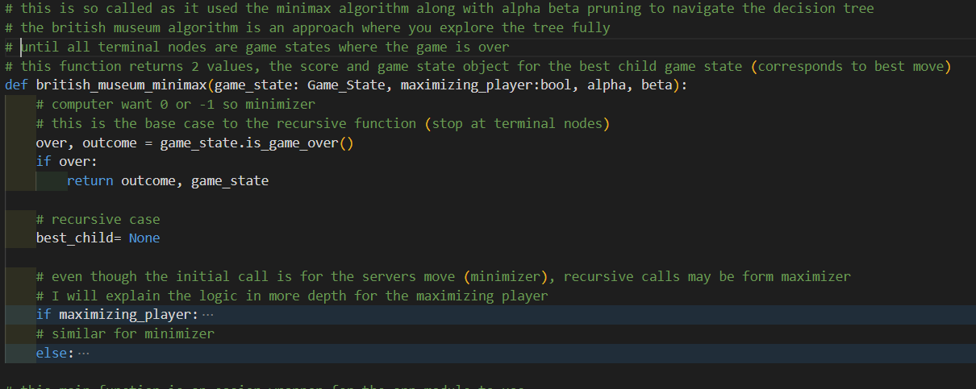

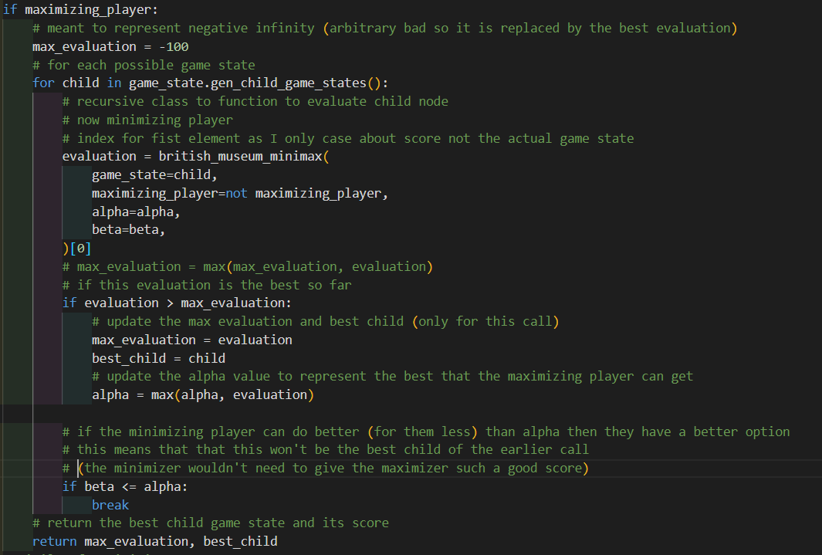

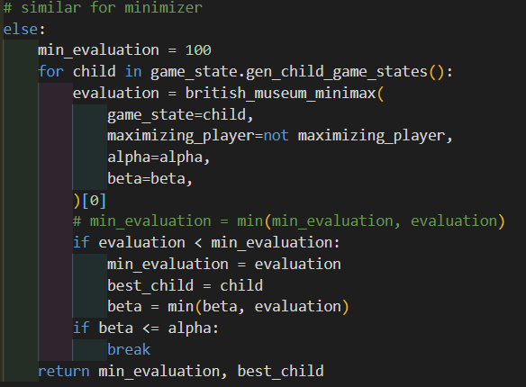

The function is explained by the comments. It explores the decision tree down to the terminal nodes where games are over and then decides what the best move is. It returns the score and the object for the best child of the current game state object

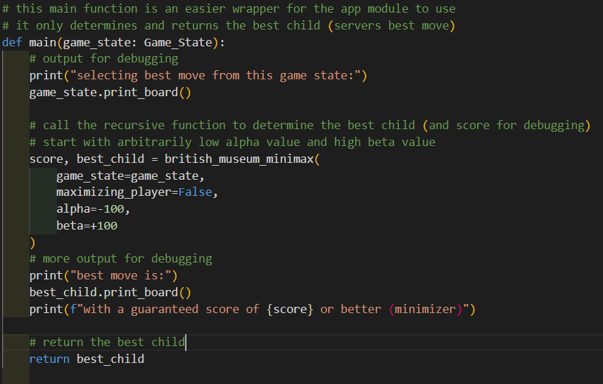

I then made a main function for the whole module that provides abstraction from the minimax function. It takes a Game_State and returns the child game state corresponding to the best move. This is the function that the app.py program uses.

This is all the code used in the project.

## Here are some screenshots of the final product:

Here is a screenshot of the webpage when viewed on my laptops resolution

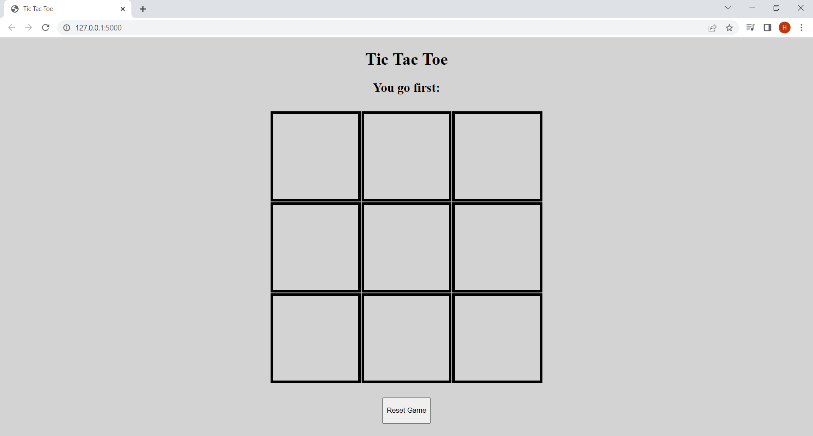

And here is a screenshot of the website from the resolution of the iPad

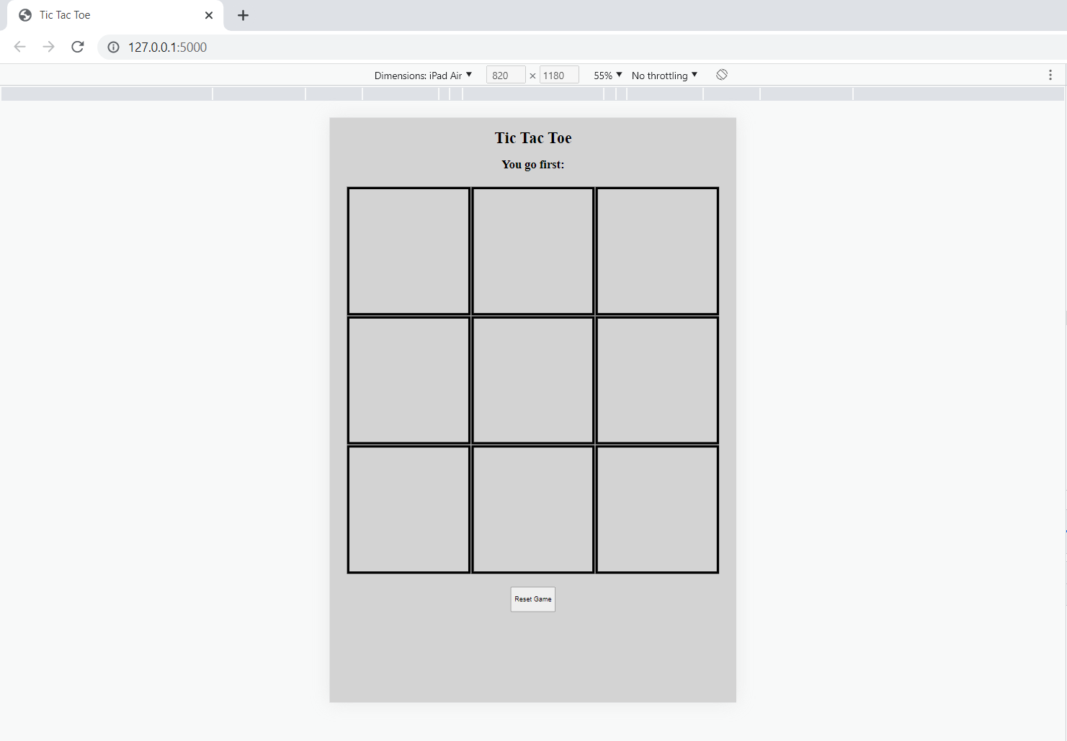

When I click on a square a ‘X’ Appears in it. Then a fraction of a second later a ‘O’ appears in another square

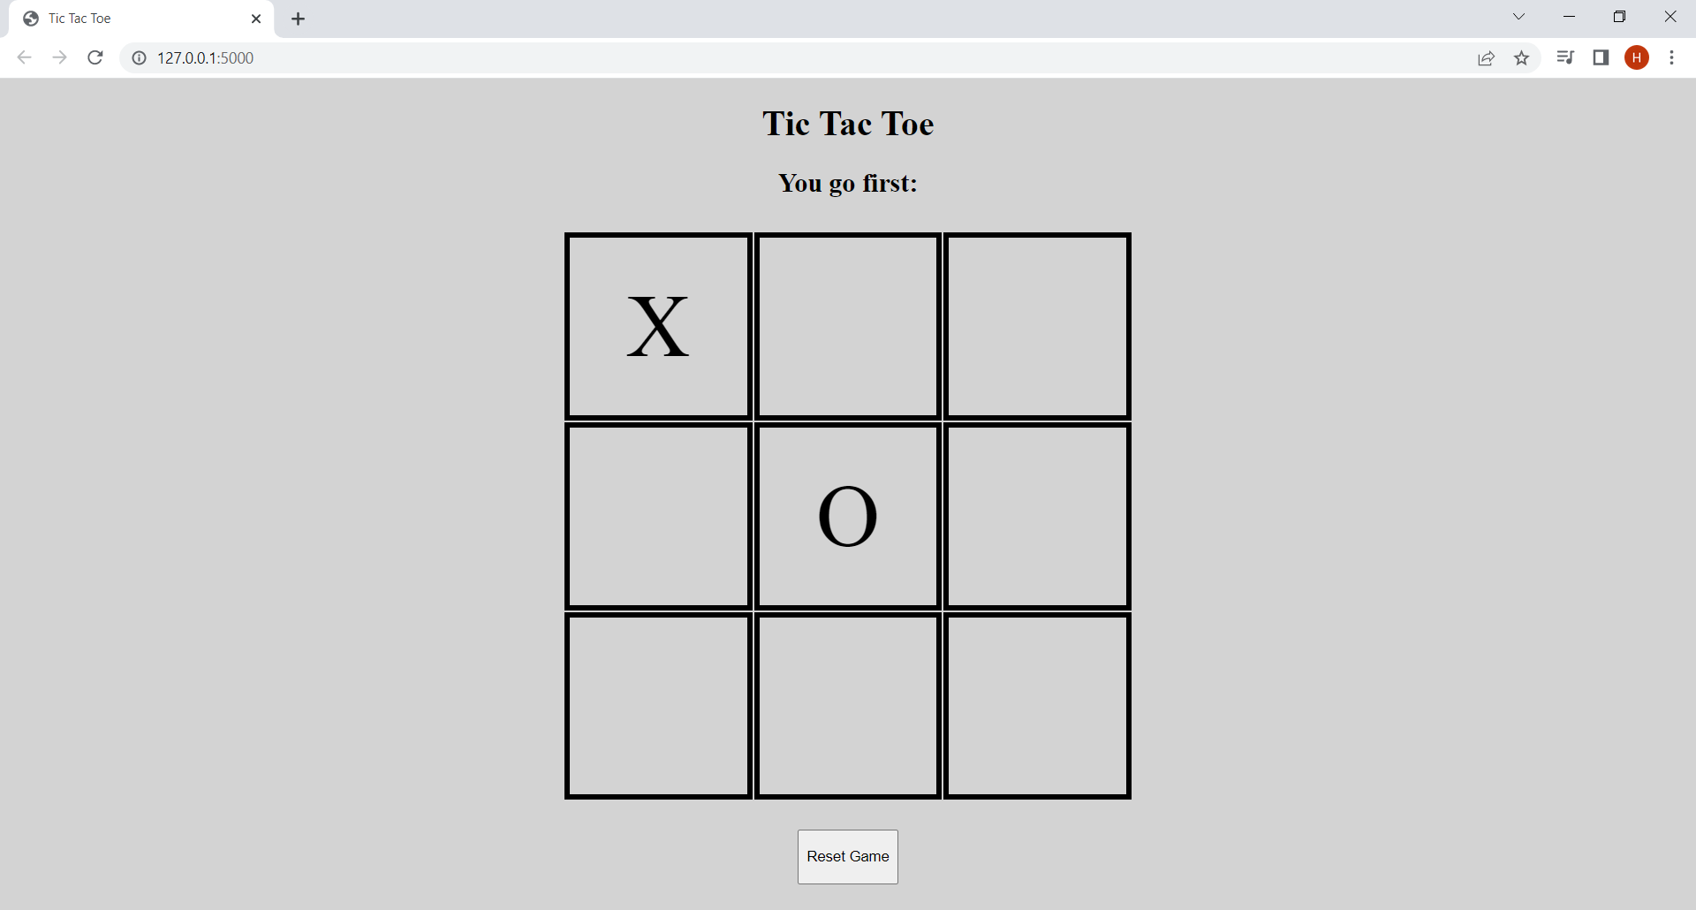

If I click one of the squares containing the ‘X’ or ‘O’, nothing happens due to client side validation

Below are a series of screenshots of a game where I allow the computer to win. (I will not show all of the webpage just the relevant part like the board as the rest is clear)

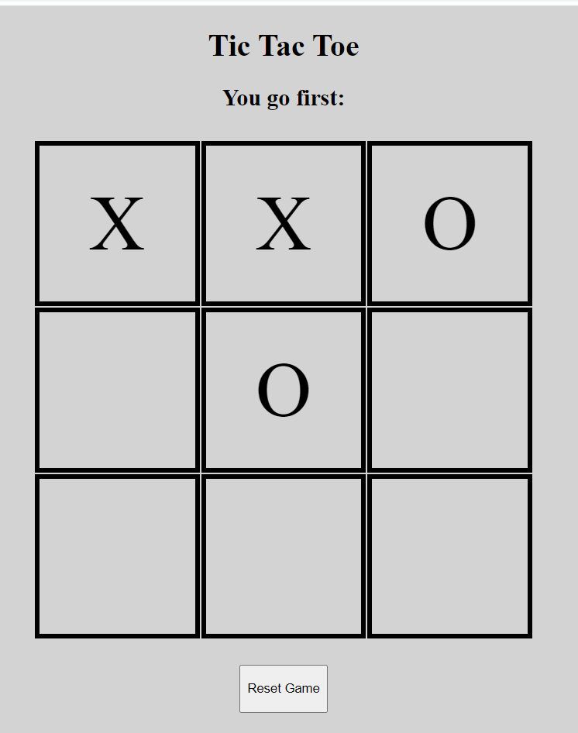

I then clicked the square in the 1st column and second row and this was the result

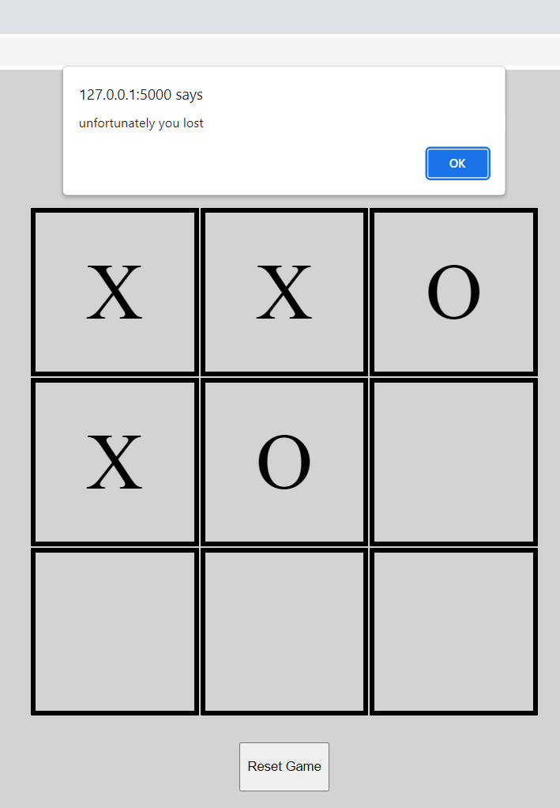

This shows a logic error that is minor but hard to deal with. It is where the alert to say that the game is over comes before the winning move (in this case a ‘O’ in the bottom left).

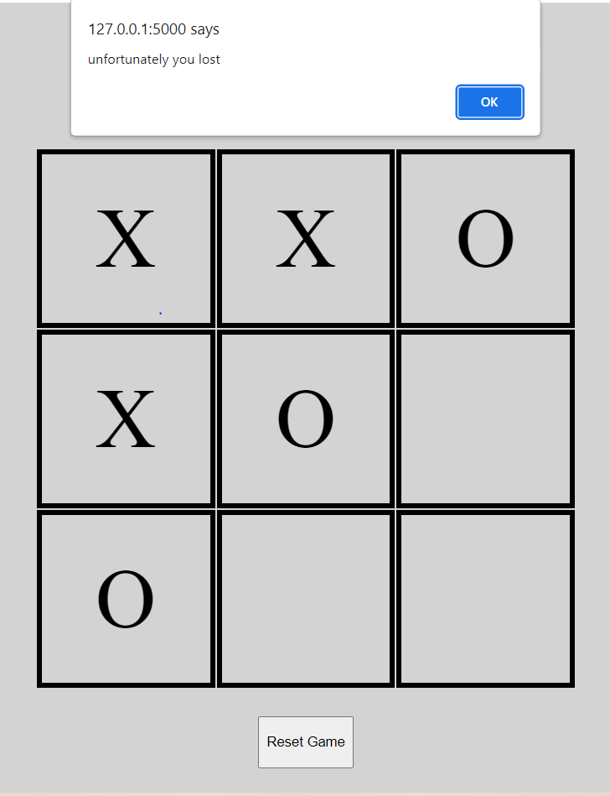

I noticed that if the window is minimised and then clicked again the winning move is shown

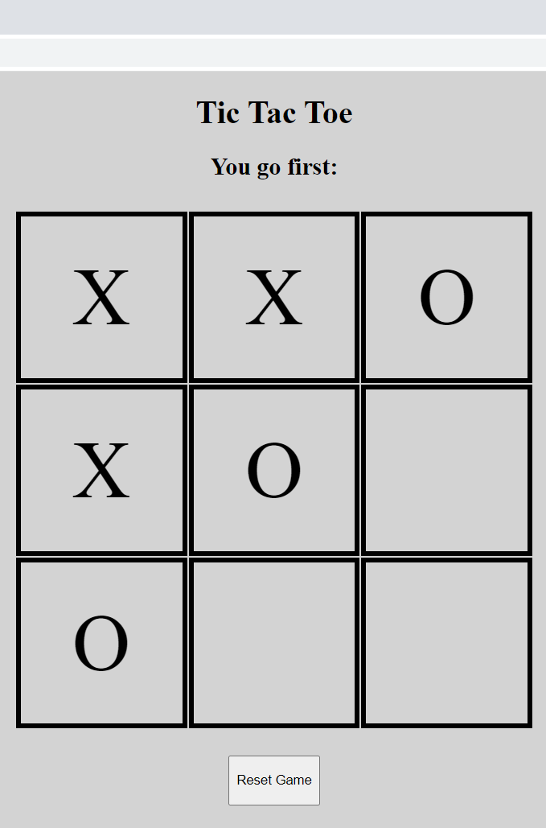

The winning move is also shown either way when the user clicks ‘ok’ on the alert. This is an issue but it doesn’t prevent the program from functioning, it is more of a ruff edge.

Now if I click any square nothing happens as the game is over

If I click the reset button the board resets as shown

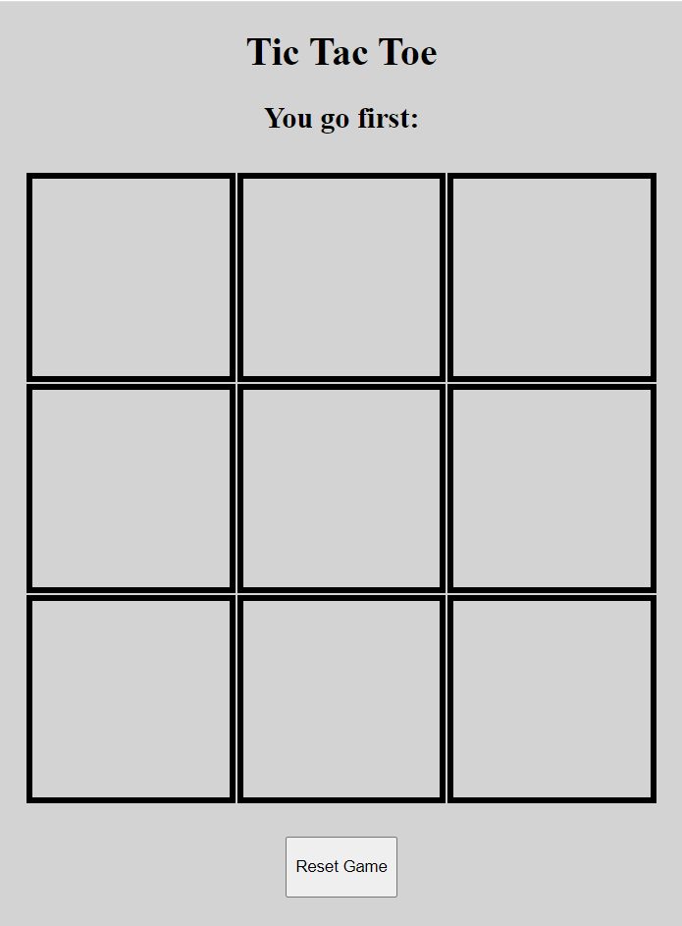

## Problems throughout and how I tackled them:

While I did have to use a bit of trial and error to get my CSS to work the main problem I had in development was with my minimax function.

The process of developing this prototype was to make a rudimentary server that couldn’t decide the best move. I then created the frontend and tested the program. The server would use command line input to allow me to input a move and simulate the minimax process before I wrote it. I then wrote my minimax function and found that it wasn’t working.

I found that it was returning a move but not always the best move. It was strangely inconsistent and missed opportunities to win or stop the user winning at times. This was a challenge to debug as the minimax function is complex and has many recursive calls. For instance, for the first computer move it could have (without alpha beta pruning) 8! or 40320 recursive calls (total calls not depth). The challenge therefore was to try to make the function more transparent so I could see how it was behaving.

To do this I tried using breakpoints and stepping but this was not fruitful as it was hard to keep track of what the correct behaviour of each recursive call should be and I was unsure where the problem was. So I created a jupyter notebook which is a python environment where I can define cells which are blocks of code I can run manually. This allowed me to import the function and to see what the results were for a variety of outputs. Here is what I did:

I started by importing some libraries and making a copy of the invalid code (which I ran)

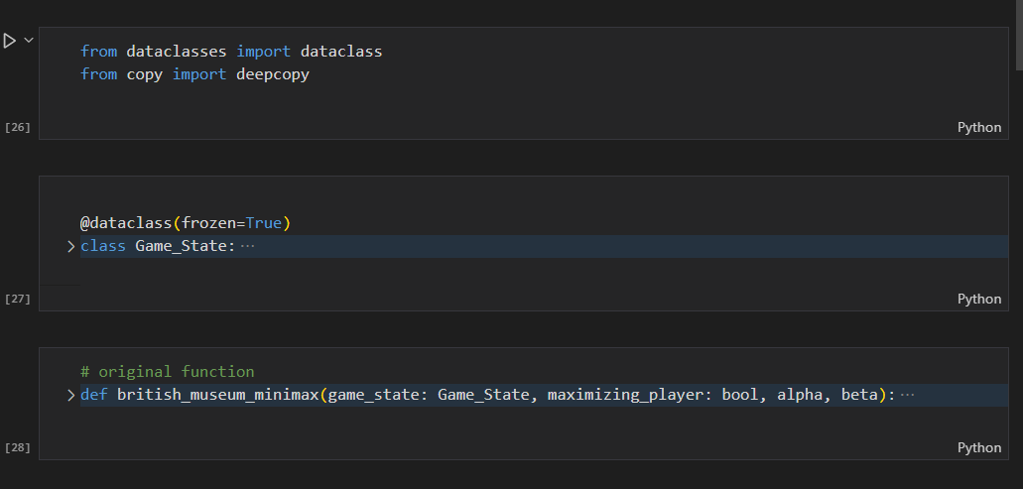

(code is hidden to save space as it is repeated from earlier)

I did this rather than import from the file so that my initial tests wouldn’t change if I tried to fix the version in the file.

I then picked an example game state to try to capture the issue

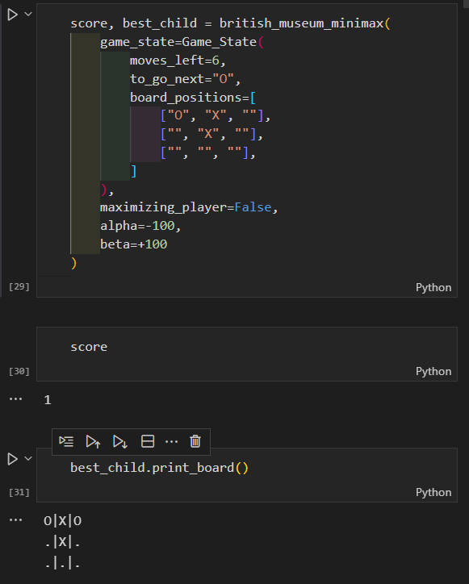

This shows a game state where the computer could prevent the user form winning by placing an O in the bottom row and middle column. As we can see there is an issue as it fails to do this. The score of 1 shows that the minimax function believes that no matter what it does, form here if the user plays optimally it has lost (computer is minimiser).

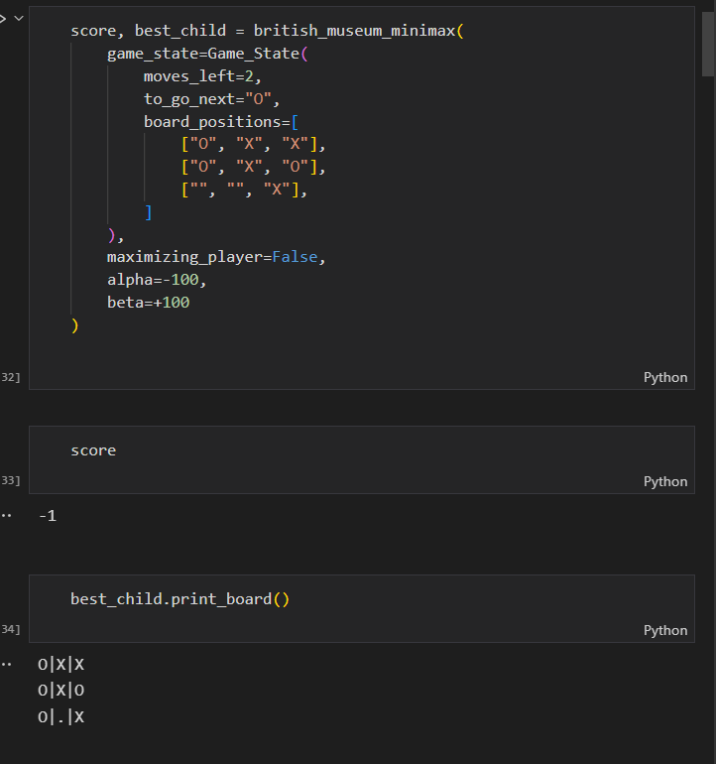

A similar test showed that sometimes the algorithm works. Here it successfully determines that it can win by putting an O in the bottom left

This was helping me to build up a picture of when it fails

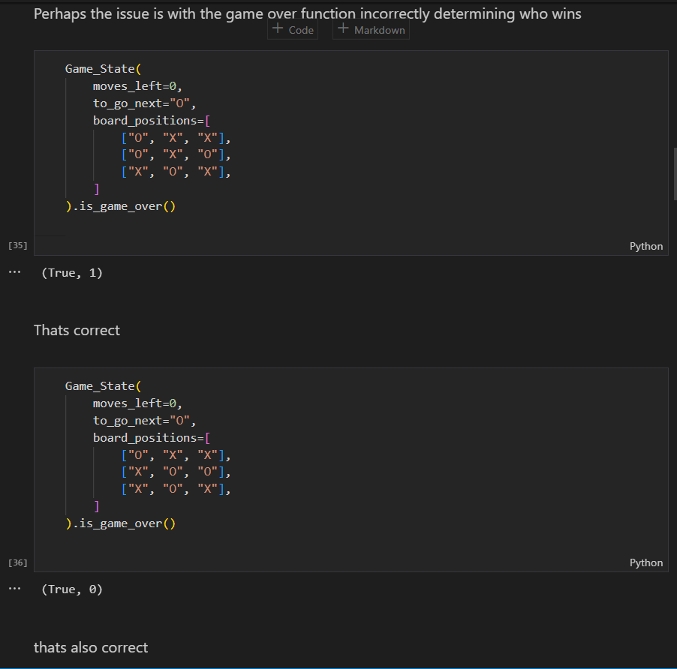

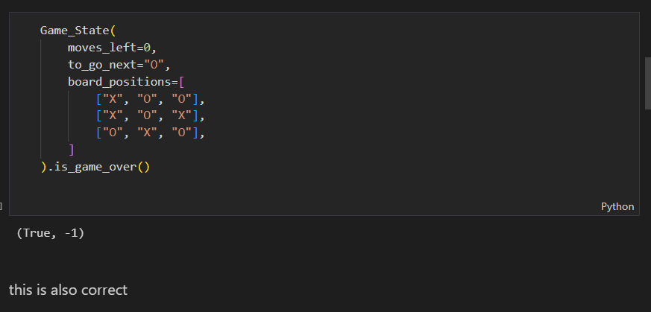

I then investigated to check that the game over function was working as it should or if it was getting confused as to who won. It was working.

I then tried to visualize the decision tree that the minimax function was exploring

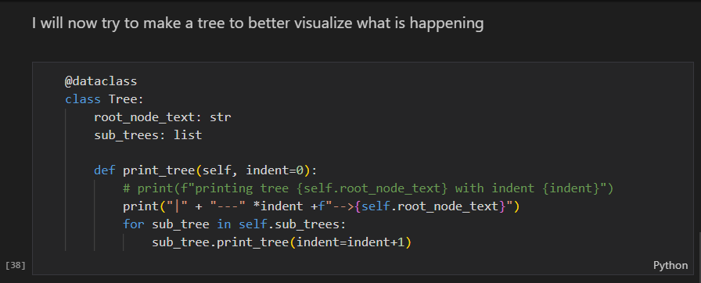

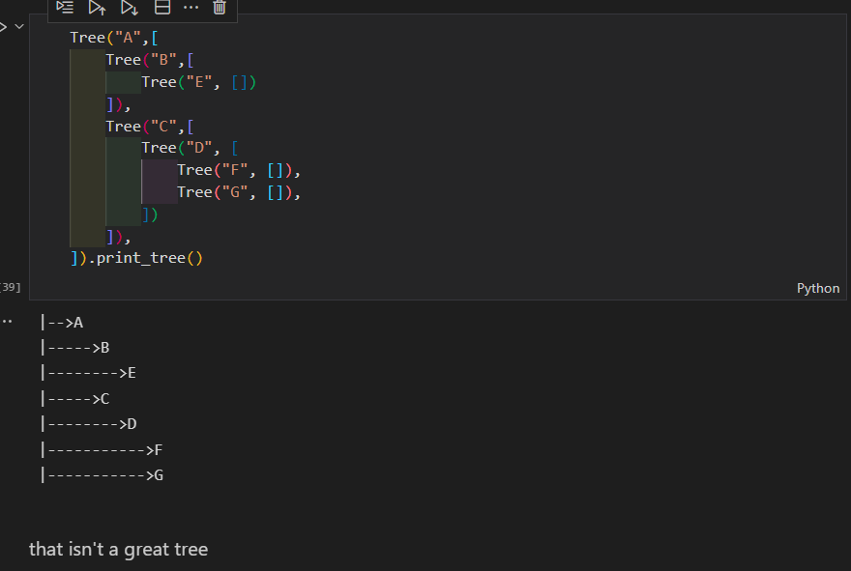

This didn’t work out and so I tried a different approach

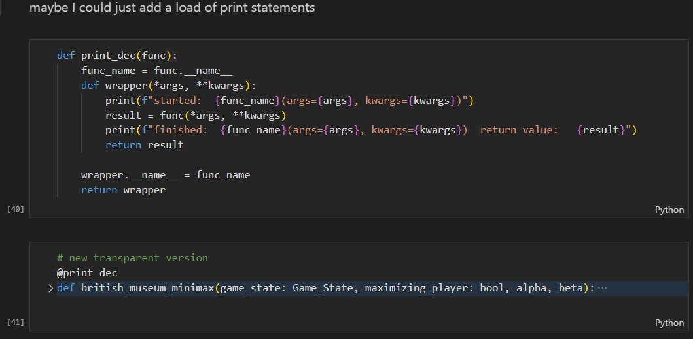

I then created a decorator to augment the function’s behaviour. It caused the function to print out its arguments when called and the result when it finished.

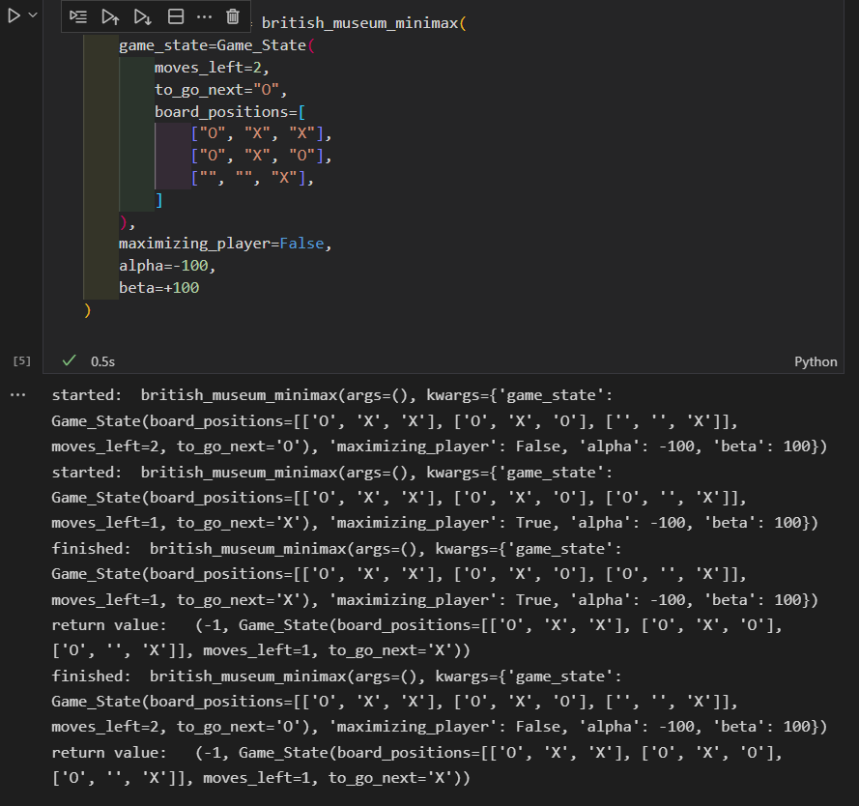

This worked as I used a near completion game so that there were fewer recursive calls. Due to pruning the there is only one recursive call as it successfully identifies the winning move.

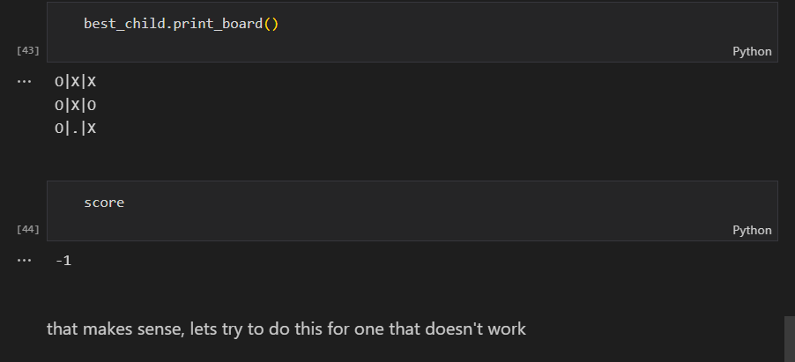

This example seemed to all be in order

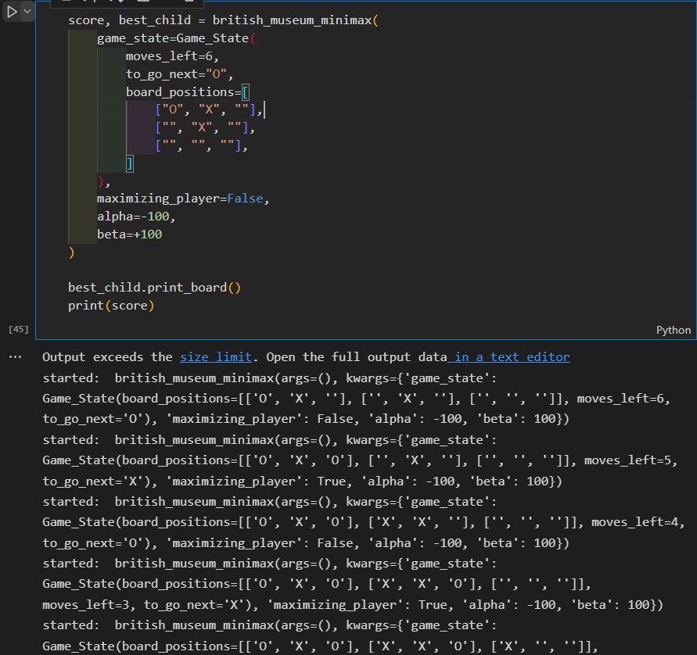

I then tried to look at the output for a game where the function had failed earlier. This was not fruitful as the output was too large to successfully analyse (6! Or 720 calls without pruning).

This is the end of my use of Jupyter notebook. It did however help me understand a little more what was happening when the program failed.

From coming back to the problem at a later date I realised that the client side JavaScript couldn’t recognise a win when it was a diagonal in a row. I then fixed this on the frontend and backend by adding to the ‘triplets’ function. This still didn’t account for some of the errors and it still wasn’t working. From looking at my research into the minimax function I realised my mistake.

            beta = min(alpha, evaluation)

the above line is the source of my logic error. It is contained in the else (so if minimiser) part of the algorithm. It is supposed to update beta with the best result the minimiser can so far obtain (to allow for pruning of clearly worse branches of the decision tree in future).

The correction is this:

            beta = min(beta, evaluation)

With the help of my debugging and jupyter notebook this unassuming logic error was found. The correction allowed the program to work in all scenarios and play tic tac toe optimally. It is worth mentioning that I, nor my stakeholders, never beat this version of the minimax function at tic tac toe.

The other significant error I encountered was the following

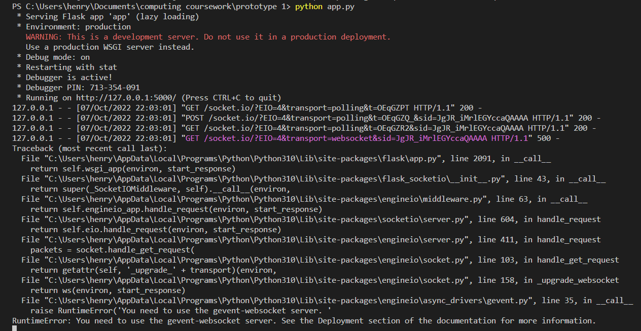

I struggled to solve this using Stack overflow as their solution didn’t work for me. I found that the program works if I run it in a different way using the following command 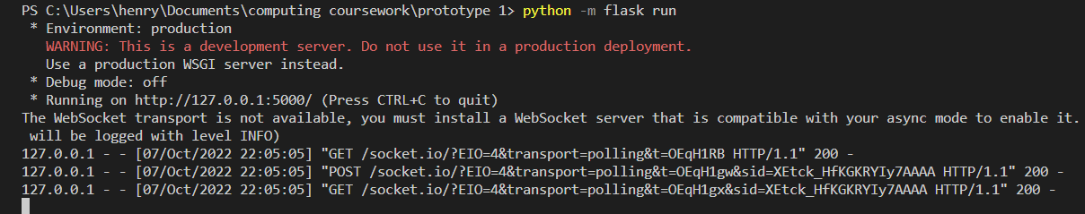

In future, rather than circumvent the error (as this still gives a warning), I will try to alter the async parameter of my socket object to fix this. 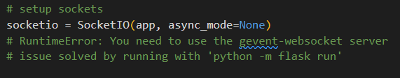

This does mean that I use an integrated terminal to run my program as running the python file directly doesn’t work.

## Test Plan for this version

The test plan for this program has 2 prongs. One set of tests will be testing that when I click on a specific square or button on the website, the expected behaviour happens. Another set of tests will be that in specific cases the tic tac program can see the correct move to win. These tests will be non-exhaustive as there are 9! Possible games which is too many to test.

The below tests are shown in a table. I use numbers to indicate what screenshots are evidence to what test (usually 2 for before and after)

|  |  |  |  |
| --- | --- | --- | --- |
| Description | Expected behaviour | Success? | Evidence |
| When the game starts I will click one of the squares | That square should fill with a ‘X’ then another square should fill with a ‘O’ | Y | Tried top left square. Before    After |
| 2: I will then try to click both of the filled squares | Nothing should happen as validation should stop me moving there | Y | Nothing to evidence but nothing did happen when I clicked the top left X or the centre O. the webpage still looked like this |
| 3: If I click on another empty square I can move there | An X should appear in that square and then an O should appear in another square | Y | I moved to the top middle  Before:    After |
| 4: It should successfully recognise a loss | I should be able to click on another square and then the computer should move into the winning square. An alert should show that the computer has won | Y (but sometimes the alert happens before the move as already discussed) | Before:    After: |
| 5: The program should successfully recognise when the user wins.  (Note this doesn’t ever happen so I changed the JavaScript so that the game starts with the user a move away form winning and the user moves next) | The user should be able to move into the winning position. There should be no subsequent server move. An alert should show that the game is over | y | Global variables changed:    Update widget to array added on load    Before:    After |
| 6: The program should handle a draw correctly | If the user plays appropriately the game should continue until the user fills the 9th square (none left empty). Then the game should end with an appropriate alert | y | Before:    After: |
| 7: once the game is over the board should be unresponsive | Once the game ends the user can click ‘ok’ on the alert and then clicking any square on the board should do nothing | Y | Before:    After: (clicking did nothing) |
| 8: the reset button should work once the game is over or halfway through | Clicking reset button should in effect reload the page to an empty board. | Fail (only worked in some cases). I address the correction as a result after the tests | Case 1: the game is over loss  Before:    After:    Before:    After:  it didn’t clear, the test failed. I reloaded the window and was able to recreate the issue  Case 2: The game is still going:  Before    After: |

## Changes to code made after testing:

So test number 8 or the reset button failed specifically when the game was over and it was a draw. I had recently added to that function and so immediately knew what the issue was. I found a logic error where a user makes a move and then immediately clicks reset, resulting in the server then responding with its move after the restart. I added an if statement to check if the program was waiting for the server’s response and if so not to reset the board as highlighted here

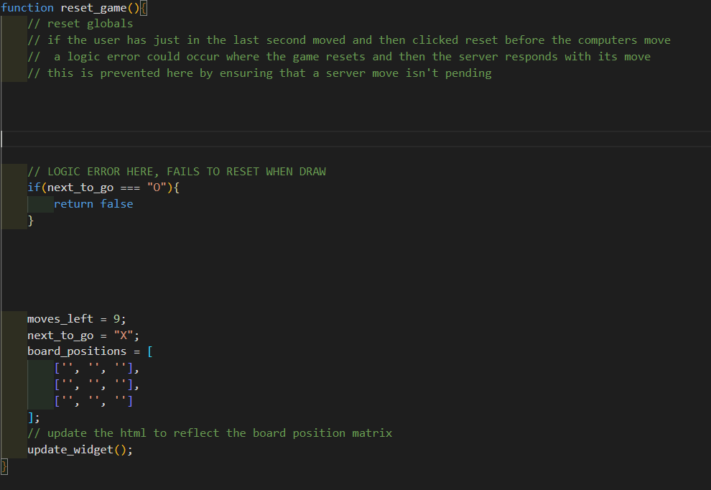

This caused the logic error. This is because there are 9 turns and the user makes all odd numbered turns, including the last turn which is 9. After the last turn in the case of a draw the game is over but the next to go has been changed to “O” after the move.

I initially thought I would correct this by adding an AND statement to the condition

If next_to_go == “O” AND moves_left >0

However in the theoretical case where the user has won, the user would have made the winning play on their go and so next to go would be “O” and there would be moves left. Therefore I need to more generally check that next to go is “O” and that the game isn’t over. Here was my corrected code

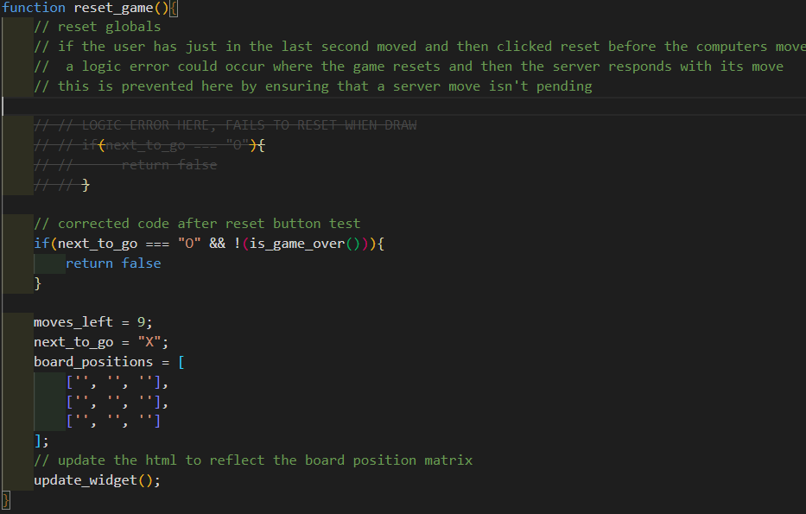

The test (test 8) now is successful. The reset button now works in all cases

Before

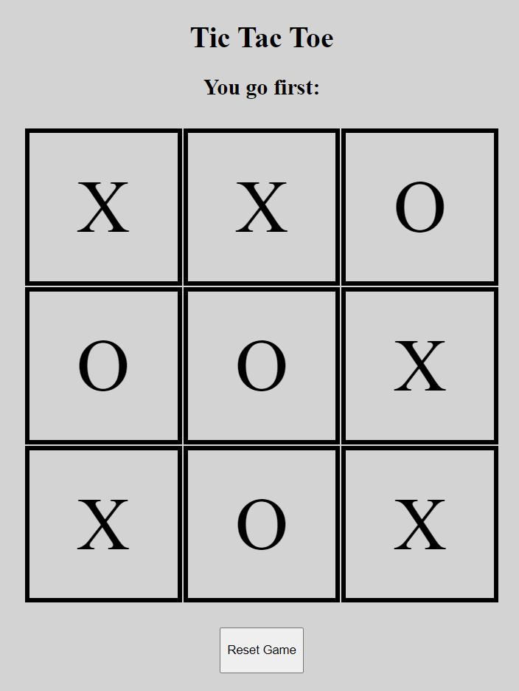

After:

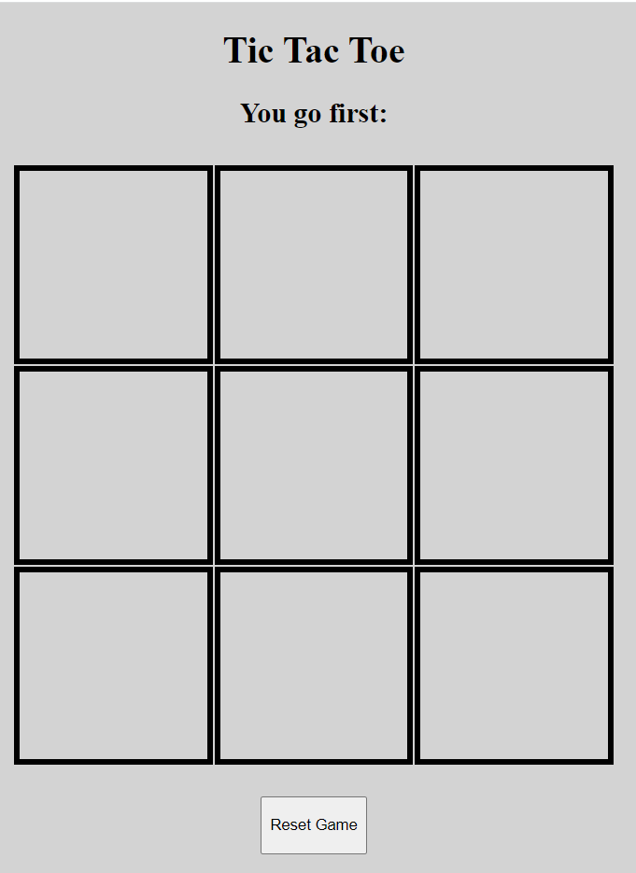

## Validation:

The validation is limited in this early prototype as there is a limited number of user inputs. Due to the lack of menus there are only really 2 types of input

* The user clicks the reset button
* The user clicks a square in the 3x3 grid

I have used validation to decide whether or not an action should be taken based on the current game state.

**For the square click input:**

The relevant action is to call the make_move function. The validation before-hand is that all the following conditions are met:

* The game isn’t over
* It is the User’s turn to make a move
* The move is a legal move (the target square is empty)

**For the reset button click input:**

The relevant action is to reset the global variable values and update the board in HTML to show this. The validation consists of a condition which if met causes the restart to be ignored. This check if both:

* It is the server’s turn to move
* and the game isn’t over

this prevents the user clicking to input as move and then immediately restarting. This would cause a logic error when the server’s move is received and shown. I was not able to create this but this could happen if the server traffic or latency (network speed) meant that the server response time was slow. (This validation is the corrected version after a failed test).

## Feedback from Stakeholder

I then received feedback from my stakeholders (namely my parents and friends). The feedback broadly focused on the user interface.

My parents told me midway though the process that the board should be larger so it fills the screen. I also increased the font size of the ‘X’ and ‘O’ characters in the squares so that they fill the boxes and are more obvious.

Then when the program was finished I got more feedback from friends:

Regarding the alerts

* They told me not to use alerts as they were too jarring. They interrupted the flow of the webpage and were not what they (the stakeholders) were used to.
* They also recognised the issue where sometimes the alert for the ‘game is over’ occurs before the last move is shown

Regarding the computer’s move:

* They thought it would be a good idea to add a small delay before the computer moves so that the user has time to finish making their move, see the computers move, and react. They said that this would also make it seem more natural.
* They also said that it would be good if the test saying ‘it’s your turn’ was dynamic an changed for when it was the computer’s turn.

Other feedback included:

* Using a different background colour other than grey. This would help make the webpage more visually appealing and help differentiate the board in the foreground from the background
* There should be more of an effort to explain what the user should do when the page loads as it isn’t necessarily intuitive.

The final piece of feedback was echoing my earlier concerns, as they said that it wasn’t really a game as there was no way for them to win. In this way it wasn’t fun.

Hopefully this issue will clear itself up when I move to a chess program. While it is an important technical achievement that my tic tac toe program is unbeatable, my chess program will be beatable. Not only will me algorithm not generate the theoretical best move but it will also be restricted in its thinking time as part of the difficulty settings.

It is worth also mentioning that I allowed my friends and parents to play with the program to help me create this feedback. In doing so it is important to recognise what they *didn’t say* an what *didn’t go wrong.*

* For one they at no point had any issue with the validation. Note this was before I accidently created my reset button issue while trying last minute to tackle another logic error. This means that the validation was working (at least it was when they used it)
* They also didn’t have any problem with the page loading or the server response times which means the WSGI HTTP and WebSocket servers were working.
* They also didn’t have to deal with any crashes on the server side, resulting in the server failing to respond with a move, or any errors client side that prevented them from playing the game. This is good as it gives me confidence that the code is robust.

### Planned changes after stakeholder feedback

There are a variety of changes that I plan to either implement in this prototype or (more likely) take into account when building prototype 2.

* I will not use alerts. In this case I could have used a hidden HTML element containing dynamically altered text to show that the game was over. This would also deal with the alert before last move problem.
* I will also try to have some consideration for colour. While it is a weak point of mine I can get feedback as I develop to make a less starch looking website.
* I will add a delay (if needed on top of thinking time) to the chess program so that it feels like the computer is thinking and doesn’t break immersion

## Evaluation

Overall I am happy with the prototype as I think that this iteration has been a useful stepping stone. Its primary goal was to get me started with the connection between the front end and backend (WebSocket) as well as the backend logic. This included the WSGI HTTP server and a basic version of the minimax function. It would have been exceedingly hard to tackle the problem of chess without tackling this simpler problem first. This prototype has been a success because it has made me feel more able (on a technical level) to tackle a simplified version of chess form my second prototype.

The feedback from stakeholders has also been clear and useful. My program has a rugged and industrial look as the user interface was not the primary goal. However despite this, the scrutiny of stakeholders as to how specifically it could be better has helped me to learn more about how to make my program more usable. I will add what I have learned to my intentions surrounding usability in my planning document. So the prototype met its primary goal of helping me to develop the backend but, to be clear, the front end user interface failed to be user friendly.

I accept that this prototype looks very basic and tic tac toe is far from chess. However another factor that has justified such ‘small’ steps to chess has been the complexity of learning full stack web development (front and back end integrated) and the heuristics used to tackle chess. This is evidenced in the informal and ‘rough’ research and planning into how the minimax algorithm and WebSocket worked (I have included it at the end).

One of my aims in the analysis and planning stage was to make my program suitable for a variety of users. I would do this by making it work for a variety of aspect ratios.

I used the chrome dev tools to change the aspect ratio between my laptop and an iPad Air and decided that there were differences in the dimensions I preferred.

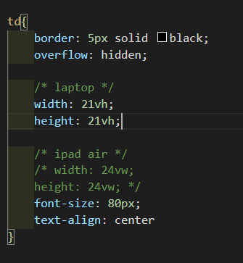

There are diminishing returns to refining a prototype when I could just bear the refinements in mind for the next prototype. One such refinement I would make if I had more time would be to add to the CSS so that it automatically used different styles for different aspect ratios.

Another change that I would have added had I had more time to refine is server side validation. Due to browsers having different versions of JS installed or users being able to circumvent client side validation, I would like to add server side validation. This could for example ensure that the client js wasn’t miss reporting the current game state to be more favourable to the user. This could be done with sessions, ensuring that the client game state is a legal move away from what it was after the server last moved. This would be of particular importance if the incentive to cheat existed. This could occur if I added a trophy / rank system or user vs user matchups (both of which are low priority features I decided weren’t suited to my target user in my analysis).

Overall, as I was able to test my prototype and correct for any test that failed, I feel that this prototype was a success. Because I was able to successfully verify the functionality through tests, I think that my prototype did achieve its design goals. This means that I think that these success criteria items have been met or worked towards:

* Working towards items 2, 3, and 4 by adding client side validation to ignore clicks when it is not the user’s turn
* Working towards items 6 and 7 as I will need to graphically show the computer and user move
* Working towards items 9, 10 and 26 as I will create a first iteration of a working minimax algorithm that can then be later adapted to play chess.
* Working towards item 17 as I will need to create a similar client server API connection for this simpler program
* Working towards item 31 as I will need to create a reset button in this game

# Iterative Development – Prototype 2

## Aims for this iteration

The main aim for this iteration is to create a working chess engine. I may also attempt to start building the frontend interface but this goal is secondary. I then should be able to create a basic chess game that the user can play against the bot.

My chess engine should:

* be functional for basic chess but will not include special moves such as on passant, promotion and castling.
* at least have some user interface which is at minimum console based and allows the user to play a game of chess.
* have a minimax function that is efficient enough to run at depth 2 in a reasonable time.
* It should be rigorously tested to ensure that it is working and that there aren’t any nasty surprises later down the line.

Prototype 2 will aim to achieve the following items form the success criteria:

* Implement validation what will be used in the final GUI to achieve success criteria items 2, 3, 4, 28, 29
* Implement a working and more efficient move engine to achieve success criteria items 9, 10, 11, 12
* Implement a working game manager to keep track of an manage the chess game:

14

* Woking towards efficiency with the minimax algorithm: item 26

## Functionality that the prototype will have

So to meet my main goal and successfully build a chess engine my end product must:

* Be able to correctly determine the legal moves available to a player, accounting for the different movements of pieces and check
* The engine should be able to identify check
* The engine should be able to give a static evaluation of each board state
* The engine should allow for a move to be executed: creating a new child board state that can be examined
* The engine should be able to identify then the game is over, who has won and the outcome type (stalemate, checkmate)

My minimax function should:

* Be able to beat a randomly moving opponent
* Have some consideration of efficiency and efficacy

My unit tests should:

* Be fully automated allowing them to be easily re-run to diagnose problems
* Be a mix of data driven and logic driven tests where appropriate
* My unit tests for minimax should be able to finish and so some efficiency is needed as it will need to undertake many games at depth 2 or 3

## Annotated code screenshots with description

Quick note: I have annotated my code by adding comments explaining it in depth. Further comments are made with reference to specific function or classes in word.

I have not added comments explain my VUE GUI as it is now redundant and is no longer being developed (still useful as parts can be reused). I will also explain both the code and the tests in tandem as they were created in tandem (I test as I went along not at the end).

I first began by attempting to make my interface. This was not used in the final product but will be used in future iterations. I used VUE js to create the interface shown:

.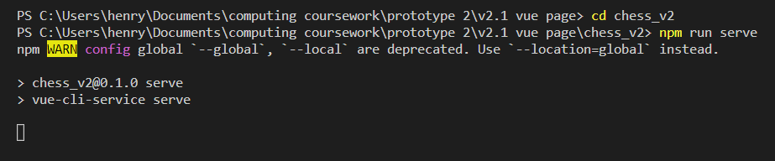

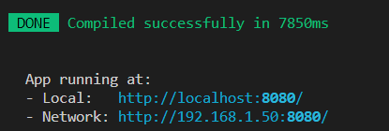

Going to the local host, the webpage is running locally on my computer

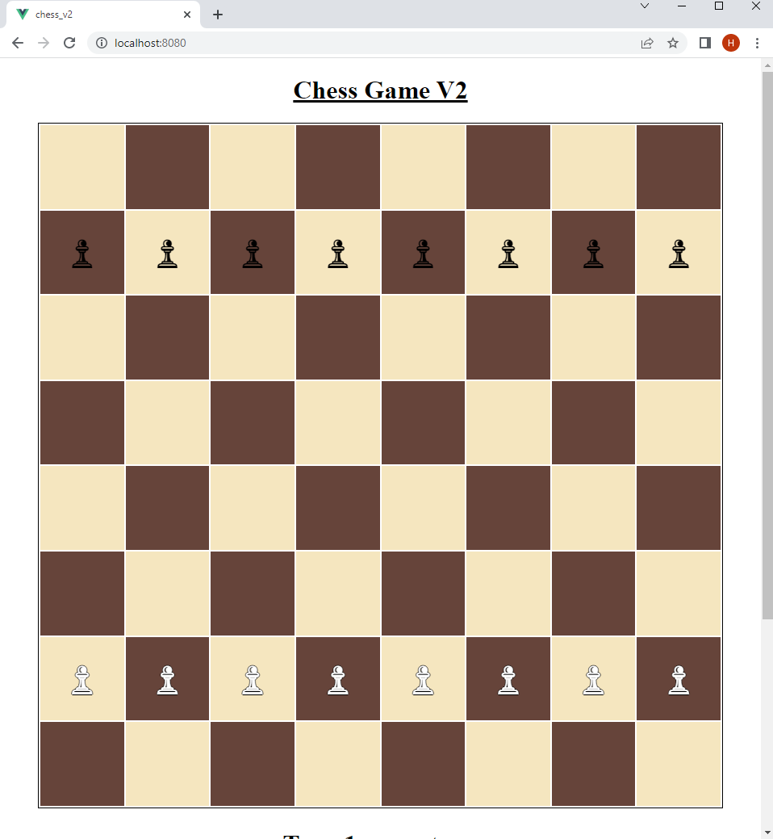

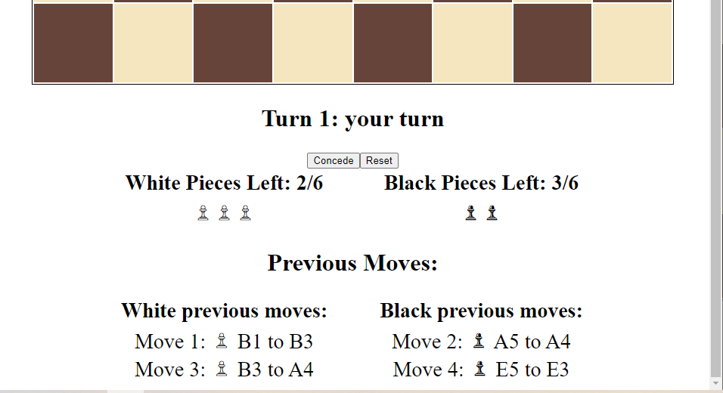

On clicking a square, a message is printed to the console to show that the correct square click is registered

.

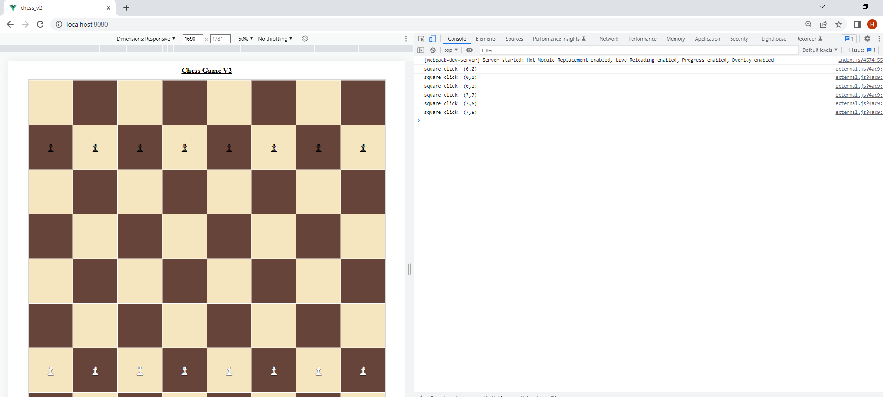

The code for this user interface is below

<template>

    <h1>Chess Game V2</h1>

    <div :style="cssVars" class="chess_board">

        <table>

            <tr v-for="[row_num, row] in board.entries()" :key="row">

                <td v-for="[col_num, square] in row.entries()" :key="square" @click="square_click(row_num, col_num)">

                    <!-- {{row_num}}, {{col_num}} -->

                    <!-- {{square !== null? square: ""}} -->

                    <!-- playing around with white pieces -->

                    <!-- https://stackoverflow.com/questions/4772906/css-is-it-possible-to-add-a-black-outline-around-each-character-in-text -->

                    <span style="color:white; text-shadow: 1px 0 0 #000, 0 -1px 0 #000, 0 1px 0 #000, -1px 0 0 #000;" v-if="square == '♙'">♟</span>

                    <!-- <span style="color:black" v-if="square == '♙'">♙</span> -->

                    <!-- <span style="color:white" v-if="square == '♙'">♙</span> -->

                    <!-- <span style="color:black; text-shadow: 1px 0 0 #000, 0 -1px 0 #000, 0 1px 0 #000, -1px 0 0 #000;" v-else-if="square == '♟'">♟</span> -->

                    <span style="color:black" v-else-if="square == '♟'">♟</span>

                    <!-- <span v-else></span> -->

                </td>

            </tr>

        </table>

    </div>

    <h2>Turn {{turn_num}}: {{next_to_go == 'user'? "your turn": "computer's turn"}}</h2>

    <div class="option_button">

        <button>Concede</button>

        <button>Reset</button>

    </div>

    <div class="pieces_left_table">

        <table>

            <tr>

                <th>White Pieces Left: {{pieces_left.black}}/6</th>

                <th>Black Pieces Left: {{pieces_left.white}}/6</th>

            </tr>

            <tr>

                <td>{{ '♙'.repeat(pieces_left.white) }}</td>

                <td>{{ '♟'.repeat(pieces_left.black) }}</td>

            </tr>

        </table>

    </div>

    <h2>Previous Moves:</h2>

    <div class="previous_moves_table">

        <table>

            <tr>

                <th>White previous moves:</th>

                <th>Black previous moves:</th>

            </tr>

            <tr>

                <td>

                    <div v-for="move in previous_moves" :key="move.num">

                        <span v-if="move.player=='white'">

                            Move {{move.num}}: ♙ {{ move.from }} to {{ move.to }}

                        </span>

                    </div>

                </td>

                <td>

                    <div v-for="move in previous_moves" :key="move.num">

                        <span v-if="move.player=='black'">

                            Move {{move.num}}: ♟ {{ move.from }} to {{ move.to }}

                        </span>

                    </div>

                </td>

            </tr>

        </table>

    </div>

</template>

<script>

    import {handle_square_click} from '@/assets/scripts/external.js'

    // import * from '@/assets/scripts/external.js'

    const white_sq_color = '#f5e6bf';

    const black_sq_color = '#66443a';

    // white pawn: '♙'; black pawn: '♟'

    const pawn_white = '♙';

    const pawn_black = '♟';

    export default {

        name: "ChessGame",

        ready_for_next_move: false,

        // pawn characters

        // https://en.wikipedia.org/wiki/Chess_symbols_in_Unicode

        data(){return{

            board: [

                Array(8).fill(null),

                Array(8).fill(pawn_black),

                Array(8).fill(null),

                Array(8).fill(null),

                Array(8).fill(null),

                Array(8).fill(null),

                Array(8).fill(pawn_white),

                Array(8).fill(null)

            ],

            next_to_go: 'user',

            turn_num: 1,

            pieces_left: {

                black: 2,

                white: 3

            },

            previous_moves: [

                { num: 1, player: "white", from: "B1", to: "B3" },

                { num: 2, player: "black", from: "A5", to: "A4" },

                { num: 3, player: "white", from: "B3", to: "A4" },

                { num: 4, player: "black", from: "E5", to: "E3" },

            ],

        }},

        methods: {

            square_click(row, col) {

                // console.log(`square click: (${row},${col})`)

                handle_square_click(row, col)

            }

        },

        // https://www.telerik.com/blogs/passing-variables-to-css-on-a-vue-component

        computed: {

            cssVars(){return{

                '--black_sq_color': black_sq_color,

                '--white_sq_color': white_sq_color,

            }}

        }

    }

</script>

<style scoped>

    /* :root {

        https://www.vectorstock.com/royalty-free-vector/chess-field-in-beige-and-brown-colors-vector-24923385

        https://imagecolorpicker.com/en

        --black_sq_color: #66443a;

        --white_sq_color: #f5e6bf;

    } */

    h1 {

        text-align: center;

        text-decoration: underline;

    }

    h2 {

        text-align: center;

        font-size: 32px;

    }

    table {

        margin: auto;

        table-layout: fixed;

        text-align: center;

    }

    .option_button {

        margin: auto;

        text-align: center;

        /* margin-left: 0.125vw;

        margin-right: 0.125vw; */

        margin-left: 20px;

        margin-right: 20px;

    }

    .chess_board td {

        height: 10.5vh;

        width: 10.5vh;

        /* dimension so it is all in view for ipad air portrait  (820 * 1180) */

        /* height: 12vw;

        width: 12vw; */

        text-align: center;

        /* border: 3px black solid; */

        font-size: 50px;

        /* font-weight: 100; */

    }

    .chess_board table {

        border: 1px black solid;

    }

    /* these odd and even rules dictate the color of chess board squares */

    .chess_board tr:nth-child(2n-1) > td:nth-child(2n-1) {

    background-color: var(--white_sq_color);

        /* color: black; */

    }

    .chess_board tr:nth-child(2n-1) > td:nth-child(2n) {

        background-color: var(--black_sq_color);

        /* color: white; */

    }

    .chess_board tr:nth-child(2n) > td:nth-child(2n-1) {

        background-color: var(--black_sq_color);

        /* color: white; */

    }

    .chess_board tr:nth-child(2n) > td:nth-child(2n) {

        background-color: var(--white_sq_color);

        /* color: black; */

    }

    .previous_moves_table th, td {

        width: 35vw;

        /* border: 3px solid black; */

        font-size: 28px;

    }

    .pieces_left_table th, td {

        width: 35vw;

        /* border: 3px solid black; */

        font-size: 28px;

    }

</style>

It is not fully finished as the idea of developing a VUE js GUI was shelved.

­

On the one hand there are many benefits to a VUE GUI. Most importantly, the html content is dynamically updated from JavaScript variables. For example the board shown automatically updates with the content of the 2d array board. The main downside however is that the single page nature of a VUE webpage clashed with what I wanted the flask server to do. This is where one single HTTP request is sent and instead multiple pages are handled by JavaScript loading different components. I used this source and decided that I wanted to implement my user interface like this:

<https://www.digitalocean.com/community/tutorials/how-to-add-authentication-to-your-app-with-flask-login>

I then moved on to implementing the backend chess engine in python. I knew that I intended to implement my chess engine using decision trees and specifically the minimax function. This function is suitable as chess is a complete information game as there is not information hidden such as a hand of cards. It is also a zero sum game as one player’s good move worsens another player’s chance of winning. It is also turn based.

To implement minimax I would need 2 functions. A utility function to determine a number for how favourable the current game state is to the maximiser (utility) and a child game state generating function that could provide all possible game states that could be achieved in one move from the current game state.

To implement the utility function I would need a robust game over function and a static evaluation function to provide an approximate guess as to the utility of a board state.

To implement the child game state generating function I will need to have a function to action a move and generate a child game state as well as a function to generate all legal moves of the current game state.

These function would need to be rigorously tested. If they contained logic errors, then the minimax function would fail without and easy way to determine why. However there functions themselves are hard to implement and so they would need to be broken down into simpler function. I clearly would also need to employ some high quality testing in order to produce sufficiently reliable code.

I decided that at its most abstracted, I would be solving this problem with a series objects built on vectors and rules. So I began by creating a vector class. It was sufficiently simple that it didn’t need any major debugging. This would still provide me a good opportunity to get to grips with my unit-test process.

I decided to use a library called data driven tests (ddt) as it would let me write a single function to execute a single type of test, then run this test for every set of test data specified in a given file.

I thought that this would be better that generating the test data and expected outcome withing the test function as this method is more transparent and reduces the risk of logic errors within the tests themselves.

Here was my vector class (**vector.py**)

# import dataclass to reduce boilerplate code

from dataclasses import dataclass

# frozen = true means that the objects will be immutable

@dataclass(frozen=True)

class Vector():

    # 2d vector has properties i and j

    i: int

    j: int

    # code to allow for  +  -  and  *  operators to be used with vectors

    def __add__(self, other):

        assert isinstance(other, Vector), "both objects must be instances of the Vector class"

        return Vector(

            i=self.i + other.i,

            j=self.j + other.j

        )

    def __sub__(self, other):

        assert isinstance(other, Vector), "both objects must be instances of the Vector class"

        return Vector(

            i=self.i - other.i,

            j=self.j - other.j

        )

    def __mul__(self, multiplier: int):

        return Vector(

            i=self.i * multiplier,

            j=self.j * multiplier

        )

    # check if a vector is in board

    def in_board(self):

        """Assumes that the current represented vector is a position vector

        checks if it points to a square that isn't in the chess board"""

        return self.i in range(8) and self.j in range(8)

    # alternative way to create instance, construct from chess square

    @classmethod

    def construct_from_square(cls, to_sqr):

        """Example from and to squares are A3 -> v(0, 2) and to B4 -> v(1, 3)"""

        to_sqr = to_sqr.upper()

        letter, number = to_sqr

        # map letters and numbers to 0 to 7 and create new vector object

        return cls(

            i=ord(letter.upper()) - ord("A"),

            j=int(number)-1

        )

    # this function is the reverse and converts a position vector to a square

    def to_square(self) -> str:

        letter = chr(self.i + ord("A"))

        number = self.j+1

        return f"{letter}{number}"

    # this function checks if 2 vectors are equal

    def __eq__(self, other) -> bool:

        try:

            # assert same subclass like rook

            assert isinstance(other, type(self))

            assert self.i == other.i

            assert self.j == other.j

        except AssertionError:

            return False

        else:

            return True

    # used to put my objects in set

    def __hash__(self):

        return hash((self.i, self.j))

and here were my tests

starting with the python file containing the logic to run the unit tests (**test_vector.py)**

import ddt

import unittest

# from vector.vector import Vector

from vector import Vector

# function for path to vector related test data

def test_path(file_name):

    return f"./test_data/vector/{file_name}.yaml"

# augment my test case class with ddt decorator

@ddt.ddt

class Test_Case(unittest.TestCase):

    # performs many checks of construct form square

    @ddt.file_data(test_path("from_square"))

    def test_square_to_vector(self, square, expected_vector):

        self.assertEqual(

            Vector.construct_from_square(square),

            Vector(*expected_vector),

            msg=f"\nVector.construct_from_square('{square}')  !=  Vector(i={expected_vector[0]}, j={expected_vector[1]})"

        )

    # performs many checks of adding vectors

    @ddt.file_data(test_path("vector_add"))

    def test_add_vectors(self, vector_1, vector_2, expected_vector):

        self.assertEqual(

            Vector(*vector_1) + Vector(*vector_2),

            Vector(*expected_vector),

            msg=f"\nVector(*{vector_1}) + Vector(*{vector_2})  !=  Vector(*{expected_vector})"

        )

    # performs many checks of multiplying vectors

    @ddt.file_data(test_path("vector_multiply"))

    def test_multiply_vectors(self, vector, multiplier, expected):

        self.assertEqual(

            Vector(*vector) * multiplier,

            Vector(*expected)

        )

    # many tests of vector in board

    @ddt.file_data(test_path("vector_in_board"))

    def test_in_board(self, vector, expected):

        self.assertEqual(

            Vector(*vector).in_board(),

            expected,

            msg=f"\nVector(*{vector}).in_board()  !=  {expected}"

        )

    # many tests of vector out of board

    @ddt.file_data(test_path('vector_to_square'))

    def test_to_square(self, vector, expected):

        self.assertEqual(

            Vector(*vector).to_square(),

            expected

        )

if __name__ == '__main__':

    unittest.main()

Here are the test data files:

**from_square.yaml**

test1:

  square: 'G3'

  expected_vector: [6, 2]

test2:

  square: 'A8'

  expected_vector: [0, 7]

test3:

  square: 'H1'

  expected_vector: [7, 0]

test4:

  square: 'C4'

  expected_vector: [2, 3]

test5:

  square: 'F6'

  expected_vector: [5, 5]

# # invalid

# test6:

#   square: 'A5'

#   expected_vector: [5, 5]

**Vector_add.yaml**

test1:

  vector_1: [1, 4]

  vector_2: [4, 6]

  expected_vector: [5, 10]

test2:

  vector_1: [1, 7]

  vector_2: [4, 6]

  expected_vector: [5, 13]

test3:

  vector_1: [1, 3]

  vector_2: [0, 6]

  expected_vector: [1, 9]

test4:

  vector_1: [-1, 32]

  vector_2: [3, 6]

  expected_vector: [2, 38]

test5:

  vector_1: [6, 0]

  vector_2: [6, 7]

  expected_vector: [12, 7]

# # invalid delete me

# test6:

#   vector_1: [6, 0]

#   vector_2: [6, 7]

#   expected_vector: [0, 7]

**Vector_in_board.yaml**

test1:

  vector: [0, 0]

  expected: True

test2:

  vector: [7, 0]

  expected: True

test3:

  vector: [0, 7]

  expected: True

test4:

  vector: [7, 7]

  expected: True

test5:

  vector: [4, 6]

  expected: True

test6:

  vector: [3, 2]

  expected: True

test7:

  vector: [-1, -1]

  expected: False

test8:

  vector: [-5, 4]

  expected: False

test9:

  vector: [8, 7]

  expected: False

test10:

  vector: [-4, 4]

  expected: False

test11:

  vector: [10, 4]

  expected: False

# adding comment inside causes logic error and false pass on test

# # invalid delete me

# test:

#   vector: [4, 6]

#   expected: True

**Vector_multiply.yaml**

test1:

  vector: [1, 1]

  multiplier: 1

  expected: [1, 1]

test2:

  vector: [1, 1]

  multiplier: -1

  expected: [-1, -1]

test3:

  vector: [1, 1]

  multiplier: 5

  expected: [5, 5]

test4:

  vector: [5, 0]

  multiplier: 0

  expected: [0, 0]

**vector_to_square.yaml**

test1:

  vector: [0, 0]

  expected: A1

test2:

  vector: [5, 7]

  expected: F8

test3:

  vector: [6, 2]

  expected: G3

test4:

  vector: [0, 6]

  expected: A7

test5:

  vector: [7, 7]

  expected: H8

as can be seen with the console:

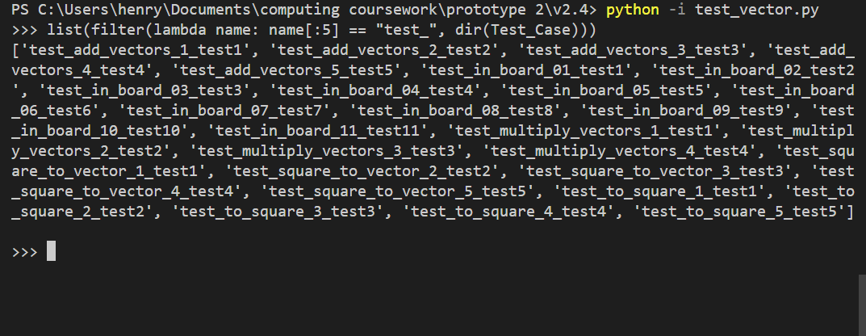

The decorators I added to my tests are unusual as they return many mutations of my original generic function that complete a specific test from my yaml file. This allows me to perform targeted testing

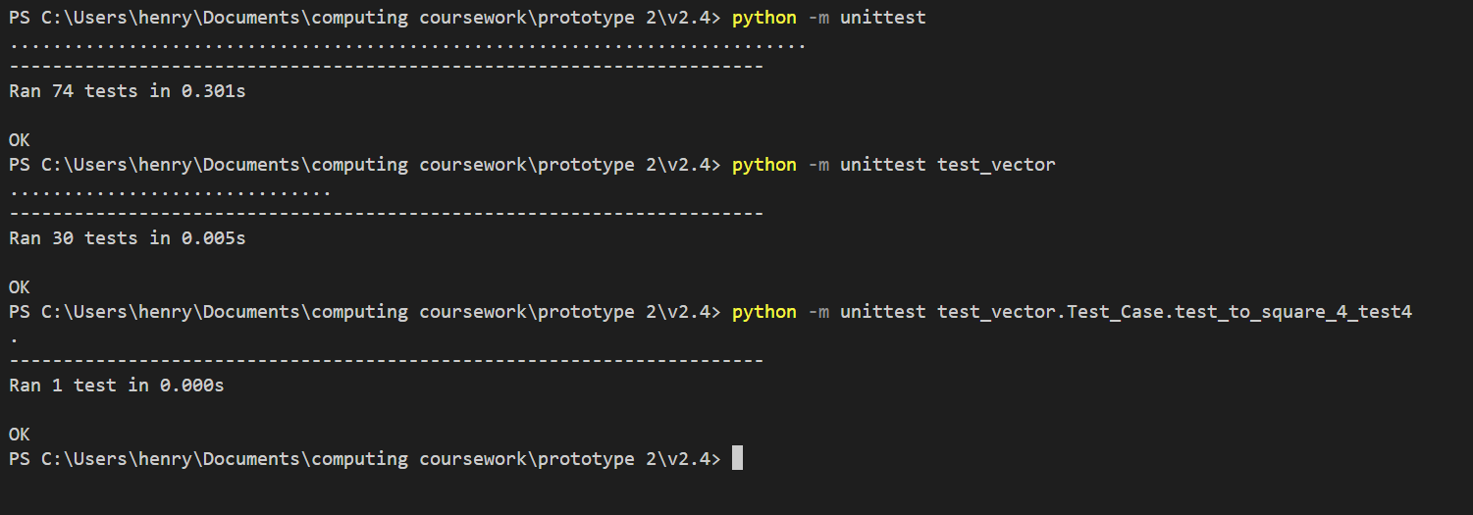

As is shown above, I can run all test, just vector tests or a specific test form a yaml file. I know the tests are working as I can change some of the tests data to create a test that I expect to fail.

For example:

# adding comment inside causes logic error and false pass on test

# invalid delete me

test:

  vector: [4, 6]

  expected: False

I have uncommented out this invalid test in the **vector_in_board.yaml** file

When I run the tests:

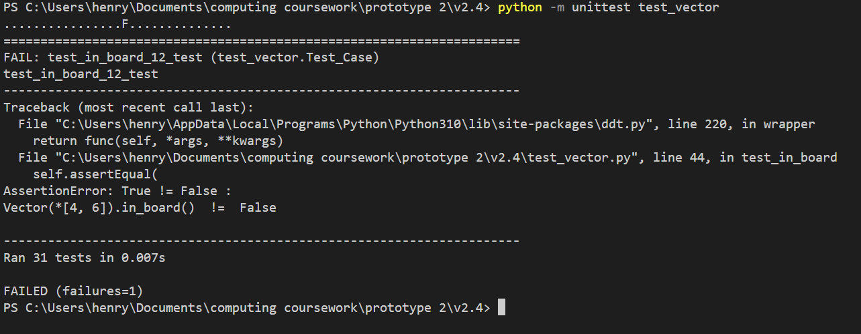

There is a summary of which of the tests fail and a traceback, including a message to help determine why one of the tests failed.

As part of testing my tests in this way I realised that my tests weren’t working. I determined that this was because I had names them all test in my yaml file. To fix this I named them test1, test2, etc.

I think it is important to document tests and code at the same time as they were developed in tandem. I didn’t move to code the next stage until all of my vector unit tests were working. This was valuable as it allowed me to use the vector module with the assumption that it was working perfectly in unit tests and code for later modules that built upon my vectors module.

The next logic to code was the various rules for how pieces could move on a chess board. To do this I created a pieces module.

I wanted to make a class for each piece to describe its value (needed for the utility function) and the ways in which is can move within a chess board. As I knew that some logic would be repeated withing the piece classes I decided to have a parent class piece and a series of child classes that inherit form it. Since I also knew that I would want to do general operations on a set of pieces later on (such as iterate through them for movement vectors or to sum up their value) I decided to use an abstract base class. This ensures that all of the piece classes have some key attributes and methods (they share the same interface). This means that I won’t need to differentiate between pieces and have different logic for each one (with the exception of the king).

I found a series of standard values and matrices for determining addition value based on location within the board on the following website

<https://www.chessprogramming.org/Simplified_Evaluation_Function>

They were not in a useful form (e.g. csv download):

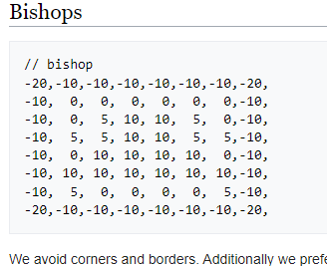

To solve this I used a jupyter notebook to process them

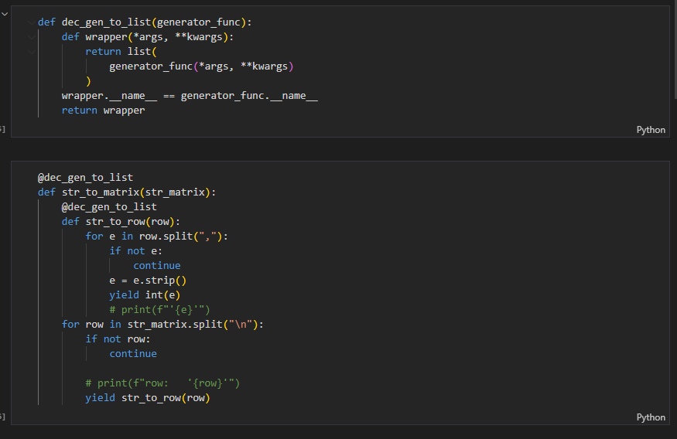

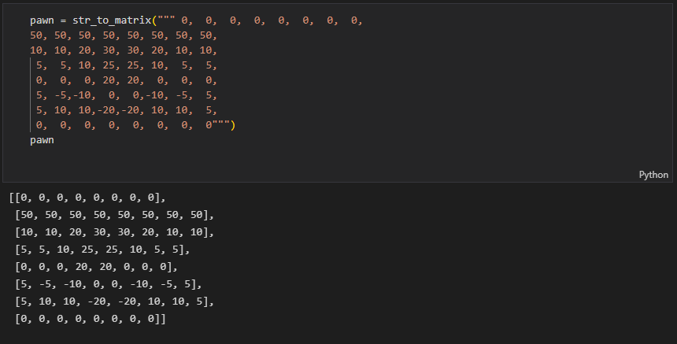

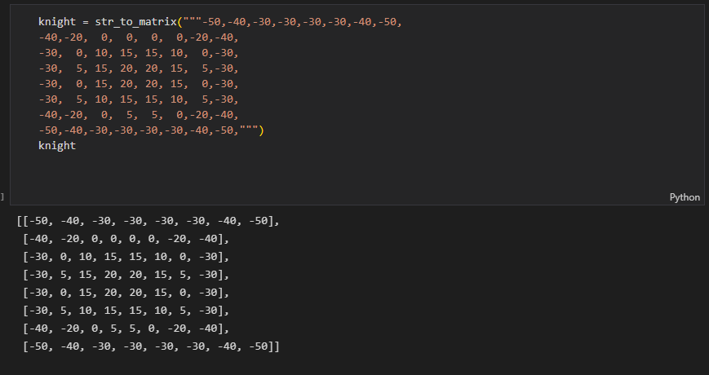(repeat for all pieces)

I then wrote them to a json file for future use.

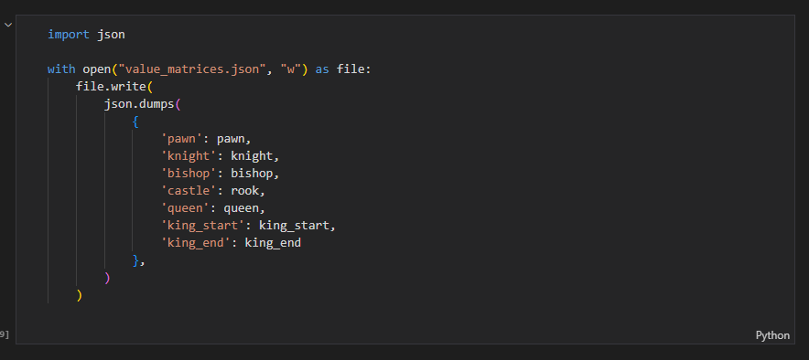

With this strategy for valuing a piece and my testes vector library I created my pieces library

**pieces.py**

# to do: make value and value matrix unchangeable of private

# https://stackoverflow.com/questions/31457855/cant-instantiate-abstract-class-with-abstract-methods

# import libraries and other local modules

import abc

from itertools import chain as iter_chain, product as iter_product

from typing import Callable

from vector import Vector

from assorted import ARBITRARILY_LARGE_VALUE

# Here is an abstract base class for piece,

# it dictates that all child object have the specified abstract attributes else and error will occur

# this ensures that all piece objects have the same interface

class Piece(abc.ABC):

    # required

    # color is public

    color: str | None

    # value and value matrix is protected

    # value is inherent value

    _value: int

    # value matrix is additional value based on location

    _value_matrix: tuple[tuple[float]]

    # must be given before init

    @abc.abstractproperty

    def _value_matrix(): pass

    @abc.abstractproperty

    def _value(): pass

    @abc.abstractproperty

    def color(): pass

    @abc.abstractmethod

    def symbol(self) -> str:

        """uses color to determine the appropriate symbol"""

    # not needed as abstract method as come classes will nor override

    def __init__(self, color):

        self.color = color

        self.last_move = None

    # this should use the position vector and value matrix to get the value of the piece

    def get_value(self, position_vector: Vector):

        # flip if black as matrices are all for white pieces

        if self.color == "W":

            row, column = 7-position_vector.j, position_vector.i

        else:

            row, column = position_vector.j, position_vector.i

        # return sum of inherent value + value relative to position on board

        return self._value + self._value_matrix[row][column]

    # this function should yield all the movement vector that the piece can move by

    # this doesn't account for check and is based on rules specific to each piece as well an checking if a vector is outside the board

    @abc.abstractmethod

    def generate_movement_vectors(self, pieces_matrix, position_vector):

        pass

    # when str(piece) called give the symbol

    def __str__(self):

        # return f"{self.color}{self.symbol}"

        return self.symbol()

    # standard repr method

    def __repr__(self):

        return f"{type(self).__name__}(color='{self.color}')"

    # logic that would be otherwise repeated in many of the child classes

    # determines the contents of a given square

    def square_contains(self, square):

        """returns 'enemy' 'ally' or None for empty"""

        # check if empty

        if square is None:

            return "empty"

        # else the square must contain a piece, so examine its color

        if square.color == self.color:

            return "ally"

        else:

            return "enemy"

    # again reduces repeated logic

    # checks the result of a position vector

    # if not illegal (out of board) the square contents is returned

    def examine_position_vector(self, position_vector: Vector, pieces_matrix):

        """returns 'enemy' 'ally' 'empty' or 'illegal'  """

        # check if the vector is out of the board

        if not position_vector.in_board():

            return 'illegal'

        # for the rest of the code I can assume the vector is in board

        # else get the square at that vector

        row, column = 7-position_vector.j, position_vector.i

        square = pieces_matrix[row][column]

        # examine its contents

        return self.square_contains(square)

    # equality operator

    def __eq__(self, other):

        try:

            # assert same subclass like rook

            assert isinstance(other, type(self))

            assert self.color == other.color

            # i am not checking that pieces had the same last move as I want to compare kings without for the check function

            # assert self.last_move == other.last_move

            # value and value_matrix should never be changes

        except AssertionError:

            return False

        else:

            return True

    # making pieces hashable allows for pieces matrices to be hashed and allows for pieces and pieces matrices to be put in sets,

    # also essential for piping data between python interpreter instances (different threads) for multitasking

    def __hash__(self):

        return hash((self.symbol(), self.color, self.last_move))

# this class inherits from Piece an so it inherits some logic and some requirements as to how its interface should be

# as many child classes are similar I will explain this one in depth and then only explain notable features of others

class Pawn(Piece):

    # defining abstract properties, needed before init

    _value = 100

    _value_matrix: tuple[tuple[float]] = [

        [0, 0, 0, 0, 0, 0, 0, 0],

        [50, 50, 50, 50, 50, 50, 50, 50],

        [10, 10, 20, 30, 30, 20, 10, 10],

        [5, 5, 10, 25, 25, 10, 5, 5],

        [0, 0, 0, 20, 20, 0, 0, 0],

        [5, -5, -10, 0, 0, -10, -5, 5],

        [5, 10, 10, -20, -20, 10, 10, 5],

        [0, 0, 0, 0, 0, 0, 0, 0]

    ]

    color = None

    # define symbol method (str method)

    def symbol(self): return f"{self.color}P"

    # override init constructor

    def __init__(self, color):

        # perform super's instructor

        super().__init__(color)

        # but in addition...

        # decide the vectors that the piece can move now as it is based on color

        multiplier = 1 if color == "W" else -1

        # method defined here as it only used here

        # decided if the pawn is allowed to move foreward 2 based on square contents and last move

        def can_move_foreword_2(square):

            return square is None and self.last_move is None

        # tuple contains pairs of vector and contition that must be met

        # (in the form of a function that takes square and returns a boolean)

        self.movement_vector_and_condition: tuple[Vector, Callable] = (

            # v(0, 1) for foreword

            (Vector(0, multiplier), lambda square: self.square_contains(square) == "empty"),

            # v(0, 2) for foreword as first move

            (Vector(0, 2*multiplier), can_move_foreword_2),

            # v(-1, 1) and v(1, 1) for take

            (Vector(1, multiplier), lambda square: self.square_contains(square) == 'enemy'),

            (Vector(-1, multiplier), lambda square: self.square_contains(square) == 'enemy'),

        )

    # generate movement vectors

    def generate_movement_vectors(self, pieces_matrix, position_vector):

        # iterate through movement vectors and conditions

        for movement_vector, condition in self.movement_vector_and_condition:

            # get resultant vector

            resultant_vector = position_vector + movement_vector

            # if vector_out of range continue

            if not resultant_vector.in_board():

                continue

            # get the contents of the square corresponding to the resultant

            row, column = 7-resultant_vector.j, resultant_vector.i

            piece = pieces_matrix[row][column]

            # if the condition is met, yield the vector

            if condition(piece):

                yield movement_vector

class Knight(Piece):

    _value = 320

    _value_matrix: tuple[tuple[float]] = [

        [-50, -40, -30, -30, -30, -30, -40, -50],

        [-40, -20, 0, 0, 0, 0, -20, -40],

        [-30, 0, 10, 15, 15, 10, 0, -30],

        [-30, 5, 15, 20, 20, 15, 5, -30],

        [-30, 0, 15, 20, 20, 15, 0, -30],

        [-30, 5, 10, 15, 15, 10, 5, -30],

        [-40, -20, 0, 5, 5, 0, -20, -40],

        [-50, -40, -30, -30, -30, -30, -40, -50]

    ]

    color = None

    # n for knight as king takes k

    def symbol(self): return f"{self.color}N"

    def generate_movement_vectors(self, pieces_matrix, position_vector):

        # this function yields all 8 possible vectirs

        def possible_movement_vectors():

            vectors = (Vector(2, 1), Vector(1, 2))

            # for each x multiplier, y multiplier and vector combination

            for i_multiplier, j_multiplier, vector in iter_product((-1, 1), (-1, 1), vectors):

                # yield corresponding vector

                yield Vector(

                    vector.i * i_multiplier,

                    vector.j * j_multiplier

                )

        # iterate through movement vectors

        for movement_vector in possible_movement_vectors():

            # get resultant

            resultant_vector = position_vector + movement_vector

            # look at contents of square

            contents = self.examine_position_vector(position_vector=resultant_vector, pieces_matrix=pieces_matrix)

            # if square is empty yield vector

            if contents == "empty":

                yield movement_vector

class Bishop(Piece):

    _value = 330

    _value_matrix: tuple[tuple[float]] = [

        [-20, -10, -10, -10, -10, -10, -10, -20],

        [-10, 0, 0, 0, 0, 0, 0, -10],

        [-10, 0, 5, 10, 10, 5, 0, -10],

        [-10, 5, 5, 10, 10, 5, 5, -10],

        [-10, 0, 10, 10, 10, 10, 0, -10],

        [-10, 10, 10, 10, 10, 10, 10, -10],

        [-10, 5, 0, 0, 0, 0, 5, -10],

        [-20, -10, -10, -10, -10, -10, -10, -20]

    ]

    color = None

    def symbol(self): return f"{self.color}B"

    def generate_movement_vectors(self, pieces_matrix, position_vector):

        # sourcery skip: use-itertools-product

        # repeat for all 4 vector directions

        for i, j in iter_product((1, -1), (1, -1)):

            unit_vector = Vector(i, j)

            # iterate through length multipliers

            for multiplier in range(1, 8):

                # get movement and resultant vectors

                movement_vector = unit_vector * multiplier

                resultant_vector = position_vector + movement_vector

                # examine the contents of the square and use switch case to decide behaviour

                match self.examine_position_vector(position_vector=resultant_vector, pieces_matrix=pieces_matrix):

                    case 'illegal':

                        # if vector extends out of the board stop extending

                        break

                    case 'ally':

                        # break of of for loop (not just match case)

                        # as cannot hop over piece so don't explore longer vectors in same direction

                        break

                    case 'enemy':

                        # this is a valid move

                        yield movement_vector

                        # break of of for loop (not just match case)

                        # as cannot hop over piece so don't explore longer vectors in same direction

                        break

                    case 'empty':

                        # is valid

                        yield movement_vector

                        # and keep exploring, don't break

class Rook(Piece):

    _value = 500

    _value_matrix: tuple[tuple[float]] = [

        [0, 0, 0, 0, 0, 0, 0, 0],

        [5, 10, 10, 10, 10, 10, 10, 5],

        [-5, 0, 0, 0, 0, 0, 0, -5],

        [-5, 0, 0, 0, 0, 0, 0, -5],

        [-5, 0, 0, 0, 0, 0, 0, -5],

        [-5, 0, 0, 0, 0, 0, 0, -5],

        [-5, 0, 0, 0, 0, 0, 0, -5],

        [0, 0, 0, 5, 5, 0, 0, 0]

    ]

    color = None

    # r for rook

    def symbol(self): return f"{self.color}R"

    # this code is very similar in structure to that of a bishop just with different direction vectors

    def generate_movement_vectors(self, pieces_matrix, position_vector):

        # sourcery skip: use-itertools-product

        unit_vectors = (

            Vector(0, 1),

            Vector(0, -1),

            Vector(1, 0),

            Vector(-1, 0),

        )

        # for unit_vector, multiplier in iter_product(unit_vectors, range(1, 8)):

        for unit_vector in unit_vectors:

            for multiplier in range(1, 8):

                movement_vector = unit_vector * multiplier

                resultant_vector = position_vector + movement_vector

                # note cases that contain only break are not redundant, they break the outer for loop

                match self.examine_position_vector(position_vector=resultant_vector, pieces_matrix=pieces_matrix):

                    case 'illegal':

                        # if vector extends out of the board stop extending

                        break

                    case 'ally':

                        # break of of for loop (not just match case)

                        # as cannot hop over piece so don't explore longer vectors in same direction

                        break

                    case 'enemy':

                        # this is a valid move

                        yield movement_vector

                        # break of of for loop (not just match case)

                        # as cannot hop over piece so don't explore longer vectors in same direction

                        break

                    case 'empty':

                        # is valid

                        yield movement_vector

                        # and keep exploring, don't break

class Queen(Piece):

    _value = 900

    _value_matrix: tuple[tuple[float]] = [

        [-20, -10, -10, -5, -5, -10, -10, -20],

        [-10, 0, 0, 0, 0, 0, 0, -10],

        [-10, 0, 5, 5, 5, 5, 0, -10],

        [-5, 0, 5, 5, 5, 5, 0, -5],

        [0, 0, 5, 5, 5, 5, 0, -5],

        [-10, 5, 5, 5, 5, 5, 0, -10],

        [-10, 0, 5, 0, 0, 0, 0, -10],

        [-20, -10, -10, -5, -5, -10, -10, -20]

    ]

    color = None

    def symbol(self): return f"{self.color}Q"

    # this code also uses a similar structure to the rook or bishop

    def generate_movement_vectors(self, pieces_matrix, position_vector):

        # unit_vectors = (Vector(i, j) for i, j in iter_product((-1, 0, 1), (-1, 0, 1)) if i != 0 and j != 0)

        unit_vectors = (Vector(i, j) for i, j in iter_product((-1, 0, 1), (-1, 0, 1)) if i != 0 or j != 0)

        # for unit_vector, multiplier in iter_product(unit_vectors, range(1, 8)):

        for unit_vector in unit_vectors:

            for multiplier in range(1, 8):

                movement_vector = unit_vector * multiplier

                resultant_vector = position_vector + movement_vector

                match self.examine_position_vector(position_vector=resultant_vector, pieces_matrix=pieces_matrix):

                    case 'illegal':

                        # if vector extends out of the board stop extending

                        break

                    case 'ally':

                        # break of of for loop (not just match case)

                        # as cannot hop over piece so don't explore longer vectors in same direction

                        break

                    case 'enemy':

                        # this is a valid move

                        yield movement_vector

                        # break of of for loop (not just match case)

                        # as cannot hop over piece so don't explore longer vectors in same direction

                        break

                    case 'empty':

                        # is valid

                        yield movement_vector

                        # and keep exploring, don't break

class King(Piece):

    # not needed as static eval does't add up kings value

    _value = ARBITRARILY_LARGE_VALUE

    # there are 2 matrices to represent the early and late game for the king

    value_matrix_early: tuple[tuple[float]] = [

        [-30, -40, -40, -50, -50, -40, -40, -30],

        [-30, -40, -40, -50, -50, -40, -40, -30],

        [-30, -40, -40, -50, -50, -40, -40, -30],

        [-30, -40, -40, -50, -50, -40, -40, -30],

        [-20, -30, -30, -40, -40, -30, -30, -20],

        [-10, -20, -20, -20, -20, -20, -20, -10],

        [20, 20, 0, 0, 0, 0, 20, 20],

        [20, 30, 10, 0, 0, 10, 30, 20]

    ]

    value_matrix_late = [

        [-50, -40, -30, -20, -20, -30, -40, -50],

        [-30, -20, -10, 0, 0, -10, -20, -30],

        [-30, -10, 20, 30, 30, 20, -10, -30],

        [-30, -10, 30, 40, 40, 30, -10, -30],

        [-30, -10, 30, 40, 40, 30, -10, -30],

        [-30, -10, 20, 30, 30, 20, -10, -30],

        [-30, -30, 0, 0, 0, 0, -30, -30],

        [-50, -30, -30, -30, -30, -30, -30, -50]

    ]

    color = None

    # initially value matrix is the early one

    _value_matrix: tuple[tuple[float]] = value_matrix_early

    # def __init__(self, *args, **kwargs):

    #     self._value_matrix = self.value_matrix_early

    #     super().__init__(self, *args, **kwargs)

    def symbol(self): return f"{self.color}K"

    # based on total pieces, changes the value matrix

    def update_value_matrix(self, pieces_matrix):

        # counts each empty square as 0 and each full one as 1 then sums them up to get total pieces

        # if total pieces less than or equal to 10: then late game

        if sum(int(isinstance(square, Piece)) for square in iter_chain(pieces_matrix)) <= 10:

            self.value_matrix = self.value_matrix_late

        # else early game

        else:

            self.value_matrix = self.value_matrix_early

    # this generates the movement vectors for the king

    def generate_movement_vectors(self, pieces_matrix, position_vector):

        # take the opportunity to update the value matrix

        self.update_value_matrix(pieces_matrix)

        # all 8 movement vectors

        unit_vectors = (Vector(i, j) for i, j in iter_product((-1, 0, 1), (-1, 0, 1)) if i != 0 or j != 0)

        # for each movement vector, get the resultant vector

        for movement_vector in unit_vectors:

            resultant_vector = position_vector + movement_vector

            # examine contents of square and use switch case to decide behaviour

            match self.examine_position_vector(position_vector=resultant_vector, pieces_matrix=pieces_matrix):

                case 'illegal':

                    continue

                case 'ally':

                    continue

                case 'enemy':

                    # this is a valid move

                    yield movement_vector

                case 'empty':

                    # is valid

                    yield movement_vector

# used by other modules to convert symbol to piece

PIECE_TYPES = {

    'P': Pawn,

    'N': Knight,

    'B': Bishop,

    'R': Rook,

    'K': King,

    'Q': Queen

}

# if __name__ == '__main__':

# ensures that all classes are valid (not missing any abstract properties) whenever the module is imported

Pawn('W')

Knight('W')

Bishop('W')

Rook('W')

Queen('W')

King('W')

I can remove one of the required abstract methods form the Rook class to show you the error this causes.

Change

    # # r for rook

    # def symbol(self): return f"{self.color}R"

Result

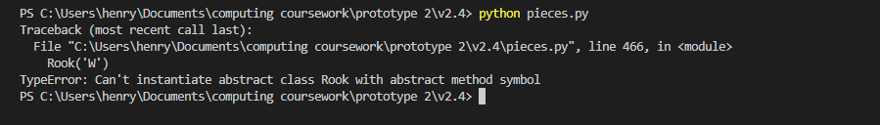

This behaviour is valid as it means that, if I am sure that a variable contains an object of type Piece, not matter which piece, I can be sure that the interface will be the same (e.g. I can assume they all have a symbol method).

For the King class I gave it a value which is arbitrarily high. This comes from a file called **assorted.py**

# this file is just a file of short assorted constants and functions that are general in use

# It only contains small functions as I have tried to group large, similar functions logically in there own file

# this is used in the static evaluation and minimax process. It is used to represent infinity in a way that still allows comparrison

ARBITRARILY_LARGE_VALUE = 1_000_000

# this function is relatively redundant but allows for print statements in debugging

# in later iteration this may be replaced with logging.

# it is useful as it allows for DEBUG print statements without needing to remove them when finished

DEBUG = True

def dev_print(*args, **kwargs):

    if DEBUG:

        print(*args, **kwargs)

# this is an exception that allows for the game data to be bound to it

# this allows for the relevant chess game that caused the error to be examined afterwards

# it is a normal exception except the constructor has been modified to save the game data as a property

class __ChessExceptionTemplate__(Exception):

    def __init__(self, *args, **kwargs) -> None:

        # none if key not present

        self.game = kwargs.pop("game", None)

        super().__init__(*args, **kwargs)

# these are custom exceptions.

# they contain no logic but have distinct types allowing for targeted error handling

class InvalidMove(__ChessExceptionTemplate__):

    pass

class NotUserTurn(__ChessExceptionTemplate__):

    pass

The kings inherent value isn’t relevant as both players will always have a king and so the value will always cancel out. I also used 2 value matrices for the king. I determined that the late game is when there are 10 or less total pieces though this is arbitrary.

The testing for the pieces module was as follows:

**Test_pieces.py**

import unittest

import ddt

import pieces

# as vector is already tested we can use it here and assume it won't cause any logic errors

from vector import Vector

def test_dir(file_name): return f"test_data/pieces/{file_name}.yaml"

EMPTY_PIECES_MATRIX = ((None,)*8,)*8

@ddt.ddt

class Test_Case(unittest.TestCase):

    # this test is based on testing the the movement vectors of a piece places at some position in an empty board are as expected

    @ddt.file_data(test_dir('test_empty_board'))

    def test_empty_board(self, piece_type, square, expected_move_squares):

        # deserialize

        position_vector = Vector.construct_from_square(square)

        piece: pieces.Piece = pieces.PIECE_TYPES[piece_type]('W')

        movement_vectors = piece.generate_movement_vectors(pieces_matrix=EMPTY_PIECES_MATRIX, position_vector=position_vector)

        resultant_squares = list(

            map(

                lambda movement_vector: (movement_vector+position_vector).to_square(),

                movement_vectors

            )

        )

        # assert as expected

        # can use sets to prevent order being an issue as vectors are hashable

        self.assertEqual(

            set(resultant_squares),

            set(expected_move_squares),

            msg=f"\n\nactual movement squares {sorted(resultant_squares)}  !=  expected movement squares {sorted(expected_move_squares)}\n{repr(piece)} at {square}"

        )

    # this test assert that that a pieces movement vectors are as expected when the piece is surrounded by other pieces

    @ddt.file_data(test_dir('test_board_populated'))

    def test_board_populated(self, pieces_matrix, square, expected_piece_symbol, expected_move_squares):

        # deserialize

        def list_map(function, iterable): return list(map(function, iterable))

        def descriptor_to_piece(descriptor) -> pieces.Piece:

            # converts WN to knight object with a color attribute of white

            if descriptor is None:

                return None

            color, symbol  = descriptor

            piece_type: pieces.Piece = pieces.PIECE_TYPES[symbol]

            return piece_type(color=color)

        def row_of_symbols_to_pieces(row): return list_map(descriptor_to_piece, row)

        # update pieces_matrix replacing piece descriptors to piece objects

        pieces_matrix = list_map(row_of_symbols_to_pieces, pieces_matrix)

        position_vector = Vector.construct_from_square(square)

        row, column = 7-position_vector.j, position_vector.i

        # assert piece as expected

        piece: pieces.Piece = pieces_matrix[row][column]

        self.assertEqual(

            piece.symbol(),

            expected_piece_symbol,

            msg=f"\nPiece at square {square} was not the expected piece"

        )

        # assert movement vectors as expected

        movement_vectors = piece.generate_movement_vectors(pieces_matrix=pieces_matrix, position_vector=position_vector)

        resultant_squares = list(

            map(

                lambda movement_vector: (movement_vector+position_vector).to_square(),

                movement_vectors

            )

        )

        self.assertEqual(

            set(resultant_squares),

            set(expected_move_squares),

                msg=f"\n\nactual movement squares {sorted(resultant_squares)}  !=  expected movement squares {sorted(expected_move_squares)}\n{repr(piece)} at {square}"

        )

if __name__ == '__main__':

    unittest.main()

**test_board_populated.yaml**

test1:

  pieces_matrix: [

    [null, null, null, null, null, null, null, null],

    [null, null, null, null, null, null, null, null],

    [null, null, null, null, null, null, null, null],

    [null, null, null, null, null, null, null, null],

    [null, null, null, null, null, null, null, null],

    [null, null, null, null, null, null, null, null],

    [BP,   null, BP,   null, null, null, null, null],

    [null, WP,   null, null, null, null, null, null]

  ]

  square: B1

  expected_piece_symbol: WP

  expected_move_squares: [

    A2, C2, B2, B3

  ]

test2:

  pieces_matrix: [

    [null, null, null, null, null, null, null, null],

    [null, null, null, null, null, null, null, null],

    [null, null, null, BP,   null, null, null, null],

    [null, null, null, null, BR,   null, null, null],

    [null, BR,   null, BQ,   null, null, WB,   null],

    [null, null, BP,   null, null, null, BP,   null],

    [null, WR,   null, null, null, null, null, null],

    [null, null, null, null, null, null, null, null]

  ]

  square: D4

  expected_piece_symbol: BQ

  expected_move_squares: [

    D5,

    E4, F4, G4,

    E3, F2, G1,

    D3, D2, D1,

    C4,

    C5, B6, A7

  ]

test3:

  pieces_matrix: [

    [null, null, null, null, null, null, null, null],

    [null, null, null, null, null, null, null, null],

    [null, null, null, BP,   null, null, null, null],

    [null, null, null, null, BR,   null, null, null],

    [null, BR,   null, BR,   null, null, WB,   null],

    [null, null, BP,   null, null, null, BP,   null],

    [null, WR,   null, null, null, null, null, null],

    [null, null, null, null, null, null, null, null]

  ]

  square: D4

  expected_piece_symbol: BR

  expected_move_squares: [

    D5,

    E4, F4, G4,

    D3, D2, D1,

    C4,

  ]

test4:

  pieces_matrix: [

    [null, null, null, null, null, null, null, null],

    [null, null, null, BP, null, null, null, null],

    [null, null, WP, null, WP, null, null, null],

    [null, null, null, null, null, null, null, null],

    [null, null, null, null, null, null, null, null],

    [null, null, null, null, null, null, null, null],

    [null, null, null, null, null, null, null, null],

    [null, null, null, null, null, null, null, null]

  ]

  square: D7

  expected_piece_symbol: BP

  expected_move_squares: [

    D6, D5,

    C6, E6

  ]

test5:

  pieces_matrix: [

    [null, null, null, BK, null, null, null, null],

    [null, null, null, WP, null, null, null, null],

    [null, null, null, WK, null, null, null, null],

    [null, null, null, null, null, null, null, null],

    [null, null, null, null, null, null, null, null],

    [null, null, null, null, null, null, null, null],

    [null, null, null, null, null, null, null, null],

    [null, null, null, null, null, null, null, null],

  ]

  square: D8

  expected_piece_symbol: BK

  expected_move_squares: [

    C7, D7, E7,

    C8, E8

  ]

test6:

  pieces_matrix: [

    [BR,   BK,   BB,   BK,   BQ,   BB,   BK,   BR  ],

    [BP,   BP,   BP,   BP,   BP,   BP,   BP,   BP  ],

    [null, null, null, null, null, null, null, null],

    [null, null, null, null, null, null, null, null],

    [null, null, null, null, null, null, null, null],

    [null, null, null, null, null, null, null, null],

    [WP,   WP,   WP,   WP,   WP,   WP,   WP,   WP  ],

    [WR,   WN,   WB,   WK,   WQ,   WB,   WN,   WR  ]

  ]

  square: B1

  expected_piece_symbol: WN

  expected_move_squares: [A3, C3]

test7:

  pieces_matrix: [

    [BR,   BN,   BB,   BK,   BQ,   BB,   BN,   BR  ],

    [BP,   BP,   BP,   BP,   BP,   BP,   BP,   BP  ],

    [null, null, null, null, null, null, null, null],

    [null, null, null, null, null, null, null, null],

    [null, null, null, null, null, null, null, null],

    [null, null, null, null, null, null, null, null],

    [WP,   WP,   WP,   WP,   WP,   WP,   WP,   WP  ],

    [WR,   WN,   WB,   WK,   WQ,   WB,   WN,   WR  ]

  ]

  square: G1

  expected_piece_symbol: WN

  expected_move_squares: [F3, H3]

**test_empty_board.yaml**

test1:

  piece_type: 'N'

  square: E4

  expected_move_squares: [

    D2, F2, D6, F6, C5, C3, G5, G3

  ]

test2:

  piece_type: Q

  square: C3

  expected_move_squares: [

    A1, B2, D4, E5, F6, G7, H8,

    C1, C2, C4, C5, C6, C7, C8,

    A3, B3, D3, E3, F3, G3, H3,

    A5, B4, D2, E1

  ]

test3:

  piece_type: K

  square: B2

  expected_move_squares: [

    C1, C2, C3,

    B1, B3,

    A1, A2, A3,

  ]

test4:

  piece_type: P

  square: E3

  expected_move_squares: [

    E4, E5

  ]

test5:

  piece_type: R

  square: F6

  expected_move_squares: [

    F1, F2, F3, F4, F5, F7, F8,

    A6, B6, C6, D6, E6, G6, H6

  ]

test6:

  piece_type: B

  square: D7

  expected_move_squares: [

    C8, E6, F5, G4, H3,

    E8, C6, B5, A4,

  ]

test7:

  piece_type: K

  square: D8

  expected_move_squares: [

    C7, D7, E7,

    C8, E8

  ]

These tests are explained by the comments. They focus on testing the movement of the pieces (needed for the legal moves function).

This sub problem of deciding where a piece could move was made easier by abstracting away complications such as how check affects the legal moves. This additional logic will be added on by later modules that will rely on the pieces module. I wrote the tests as I coded the pieces module and so I was able to detect and fix issues as I developed the module until and the tests needed had been written and were working.

Evidence:

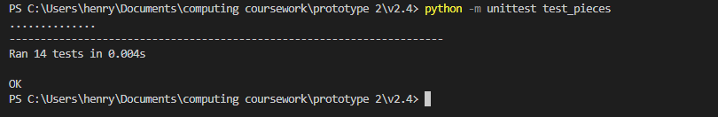

There was, in hind sight a flaw with my testing of this module which I will get to later (mirroring where I was in my development journey when I discovered it).

Next I created a board state class. This class was to be responsible for keeping track of a single board state: a snapshot in the whole game. It would include a utility function, a move executer function and a generate legal moves function. It would be immutable. This was because I knew that the minimax function would want to make many different combinations of moves on a given board state without irreversibly mutating the object or needing to make a deep copy.

Here is the class I came up with:

**Board_state.py**

from copy import deepcopy

from dataclasses import dataclass

from itertools import product as iter_product

import pieces as pieces_mod

from assorted import ARBITRARILY_LARGE_VALUE

from vector import Vector

# this is a pieces matrix for the starting position is chess

# white is at the bottom as it is from the user's perspective and I am currently assuming the user is white.

# I can change this in the frontend later

STARTING_POSITIONS: tuple[tuple[pieces_mod.Piece]] = (

    (

        pieces_mod.Rook(color="B"),

        pieces_mod.Knight(color="B"),

        pieces_mod.Bishop(color="B"),

        pieces_mod.Queen(color="B"),

        pieces_mod.King(color="B"),

        pieces_mod.Bishop(color="B"),

        pieces_mod.Knight(color="B"),

        pieces_mod.Rook(color="B")

    ),

    (pieces_mod.Pawn(color="B"),)*8,

    (None,)*8,

    (None,)*8,

    (None,)*8,

    (None,)*8,

    (pieces_mod.Pawn(color="W"),)*8,

    (

        pieces_mod.Rook(color="W"),

        pieces_mod.Knight(color="W"),

        pieces_mod.Bishop(color="W"),

        pieces_mod.Queen(color="W"),

        pieces_mod.King(color="W"),

        pieces_mod.Bishop(color="W"),

        pieces_mod.Knight(color="W"),

        pieces_mod.Rook(color="W")

    )

)

# frozen makes each instance of the board_state class is immutable

@dataclass(frozen=True)

class Board_State():

    next_to_go: str = "W"

    # the pieces matrix keeps track of the board positions and the pieces

    pieces_matrix: tuple[tuple[pieces_mod.Piece]] = STARTING_POSITIONS

    # this function outputs the board in a user friendly way

    # 8| BR  BN  BB  BQ  BK  BB  BN  BR

    # 7| ·   ·   BP  BP  BP  BP  BP  BP

    # 6| ·   ·   ·   ·   ·   ·   ·   ·

    # 5| BP  BP  ·   ·   ·   ·   ·   ·

    # 4| ·   ·   ·   WP  ·   WP  ·   ·

    # 3| ·   ·   ·   ·   ·   ·   ·   ·

    # 2| WP  WP  WP  ·   WP  ·   WP  WP

    # 1| WR  WN  WB  WQ  WK  WB  WN  WR

    #   (A   B   C   D   E   F   G   H )

    def print_board(self):

        # convert each piece to a symbol BP and replace none with dots

        # add numbers to left and add letters at the bottom

        numbers = range(8, 0, -1)

        letters = [chr(i) for i in range(ord("A"), ord("H")+1)]

        for row, number in zip(self.pieces_matrix, numbers):

            # clean up row of pieces

            symbols_row = map(lambda piece: piece.symbol() if piece else "· ", row)

            pretty_row = f"{number}| {'  '.join(symbols_row)}"

            print(pretty_row)

        print(f"  ({'   '.join(letters)} )")

    def get_piece_at_vector(self, vector: Vector):

        # this function exists as it is a really common operation.

        # due to vector 0, 0 pointing the the bottom left not top left of the 2d array,

        # some correction is needed

        column, row = vector.i, 7-vector.j

        return self.pieces_matrix[row][column]

    # this function should yield all the pieces on the board

    def generate_all_pieces(self):

        # nested loop for i and j to iterate through all possible vectors

        for i, j in iter_product(range(8), range(8)):

            position_vector = Vector(i,j)

            # get the contents of the corresponding square

            piece = self.get_piece_at_vector(position_vector)

            # skip if none: skip if square empty

            if piece:

                yield piece, position_vector

    # this yields all pieces of a given color:

    # used when examining legal moves of a given player

    def generate_pieces_of_color(self, color=None):

        # be default give pieces of player next to go

        if color is None:

            color = self.next_to_go

        # return all piece and position vector pairs

        # filtered by piece must match in color

        yield from filter(

            # lambda piece, _: piece.color == color,

            lambda piece_and_vector: piece_and_vector[0].color == color,

            self.generate_all_pieces()

        )

    # determines if a given player is in check based on the player's color

    def color_in_check(self, color=None):

        # default is to check if the player next to go is in check

        if color is None:

            color = self.next_to_go

        # let is now be A's turn

        # I use this player a and b model to keep track of the logic here

        color_a = color

        color_b = "W" if color == "B" else "B"

        # we will examine all the movement vectors of B's pieces

        # if any of them could take the A's King then currently A is in check as their king is threatened by 1 or more pieces (which could take it next turn)

        # for each of b's pieces

        for piece, position_v in self.generate_pieces_of_color(color=color_b):

            movement_vs = piece.generate_movement_vectors(

                pieces_matrix=self.pieces_matrix,

                position_vector=position_v

            )

            # for each movement vector that the piece could make

            for movement_v in movement_vs:

                resultant = position_v + movement_v

                # check the contents of the square

                to_square = self.get_piece_at_vector(resultant)

                # As_move_threatens_king_A = isinstance(to_square, pieces_mod.King) and to_square.color == color_a

                # if the contents is A's king then the a is in check.

                As_move_threatens_king_A = (to_square == pieces_mod.King(color=color_a))

                # if As_move_threatens_king_A then return true

                if As_move_threatens_king_A:

                    return True

        # if none of B's pieces were threatening to take A's king then A isn't in check

        return False

    # this function is a generator to be iterated through.

    # it is responsible for yielding every possible move that a given player can make

    # yields this as a position and a movement vector

    def generate_legal_moves(self):

        # iterate through all pieces belonging to player next to go

        for piece, piece_position_vector in self.generate_pieces_of_color(color=self.next_to_go):

            movement_vectors = piece.generate_movement_vectors(

                pieces_matrix=self.pieces_matrix,

                position_vector=piece_position_vector

            )

            # iterate through movement vectors of this piece

            for movement_vector in movement_vectors:

                # examine resulting child game state

                child_game_state = self.make_move(from_position_vector=piece_position_vector, movement_vector=movement_vector)

                # determine if current player next to go (different to next to go of child game state) is in check

                is_check_after_move = child_game_state.color_in_check(color=self.next_to_go)

                # only yield the move if it doesn't result in check

                if not is_check_after_move:

                    yield piece_position_vector, movement_vector

    # determines if the game is over

    # returns over, winner

    def is_game_over_for_next_to_go(self):

        # sourcery skip: remove-unnecessary-else, swap-if-else-branches

        # in all cases, the game if over if a player has no legal moves left

        if not list(self.generate_legal_moves()):

            # if b in check

            if self.color_in_check():

                # checkmate for b, a wins

                winner = "W" if self.next_to_go == "B" else "B"

                return True, winner

            else:

                # stalemate

                return True, None

        # game not over

        return False, None

    # this function if responsible for generating a static evaluation for a given board-stat

    # it should be used by a maximiser or minimiser

    # starting position should have and evaluation of 0

    def static_evaluation(self):

        # if over give an appropriate score for win loss or draw

        over, winner = self.is_game_over_for_next_to_go()

        if over:

            match winner:

                case None: multiplier = 0

                case "W": multiplier = 1

                case "B": multiplier = -1

            # return winner * ARBITRARILY_LARGE_VALUE

            return multiplier * ARBITRARILY_LARGE_VALUE

        # this function takes a piece as an argument and uses its color to decide if its value should be positive or negative

        def get_piece_value(piece: pieces_mod.Piece, position_vector: Vector):

            # this function assumes white it maximizer and so white pieces have a positive score and black negative

            match piece.color:

                case "W": multiplier = 1

                case "B": multiplier = (-1)

            value = multiplier * piece.get_value(position_vector)

            # print(f"{piece.symbol()} at {position_vector.to_square} has value {value}")

            return value

        # for each piece, get the value (+/-)

        values = map(

            lambda x: get_piece_value(*x),

            self.generate_all_pieces()

        )

        # sum values for static eval

        return sum(values)

    def make_move(self, from_position_vector: Vector, movement_vector: Vector):

        resultant_vector = from_position_vector + movement_vector

        # make a coppy of the position vector, deep coppy is used to ensure no parts are shared be reference

        new_pieces_matrix = deepcopy(self.pieces_matrix)

        # convert to list

        new_pieces_matrix = list(map(list, new_pieces_matrix))

        # look at square with position vecotor

        row, col = 7-from_position_vector.j, from_position_vector.i

        # get piece thats moving

        piece: pieces_mod.Piece = new_pieces_matrix[row][col]

        # set from square to blank

        new_pieces_matrix[row][col] = None

        # update piece to keep track of its last move

        piece.last_move = movement_vector

        # set to square to this piece

        row, col = 7-resultant_vector.j, resultant_vector.i

        new_pieces_matrix[row][col] = piece

        # convert back to tuple

        new_pieces_matrix = tuple(map(tuple, new_pieces_matrix))

        # update next to go

        new_next_to_go = "W" if self.next_to_go == "B" else "B"

        # return new board state instance

        return Board_State(

            next_to_go=new_next_to_go,

            pieces_matrix=new_pieces_matrix

        )

I wrote the functions and tested them in the order of dependency.

Starting with:

* Get_piece_at_vecotor as it had not dependency to other functions

Then in order

* Generate_all_pieces
* Generate_pieces_of_color
* Color_in_check
* Generate_legal_moves
* Game_over
* Static_Evaluation

I had a significant issue in testing this module, specifically the generate legal moves function and the static evaluation function. I will show all the testing code and data and then explain the issue.

**Test_board_state.py**

import unittest

import ddt

from board_state import Board_State

# tested so assumed correct

import pieces

from vector import Vector

def test_dir(file_name): return f"test_data/board_state/{file_name}.yaml"

# code used to deserialize

# code repeated from test pieces, opportunity to reduce redundancy

def list_map(function, iterable): return list(map(function, iterable))

def tuple_map(function, iterable): return tuple(map(function, iterable))

def descriptor_to_piece(descriptor) -> pieces.Piece:

    # converts WN to knight object with a color attribute of white

    if descriptor is None:

        return None

    color, symbol = descriptor

    piece_type: pieces.Piece = pieces.PIECE_TYPES[symbol]

    return piece_type(color=color)

def deserialize_pieces_matrix(pieces_matrix, next_to_go="W") -> Board_State:

    def row_of_symbols_to_pieces(row):

        return list_map(descriptor_to_piece, row)

    # update pieces_matrix replacing piece descriptors to piece objects

    pieces_matrix = list_map(row_of_symbols_to_pieces, pieces_matrix)

    board_state: Board_State = Board_State(pieces_matrix=pieces_matrix, next_to_go=next_to_go)

    return board_state

@ddt.ddt

class Test_Case(unittest.TestCase):

    # this test isn't data driven,

    # it tests that the static evaluation is 0 for starting positions

    def test_static_eval_starting_positions(self):

        self.assertEqual(

            Board_State().static_evaluation(),

            0

        )

    # this test is testing that a list of all pieces and there position vectors can be generated

    @ddt.file_data(test_dir('generate_all_pieces'))

    def test_generate_all_pieces(self, pieces_matrix, pieces_and_squares):

        pieces_and_squares = tuple_map(tuple, pieces_and_squares)

        board_state: Board_State = deserialize_pieces_matrix(pieces_matrix)

        # use set as order irrelevant

        all_pieces: set[pieces.Piece, Vector] = set(board_state.generate_all_pieces())

        # convert square to vector, allowed as this is tested

        def deserialize(data_unit):

            # unpack test data unit

            descriptor, square = data_unit

            # return [descriptor_to_piece(descriptor), Vector.construct_from_square(square)]

            return (descriptor_to_piece(descriptor), Vector.construct_from_square(square))

        def serialize(data_unit):

            piece, vector = data_unit

            # return [piece.symbol(), vector.to_square()]

            return (piece.symbol(), vector.to_square())

        all_pieces_expected: set[pieces.Piece, Vector] = set(map(deserialize, pieces_and_squares))

        # legal_moves_expected: list[pieces.Piece, Vector] = sorted(

        #     map(deserialize, pieces_and_squares),

        #     key=repr

        # )

        self.assertEqual(

            all_pieces,

            all_pieces_expected,

            msg=f"\nactual {list_map(serialize, all_pieces)}  !=  expected {list_map(serialize, all_pieces_expected)}"

        )

    # this test is to test the function responsible for getting the piece at a given position vector

    @ddt.file_data(test_dir('piece_at_vector'))

    def test_piece_at_vector(self, pieces_matrix, vectors_and_expected_piece):

        board_state: Board_State = deserialize_pieces_matrix(pieces_matrix)

        # could use all method and one assert but this would have been less readable, also hard to make useful message,

        # wanting different messages implies multiple asserts should be completed

        for vector, expected_piece in vectors_and_expected_piece:

            # deserialize vector / cast to Vector

            vector: Vector = Vector(*vector)

            # repeat for piece

            expected_piece: pieces.Piece = descriptor_to_piece(expected_piece)

            # actual

            piece: piece.Piece = board_state.get_piece_at_vector(vector)

            msg = f"Piece at vector {repr(vector)} is {repr(piece)} not expected piece {repr(expected_piece)}"

    # this test ensures that all the pieces belonging to a specific color and there position vectors can be identified

    @ddt.file_data(test_dir('generate_pieces_of_color'))

    def test_generate_pieces_of_color(self, pieces_matrix, color, pieces_and_squares):

        pieces_and_squares = tuple_map(tuple, pieces_and_squares)

        board_state: Board_State = deserialize_pieces_matrix(pieces_matrix)

        # use set as order irrelevant

        legal_moves_actual: set[pieces.Piece, Vector] = set(board_state.generate_pieces_of_color(color))

        # convert square to vector, allowed as this is tested

        def deserialize(data_unit):

            # unpack test data unit

            descriptor, square = data_unit

            # return [descriptor_to_piece(descriptor), Vector.construct_from_square(square)]

            return (descriptor_to_piece(descriptor), Vector.construct_from_square(square))

        def serialize(data_unit):

            piece, vector = data_unit

            # return [piece.symbol(), vector.to_square()]

            return (piece.symbol(), vector.to_square())

        legal_moves_expected: set[pieces.Piece, Vector] = set(map(deserialize, pieces_and_squares))

        self.assertEqual(

            legal_moves_actual,

            legal_moves_expected,

            msg=f"\nactual {list_map(serialize, legal_moves_actual)}  !=  expected {list_map(serialize, legal_moves_expected)}"

        )

    # this test ensures that the chess engine can determine if a specified player is currently in check

    @ddt.file_data(test_dir('color_in_check'))

    def test_color_in_check(self, pieces_matrix, white_in_check, black_in_check):

        board_state: Board_State = deserialize_pieces_matrix(pieces_matrix)

        self.assertEqual(

            board_state.color_in_check("W"),

            white_in_check,

            msg=f"white {'should' if white_in_check else 'should not'} be in check but {'is' if board_state.color_in_check('W') else 'is not'}"

        )

        self.assertEqual(

            board_state.color_in_check("B"),

            black_in_check,

            msg=f"black {'should' if black_in_check else 'should not'} be in check but {'is' if board_state.color_in_check('B') else 'is not'}"

        )

    # this test ensures that a game over situation can be identified and its nature discerned

    @ddt.file_data(test_dir("game_over"))

    def test_game_over(self, pieces_matrix, expected_over, expected_outcome, next_to_go):

        board_state: Board_State = deserialize_pieces_matrix(pieces_matrix, next_to_go=next_to_go)

        self.assertEqual(

            board_state.is_game_over_for_next_to_go(),

            (expected_over, expected_outcome),

            msg=f"\nactual {board_state.is_game_over_for_next_to_go()} != expected {(expected_over, expected_outcome)}"

        )

    # this is one of the most important functions to test

    # this function determines all the possible legal moves a player can make with their pieces, accounting for check

    # this test checks this for many inputs

    @ddt.file_data(test_dir("generate_legal_moves"))

    def test_generate_legal_moves(self, pieces_matrix, next_to_go, expected_legal_moves):

        board_state: Board_State = deserialize_pieces_matrix(pieces_matrix=pieces_matrix, next_to_go=next_to_go)

        actual_legal_moves = set(board_state.generate_legal_moves())

        # convert square to vector, allowed as this is tested

        def deserialize_expected_legal_moves():

            # unpack test data unit

            for test_datum in expected_legal_moves:

                from_square, all_to_squares = test_datum

                for to_square in all_to_squares:

                    position_vector: Vector = Vector.construct_from_square(from_square)

                    movement_vector: Vector = Vector.construct_from_square(to_square) - position_vector

                    yield (position_vector, movement_vector)

        expected_legal_moves = set(deserialize_expected_legal_moves())

        self.assertEqual(

            actual_legal_moves,

            expected_legal_moves,

        )

if __name__ == '__main__':

    unittest.main()

**Color_in_check.yaml**

test1:

  pieces_matrix: [

    [BR,   BK,   BB,   BK,   BQ,   BB,   BK,   BR  ],

    [BP,   BP,   BP,   BP,   BP,   BP,   BP,   BP  ],

    [null, null, null, null, null, null, null, null],

    [null, null, null, null, null, null, null, null],

    [null, null, null, null, null, null, null, null],

    [null, null, null, null, null, null, null, null],

    [WP,   WP,   WP,   WP,   WP,   WP,   WP,   WP  ],

    [WR,   WK,   WB,   WK,   WQ,   WB,   WK,   WR  ]

  ]

  white_in_check: false

  black_in_check: false

test2:

  pieces_matrix: [

    [null, null, null, null, null, null, null, null],

    [null, null, null, null, null, null, null, null],

    [null, null, null, null, null, null, null, null],

    [null, null, null, null, null, null, null, null],

    [null, null, null, null, null, null, null, null],

    [null, null, null, null, null, WK, WQ, BK],

    [null, null, null, null, null, null, null, null],

    [null, null, null, null, null, null, null, null],

  ]

  white_in_check: false

  black_in_check: true

test3:

  pieces_matrix: [

    [null, null, null, null, null, null, null, null],

    [null, null, null, null, null, null, null, null],

    [null, null, null, null, null, null, null, null],

    [null, null, null, null, null, null, null, null],

    [null, null, null, null, null, null, null, BQ],

    [null, null, null, null, null, null, null, null],

    [null, null, null, WP, WP, null, null, null],

    [null, null, null, WB, WK, WB, null, null],

  ]

  white_in_check: true

  black_in_check: false

test4:

  pieces_matrix: [

    [null, null, null, null, null, null, null, null],

    [null, null, null, null, null, null, null, null],

    [null, null, null, null, null, null, null, null],

    [null, null, null, null, null, WK, null, BK],

    [null, null, null, null, null, null, null, null],

    [null, null, null, null, null, null, null, null],

    [null, null, null, null, null, null, null, null],

    [null, null, null, null, null, null, null, WR]

  ]

  white_in_check: false

  black_in_check: true

test5:

  pieces_matrix: [

    [null, null, null, BK, null, null, null, null],

    [null, null, null, WP, null, null, null, null],

    [null, null, null, WK, null, null, null, null],

    [null, null, null, null, null, null, null, null],

    [null, null, null, null, null, null, null, null],

    [null, null, null, null, null, null, null, null],

    [null, null, null, null, null, null, null, null],

    [null, null, null, null, null, null, null, null],

  ]

  white_in_check: false

  black_in_check: false

test6:

  pieces_matrix: [

    [null, null, BK, null, null, null, null, null],

    [null, null, null, WP, null, null, null, null],

    [null, null, null, WK, null, null, null, null],

    [null, null, null, null, null, null, null, null],

    [null, null, null, null, null, null, null, null],

    [null, null, null, null, null, null, null, null],

    [null, null, null, null, null, null, null, null],

    [null, null, null, null, null, null, null, null],

  ]

  white_in_check: false

  black_in_check: true

test7:

  pieces_matrix: [

    [null, null, null, null, BK, null, null, null],

    [null, null, null, WP, null, null, null, null],

    [null, null, null, WK, null, null, null, null],

    [null, null, null, null, null, null, null, null],

    [null, null, null, null, null, null, null, null],

    [null, null, null, null, null, null, null, null],

    [null, null, null, null, null, null, null, null],

    [null, null, null, null, null, null, null, null],

  ]

  white_in_check: false

  black_in_check: true

test8:

  pieces_matrix: [

    [null, null, null, null, null, null, null, null],

    [null, null, null, WP, BK, null, null, null],

    [null, null, null, WK, null, null, null, null],

    [null, null, null, null, null, null, null, null],

    [null, null, null, null, null, null, null, null],

    [null, null, null, null, null, null, null, null],

    [null, null, null, null, null, null, null, null],

    [null, null, null, null, null, null, null, null],

  ]

  white_in_check: true

  black_in_check: true

test9:

  pieces_matrix: [

    [null, null, null, null, null, null, null, null],

    [null, null, BK, WP, null, null, null, null],

    [null, null, null, WK, null, null, null, null],

    [null, null, null, null, null, null, null, null],

    [null, null, null, null, null, null, null, null],

    [null, null, null, null, null, null, null, null],

    [null, null, null, null, null, null, null, null],

    [null, null, null, null, null, null, null, null],

  ]

  white_in_check: true

  black_in_check: true

**Game_over.yaml**

test1:

  next_to_go: W

  pieces_matrix: [

    [BR,   BK,   BB,   BK,   BQ,   BB,   BK,   BR  ],

    [BP,   BP,   BP,   BP,   BP,   BP,   BP,   BP  ],

    [null, null, null, null, null, null, null, null],

    [null, null, null, null, null, null, null, null],

    [null, null, null, null, null, null, null, null],

    [null, null, null, null, null, null, null, null],

    [WP,   WP,   WP,   WP,   WP,   WP,   WP,   WP  ],

    [WR,   WK,   WB,   WK,   WQ,   WB,   WK,   WR  ]

  ]

  expected_over: false

  expected_outcome: null

test2:

  next_to_go: B

  pieces_matrix: [

    [null, null, null, BK,   null, null, null, null],

    [null, null, null, WP,   null, null, null, null],

    [null, null, null, WK,   null, null, null, null],

    [null, null, null, null, null, null, null, null],

    [null, null, null, null, null, null, null, null],

    [null, null, null, null, null, null, null, null],

    [null, null, null, null, null, null, null, null],

    [null, null, null, null, null, null, null, null],

  ]

  expected_over: true

  expected_outcome: null

test3:

  next_to_go: B

  pieces_matrix: [

    [WR,   null, null, null, null, null, BK,   null],

    [null, WR,   null, null, null, null, null, null],

    [null, null, null, null, null, null, null, null],

    [null, null, null, null, null, null, null, null],

    [null, null, null, null, null, null, null, null],

    [null, null, null, null, null, null, null, null],

    [null, null, null, null, null, null, null, null],

    [null, null, null, null, null, null, null, WK  ],

  ]

  expected_over: true

  expected_outcome: W

test4:

  next_to_go: B

  pieces_matrix: [

    [null, null, null, BK,   null, null, null, null],

    [null, null, null, WP,   null, null, null, null],

    [null, null, WP,   WK,   null, null, null, null],

    [null, null, null, null, null, null, null, null],

    [null, null, null, null, null, null, null, null],

    [null, null, null, null, null, null, null, null],

    [null, null, null, null, null, null, null, null],

    [null, null, null, null, null, null, null, null],

  ]

  expected_over: true

  expected_outcome: null

test5:

  next_to_go: B

  pieces_matrix: [

    [null, null, null, BK,   null, null, null, null],

    [null, null, WP,   WP,   null, null, null, null],

    [null, null, null, WK,   null, null, null, null],

    [null, null, null, null, null, null, null, null],

    [null, null, null, null, null, null, null, null],

    [null, null, null, null, null, null, null, null],

    [null, null, null, null, null, null, null, null],

    [null, null, null, null, null, null, null, null],

  ]

  expected_over: true

  expected_outcome: W

test6:

  next_to_go: W

  pieces_matrix: [

    [BR,   null, null, null, null, BR,   BK,   null],

    [BP,   null, null, null, null, BP,   BP,   null],

    [null, BP,   null, null, null, null, null, null],

    [null, null, BQ,   null, null, null, null, null],

    [null, null, null, null, null, null, null, WQ  ],

    [null, null, null, null, null, null, WP,   null],

    [WP,   null, null, null, null, WP,   WB,   null],

    [WR,   null, null, null, null, null, null, WR  ],

  ]

  expected_over: false

  expected_outcome: null

test7:

  next_to_go: B

  pieces_matrix: [

    [BR,   null, null, null, null, BR,   BK,   WQ  ],

    [BP,   null, null, null, null, BP,   BP,   null],

    [null, BP,   null, null, null, null, null, null],

    [null, null, BQ,   null, null, null, null, null],

    [null, null, null, null, null, null, null, null],

    [null, null, null, null, null, null, WP,   null],

    [WP,   null, null, null, null, WP,   WB,   null],

    [WR,   null, null, null, null, null, null, WR  ],

  ]

  expected_over: true

  expected_outcome: W

**generate_all_pieces.yaml**

test1:

  pieces_matrix: [

    [null, null, null, null, null, null, null, null],

    [null, null, null, null, null, null, null, null],

    [null, null, null, null, null, null, null, null],

    [null, null, null, null, null, null, null, null],

    [null, null, null, null, null, null, null, null],

    [null, null, null, null, null, null, null, null],

    [BP,   null, BP,   null, null, null, null, null],

    [null, WP,   null, null, null, null, null, null]

  ]

  pieces_and_squares: [

    [WP, B1],

    [BP, A2],

    [BP, C2]

  ]

test2:

  pieces_matrix: [

    [null, null, null, null, null, null, null, null],

    [null, null, null, null, null, null, null, null],

    [null, null, null, BP,   null, null, null, null],

    [null, null, null, null, BR,   null, null, null],

    [null, BR,   null, BR,   null, null, WB,   null],

    [null, null, BP,   null, null, null, BP,   null],

    [null, WR,   null, null, null, null, null, null],

    [null, null, null, null, null, null, null, null]

  ]

  pieces_and_squares: [

    [WR, B2],

    [BR, B4],

    [BP, C3],

    [BR, D4],

    [BP, D6],

    [BP, G3],

    [WB, G4],

    [BR, E5]

  ]

**Generate_legal_moves.yaml**

test1:

  next_to_go: B

  pieces_matrix: [

    [null, null, null, BK, null, null, null, null],

    [null, null, null, WP, null, null, null, null],

    [null, null, null, WK, null, null, null, null],

    [null, null, null, null, null, null, null, null],

    [null, null, null, null, null, null, null, null],

    [null, null, null, null, null, null, null, null],

    [null, null, null, null, null, null, null, null],

    [null, null, null, null, null, null, null, null],

  ]

  expected_legal_moves: []

test2:

  next_to_go: W

  pieces_matrix: [

    [null, null, null, null, null, null, null, null],

    [null, null, null, null, null, null, null, null],

    [null, null, null, null, null, null, null, null],

    [null, null, null, null, null, null, null, null],

    [null, null, null, null, null, null, null, null],

    [null, null, null, null, null, null, null, null],

    [BP,   null, BP,   null, null, null, null, null],

    [null, WP,   null, null, null, null, null, null]

  ]

  expected_legal_moves: [

    [B1, [B2, B3, A2, C2]]

  ]

test3:

  next_to_go: B

  pieces_matrix: [

    [null, null, null, null, null, null, null, null],

    [null, null, null, null, null, null, null, null],

    [null, null, null, null, null, null, null, null],

    [null, null, null, null, null, null, null, null],

    [null, null, null, null, null, null, null, null],

    [null, null, null, null, null, null, null, null],

    [BP,   null, BP,   null, null, null, null, null],

    [null, WP,   null, null, null, null, null, null]

  ]

  expected_legal_moves: [

    [A2, [A1, B1]],

    [C2, [C1, B1]],

  ]

test4:

  next_to_go: W

  pieces_matrix: [

    [BR,   BN,   BB,   BK,   BQ,   BB,   BN,   BR  ],

    [BP,   BP,   BP,   BP,   BP,   BP,   BP,   BP  ],

    [null, null, null, null, null, null, null, null],

    [null, null, null, null, null, null, null, null],

    [null, null, null, null, null, null, null, null],

    [null, null, null, null, null, null, null, null],

    [WP,   WP,   WP,   WP,   WP,   WP,   WP,   WP  ],

    [WR,   WN,   WB,   WK,   WQ,   WB,   WN,   WR  ]

  ]

  expected_legal_moves: [

    [A2, [A3, A4]],

    [B2, [B3, B4]],

    [C2, [C3, C4]],

    [D2, [D3, D4]],

    [E2, [E3, E4]],

    [F2, [F3, F4]],

    [G2, [G3, G4]],

    [H2, [H3, H4]],

    [B1, [A3, C3]],

    [G1, [F3, H3]]

  ]

test5:

  next_to_go: W

  pieces_matrix: [

    [BK, BP, null, null, null, null, WP, WK],

    [BP, BP, null, null, null, null, WP, WP],

    [null, null, null, BP,   null, null, null, null],

    [null, null, null, null, BR,   null, null, null],

    [null, BR,   null, BR,   null, null, WB,   null],

    [null, null, BP,   null, null, null, BP,   null],

    [null, WN,   null, null, null, null, null, null],

    [null, null, null, null, null, null, null, null]

  ]

  expected_legal_moves: [

    [B2, [A4, C4, D1, D3]],

    [G4, [

      H3, F5, E6, D7, C8,

      H5, F3, E2, D1

    ]],

  ]

**Generate_pieces_of_color.yaml**

test1:

  pieces_matrix: [

    [null, null, null, null, null, null, null, null],

    [null, null, null, null, null, null, null, null],

    [null, null, null, null, null, null, null, null],

    [null, null, null, null, null, null, null, null],

    [null, null, null, null, null, null, null, null],

    [null, null, null, null, null, null, null, null],

    [BP,   null, BP,   null, null, null, null, null],

    [null, WP,   null, null, null, null, null, null]

  ]

  color: W

  pieces_and_squares: [

    [WP, B1]

  ]

test2:

  pieces_matrix: [

    [null, null, null, null, null, null, null, null],

    [null, null, null, null, null, null, null, null],

    [null, null, null, null, null, null, null, null],

    [null, null, null, null, null, null, null, null],

    [null, null, null, null, null, null, null, null],

    [null, null, null, null, null, null, null, null],

    [BP,   null, BP,   null, null, null, null, null],

    [null, WP,   null, null, null, null, null, null]

  ]

  color: B

  pieces_and_squares: [

    [BP, A2],

    [BP, C2]

  ]

test3:

  pieces_matrix: [

    [null, null, null, null, null, null, null, null],

    [null, null, null, null, null, null, null, null],

    [null, null, null, BP,   null, null, null, null],

    [null, null, null, null, BR,   null, null, null],

    [null, BR,   null, BR,   null, null, WB,   null],

    [null, null, BP,   null, null, null, BP,   null],

    [null, WR,   null, null, null, null, null, null],

    [null, null, null, null, null, null, null, null]

  ]

  color: W

  pieces_and_squares: [

    [WR, B2],

    [WB, G4]

  ]

test4:

  pieces_matrix: [

    [null, null, null, null, null, null, null, null],

    [null, null, null, null, null, null, null, null],

    [null, null, null, BP,   null, null, null, null],

    [null, null, null, null, BR,   null, null, null],

    [null, BR,   null, BR,   null, null, WB,   null],

    [null, null, BP,   null, null, null, BP,   null],

    [null, WR,   null, null, null, null, null, null],

    [null, null, null, null, null, null, null, null]

  ]

  color: B

  pieces_and_squares: [

    [BR, B4],

    [BP, C3],

    [BR, D4],

    [BP, D6],

    [BP, G3],

    [BR, E5]

  ]

**Piece_at_vector.yaml**

test1:

  pieces_matrix: [

    [BR,   BN,   BB,   BK,   BQ,   BB,   BN,   BR  ],

    [BP,   BP,   BP,   BP,   BP,   BP,   BP,   BP  ],

    [null, null, null, null, null, null, null, null],

    [null, null, null, null, null, null, null, null],

    [null, null, null, null, null, null, null, null],

    [null, null, null, null, null, null, null, null],

    [WP,   WP,   WP,   WP,   WP,   WP,   WP,   WP  ],

    [WR,   WN,   WB,   WK,   WQ,   WB,   WN,   WR  ]

  ]

  vectors_and_expected_piece: [

    [[0, 0], WR],

    [[1, 1], WP],

    [[2, 4], null],

    [[7, 3], null],

    [[5, 7], BB],

    [[2, 6], BP]

  ]

test2:

  pieces_matrix: [

    [null, null, null, null, null, null, null, null],

    [null, null, null, null, null, null, null, null],

    [null, null, null, BP,   null, null, null, null],

    [null, null, null, null, BR,   null, null, null],

    [null, BR,   null, BR,   null, null, WB,   null],

    [null, null, BP,   null, null, null, BP,   null],

    [null, WR,   null, null, null, null, null, null],

    [null, null, null, null, null, null, null, null]

  ]

  vectors_and_expected_piece: [

    [[0, 0], null],

    [[1, 1], WR],

    [[1, 3], BR],

    [[0, 7], null],

    [[7, 0], null],

    [[7, 7], null],

    [[3, 3], BR],

    [[3, 5], BP],

    [[6, 3], WB],

    [[6, 1], null]

  ]

The tests now work fine:

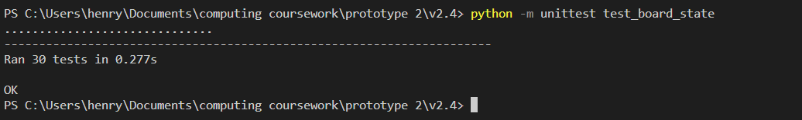

But I was extremely stumped as I was testing my legal moves generator function when I got this issue:

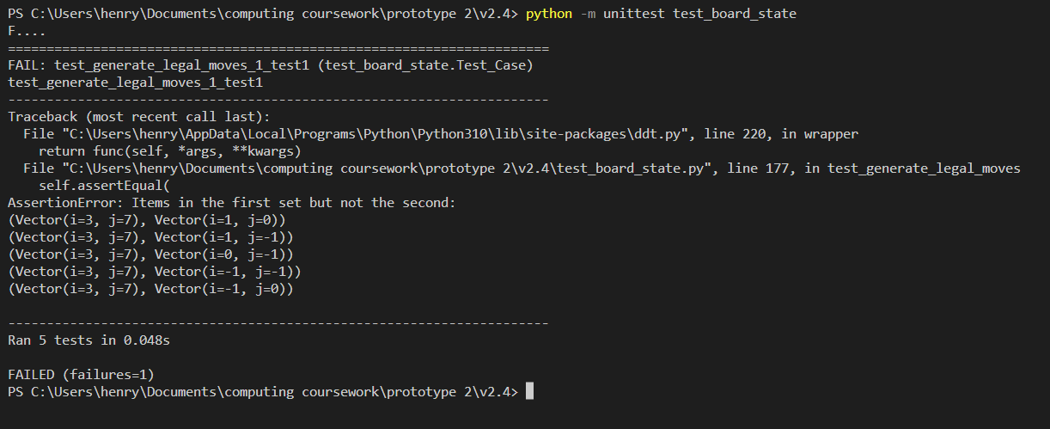

(other tests disables to show only this issue)

The test that had failed was (**generate_legal_moves.yaml**)

test1:

  next_to_go: B

  pieces_matrix: [

    [null, null, null, BK, null, null, null, null],

    [null, null, null, WP, null, null, null, null],

    [null, null, null, WK, null, null, null, null],

    [null, null, null, null, null, null, null, null],

    [null, null, null, null, null, null, null, null],

    [null, null, null, null, null, null, null, null],

    [null, null, null, null, null, null, null, null],

    [null, null, null, null, null, null, null, null],

  ]

  expected_legal_moves: []

There are supposed to be no legal moves as black in in checkmate. Instead the restriction of check was ignored and my function said that the black king could move to all 5 adjacent squares. I added this test to the check tests:

(**color_in_check.yaml**)

test5:

  pieces_matrix: [

    [null, null, null, BK, null, null, null, null],

    [null, null, null, WP, null, null, null, null],

    [null, null, null, WK, null, null, null, null],

    [null, null, null, null, null, null, null, null],

    [null, null, null, null, null, null, null, null],

    [null, null, null, null, null, null, null, null],

    [null, null, null, null, null, null, null, null],

    [null, null, null, null, null, null, null, null],

  ]

  white_in_check: false

  black_in_check: false

test6:

  pieces_matrix: [

    [null, null, BK, null, null, null, null, null],

    [null, null, null, WP, null, null, null, null],

    [null, null, null, WK, null, null, null, null],

    [null, null, null, null, null, null, null, null],

    [null, null, null, null, null, null, null, null],

    [null, null, null, null, null, null, null, null],

    [null, null, null, null, null, null, null, null],

    [null, null, null, null, null, null, null, null],

  ]

  white_in_check: false

  black_in_check: true

test7:

  pieces_matrix: [

    [null, null, null, null, BK, null, null, null],

    [null, null, null, WP, null, null, null, null],

    [null, null, null, WK, null, null, null, null],

    [null, null, null, null, null, null, null, null],

    [null, null, null, null, null, null, null, null],

    [null, null, null, null, null, null, null, null],

    [null, null, null, null, null, null, null, null],

    [null, null, null, null, null, null, null, null],

  ]

  white_in_check: false

  black_in_check: true

test8:

  pieces_matrix: [

    [null, null, null, null, null, null, null, null],

    [null, null, null, WP, BK, null, null, null],

    [null, null, null, WK, null, null, null, null],

    [null, null, null, null, null, null, null, null],

    [null, null, null, null, null, null, null, null],

    [null, null, null, null, null, null, null, null],

    [null, null, null, null, null, null, null, null],

    [null, null, null, null, null, null, null, null],

  ]

  white_in_check: true

  black_in_check: true

test9:

  pieces_matrix: [

    [null, null, null, null, null, null, null, null],

    [null, null, BK, WP, null, null, null, null],

    [null, null, null, WK, null, null, null, null],

    [null, null, null, null, null, null, null, null],

    [null, null, null, null, null, null, null, null],

    [null, null, null, null, null, null, null, null],

    [null, null, null, null, null, null, null, null],

    [null, null, null, null, null, null, null, null],

  ]

  white_in_check: true

  black_in_check: true

All these tests passed which really confused me. The check function correctly determined that the child game states resulting from each of these moves were check for black.

To further analyse this I created a jupyter notebook. I tried to replicate the exact function call being made by the test with a version of the legal moves generator that included a lot of print statements to reveal the inner workings.

I was able to recreate the contradictory outcomes

Cell 1:

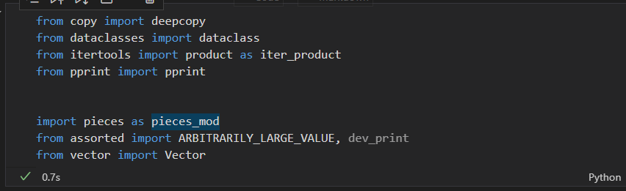

Cell 2 (copied as too big to screenshot)

STARTING_POSITIONS: tuple[tuple[pieces_mod.Piece]] = (

    (

        pieces_mod.Rook(color="B"),

        pieces_mod.Knight(color="B"),

        pieces_mod.Bishop(color="B"),

        pieces_mod.Queen(color="B"),

        pieces_mod.King(color="B"),

        pieces_mod.Bishop(color="B"),

        pieces_mod.Knight(color="B"),

        pieces_mod.Rook(color="B")

    ),

    (pieces_mod.Pawn(color="B"),)*8,

    (None,)*8,

    (None,)*8,

    (None,)*8,

    (None,)*8,

    (pieces_mod.Pawn(color="W"),)*8,

    (

        pieces_mod.Rook(color="W"),

        pieces_mod.Knight(color="W"),

        pieces_mod.Bishop(color="W"),

        pieces_mod.Queen(color="W"),

        pieces_mod.King(color="W"),

        pieces_mod.Bishop(color="W"),

        pieces_mod.Knight(color="W"),

        pieces_mod.Rook(color="W")

    )

)

@dataclass(frozen=True)

class Board_State():

    pieces_matrix: tuple[tuple[pieces_mod.Piece]]

    next_to_go: int = "W"

    # pieces_matrix: tuple[tuple[pieces_mod.Piece]] = STARTING_POSITIONS

    def print_board(self, print_function=pprint):

        print_function(

            list(map(

                lambda row: list(map(

                    lambda piece: None if piece is None else piece.symbol(),

                    row

                )),

                self.pieces_matrix

            ))

        )

    def get_piece_at_vector(self, vector: Vector):

        column, row = vector.i, 7-vector.j

        # column, row = vector.i, vector.j

        return self.pieces_matrix[row][column]

    def generate_all_pieces(self):

        # for i, j in zip(range(8), range(8)):

        # should be product

        for i, j in iter_product(range(8), range(8)):

            position_vector = Vector(i,j)

            piece = self.get_piece_at_vector(position_vector)

            # skip if none

            if piece:

                yield piece, position_vector

            # if piece:

            #     dev_print(f"not skipping {position_vector}")

            #     yield piece, position_vector

            # else:

            #     dev_print(f"skipping {position_vector}")

    def generate_pieces_of_color(self, color=None):

        if color is None:

            color = self.next_to_go

        def same_color(data_item):

            piece, _ = data_item

            return piece.color == color

        yield from filter(

            same_color,

            self.generate_all_pieces()

        )

    def color_in_check(self, color=None):

        if color is None:

            color = self.next_to_go

        # it is now A's turn

        color_a = color

        color_b = "W" if color == "B" else "B"

        # we will examine all the movement vectors of B's pieces

        # if any of them could take the A's King then currently A is in check as their king is threatened by 1 or more pieces (which could take it next turn)

        for piece, position_v in self.generate_pieces_of_color(color=color_b):

            movement_vs = piece.generate_movement_vectors(

                pieces_matrix=self.pieces_matrix,

                position_vector=position_v

            )

            for movement_v in movement_vs:

                resultant = position_v + movement_v

                to_square = self.get_piece_at_vector(resultant)

                # print(f"to_square   -->   {to_square!r}")

                # dev_print(f"piece at square {resultant.to_square()} is {to_square.symbol() if to_square else '<empty>'}")

                # dev_print(f"piece at square {resultant.to_square()} is {repr(to_square) if to_square else '<empty>'}")

                # As_move_threatens_king_A = isinstance(to_square, pieces_mod.King) and to_square.color == color_a

                As_move_threatens_king_A = (to_square == pieces_mod.King(color=color_a))

                # print(f"to_square == pieces_mod.King(color='B')   -->   {to_square!r} == {pieces_mod.King(color='B')!r}   -->    {to_square == pieces_mod.King(color='B')}")

                # dev_print(f"therefore king {'IS' if As_move_threatens_king_A else 'NOT'} threatened as square {'DOES' if As_move_threatens_king_A else 'DOES NOT'} contain {pieces_mod.King(color=color_a)!r} instead containing {repr(to_square) if to_square else '<empty>'}")

                # if As_move_threatens_king_A break out of all 3 loops

                if As_move_threatens_king_A:

                    # dev_print(f"color_in_check(color='{color}') returning True")

                    # dev_print(f"piece {piece.symbol()} at {position_v.to_square()} moving to {resultant.to_square()} IS threatening king")

                    return True

                # else:

                    # dev_print(f"piece {piece.symbol()} at {position_v.to_square()} moving to {resultant.to_square()} NOT threatening king")

        # dev_print(f"color_in_check(color='{color}') returning False")

        return False

    def generate_legal_moves(self):

        # dev_print(f"analysing legal moves for next to go {self.next_to_go}")

        for piece, piece_position_vector in self.generate_pieces_of_color(color=self.next_to_go):

            # dev_print(f"analysing moves for piece: {piece.symbol()}")

            movement_vectors = piece.generate_movement_vectors(

                pieces_matrix=self.pieces_matrix,

                position_vector=piece_position_vector

            )

            for movement_vector in movement_vectors:

                # dev_print(f"\tpiece {piece.symbol()}:_analysing movement vector {repr(movement_vector)}")

                child_game_state: Board_State = self.make_move(from_position_vector=piece_position_vector, movement_vector=movement_vector)

                # dev_print(f"\t\tmovement vector {repr(movement_vector)}: results in child game state")

                # child_game_state.print_board(

                #     print_function=lambda rows: list(map(

                #         lambda item: print(f"\t\t{item}"),

                #         rows

                #     ))

                # )

                # dev_print(repr(child_game_state))

                is_check_after_move = child_game_state.color_in_check(color=self.next_to_go)

                dev_print(f"\t\tThis game state in check? for {self.next_to_go}:  {is_check_after_move}")

                if not is_check_after_move:

                    yield piece_position_vector, movement_vector

    # def generate_legal_moves(self):

    #     for piece, piece_position_vector in self.generate_pieces_of_color(color=self.next_to_go):

    #         movement_vectors = piece.generate_movement_vectors(

    #             pieces_matrix=self.pieces_matrix,

    #             position_vector=piece_position_vector

    #         )

    #         for movement_vector in movement_vectors:

    #             child_game_state = self.make_move(from_position_vector=piece_position_vector, movement_vector=movement_vector)

    #             is_check_after_move = child_game_state.color_in_check(color=self.next_to_go)

    #             if not is_check_after_move:

    #                 yield piece_position_vector, movement_vector

    def is_game_over_for_next_to_go(self):

        # check if in checkmate

        # for player a

        # if b has no moves

        if not list(self.generate_legal_moves()):

            # if b in check

            if self.color_in_check():

                # checkmate for b, a wins

                return True, self.next_to_go

            else:

                # stalemate

                return True, None

        return False, None

    def static_evaluation(self):

        """Give positive static evaluation if white is winning"""

        def generate_all_pieces():

            for i, j in iter_product(range(8), range(8)):

                piece_position_vector = Vector(i, j)

                piece: pieces_mod.Piece = self.get_piece_at_vector(piece_position_vector)

                if not piece:

                    continue

                yield piece, piece_position_vector

        over, winner = self.is_game_over_for_next_to_go()

        if over:

            match winner:

                case None: multiplier = 0

                case "W": multiplier = 1

                case "B": multiplier = -1

            return winner * ARBITRARILY_LARGE_VALUE

        else:

            return sum(piece.get_value(position_vector) * multiplier for piece, position_vector in generate_all_pieces())

    def make_move(self, from_position_vector: Vector, movement_vector: Vector):

        to_position_vector = from_position_vector + movement_vector

        # poor code, this below line can cause infinite recursion when legal moves generator called post check changes

        # assert (from_position_vector, movement_vector) in self.generate_legal_moves()

        new_pieces_matrix = deepcopy(self.pieces_matrix)

        # convert to list

        new_pieces_matrix = list(map(list, new_pieces_matrix))

        # set from to blank

        row, col = 7-from_position_vector.j, from_position_vector.i

        piece: pieces_mod.Piece = new_pieces_matrix[row][col]

        piece.last_move = movement_vector

        new_pieces_matrix[row][col] = None

        # set to square to this piece

        row, col = 7-to_position_vector.j, to_position_vector.i

        new_pieces_matrix[row][col] = piece

        # convert back to tuple

        new_pieces_matrix = tuple(map(tuple, new_pieces_matrix))

        new_next_to_go = "W" if self.next_to_go == "B" else "B"

        return Board_State(

            next_to_go=new_next_to_go,

            pieces_matrix=new_pieces_matrix

        )

Cell 3:

# tested so assumed correct

import pieces

from vector import Vector

def test_dir(file_name): return f"test_data/board_state/{file_name}.yaml"

# code repeated from test pieces, opportunity to reduce redundancy

def list_map(function, iterable): return list(map(function, iterable))

def tuple_map(function, iterable): return tuple(map(function, iterable))

def descriptor_to_piece(descriptor) -> pieces.Piece:

    # converts WN to knight object with a color attribute of white

    if descriptor is None:

        return None

    color, symbol = descriptor

    piece_type: pieces.Piece = pieces.PIECE_TYPES[symbol]

    return piece_type(color=color)

def deserialize_pieces_matrix(pieces_matrix, next_to_go="W") -> Board_State:

    def row_of_symbols_to_pieces(row):

        return list_map(descriptor_to_piece, row)

    # update pieces_matrix replacing piece descriptors to piece objects

    pieces_matrix = list_map(row_of_symbols_to_pieces, pieces_matrix)

    board_state: Board_State = Board_State(pieces_matrix=pieces_matrix, next_to_go=next_to_go)

    return board_state

cell 4 though 6

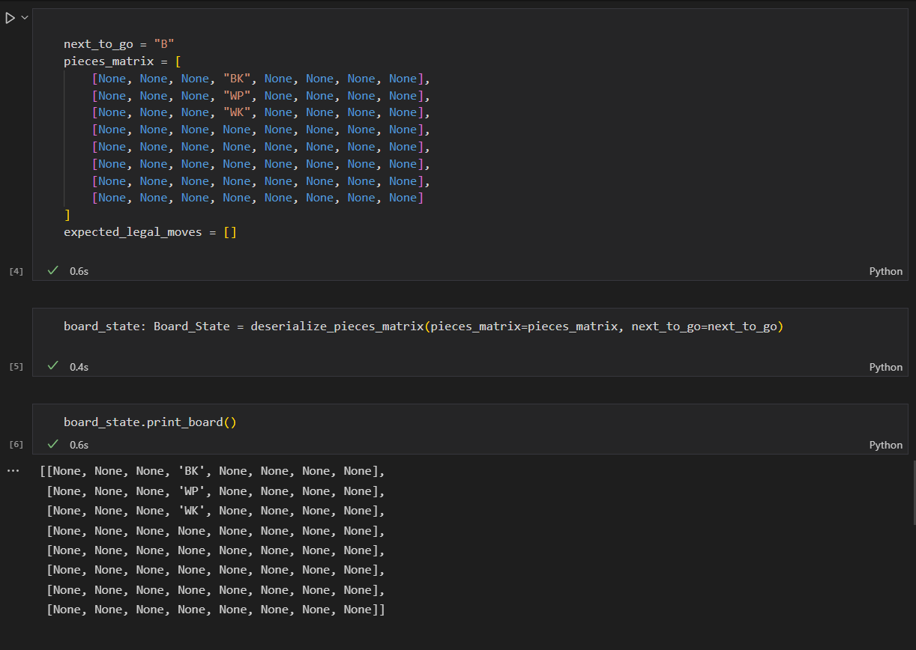

cell 7-8

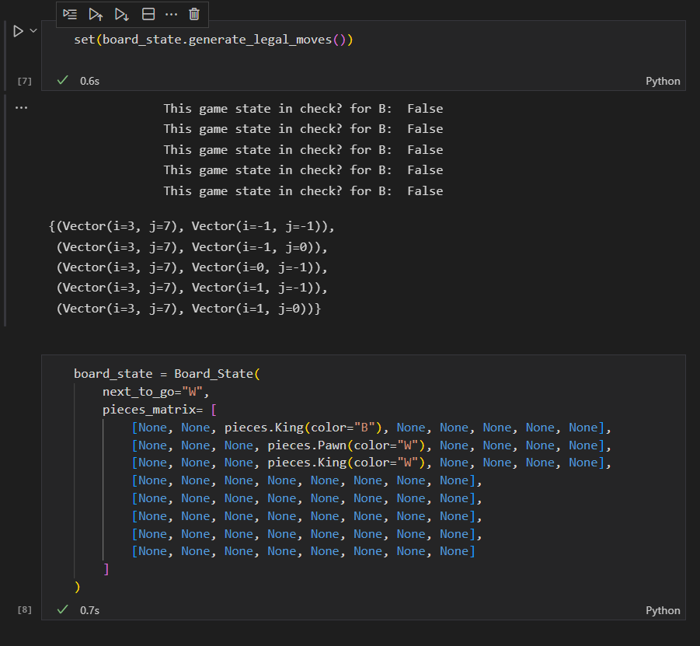

Cell 9-11

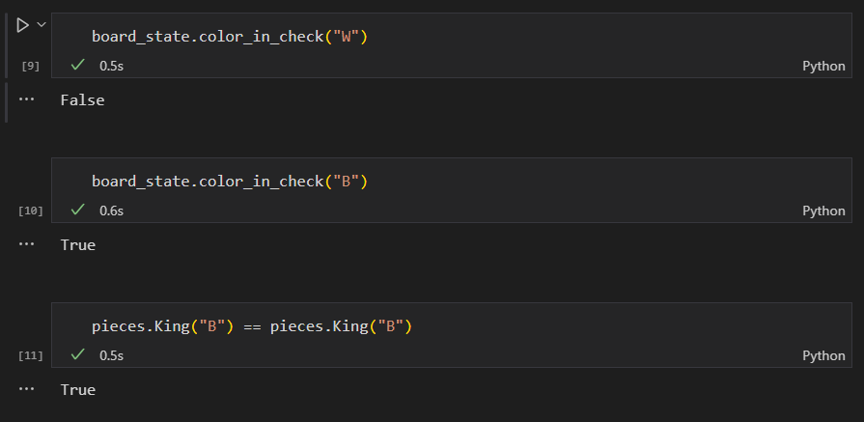

This highlights the issue and apparent contradiction in logic. My chess program is checking each child game state and reporting that black isn’t in check, yielding all 5 moves. Then for one of the child game states the color in check functions seen to directly contradict this by correctly identifying that black is in check.

I later realised the issue and why all my unit tests for the check function had worked and yet a practical test vie the legal moves generator function failed.

The line that was the issue what part of the Piece.__eq__ method

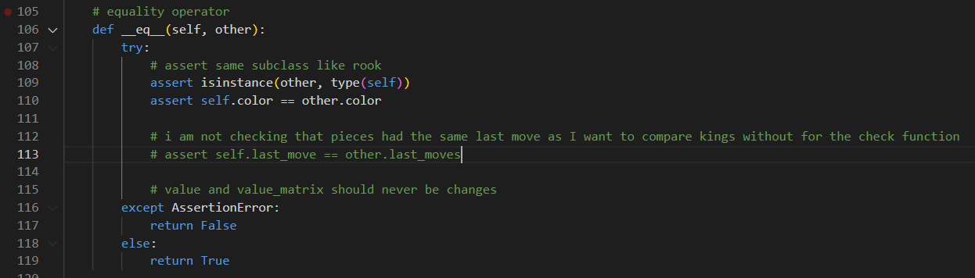

Line 113 was the issue. Shown commented out.

This line meant that a king that had been moved was not equal to a king that had just been initialised for the purpose of a test. This is because they would have different last moves attributes. The comparison in the check function is to a king of the same color but with last_moves set to None. This worked for the unit tests as the kings in the tests also had not moved. Once this line was removed, all the tests passed.

This was an issue with the pieces testing ad my assumption that the module was robust, but it was fixed.

Next I moved onto a module that would contain a game class that was able to keep track of the whole game.

It should enable user moves to be implemented and computer moves to be generated and implemented (I will get to minimax).

Here was my code:

**Game.py**

# import other modules

from board_state import Board_State

from minimax import minimax

from vector import Vector

from assorted import ARBITRARILY_LARGE_VALUE, dev_print, NotUserTurn, InvalidMove

# the game class is used to keep track of a chess game between a user and the computer

class Game(object):

    # it keeps track of:

    # the player's color's

    player_color_key: dict

    # the difficulty or depth of the game

    depth: int

    # the current board state

    board_state: Board_State

    # the number of moves so far

    move_counter: int

    # a table of game state hashes and there frequency

    piece_matrix_occurrence_hash_table: list

    # this adds a new game state to the frequency table

    def add_new_piece_matrix_to_hash_table(self, piece_matrix):

        # the pieces matrix is hashed

        matrix_hash = hash(piece_matrix)

        # if this pieces matrix has been encountered before, add 1 to the frequency

        if matrix_hash in self.piece_matrix_occurrence_hash_table.keys():

            self.piece_matrix_occurrence_hash_table[matrix_hash] += 1

        # else set frequency to 1

        else:

            self.piece_matrix_occurrence_hash_table[matrix_hash] = 1

    # determines if there is a 3 repeat stalemate

    def is_3_board_repeats_in_game_history(self):

        # if any of the board states have been repeated 3 or more times: stalemate

        return any(value >= 3 for value in self.piece_matrix_occurrence_hash_table.values())

    # constructor for game object

    def __init__(self, depth=2, user_color="W") -> None:

        # based on user's color, determine color key

        self.player_color_key = {

            "W": 1 if user_color=="W" else -1,

            "B": -1 if user_color=="W" else 1

        }

        # set depth property from parameters

        self.depth = depth

        # set attributes for game at start

        self.board_state = Board_State()

        self.move_counter = 0

        self.piece_matrix_occurrence_hash_table = {}

    # this function validates if the user's move is allowed and if so, makes it

    def implement_user_move(self, from_square, to_square) -> None:

        # check that the user is allowed to move

        which_player_next_to_go = self.player_color_key.get(

            self.board_state.next_to_go

        )

        if which_player_next_to_go != 1:

            raise NotUserTurn(game=self)

        # unpack move into vector form

        # invalid square syntaxes will cause a value error here

        try:

            position_vector = Vector.construct_from_square(from_square)

            movement_vector = Vector.construct_from_square(to_square) - position_vector

        except Exception:

            raise ValueError("Square's not in valid format")

        # if the move is not in the set of legal moves, raise and appropriate exception

        if (position_vector, movement_vector) not in self.board_state.generate_legal_moves():

            raise InvalidMove(game=self)

        # implement move

        self.board_state = self.board_state.make_move(from_position_vector=position_vector, movement_vector=movement_vector)

        # adjust other properties that keep track of the game

        self.move_counter += 1

        self.add_new_piece_matrix_to_hash_table(self.board_state.pieces_matrix)

        return (position_vector, movement_vector), self.board_state.static_evaluation()

    # this function determines if the game is over and if so, what is the nature of the outcome

    def check_game_over(self):

        # returns: over: bool, winning_player: (1/-1), classification: str

        # check for 3 repeat stalemate

        if self.is_3_board_repeats_in_game_history():

            return True, None, "Stalemate"

        # determine if board state is over for next player

        over, winner = self.board_state.is_game_over_for_next_to_go()

        # switch case statement to determine the appropriate values to be returned in each case

        match (over, winner):

            case False, _:

                victory_classification = None

                winning_player = None

            case True, None:

                victory_classification = "Stalemate"

                winning_player = None

            case True, winner:

                victory_classification = "Checkmate"

                winning_player = self.player_color_key[winner]

        # return appropriate values

        return over, winning_player, victory_classification

    # this function determines and implements the computer move

    def implement_computer_move(self, best_move_function=None):

        # for use with testing bots, a best move function can be provided for use, but minimax if the default

        # get next to go player (1/-1)

        which_player_next_to_go = self.player_color_key.get(

            self.board_state.next_to_go

        )

        # check that is it the computer's turn

        if which_player_next_to_go != -1:

            raise ValueError(f"Next to go is user: {self.board_state.next_to_go} not computer")

        # if no function provided, default to minimax

        if best_move_function is None:

            score, best_child, best_move = minimax(

                board_state = self.board_state,

                # assume white / user always maximizer

                # is_maximizer = (self.board_state.next_to_go == "W"),

                is_maximizer = False,

                # depth is based of difficulty of game based on depth parameter

                depth = self.depth,

                # default values for alpha and beta

                alpha = (-1)*ARBITRARILY_LARGE_VALUE,

                beta = ARBITRARILY_LARGE_VALUE

            )

        else:

            # otherwise use provided function,

            # the provided function should take game as an argument and then return data in the same format as the minimax function

            score, best_child, best_move = best_move_function(self)

        # adjust properties that keep track of the game state

        self.board_state = best_child

        self.move_counter += 1

        self.add_new_piece_matrix_to_hash_table(self.board_state.pieces_matrix)

        # incase is it wanted for a print out ect, return move and score

        return best_move, score

in tandem with this I created a minimax function which I will go into more detail about shortly.

Rather than make a test for this I created a rudementry console chess game to play chess using this library.

from game import Game

from assorted import InvalidMove

# create new chess game

# difficulty set to depth 2

game = Game(depth=2)

# this function informs the user of the details when the game is over

def handle_game_over(winner, classification):

    print(f"The game is over, the {'user' if winner==1 else 'computer'} has won in a {classification}")

# print out the starting board

game.board_state.print_board()

print()

# keep game going until loop broken

while True:

    # user goes first

    print("Your go USER:")

    # while loop and error checking used to ensure move input

    while True:

        try:

            print("Please enter move in 2 parts")

            from_square = input("From square:  ")

            to_square = input("To square:   ")

            # check

            game.implement_user_move(from_square, to_square)

        except InvalidMove:

            print("This isn't a legal move, try again")

        except ValueError:

            print("This isn't valid input, try again")

        else:

            # if it worked break out of the loop

            break

    # if move results in check then output this

    if game.board_state.color_in_check():

            print("CHECK!")

    # print out the current board_state

    game.board_state.print_board()

    print()

    # check if game over after user's move

    over, winner, classification = game.check_game_over()

    # if over, handle it.

    if over:

        handle_game_over(winner=winner, classification=classification)

        break

    # alternate, it is now the computers go

    print("Computer's go: ")

    # get the computers move

    move, _ = game.implement_computer_move()

    # print out the board again

    game.board_state.print_board()

    # print out the computer's move in terms of squares

    position_vector, movement_vector = move

    resultant_vector = position_vector + movement_vector

    piece_symbol = game.board_state.get_piece_at_vector(resultant_vector).symbol()

    print(f"Computer Moved  {piece_symbol}:  {position_vector.to_square()} to {resultant_vector.to_square()}")

    # print check if applicable

    if game.board_state.color_in_check():

            print("CHECK!")

    # check if the game is over, if so handle it

    over, winner, classification = game.check_game_over()

    if over:

        handle_game_over(winner=winner, classification=classification)

        break

    # create a new line to separate for the user's next move

    print()

This allowed the user to play check against the computer. The game wasn’t configurable as the user was white against depth 2 minimax but it was playable.

Here is an example of it running:

PS C:\Users\henry\Documents\computing coursework\prototype 2\v2.4> python console_chess.py

8| BR  BN  BB  BQ  BK  BB  BN  BR

7| BP  BP  BP  BP  BP  BP  BP  BP

6| ·   ·   ·   ·   ·   ·   ·   ·

5| ·   ·   ·   ·   ·   ·   ·   ·

4| ·   ·   ·   ·   ·   ·   ·   ·

3| ·   ·   ·   ·   ·   ·   ·   ·

2| WP  WP  WP  WP  WP  WP  WP  WP

1| WR  WN  WB  WQ  WK  WB  WN  WR

  (A   B   C   D   E   F   G   H )

Your go USER:

Please enter move in 2 parts

From square:  D2

To square:   D4

8| BR  BN  BB  BQ  BK  BB  BN  BR

7| BP  BP  BP  BP  BP  BP  BP  BP

6| ·   ·   ·   ·   ·   ·   ·   ·

5| ·   ·   ·   ·   ·   ·   ·   ·

4| ·   ·   ·   WP  ·   ·   ·   ·

3| ·   ·   ·   ·   ·   ·   ·   ·

2| WP  WP  WP  ·   WP  WP  WP  WP

1| WR  WN  WB  WQ  WK  WB  WN  WR

  (A   B   C   D   E   F   G   H )

Computer's go:

8| BR  ·   BB  BQ  BK  BB  BN  BR

7| BP  BP  BP  BP  BP  BP  BP  BP

6| ·   ·   BN  ·   ·   ·   ·   ·

5| ·   ·   ·   ·   ·   ·   ·   ·

4| ·   ·   ·   WP  ·   ·   ·   ·

3| ·   ·   ·   ·   ·   ·   ·   ·

2| WP  WP  WP  ·   WP  WP  WP  WP

1| WR  WN  WB  WQ  WK  WB  WN  WR

  (A   B   C   D   E   F   G   H )

Computer Moved  BN:  B8 to C6

Your go USER:

Please enter move in 2 parts

From square:  rubbish that is invalid input

To square:   more rubbish

This isn't valid input, try again

Please enter move in 2 parts

From square:  a0

To square:   i9

This isn't a legal move, try again

Please enter move in 2 parts

From square:  e1

To square:   e2

This isn't a legal move, try again

Please enter move in 2 parts

From square:  E2

To square:   E3

8| BR  ·   BB  BQ  BK  BB  BN  BR

7| BP  BP  BP  BP  BP  BP  BP  BP

6| ·   ·   BN  ·   ·   ·   ·   ·

5| ·   ·   ·   ·   ·   ·   ·   ·

4| ·   ·   ·   WP  ·   ·   ·   ·

3| ·   ·   ·   ·   WP  ·   ·   ·

2| WP  WP  WP  ·   ·   WP  WP  WP

1| WR  WN  WB  WQ  WK  WB  WN  WR

  (A   B   C   D   E   F   G   H )

Computer's go:

8| BR  ·   BB  BQ  BK  BB  ·   BR

7| BP  BP  BP  BP  BP  BP  BP  BP

6| ·   ·   BN  ·   ·   BN  ·   ·

5| ·   ·   ·   ·   ·   ·   ·   ·

4| ·   ·   ·   WP  ·   ·   ·   ·

3| ·   ·   ·   ·   WP  ·   ·   ·

2| WP  WP  WP  ·   ·   WP  WP  WP

1| WR  WN  WB  WQ  WK  WB  WN  WR

  (A   B   C   D   E   F   G   H )

Computer Moved  BN:  G8 to F6

Your go USER:

Please enter move in 2 parts

From square:  F2

To square:   F3

8| BR  ·   BB  BQ  BK  BB  ·   BR

7| BP  BP  BP  BP  BP  BP  BP  BP

6| ·   ·   BN  ·   ·   BN  ·   ·

5| ·   ·   ·   ·   ·   ·   ·   ·

4| ·   ·   ·   WP  ·   ·   ·   ·

3| ·   ·   ·   ·   WP  WP  ·   ·

2| WP  WP  WP  ·   ·   ·   WP  WP

1| WR  WN  WB  WQ  WK  WB  WN  WR

  (A   B   C   D   E   F   G   H )

Computer's go:

8| BR  ·   BB  BQ  BK  BB  ·   BR

7| BP  BP  BP  ·   BP  BP  BP  BP

6| ·   ·   BN  ·   ·   BN  ·   ·

5| ·   ·   ·   BP  ·   ·   ·   ·

4| ·   ·   ·   WP  ·   ·   ·   ·

3| ·   ·   ·   ·   WP  WP  ·   ·

2| WP  WP  WP  ·   ·   ·   WP  WP

1| WR  WN  WB  WQ  WK  WB  WN  WR

  (A   B   C   D   E   F   G   H )

Computer Moved  BP:  D7 to D5

Your go USER:

Please enter move in 2 parts

From square:  C2

To square:   C3

8| BR  ·   BB  BQ  BK  BB  ·   BR

7| BP  BP  BP  ·   BP  BP  BP  BP

6| ·   ·   BN  ·   ·   BN  ·   ·

5| ·   ·   ·   BP  ·   ·   ·   ·

4| ·   ·   ·   WP  ·   ·   ·   ·

3| ·   ·   WP  ·   WP  WP  ·   ·

2| WP  WP  ·   ·   ·   ·   WP  WP

1| WR  WN  WB  WQ  WK  WB  WN  WR

  (A   B   C   D   E   F   G   H )

Computer's go:

8| BR  ·   ·   BQ  BK  BB  ·   BR

7| BP  BP  BP  ·   BP  BP  BP  BP

6| ·   ·   BN  ·   BB  BN  ·   ·

5| ·   ·   ·   BP  ·   ·   ·   ·

4| ·   ·   ·   WP  ·   ·   ·   ·

3| ·   ·   WP  ·   WP  WP  ·   ·

2| WP  WP  ·   ·   ·   ·   WP  WP

1| WR  WN  WB  WQ  WK  WB  WN  WR

  (A   B   C   D   E   F   G   H )

Computer Moved  BB:  C8 to E6

Your go USER:

Please enter move in 2 parts

From square:  D1

To square:   D4

This isn't a legal move, try again

Please enter move in 2 parts

From square:  D1

To square:   A4

8| BR  ·   ·   BQ  BK  BB  ·   BR

7| BP  BP  BP  ·   BP  BP  BP  BP

6| ·   ·   BN  ·   BB  BN  ·   ·

5| ·   ·   ·   BP  ·   ·   ·   ·

4| WQ  ·   ·   WP  ·   ·   ·   ·

3| ·   ·   WP  ·   WP  WP  ·   ·

2| WP  WP  ·   ·   ·   ·   WP  WP

1| WR  WN  WB  ·   WK  WB  WN  WR

  (A   B   C   D   E   F   G   H )

Computer's go:

8| BR  ·   ·   BQ  BK  BB  ·   BR

7| BP  BP  BP  ·   ·   BP  BP  BP

6| ·   ·   BN  ·   BB  BN  ·   ·

5| ·   ·   ·   BP  BP  ·   ·   ·

4| WQ  ·   ·   WP  ·   ·   ·   ·

3| ·   ·   WP  ·   WP  WP  ·   ·

2| WP  WP  ·   ·   ·   ·   WP  WP

1| WR  WN  WB  ·   WK  WB  WN  WR

  (A   B   C   D   E   F   G   H )

Computer Moved  BP:  E7 to E5

Your go USER:

Please enter move in 2 parts

From square:  A4

To square:   B4

8| BR  ·   ·   BQ  BK  BB  ·   BR

7| BP  BP  BP  ·   ·   BP  BP  BP

6| ·   ·   BN  ·   BB  BN  ·   ·

5| ·   ·   ·   BP  BP  ·   ·   ·

4| ·   WQ  ·   WP  ·   ·   ·   ·

3| ·   ·   WP  ·   WP  WP  ·   ·

2| WP  WP  ·   ·   ·   ·   WP  WP

1| WR  WN  WB  ·   WK  WB  WN  WR

  (A   B   C   D   E   F   G   H )

Computer's go:

8| BR  ·   ·   BQ  BK  ·   ·   BR

7| BP  BP  BP  ·   ·   BP  BP  BP

6| ·   ·   BN  ·   BB  BN  ·   ·

5| ·   ·   ·   BP  BP  ·   ·   ·

4| ·   BB  ·   WP  ·   ·   ·   ·

3| ·   ·   WP  ·   WP  WP  ·   ·

2| WP  WP  ·   ·   ·   ·   WP  WP

1| WR  WN  WB  ·   WK  WB  WN  WR

  (A   B   C   D   E   F   G   H )

Computer Moved  BB:  F8 to B4

Your go USER:

Please enter move in 2 parts

From square:  C3

To square:   B4

8| BR  ·   ·   BQ  BK  ·   ·   BR

7| BP  BP  BP  ·   ·   BP  BP  BP

6| ·   ·   BN  ·   BB  BN  ·   ·

5| ·   ·   ·   BP  BP  ·   ·   ·

4| ·   WP  ·   WP  ·   ·   ·   ·

3| ·   ·   ·   ·   WP  WP  ·   ·

2| WP  WP  ·   ·   ·   ·   WP  WP

1| WR  WN  WB  ·   WK  WB  WN  WR

  (A   B   C   D   E   F   G   H )

Computer's go:

8| BR  ·   ·   BQ  BK  ·   ·   BR

7| BP  BP  BP  ·   ·   BP  BP  BP

6| ·   ·   BN  ·   BB  BN  ·   ·

5| ·   ·   ·   BP  ·   ·   ·   ·

4| ·   WP  ·   BP  ·   ·   ·   ·

3| ·   ·   ·   ·   WP  WP  ·   ·

2| WP  WP  ·   ·   ·   ·   WP  WP

1| WR  WN  WB  ·   WK  WB  WN  WR

  (A   B   C   D   E   F   G   H )

Computer Moved  BP:  E5 to D4

Your go USER:

Please enter move in 2 parts

From square:  E1

To square:   D2

8| BR  ·   ·   BQ  BK  ·   ·   BR

7| BP  BP  BP  ·   ·   BP  BP  BP

6| ·   ·   BN  ·   BB  BN  ·   ·

5| ·   ·   ·   BP  ·   ·   ·   ·

4| ·   WP  ·   BP  ·   ·   ·   ·

3| ·   ·   ·   ·   WP  WP  ·   ·

2| WP  WP  ·   WK  ·   ·   WP  WP

1| WR  WN  WB  ·   ·   WB  WN  WR

  (A   B   C   D   E   F   G   H )

Computer's go:

8| BR  ·   ·   BQ  BK  ·   ·   BR

7| BP  BP  BP  ·   ·   BP  BP  BP

6| ·   ·   BN  ·   BB  BN  ·   ·

5| ·   ·   ·   BP  ·   ·   ·   ·

4| ·   WP  ·   ·   ·   ·   ·   ·

3| ·   ·   ·   ·   BP  WP  ·   ·

2| WP  WP  ·   WK  ·   ·   WP  WP

1| WR  WN  WB  ·   ·   WB  WN  WR

  (A   B   C   D   E   F   G   H )

Computer Moved  BP:  D4 to E3

CHECK!

Your go USER:

Please enter move in 2 parts

From square:  D2

To square:   E3

8| BR  ·   ·   BQ  BK  ·   ·   BR

7| BP  BP  BP  ·   ·   BP  BP  BP

6| ·   ·   BN  ·   BB  BN  ·   ·

5| ·   ·   ·   BP  ·   ·   ·   ·

4| ·   WP  ·   ·   ·   ·   ·   ·

3| ·   ·   ·   ·   WK  WP  ·   ·

2| WP  WP  ·   ·   ·   ·   WP  WP

1| WR  WN  WB  ·   ·   WB  WN  WR

  (A   B   C   D   E   F   G   H )

Computer's go:

8| BR  ·   ·   BQ  BK  ·   ·   BR

7| BP  BP  BP  ·   ·   BP  BP  BP

6| ·   ·   BN  ·   BB  BN  ·   ·

5| ·   ·   ·   ·   ·   ·   ·   ·

4| ·   WP  ·   BP  ·   ·   ·   ·

3| ·   ·   ·   ·   WK  WP  ·   ·

2| WP  WP  ·   ·   ·   ·   WP  WP

1| WR  WN  WB  ·   ·   WB  WN  WR

  (A   B   C   D   E   F   G   H )

Computer Moved  BP:  D5 to D4

CHECK!

Your go USER:

Please enter move in 2 parts

From square:  E3

To square:   D4

This isn't a legal move, try again

You can see 1 problem and some sophisticated behaviours.

* It prints out the board after each move, makes it clear who’s turn it is and what move the computer has made.
* We can see that the validation works as I try in my second move to move in invalid ways or to input jargon and the program asks me again.
* We can also see that, when given the opportunity the computer sacrificed a rook to take a queen.
* We see that I cannot move in a way that causes check. This is after I moved out my king to present an easy check. We also see that it printed check which is useful

The issue we see is when the computer moves a pawn from E7 to E5 over the top of a bishop. This isn’t a legal move but I forgot to check that the middle square and more to squares were empty when coding in the pawns movement. **This will be corrected for future.**

## Testing

### Testing of Chess Engine and Move Engine:

I created the following automated test for the minimax function

# import local modules

# cannot import game as causes circular import, if necessary put in same file

from board_state import Board_State

from assorted import ARBITRARILY_LARGE_VALUE

from vector import Vector

# my minimax function takes as arguments:

# Board_State, is_maximiser, alpha and beta (used for pruning) and check_extra_depth (produces better outcome but slower)

# it returns

# score, child, move

def minimax(board_state: Board_State, is_maximizer: bool, depth, alpha, beta, check_extra_depth=True):

    # sourcery skip: low-code-quality, remove-unnecessary-else, swap-if-else-branches

    # assume white is maximizer

    # when calling, if give appropriate max min arg

    # base case

    # if over or depth==0 return static evaluation

    over, _ = board_state.is_game_over_for_next_to_go()

    if depth == 0 or over:

        # special recursive case 1

        # examine terminal nodes that are check to depth 2 (variable depth)

        # to avoid goose chaises, extra resources are allowed if check not already explored

        if board_state.color_in_check() and check_extra_depth and not over:

            # print(f"checking board state {hash(board_state)} at additional depth due to check")

            return minimax(

                board_state=board_state,

                is_maximizer=is_maximizer,

                depth=2,

                alpha=alpha,

                beta=beta,

                check_extra_depth=False

            )

        else:

            # static eval works for game over to

            return board_state.static_evaluation(), None, None

    # define variables used to return more that just score (move and child)

    best_child_game_state: Board_State | None = None

    best_move_vector: Vector | None = None

    # function yields move ordered by how favorable they are (low depth minimax approximation)

    def gen_ordered_child_game_states():

        # this function does a low depth minimax recursive call (special recursive case 2) to give a move a score

        def approx_score_move(move):

            child_game_state = board_state.make_move(*move)

            return minimax(

                board_state=child_game_state,

                depth=depth-2,

                is_maximizer=not is_maximizer,

                alpha=alpha,

                beta=beta,

                check_extra_depth=False

            )[0]

            # print(f"approx_score_move(move={move!r})  ->  {result!r}")

        # if depth is 1 or less just yield moves form legal moves

        if depth <= 1:

            yield from board_state.generate_legal_moves()

        # else sort them

        else:

            # sort best to worse

            # sort ascending order if minimizer, descending if maximizer

            yield from sorted(

                board_state.generate_legal_moves(),

                key=approx_score_move,

                reverse=is_maximizer

            )

    if is_maximizer:

        # set max to -infinity

        maximum_evaluation = (-1)*ARBITRARILY_LARGE_VALUE

        # iterate through moves and resulting game states

        for position_vector, movement_vector in gen_ordered_child_game_states():

            child_game_state = board_state.make_move(from_position_vector=position_vector, movement_vector=movement_vector)

            # evaluate each one

            # general recursive case 1

            evaluation, _, _ = minimax(

                board_state=child_game_state,

                is_maximizer=not is_maximizer,

                depth=depth-1,

                alpha=alpha,

                beta=beta,

                check_extra_depth=check_extra_depth

            )

            # update alpha and max evaluation

            if evaluation > maximum_evaluation:

                maximum_evaluation = evaluation

                best_child_game_state = child_game_state

                best_move_vector = (position_vector, movement_vector)

                alpha = max(alpha, evaluation)

            # where possible, prune

            if beta <= alpha:

                # print("Pruning!")

                break

        # once out of loop, return result

        return maximum_evaluation, best_child_game_state, best_move_vector

    else:

        minimum_evaluation = ARBITRARILY_LARGE_VALUE

        for position_vector, movement_vector in gen_ordered_child_game_states():

            child_game_state = board_state.make_move(from_position_vector=position_vector, movement_vector=movement_vector)

            evaluation, _, _ = minimax(

                board_state=child_game_state,

                is_maximizer=not is_maximizer,

                depth=depth-1,

                alpha=alpha,

                beta=beta,

                check_extra_depth=check_extra_depth

            )

            if evaluation < minimum_evaluation:

                minimum_evaluation = evaluation

                best_child_game_state = child_game_state

                best_move_vector = (position_vector, movement_vector)

                beta = min(beta, evaluation)

            if beta <= alpha:

                # print("Pruning!")

                break

        return minimum_evaluation, best_child_game_state, best_move_vector

it features some efficiency upgrades:

* Alpha beta pruning
* Child nodes examined best first to enhance pruning
* Variable depth in check to close out games

I then created a test for the minimax function

# this test is responsible for testing various mutations of the minimax function and how they play, it is not a data driven test

# imports

from random import choice as random_choice

import unittest

# from functools import wraps

import multiprocessing

import os.path

import csv

from game import Game

from minimax import minimax

from assorted import ARBITRARILY_LARGE_VALUE

# from board_state import Board_State

# from vector import Vector

# # was not needed in the end, this decorator would have repeated a given function a given number of times

# def repeat_decorator_factory(times):

#     def decorator(func):

#         @wraps(func)

#         def wrapper(*args, **kwargs):

#             for _ in range(times):

#                 func(*args, **kwargs)

#         return wrapper

#     return decorator

# this is a utility function that maps a function across an iterable but also converts the result to a list data structure

def list_map(func, iter):

    return list(map(func, iter))

# this function is used to serialize a pieces matrix for output in a message

# it converts pieces to symbols

def map_pieces_matrix_to_symbols(pieces_matrix):

    return list_map(

        lambda row: list_map(

            lambda square: square.symbol() if square else None,

            row

        ),

        pieces_matrix

    )

# this functions updates a CSV file with the moves and scores of a chess game for graphical analysis in excel

def csv_write_move_score(file_path, move, score):

    # convert move to a pair of squares

    position_vector, movement_vector = move

    resultant_vector = position_vector + movement_vector

    from_square = position_vector.to_square()

    to_square = resultant_vector.to_square()

    # if file doesn't exist, create is and add the headers

    if not os.path.exists(file_path):

        with open(file_path, "w", newline="") as file:

            writer = csv.writer(file, delimiter=",")

            writer.writerow(("from_square", "to_square", "score"))

    # add data as a new row

    with open(file_path, "a", newline="") as file:

        writer = csv.writer(file, delimiter=",")

        writer.writerow((from_square, to_square, score))

# this contains the majority of the logic to do a bot vs bot test with the game class

# it is a component as it isn't the whole test

def minimax_test_component(description, good_bot, bad_bot, success_criteria, write_to_csv=False):

    # sourcery skip: extract-duplicate-method

    # good bot and bad bot make decisions about moves,

    # the test is designed to assert that good bot wins (and or draws in some cases)

    # generate csv path

    if write_to_csv:

        # not sure why but the description sometimes contains an erroneous colon, this is caught and removed

        # was able to locate bug to here, as it is a test I added a quick fix

        # bug located, some description stings included them

        csv_path = f"test_reports/{description}.csv".replace(" ", "_").replace(":", "")

    # start a new blank game

    # depth irrelevant as computer move function passed as parameter

    game: Game = Game()

    # keep them making moves until return statement breaks loop

    while True:

        # get move choice from bad bot

        _, _, move_choice = bad_bot(game)

        # serialised to is can be passed as a user move (reusing game class)

        position_vector, movement_vector = move_choice

        resultant_vector = position_vector + movement_vector

        from_square, to_square = position_vector.to_square(), resultant_vector.to_square()

        # implement bad bot move and update csv

        move, score = game.implement_user_move(from_square=from_square, to_square=to_square)

        if write_to_csv:

            csv_write_move_score(

                file_path=csv_path,

                move=move,

                score=score

            )

        # see if this move causes the test to succeed or fail or keep going

        success, msg, board_state = success_criteria(game, description=description)

        if success is not None:

            return success, msg, board_state

        # providing good bot function, implement good bot move and update csv

        move, score = game.implement_computer_move(best_move_function=good_bot)

        if write_to_csv:

            csv_write_move_score(

                file_path=csv_path,

                move=move,

                score=score

            )

        # again check if this affects the test

        success, msg, board_state = success_criteria(game, description=description)

        if success is not None:

            return success, msg, board_state

        # # if needed provide console output to clarify that slow bot hasn't crashed

        # if game.move_counter % 10 == 0 or depth >= 3:

        # print(f"Moves {game.move_counter}:  static evaluation -> {game.board_state.static_evaluation()}, Minimax evaluation -> {score} by turn {description}")

# below are some function that have been programmed as classes with a __call__ method.

# these are basically fancy functions that CAN BE HASHED.

# I had to manually do this under the hood hashing as it is needed to allow communication between the threads

# a job must be hashable to be piped to a thread (separate python instance)

class Random_Bot():

    # picks a random move

    def __call__(self, game):

        # determine move at random

        legal_moves = list(game.board_state.generate_legal_moves())

        assert len(legal_moves) != 0

        # match minimax output structure

        # score, best_child, best_move

        return None, None, random_choice(legal_moves)

    def __hash__(self) -> int:

        return hash("I am random bot, I am a unique singleton so each instance can share a hash")

# picks a good move

# has constructor to allow for configuration

class Good_Bot():

    # configure for depth and allow variable depth

    def __init__(self, depth, check_extra_depth):

        self.depth = depth

        self.check_extra_depth = check_extra_depth

    # make minimax function call given config

    def __call__(self, game):

        return minimax(

            board_state=game.board_state,

            is_maximizer=(game.board_state.next_to_go == "W"),

            depth=self.depth,

            alpha=(-1)*ARBITRARILY_LARGE_VALUE,

            beta=ARBITRARILY_LARGE_VALUE,

            check_extra_depth=self.check_extra_depth

        )

    def __hash__(self) -> int:

        return hash(f"Good_Bot(depth={self.depth}, check_extra_depth={self.check_extra_depth})")

# used to look at a game and decide if the test should finish

class Success_Criteria():

    # constructor allow config for stalemates to sill allow test to pass

    def __init__(self, allow_stalemate_3_states_repeated: bool):

        self.allow_stalemate_3_states_repeated = allow_stalemate_3_states_repeated

    def __call__(self, game: Game, description):

        # returns: success, message, serialised pieces matrix

        # call game over and use a switch case to decide what to do

        match game.check_game_over():

            # if 3 repeat stalemate, check with config wether is is allows

            case True, None, "Stalemate":

                # game.board_state.print_board()

                if game.is_3_board_repeats_in_game_history and self.allow_stalemate_3_states_repeated:

                    # game.board_state.print_board()

                    # print(f"Success: Stalemate at {game.moves} moves in test {description}: 3 repeat board states, outcome specify included in allowed outcomes")

                    return True, f"Success: Stalemate at {game.move_counter} moves in test {description}: 3 repeat board states, outcome specify included in allowed outcomes", map_pieces_matrix_to_symbols(game.board_state.pieces_matrix)

                else:

                    # game.board_state.print_board()

                    # print(f"FAILURE: ({description}) stalemate caused (3 repeats?  -> {game.is_3_board_repeats_in_game_history()})")

                    return False, f"FAILURE: ({description}) stalemate caused (3 repeats?  -> {game.is_3_board_repeats_in_game_history()})", map_pieces_matrix_to_symbols(game.board_state.pieces_matrix)

            # good bot loss causes test to fail

            case True, 1, "Checkmate":

                # game.board_state.print_board()

                # print(f"Failure: ({description}) computer lost")

                return False, f"Failure: ({description}) computer lost", map_pieces_matrix_to_symbols(game.board_state.pieces_matrix)

            # good bot win causes test to pass

            case True, -1, "Checkmate":

                # game.board_state.print_board()

                # print(f"SUCCESS: ({description}) Game has finished and been won in {game.move_counter} moves")

                return True, f"SUCCESS: ({description}) Game has finished and been won in {game.move_counter} moves", map_pieces_matrix_to_symbols(game.board_state.pieces_matrix)

            # if the game isn't over, return success as none and test will continue

            case False, _, _:

                return None, None, None

    def hash(self):

        return hash(f"Success_Criteria(allow_stalemate_3_states_repeated={self.allow_stalemate_3_states_repeated})")

# given a test package (config for one test), carry it out

def execute_test_job(test_data_package):

    # deal with unexplained bug where argument is tuple / list length 1 containing relevant dict (quick fix as only a test)

    # I was able to identify that this is where it occurs and add a correction but I am not sure what the cause of the bug is

    if any(isinstance(test_data_package, some_type) for some_type in (tuple, list)):

        if len(test_data_package) == 1:

            test_data_package = test_data_package[0]

    # print(f"test_data_package   -->   {test_data_package}")

    # really simple, call minimax test component providing all keys in package as keyword arguments

    return minimax_test_component(**test_data_package)

# this function takes an iterable of hashable test_packages

# it all 8 logical cores on my computer to multitask to finish the test sooner

def pool_jobs(test_data):

    # counts logical cores

    # my CPU is a 10th gen i7

    # it has 4 cores and 8 logical cores due to hyper threading

    # with 4-8 workers I can use 100% of my CPU

    cores = multiprocessing.cpu_count()

    # create a pool

    with multiprocessing.Pool(cores) as pool:

        # map the execute_test_job function across the set of test packages using multitasking

        # return the result

        return pool.map(

            func = execute_test_job,

            iterable = test_data

        )

# test case contains unit tests

# multitasking only occurs within a test, tests are themselves executed sequentially

# I could pool all tests into one test function but this way multiple failures can occur in different tests

# (one single test would stop at first failure)

class Test_Case(unittest.TestCase):

    # this function takes the results of the tests from the test pool and checks the results with a unittest

    # a failure is correctly identified to correspond to the function that called this function

    # reduces repeated logic

    def check_test_results(self, test_results):

        for success, msg, final_pieces_matrix in test_results:

            # print()

            # for row in final_pieces_matrix:

            #     row = "  ".join(map(

            #         lambda square: str(square).replace("None", ". "),

            #         row

            #     ))

            #     print(row)

            # print(msg)

            # i choose to iterate rather than assert all as this allows me to have the appropriate message on failure

            self.assertTrue(

                success,

                msg=msg

            )

    # tests basic minimax vs random moves

    def test_vanilla_depth_1_vs_randotron(self):

        # 10 trials as outcome is linked to a random behaviour

        trials = 10

        # test package generated to include relevant data and logic (bots and success criteria)

        test_data = {

            "description": "test: depth 1 vanilla vs randotron",

            "good_bot": Good_Bot(depth=1, check_extra_depth=False),

            "bad_bot": Random_Bot(),

            "success_criteria": Success_Criteria(allow_stalemate_3_states_repeated=True),

            "write_to_csv": False

        }

        # only trial will write to a csv

        test_data_but_to_csv = test_data

        test_data_but_to_csv["write_to_csv"] = True

        self.check_test_results(

            pool_jobs(

                (trials-1) * [test_data] +  [test_data_but_to_csv]

            )

        )

    def test_advanced_depth_1_vs_randotron(self):

        trials = 10

        test_data = {

            "description": "test: depth 1 advanced vs randotron",

            "good_bot": Good_Bot(depth=1, check_extra_depth=True),

            "bad_bot": Random_Bot(),

            "success_criteria": Success_Criteria(allow_stalemate_3_states_repeated=True),

            "write_to_csv": False

        }

        test_data_but_to_csv = test_data

        test_data_but_to_csv["write_to_csv"] = True

        self.check_test_results(

            pool_jobs(

                (trials-1) * [test_data] + [test_data_but_to_csv]

            )

        )

    def test_depth_2_vs_randotron(self):

        trials = 10

        test_data = {

            "description": "test: depth 2 advanced vs randotron",

            "good_bot": Good_Bot(depth=2, check_extra_depth=True),

            "bad_bot": Random_Bot(),

            "success_criteria": Success_Criteria(allow_stalemate_3_states_repeated=False),

            "write_to_csv": False

        }

        test_data_but_to_csv = test_data

        test_data_but_to_csv["write_to_csv"] = True

        self.check_test_results(

            pool_jobs(

                (trials-1) * [test_data] + [test_data_but_to_csv]

            )

        )

    def test_depth_1_advanced_vs_depth_1_vanilla(self):

        # only one trial needed as outcome is deterministic

        trials = 1

        test_data = {

            "description": "test: depth 1 vanilla vs depth 1 variable check",

            "good_bot": Good_Bot(depth=1, check_extra_depth=True),

            "bad_bot": Good_Bot(depth=1, check_extra_depth=False),

            # they aren't different enough in efficacy to guarantee no draws

            "success_criteria": Success_Criteria(allow_stalemate_3_states_repeated=True),

            "write_to_csv": True

        },

        self.check_test_results(

            pool_jobs(trials*[test_data])

        )

    def test_depth_2_vs_depth_1(self):

        trials = 1

        test_data = {

            "description": "test: depth 2 vs depth 1",

            "good_bot": Good_Bot(depth=2, check_extra_depth=True),

            "bad_bot": Good_Bot(depth=1, check_extra_depth=True),

            "success_criteria": Success_Criteria(allow_stalemate_3_states_repeated=False),

            "write_to_csv": True

        }

        self.check_test_results(

            pool_jobs(trials*[test_data])

        )

    def test_depth_3_vs_depth_2(self):

        trials = 1

        test_data = {

            "description": "test: depth 3 vs depth 2",

            "good_bot": Good_Bot(depth=3, check_extra_depth=True),

            "bad_bot": Good_Bot(depth=2, check_extra_depth=True),

            "success_criteria": Success_Criteria(allow_stalemate_3_states_repeated=False),

            "write_to_csv": True

        }

        self.check_test_results(

            pool_jobs(trials*[test_data])

        )

    def test_depth_3_vs_depth_1(self):

        trials = 1

        test_data = {

            "description": "test: depth 3 vs depth 1",

            "good_bot": Good_Bot(depth=3, check_extra_depth=True),

            "bad_bot": Good_Bot(depth=1, check_extra_depth=True),

            "success_criteria": Success_Criteria(allow_stalemate_3_states_repeated=False),

            "write_to_csv": True

        }

        self.check_test_results(

            pool_jobs(trials*[test_data])

        )

    def test_depth_3_vs_randotron(self):

        trials = 4

        test_data = {

            "description": "test: depth 3 vs randotron",

            "good_bot": Good_Bot(depth=3, check_extra_depth=True),

            "bad_bot": Random_Bot(),

            "success_criteria": Success_Criteria(allow_stalemate_3_states_repeated=False),

            "write_to_csv": False

        }

        test_data_but_to_csv = test_data

        test_data_but_to_csv["write_to_csv"] = True

        self.check_test_results(

            pool_jobs(

                (trials-1) * [test_data] + [test_data_but_to_csv]

            )

        )

if __name__ == '__main__':

    unittest.main()

I went to great effort to improve the tests efficiency and this wasn’t wasted. It allowed me to perform tests with many trials simultaneously in order to fully utilise my CPU.

Currently all the test I have run today were successful **but** even given a whole afternoon I haven’t been able to run all the tests. This is due to the depth 3 tests. Due to variable depth, the number of static evaluations can be (branching factor)^5 (really slow). This combinatorial explosion means that it takes more than 4 hours to run the tests.

The tests I have run successfully are:

* test_depth_1_vanilla_vs_depth_1_variable_check
* test_depth_2_vs_depth_1
* test_depth_2_advanced_vs_randotron
* test_depth_3_vs_depth_1
* test_depth_1_advanced_vs_randotron

Here is me showing how multitasking has allowed me to fully utilise my CPU

Let me run depth 2 vs Ranotron with 10 trials to demonstrate:

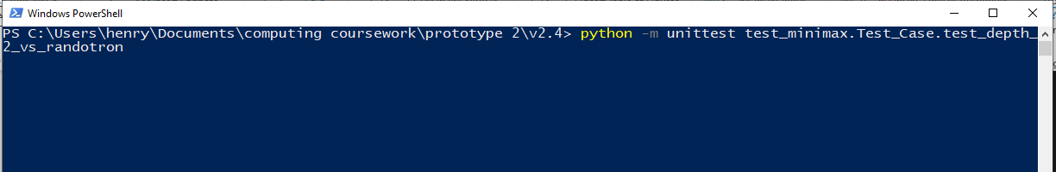

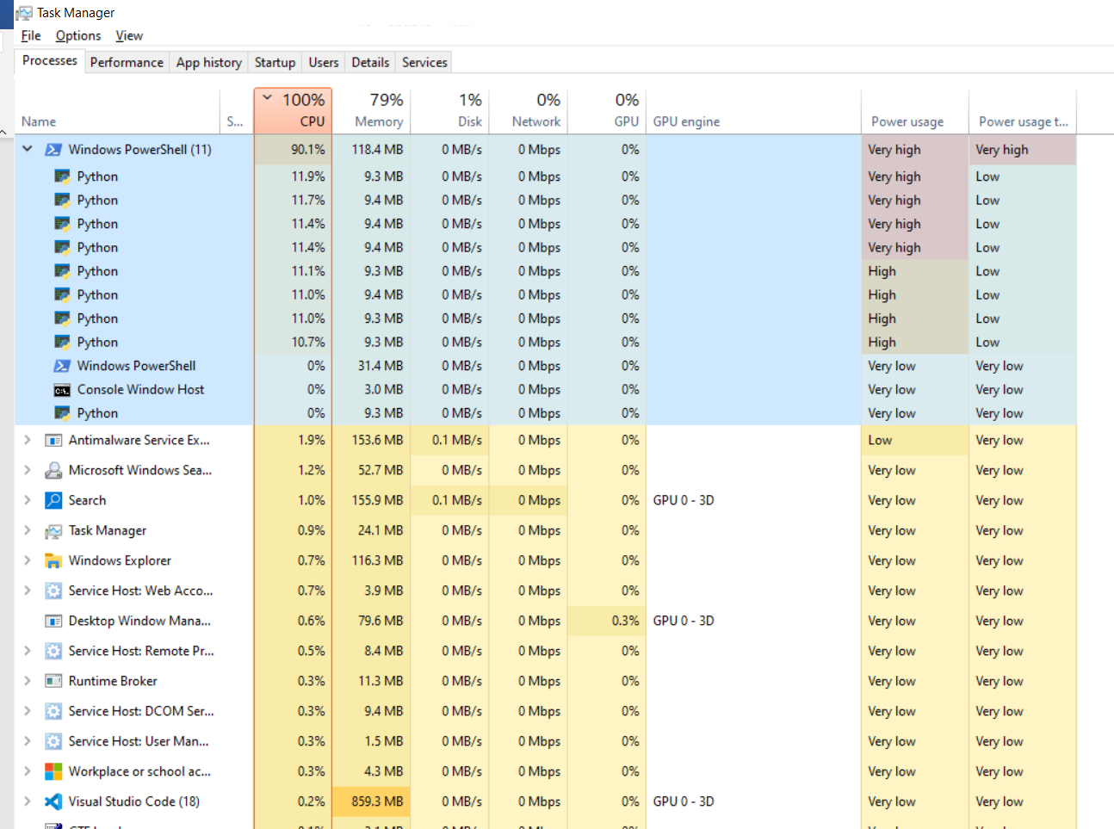

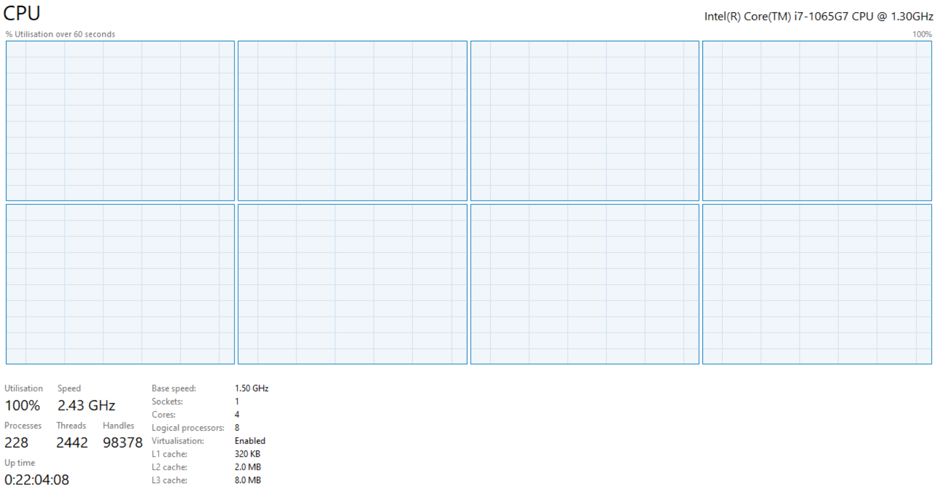

Before doing this my CPU was only ever able to devote 25% power to my python program.

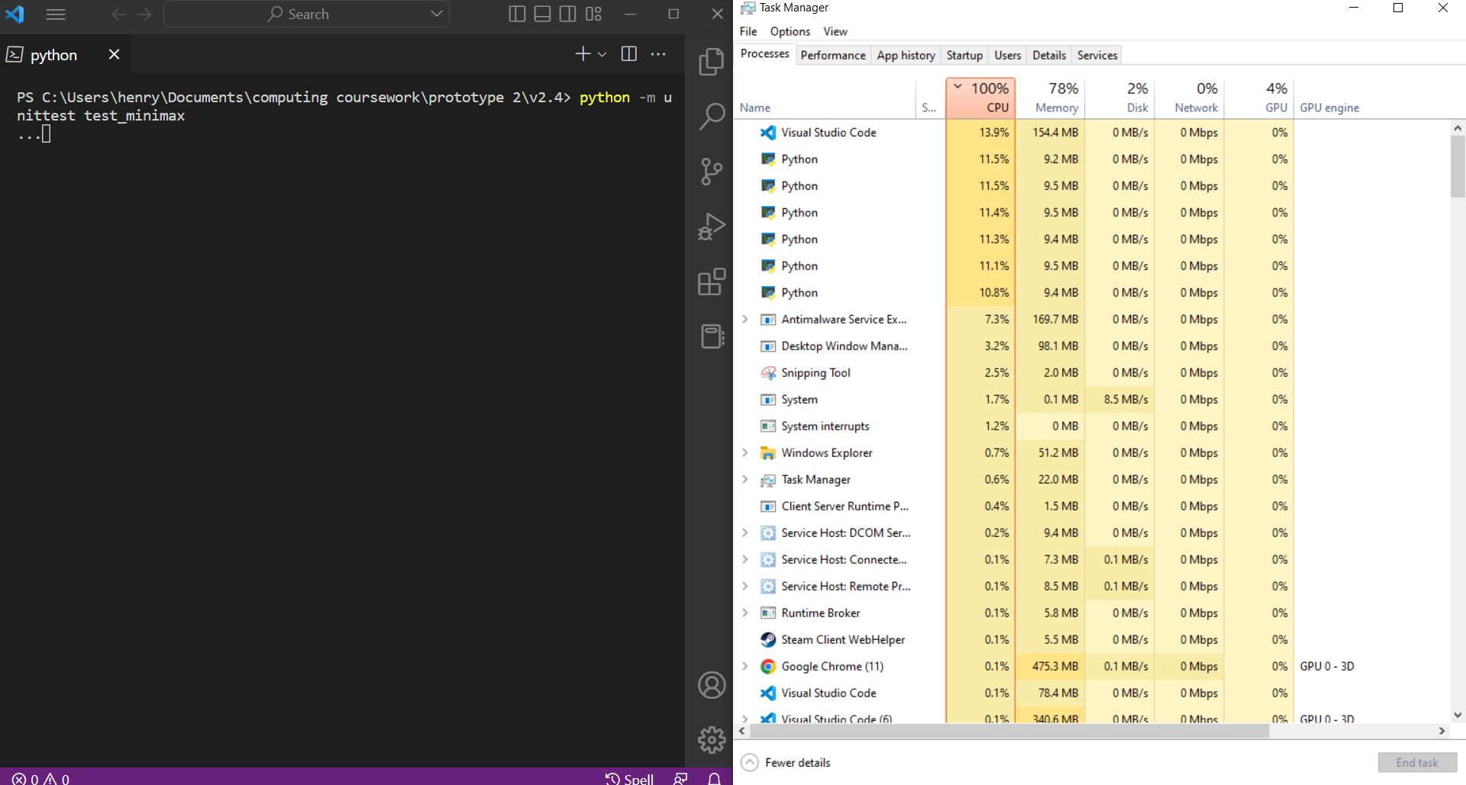

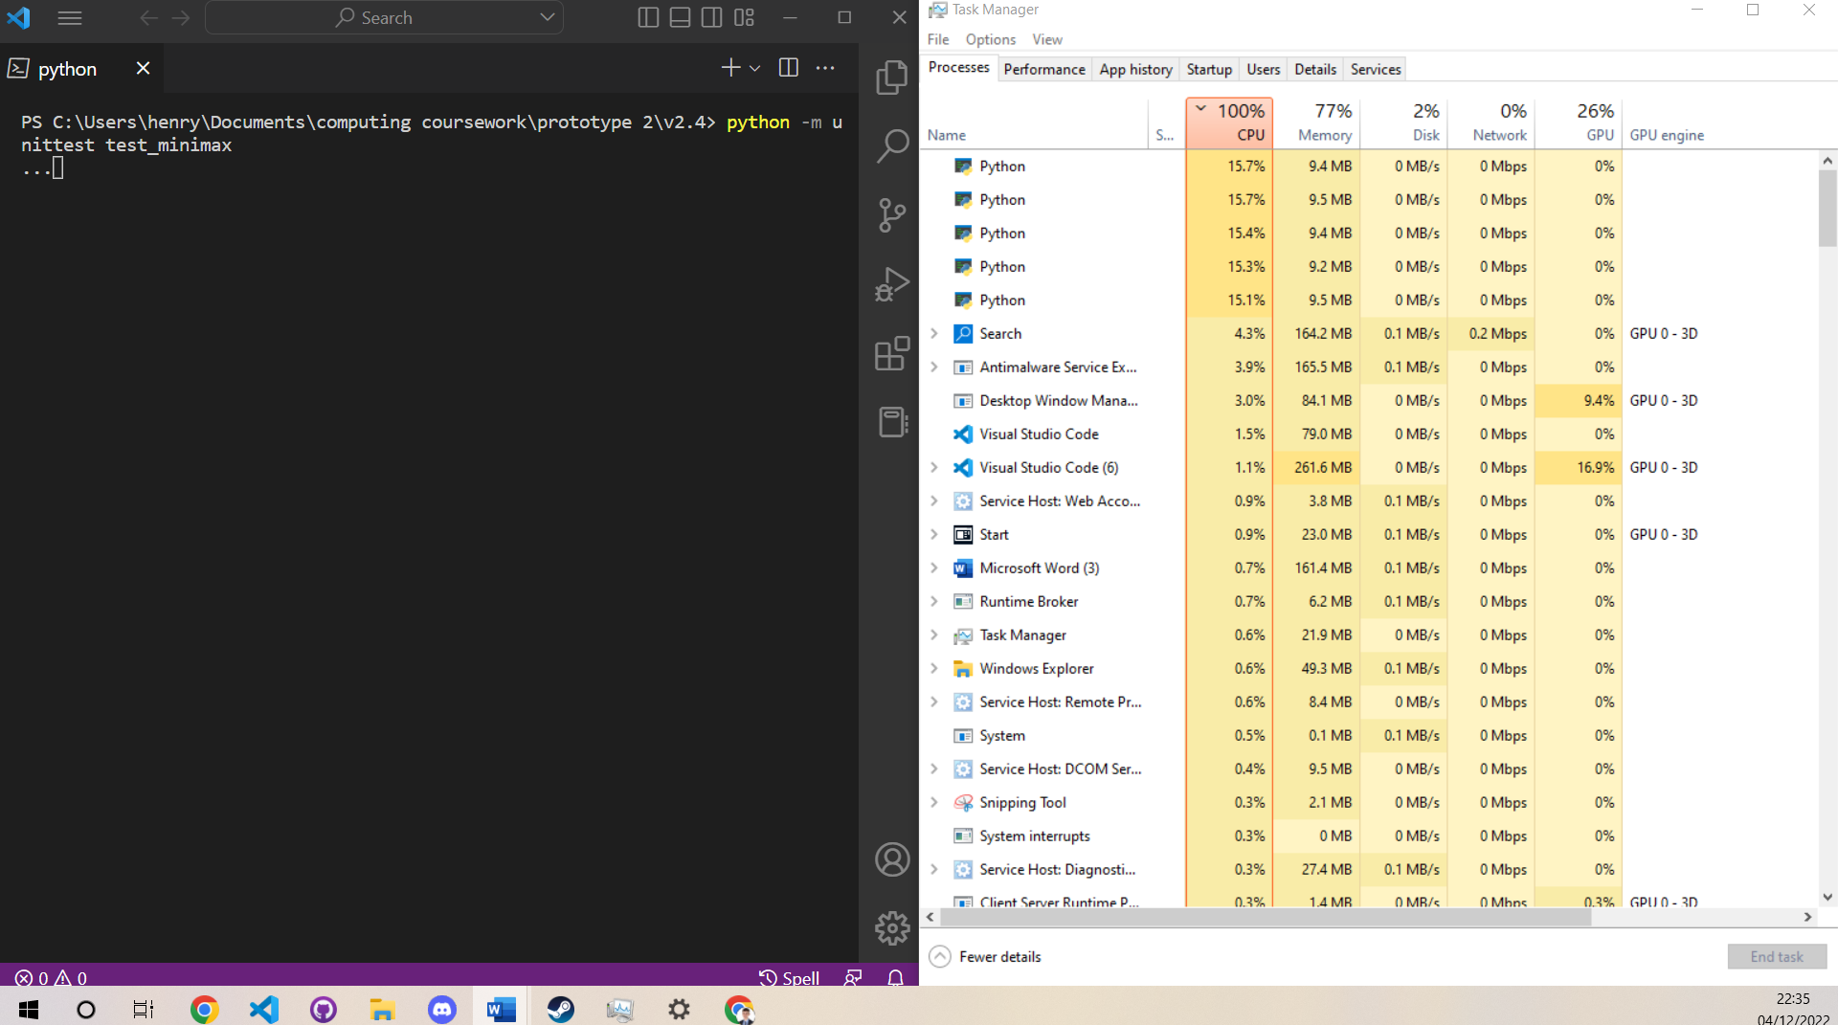

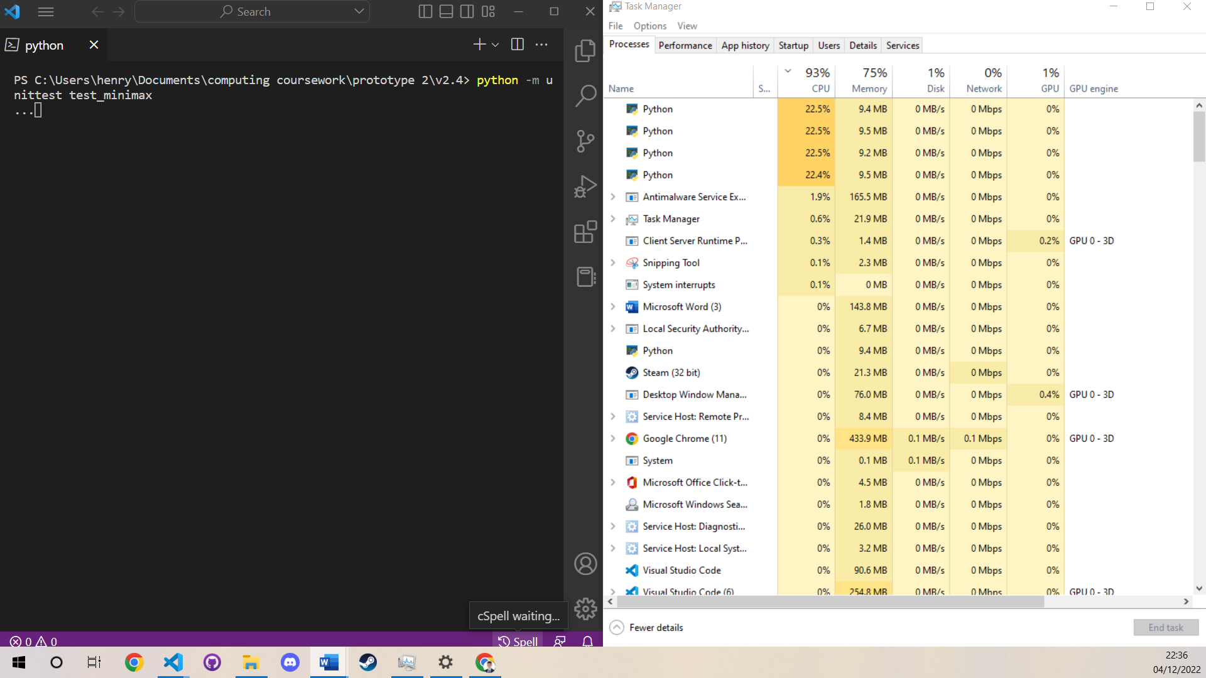

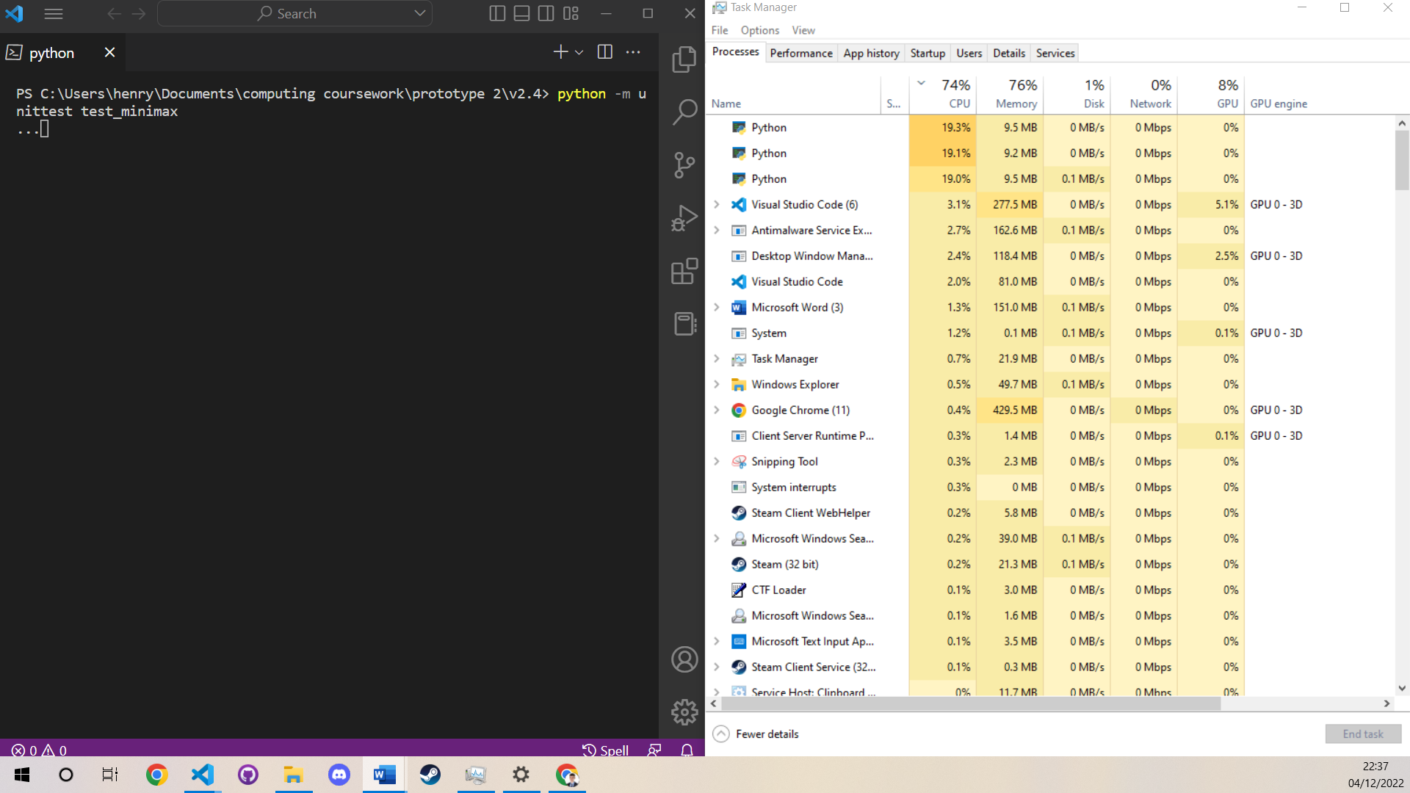

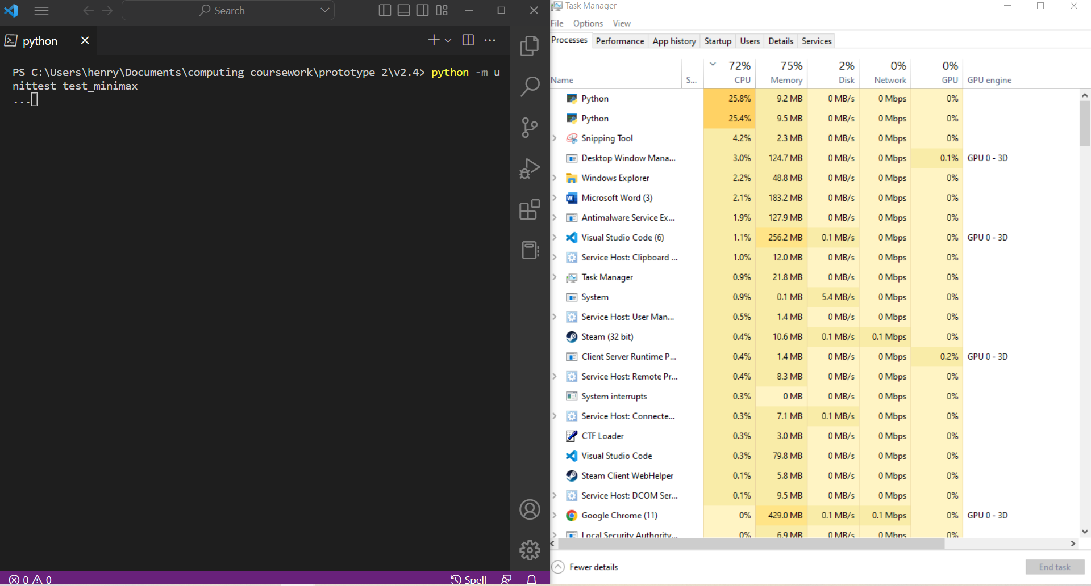

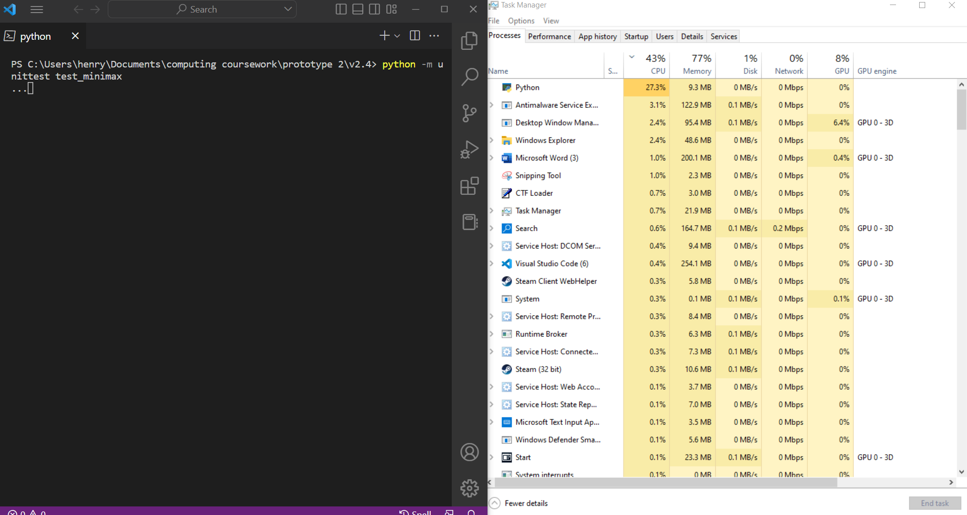

As tasks finish the number of workers decreases. As my computer has 4 physical cores and 8 logical cores, near 100% CPU usage can continue until there are less than 4 threads. At this point each thread can only use 25% of the available CPU power. This means that the test doesn’t use the CPU fully at the end. This is only problematic is one of the games is particularly long and tends to stalemate as the next test cannot begin until this one has finished.

The first time I created the randobot and ran the test for depth 1 I found the issue where the game was resulting in a stalemate where it was endlessly repeating. I looked it up and in chess if a game state is repeated 3 times a stalemate occurs. I implemented this using the hash and frequency table in the Game class. This does end the game when this occurs. However it does mean that that the minimax function is unaware that a stalemate can occur this way as the logic isn’t happening in the board state class. This shouldn’t be an issue however as, when an infinite loop occurs the minimax will anticipate that its mean evaluation won’t change and so the stalemate wouldn’t affect its behaviour greatly anyway.

I have added this to my unit test as bots of similar skill level may sometimes draw. This can be specified in the test criteria.

I also recorded the utility values of the various tests in CSV files so that it could be graphed. I had a problem with this where the workers from each thread were all adding to the file, making it a useless mess. The fix was to add a .copy()

    # tests basic minimax vs random moves

    def test_vanilla_depth_1_vs_randotron(self):

        # 10 trials as outcome is linked to a random behaviour

        # trials = 10

        trials = 5

        # test package generated to include relevant data and logic (bots and success criteria)

        test_data = {

            "description": "test: depth 1 vanilla vs randotron",

            "good_bot": Good_Bot(depth=1, check_extra_depth=False),

            "bad_bot": Random_Bot(),

            "success_criteria": Success_Criteria(allow_stalemate_3_states_repeated=True),

            "write_to_csv": False

        }

        # only trial will write to a csv

        test_data_but_to_csv = test_data.copy()

        test_data_but_to_csv["write_to_csv"] = True

        self.check_test_results(

            pool_jobs(

                (trials-1) * [test_data] +  [test_data_but_to_csv]

            )

        )

The issue was that I was passing the dictionary by reference to a new variable and so I wasn’t mutating one test to use the CSV file but all of them.

This issue was particularly frustrating as I was wating hours for a set of corrupted data.

I have left my unit test running overnight and in 9 hours it still hasn’t finished. The depth 3 vs depth 2 and depth 3 vs randotron tests haven’t finished. This highlights an issue with the minimax testing as the depth 3 tests far too long. I should still be able to analyse some of the other data:

Here is the data to illustrate, I added columns D and E and then created a graph

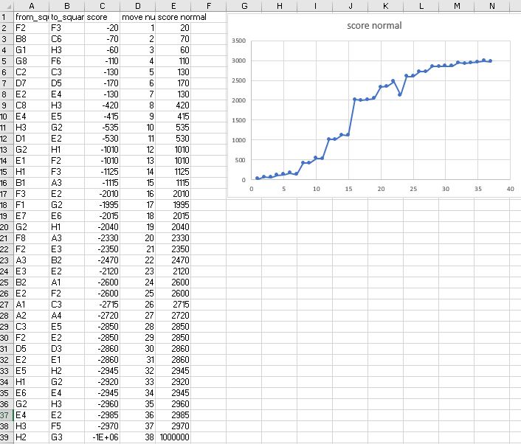

It shows the static evaluations and how it improves for the computer until a win

I will now show some of the graphs:

Depth 1 advanced vs Ranotron (ends in a win)

Depth 1 advanced vs depth 1 vanilla (ends in stalemate 3 repeat)

Depth 2 advanced vs Ranotron (ends in win):

Depth 2 advanced vs depth 1 advanced (deterministic: win every time):

Depth 3 advanced vs depth 1 advanced (deterministic: win every time)

Depth 3 vs depth 2:

Depth 1 vanilla vs Ranotron:

I found analysing these graphs to be very interesting. It seems that both depth 1 and depth 2 can occasionally stalemate with Ranotron. It also seems that depth 1 vanilla vs advanced can stalemate. I believe that this is because they are quite well matched algorithms therefore the better one can only guarantee win or draw.

I thought It was also nice to see how depth 3 vs depth 1 got to checkmate quicker (25 moves) than depth 2 (37 moves). This shows that these algorithms are at there best when playing a rational opponent they can predict.

The antithesis of this is that, while depth 2 wins against depth 1, depth 1 wins quicker against Ranotron. This is because the minimax function assumes the opponent will play optimally. If the opponent isn’t playing rationally then carefully selected move will result in the game lasting longer than necessary.

We also see that depth 3 vs depth 2 resulted in a stalemate however depth 3 was able to maximise its score. This shows how the algorithms are relatively similar and are a match for each other (able to draw)

I hope to get the graphs for the other tests. To do this I will run the tests that haven’t finished again another time. However not finishing is still a outcome. It shows that it would not currently be possible to play a chess game vs depth 3 as it takes too long. This is due to the combinatorial explosion at a higher depth and the exponential time complexity of the algorithm.

We can also see that depth 1 vanilla beat Ranotron faster (29moves vs 37 moves) than vanilla depth 1. We also saw that even though these 2 algorithms drew in a 3 repeat stalemate, the advanced version was able to have a higher static evaluation.

All of these results show that:

* my minimax algorithm works
* a higher depth beat lower depth in effectiveness
* variable depth checking beats without in effectiveness

I also saw from manually running the algorithm with and without, that alpha beta pruning was improving performance. It is unclear whether pre-sorting child nodes has improved performance as this performance increase would only kick in at higher depths which I was unable to run before.

### Testing of Console Chess:

|  |  |  |  |  |  |
| --- | --- | --- | --- | --- | --- |
| **Test No.** | **Aspect Being Tested** | | **Type of test** | **Test Data Used** | **Expected Result** |
| 1 | When I input a correct move, the right piece is moved and the board is shown to me | | valid | Starting positions, then moving a pawn from A2 to A4 | The move will be accepted and the pawn will move |
| **Actual Result** | **Evidence** | | | **Success?** |
| As expected | The below screenshot shows the user move then computer move as expected | | | Full success |

|  |  |  |  |  |  |
| --- | --- | --- | --- | --- | --- |
| **Test No.** | **Aspect Being Tested** | | **Type of test** | **Test Data Used** | **Expected Result** |
| 2 | When I input an invalid move (wrong format), the program asks me to input it again. | | Erroneous | Inputting “x”, “5”, “A8”, “” and “00” | The program should reject these erroneous inputs and force me to provide anther input |
| **Actual Result** | **Evidence** | | | **Success?** |
| The result was as expected. All the validation was working, the message could have been clearer about the desired format of the input. |  | | | Full Success |

|  |  |  |  |  |  |
| --- | --- | --- | --- | --- | --- |
| **Test No.** | **Aspect Being Tested** | | **Type of test** | **Test Data Used** | **Expected Result** |
| 3 | When I input an invalid move the program gives me the valid moves and asks me to try again. | | Invalid | Try to make invalid moves from stating positions. “A1” to A2”, “A2 to A5” “D4, D5”, “C2 to C2”. “B6 to B4” | The program will say that the input move is invalid and ask for a different input and ask me to give a different input. |
| **Actual Result** | **Evidence** | | | **Success?** |
| As expected |  | | | Full Success |

|  |  |  |  |  |  |
| --- | --- | --- | --- | --- | --- |
| **Test No.** | **Aspect Being Tested** | | **Type of test** | **Test Data Used** | **Expected Result** |
| 4 | The program can handle losing to checkmate | | valid | I used a board state one move form checkmate where white wins. | The program should output that the game has ended, who has won and not allow me to continue to move. |
| **Actual Result** | **Evidence** | | | **Success?** |
| As expected | Screenshot shows user winning by checkmate | | | Full success |

|  |  |  |  |  |  |
| --- | --- | --- | --- | --- | --- |
| **Test No.** | **Aspect Being Tested** | | **Type of test** | **Test Data Used** | **Expected Result** |
| 5 | The program tries to win by checkmate | | valid | I used a board state one move form checkmate where black wins. | The program should make the move to win by checkmate. It should then prevent the game form continuing and give the appropriate output. |
| **Actual Result** | **Evidence** | | | **Success?** |
| As expected | This screenshot show the computer winning | | | Full success |

All these test passed showing that the Game Manager class is working. I will make significant improvements to the user interface in prototype 3.

## Validation:

With regards to validation, some was added in the game class and console chess program. This included:

* invalid input for users move (not chess squares) 🡪 value error
* illegal move 🡪 illegal move error
* not the users turn to go 🡪not user turn error

This validation worked well enough to allow for the console chess game to be robust.

However, the intended use for this engine is in a webserver as part of a full stack website. This means that I will need both client side and server side validation. The server side validation will be added to the flask server.

I intend to add more robust validation when I write the flask server, the chess engine will assume that the inputs it gets are valid.

## Feedback from Stakeholders

I received feedback from a stakeholder who played the chess game:

They were very impressed that is could play chess and, in their game, the pawn forward 2 bug didn’t arise.

Regarding the user interface they liked:

* the fact you could see the letters and numbers at the side of the board
* the fact that if printed out the computer’s move
* the fact that it printed out check
* the fact that it correctly prevented illegal moves when in check
* the fact that it took pieces of high value when given the opportunity

They suggested:

* that I find a way of clearing the console / text output after the computer’s move so that the user only sees the one relevant board and not many older ones if they scroll up.

What I took from this feedback:

I will keep this suggestion in mind if I am unable to get the GUI to work in the next protype. I will also consider adding letters and squares to the edges of the chess board in my GUI. While the user will input their moves by clicking, this will help contextualise the move history.

I did have an issue with the minimax function where the static evaluations were not what they should have been. I realised that the static evaluation for the starting positions was not 0. To correct this I made a test and then reviewed my code. The corrections was to flip the value matrices for black pieces as the matrices were not symmetrical and were from white’s perspective. This corrections was easy as it could be made just in the pieces class.

    # this should use the position vector and value matrix to get the value of the piece

    def get_value(self, position_vector: Vector):

        # flip if black as matrices are all for white pieces

        if self.color == "W":

            row, column = 7-position_vector.j, position_vector.i

        else:

            row, column = position_vector.j, position_vector.i

        # return sum of inherent value + value relative to positon on board

        return self._value + self._value_matrix[row][column]

I also attempted to refactor the King.movement_vecotor method, accidently breaking it. This was an easy fix as I ran the unit tests which highlighted the issue.

### Changes/Fixes that I now plan to make to the design or code as a result of testing and feedback

* I intend to make changes to the command line interface (CLI) to make it clearer by removing old boards
* I intend to make the minimax function more efficient so that I can run at depth 3 in a reasonable time frame.
* I intend to fix the pawn forward 2 issue and add a test to ensure that it is fixed.

## Evaluation

Overall I am extremely happy with this iteration.

I feel that in this iteration I accomplished my ambitions goals and created a robust chess engine complete with a chess bot that can beat me (I believe minimax depth 3 with variable depth surpasses my average ability). With odd exceptions such as the pawn move forward 2 bug, everything is fully functional and tested. This is a lesson in how testing isn’t always perfect however, without the automated testing, I don’t think I would have succeeded.

My stakeholders seem very impressed that my program can actually play chess in an intelligent manner. I am also pleasantly surprised by how well the final product has turned out.

While my testing was not a complete success (as expected) it was invaluable. My pieces module ended up having the most undiagnosed issues so in hindsight I should have tested it more thoroughly. I realised that most of the time testing was not writing tests but debugging functions. Because tests were quick to write I approached the problem like an engineer and wrote many. I was extremely happy with the results. They allowed me to debug essential function to allow my minimax function to work.

Evidence of testing (excluding minimax tests)

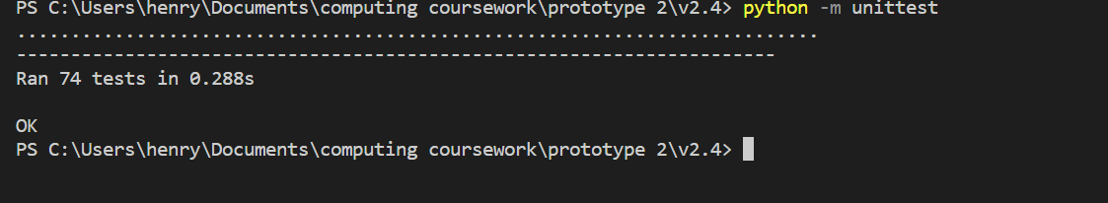

The interface was not a focus of the project and so it received limited time investment. However, I was able to make the interface clear to my stakeholders by using standard chess symbols for pieces and standard coordinates. Because of this I think that the interface was also, considering requirements and expectations at this state, a success.

This prototype was a success as it was able to achieve the specified aims beyond the bare minimum. This will make producing the next prototype much easier as I have already created a robust chess engine. Due to the robust testing, including testing of the console chess program and the chess engine itself I feel confident that the following success criteria items have been achieves / worked towards:

* Implement validation what will be used in the final GUI to achieve success criteria items 2, 3, 4, 28, 29
* Implement a working and more efficient move engine to achieve success criteria items 9, 10, 11, 12
* Implement a working game manager to keep track of an manage the chess game:

14

* Woking towards efficiency with the minimax algorithm: item 26

# Iterative Development – Prototype 3:

The aim for this prototype is to bring together all of the elements created in the previous prototypes and improve them to create a final program. For example, I will use my exploration into sockets form prototype 1 and the chess computer that I created in prototype 2.

This final prototype should include a graphical user interface in the form of a webpage. The interface should be interactive and should be connected to the server, allowing for a full chess game where the computer make moves to be facilitated.

## Functionality that the prototype should have:

The prototype should aim to meet all desirable, high priority and essential components of the success criteria. To do this it must meet all of the 31 points laid out in the design specification within the design section. This should result in this prototype achieving all the following success criteria items:

1-13, 15, 17, 19, 24-32.

To do this the move engine must be optimised. Then the code for the client and server API handlers must be created. Then client side code including the Chess_Board class and DOM methods must be created.

## Annotated code screenshots with description:

The first part of this project was to improve the structure of the python project. The previous structure uses many python files in the same folder for easy import statements. The new directory structure has divided the code up logically into different modules. Here is the directory tree.

PS C:\Users\henry\Documents\computing coursework\prototype 6> tree /f

Folder PATH listing for volume OS

Volume serial number is 4ED8-B070

C:.

│   app.py

│   run_tests_fast.ps1

│   run_tests_slow.ps1

│   schema_playground.ipynb

│   __init__.py

│

├───.vscode

│       settings.json

│

├───assorted

│   │   chess_exceptions.py

│   │   general.py

│   │   safe_hash.py

│   │   __init__.py

│   │

│   └───__pycache__

│           assorted.cpython-310.pyc

│           chess_exceptions.cpython-310.pyc

│           general.cpython-310.pyc

│           random_board_state.cpython-310.pyc

│           safe_hash.cpython-310.pyc

│           __init__.cpython-310.pyc

│

├───chess_functions

│   │   board_state.py

│   │   pieces.py

│   │   test_fast_board_state.py

│   │   test_fast_pieces.py

│   │   test_fast_vector.py

│   │   vector.py

│   │   __init__.py

│   │

│   ├───test_data

│   │   ├───board_state

│   │   │       color_in_check.yaml

│   │   │       game_over.yaml

│   │   │       generate_all_pieces.yaml

│   │   │       generate_legal_moves.yaml

│   │   │       generate_pieces_of_color.yaml

│   │   │       piece_at_vector.yaml

│   │   │

│   │   ├───pieces

│   │   │       test_board_populated.yaml

│   │   │       test_empty_board.yaml

│   │   │

│   │   └───vector

│   │           from_square.yaml

│   │           vector_add.yaml

│   │           vector_in_board.yaml

│   │           vector_multiply.yaml

│   │           vector_to_square.yaml

│   │

│   └───__pycache__

│           assorted.cpython-310.pyc

│           board_state.cpython-310.pyc

│           pieces.cpython-310.pyc

│           test_board_state.cpython-310.pyc

│           test_fast_board_state.cpython-310.pyc

│           test_fast_pieces.cpython-310.pyc

│           test_fast_vector.cpython-310.pyc

│           test_pieces.cpython-310.pyc

│           test_vector.cpython-310.pyc

│           vector.cpython-310.pyc

│           __init__.cpython-310.pyc

│

├───chess_game

│   │   console_chess.py

│   │   game.py

│   │   game_web.py

│   │   test_fast_game.py

│   │   __init__.py

│   │

│   ├───test_data

│   │   └───test_save_and_restore

│   │           saved_game.game

│   │

│   └───__pycache__

│           console_chess.cpython-310.pyc

│           game.cpython-310.pyc

│           game_web.cpython-310.pyc

│           game_with_difficulty.cpython-310.pyc

│           test_fast_game.cpython-310.pyc

│           __init__.cpython-310.pyc

│

├───database

│   │   create_database.py

│   │   database.db

│   │   handle_games.py

│   │   models.py

│   │   __init__.py

│   │

│   └───__pycache__

│           create_database.cpython-310.pyc

│           handle_games.cpython-310.pyc

│           models.cpython-310.pyc

│           move_model.cpython-310.pyc

│           move_model_schema.cpython-310.pyc

│           __init__.cpython-310.pyc

│

├───move_engine

│   │   broken_minimax_parallel.py

│   │   cache_managers.py

│   │   minimax.py

│   │   minimax_parallel.py

│   │   parallel_minimax_testing.py

│   │   test_slow_timed_minimax_engine.py

│   │   __init__.py

│   │

│   ├───test_reports

│   │   ├───test_depth_2_vs_depth_1

│   │   │       test_1.csv

│   │   │       test_1.games

│   │   │

│   │   └───test_depth_3_vs_depth_2

│   │           test_1.csv

│   │           test_1.games

│   │

│   └───__pycache__

│           cache_managers.cpython-310.pyc

│           minimax.cpython-310.pyc

│           minimax_parallel.cpython-310.pyc

│           test_minimax.cpython-310.pyc

│           test_slow_minimax.cpython-310.pyc

│           test_slow_timed_minimax_engine.cpython-310.pyc

│           test_slow_time_minimax.cpython-310.pyc

│           test_time_minimax.cpython-310.pyc

│           __init__.cpython-310.pyc

│

│

├───schemas

│   │   cache_item_schema.py

│   │   socket_schemas.py

│   │   __init__.py

│   │

│   └───__pycache__

│           cache_item_schema.cpython-310.pyc

│           move_schema.cpython-310.pyc

│           socket_schemas.cpython-310.pyc

│           __init__.cpython-310.pyc

│

├───test_reports

│   ├───test_bots_by_depth

│   │       test_depth_2_vs_depth_1.csv

│   │       test_depth_3_vs_depth_2.csv

│   │

│   ├───test_bots_by_time

│   │       test_10s_timed_bot_vs_2s_timed_bot.csv

│   │       test_10s_timed_bot_vs_5s_timed_bot.csv

│   │       test_12s_timed_bot_vs_2s_timed_bot.csv

│   │       test_13s_timed_bot_vs_5s_timed_bot.csv

│   │       test_14.0s_timed_bot_vs_10s_timed_bot.csv

│   │       test_15s_timed_bot_vs_5s_timed_bot.csv

│   │       test_17s_timed_bot_vs_2s_timed_bot.csv

│   │       test_20s_timed_bot_vs_10s_timed_bot.csv

│   │       test_20s_timed_bot_vs_5s_timed_bot.csv

│   │       test_21.0s_timed_bot_vs_15s_timed_bot.csv

│   │       test_28.0s_timed_bot_vs_20s_timed_bot.csv

│   │       test_30s_timed_bot_vs_15s_timed_bot.csv

│   │       test_40s_timed_bot_vs_10s_timed_bot.csv

│   │       test_40s_timed_bot_vs_20s_timed_bot.csv

│   │       test_60s_timed_bot_vs_30s_timed_bot.csv

│   │       test_6s_timed_bot_vs_2s_timed_bot.csv

│   │       test_7s_timed_bot_vs_2s_timed_bot.csv

│   │       test_9s_timed_bot_vs_5s_timed_bot.csv

│   │

│   └───test_depth_vs_randotron

│           test_depth_1_num_1.csv

│           test_depth_1_num_2.csv

│           test_depth_1_num_3.csv

│           test_depth_2_num_1.csv

│           test_depth_2_num_2.csv

│           test_depth_2_num_3.csv

│

├───website

│   │   flask_server.py

│   │   secret_key.key

│   │   __init__.py

│   │

│   ├───static

│   │       chess_class.js

│   │       favicon.ico

│   │       initial_game_data.js

│   │       initial_game_data.json

│   │       main.js

│   │       style.css

│   │       vector.js

│   │

│   ├───templates

│   │       chess_game.html

│   │

│   └───__pycache__

│           flask_server.cpython-310.pyc

│           __init__.cpython-310.pyc

│

This has allowed each python module to be self-contained like a class. All objects from all files within the folder can be accessed internally. The __init__.py files dictate which objects will be exported as part of the module.

I will now explain each module in turn and any changes that were made.

## Assorted Module:

This module contained general functions, variables and objects that were small and used throughout the whole program.

Here is the __init__.py file for the module which decides which objects are exported by the module:

# this file decides that components from within this folder are exported as part of the assorted module

from .general import ARBITRARILY_LARGE_VALUE, cache_decorator, dev_print

from .safe_hash import safe_hash

from .chess_exceptions import TimeOutError, InvalidMove, NotUserTurn, NotComputerTurn, UnexplainedErroneousMinimaxResultError

And is the code that for these objects:

### General.py

# this file is just a file of short assorted constants and functions that are general in use

# It only contains small functions as I have tried to group large, similar functions logically in there own file

# from functools import lru_cache

# cache_decorator = lru_cache(maxsize=10000)

def cache_decorator(func): return func

# this is used in the static evaluation and minimax process. It is used to represent infinity in a way that still allows comparrison

ARBITRARILY_LARGE_VALUE = 1_000_000

# this function is relatively redundant but allows for print statements in debugging

# in later iteration this may be replaced with logging.

# it is useful as it allows for DEBUG print statements without needing to remove them when finished

DEBUG = False

def dev_print(*args, **kwargs):

    if DEBUG:

        print(*args, **kwargs)

In the above file:

* The dev print method was rarely used as I found it easier to comment out print statements that were used in development
* The ARBITRARILY_LARGE_VALUE variable is used to represent infinity. This is needed to provide static evaluations of board states that are checkmate or to set the initial values for alpha and beta in the move engine.
* The cache decorator was applied to various function within the Chess Engine module. You can see that ultimately I set the decorator to do nothing as the use of the decorator made to program noticeable slower. This was not at all the expected outcome.

### chess_exceptions.py

# this error is used to cause the timed minimax function

# raising and then catching this error allows for the algorithm to be self-interrupting

class TimeOutError(Exception):

    pass

# this is an exception that allows for the game data to be bound to it

# this allows for the relevant chess game that caused the error to be examined afterwards

# it is a normal exception except the constructor has been modified to save the game data as a property

class __ChessExceptionTemplate__(Exception):

    def __init__(self, *args, **kwargs) -> None:

        # none if key not present

        self.game = kwargs.pop("game", None)

        super().__init__(*args, **kwargs)

# these are custom exceptions.

# these are used primarily by the game class

# they contain no logic but have distinct types allowing for targeted error handling

class InvalidMove(__ChessExceptionTemplate__):

    pass

class NotUserTurn(__ChessExceptionTemplate__):

    pass

class NotComputerTurn(__ChessExceptionTemplate__):

    pass

class UnexplainedErroneousMinimaxResultError(__ChessExceptionTemplate__):

    pass

The above exceptions could hold data about a chess game but generally their functionality and logic wasn’t used. The were used as specific names expressions that could be raised and caught using error handling in the Game Manager and Move Engine Modules.

from hashlib import sha256

# this hash function produces an integer hash of a python object

# it is necessary as the in built hash function produces different hashes for the same object,

# this function always produces the same hash for a given object, this allows the hash to be stored in a database for later use

def safe_hash(item):

        # convert item (usually tuple) to string

    encoded_string = repr(item).encode("utf-8")

    # produce a hexadecimal string hash of the object

    hex_hash = sha256(encoded_string).hexdigest()

    # convert this to an integer

    # int_hash = int(hex_hash, 16)

    # return int_hash

    return hex_hash

This hash function that uses sha256 was needed as the python hash function produces a smaller hash. In addition the value that the hash function produces for the same input changes as the program is stopped and rerun. This means that if I want to store the hash of a python object in a persistent database, I will need to use the above hash function.

## Chess Functions Module (Chess Engine):

Within this module there have been minimal changes. This module was completed and tested in prototype 2.

The main changes were:

* A hash function was used to hash the board state for use in a minimax cache database entry
* The create random board state function was moved to the board state file (to avoid it being repeated elsewhere)

# this function produces a random board state

# this is done by selecting and then implementing a legal move at random up to so many moves

# it is used in unittest

def random_board_state(moves: int):

    board_state = Board_State()

    # keep trying to get a non over board state

    while True:

        try:

            # iteratively pick a move at random and implement it until the right number of move is reached

            for _ in range(moves):

                legal_moves = list(board_state.generate_legal_moves())

                assert len(legal_moves) > 0

                random_move = random_choice(legal_moves)

                board_state = board_state.make_move(*random_move)

        except AssertionError:

            # if no legal moves (over) then try again

            continue

        else:

            return board_state

The board state module had the following __init__.py file that decided what functions it exports:

# this file decided which function and classes from within this folder should be exported as part of the chess functions module.

from .board_state import Board_State, random_board_state

from .vector import Vector

from .pieces import PIECE_TYPES, Piece, Pawn, Knight, Bishop, Rook, King, Queen

Other changes that were made were due to failed tests. These will be explained later.

### Move Engine:

This module is responsible for executing an efficient minimax search to determine the computer’s move. I have heavily modified the code to add various optimisations.

Here is the file minimax.py:

# import local modules

# cannot import game as causes circular import, if necessary put in same file

from board_state import Board_State

from assorted import ARBITRARILY_LARGE_VALUE

from vector import Vector

# my minimax function takes as arguments:

# Board_State, is_maximiser, alpha and beta (used for pruning) and check_extra_depth (produces better outcome but slower)

# it returns

# score, child, move

def minimax(board_state: Board_State, is_maximizer: bool, depth, alpha, beta, check_extra_depth=True):

    # sourcery skip: low-code-quality, remove-unnecessary-else, swap-if-else-branches

    # assume white is maximizer

    # when calling, if give appropriate max min arg

    # base case

    # if over or depth==0 return static evaluation

    over, _ = board_state.is_game_over_for_next_to_go()

    if depth == 0 or over:

        # special recursive case 1

        # examine terminal nodes that are check to depth 2 (variable depth)

        # to avoid goose chaises, extra resources are allowed if check not already explored

        if board_state.color_in_check() and check_extra_depth and not over:

            # print(f"checking board state {hash(board_state)} at additional depth due to check")

            return minimax(

                board_state=board_state,

                is_maximizer=is_maximizer,

                depth=2,

                alpha=alpha,

                beta=beta,

                check_extra_depth=False

            )

        else:

            # static eval works for game over to

            return board_state.static_evaluation(), None, None

    # define variables used to return more that just score (move and child)

    best_child_game_state: Board_State | None = None

    best_move_vector: Vector | None = None

    # function yields move ordered by how favorable they are (low depth minimax approximation)

    def gen_ordered_child_game_states():

        # this function does a low depth minimax recursive call (special recursive case 2) to give a move a score

        def approx_score_move(move):

            child_game_state = board_state.make_move(*move)

            return minimax(

                board_state=child_game_state,

                depth=depth-2,

                is_maximizer=not is_maximizer,

                alpha=alpha,

                beta=beta,

                check_extra_depth=False

            )[0]

            # print(f"approx_score_move(move={move!r})  ->  {result!r}")

        # if depth is 1 or less just yield moves form legal moves

        if depth <= 1 :

            yield from board_state.generate_legal_moves()

        # else sort them

        else:

            # sort best to worse

            # sort ascending order if minimizer, descending if maximizer

            yield from sorted(

                board_state.generate_legal_moves(),

                key=approx_score_move,

                reverse=is_maximizer

            )

    if is_maximizer:

        # set max to -infinity

        maximum_evaluation = (-1)*ARBITRARILY_LARGE_VALUE

        # iterate through moves and resulting game states

        for position_vector, movement_vector in gen_ordered_child_game_states():

            child_game_state = board_state.make_move(from_position_vector=position_vector, movement_vector=movement_vector)

            # evaluate each one

            # general recursive case 1

            evaluation, _, _ = minimax(

                board_state=child_game_state,

                is_maximizer=not is_maximizer,

                depth=depth-1,

                alpha=alpha,

                beta=beta,

                check_extra_depth=check_extra_depth

            )

            # update alpha and max evaluation

            if evaluation > maximum_evaluation:

                maximum_evaluation = evaluation

                best_child_game_state = child_game_state

                best_move_vector = (position_vector, movement_vector)

                alpha = max(alpha, evaluation)

            # where possible, prune

            if beta <= alpha:

                # print("Pruning!")

                break

        # once out of loop, return result

        return maximum_evaluation, best_child_game_state, best_move_vector

    else:

        minimum_evaluation = ARBITRARILY_LARGE_VALUE

        for position_vector, movement_vector in gen_ordered_child_game_states():

            child_game_state = board_state.make_move(from_position_vector=position_vector, movement_vector=movement_vector)

            evaluation, _, _ = minimax(

                board_state=child_game_state,

                is_maximizer=not is_maximizer,

                depth=depth-1,

                alpha=alpha,

                beta=beta,

                check_extra_depth=check_extra_depth

            )

            if evaluation < minimum_evaluation:

                minimum_evaluation = evaluation

                best_child_game_state = child_game_state

                best_move_vector = (position_vector, movement_vector)

                beta = min(beta, evaluation)

            if beta <= alpha:

                # print("Pruning!")

                break

        return minimum_evaluation, best_child_game_state, best_move_vector

I have implemented decomposed the large minimax function into sub function within a class. Some parameters are provided directly to the minimax method within the class while others that configure the move engine (e.g. is cache allowed) are instead parameters of the objects constructor. This has helped reduce the parameters to the minimax method which helps avoid unnecessary complexity.

To use the minimax algorithm, the object is initialised and then called like a function. Calling the object in this way runs the __call__ method which runs the minimax_first_call method. This method is run only the first time the minimax function is called (not on any recursive calls). The first call handler function is responsible for starting up the cache manager object and using the validator function to check the minimax output if enables. The cache handler objects allow for minimax data to be cached to improve the functions efficiency. Some of the objects has a start up and cool down sequence (e.g. opening and then disposing of a database session). The use of a context manager vie the “with” command calls the __enter__() method on the cache manager object, then completed the minimax search and then calls the __exit__() method on the object.

The method names minimax if responsible for the bulk of the logic behind the minimax algorithm in this implementation although some large blocks of logic have been extracted into separate private methods.

The core principles behind the algorithm remain the same. It has a base case to stop recurring and evaluate a terminal node. A minimax search of a given Board_State object at a depth of N then uses the recursive case. It iterates though the legal moves of the board and then recursively evaluates the child nodes with a depth of n-1. It then updates its pruning variables and its best variables. Once it stops iterating it returns the best move and score.

In the above algorithm, the base case has been abstracted out into another function called pseudo_base_case(). This method will normally returns a static evaluation of the board (base case) but if check has been encountered, it can search to an additional depth using a hidden recursive case. This optimisation should improve the quality of the result.

Minimax method also extracts out the logic of getting the legal moves and child board states to another method called generate_move_child. This method uses depth N-2 searches (another hidden recursive case) to estimate the score of each of the child nodes before they are searched. This allows it to sort the child nodes in order from best to worst. This should improve the frequency by which parts of the tree can be pruned. In addition, if a depth N-1 search has already been completed and cached, then this sorting will not cost any additional computations.

The only other change is that the minimax method checks the cache first to see if it can retrieve the result and skip the rest of the function. Then if this wasn’t possible, at the end of the function, the search result is added to the cache. Recursive sub-searches should also be able to retrieve and save results to and from the cache. This means that even if the cache doesn’t already contain the whole search, it may still contain part of it. This will save computations and improve average time complexity at the cost of a worse space complexity.

I then created a series objects that were designed to allow me to easily cache the minimax search results. Each object has the same interface meaning that they can be used in the same way. All logic around how it stores the results is self-contained and abstracted.

Cache_managers.py

# import from external modules

import os

import json

from time import perf_counter

# import local modules

from assorted import safe_hash

from chess_functions import Board_State, Vector

from database import create_session, end_session, persistent_DB_engine, volatile_RAM_engine, Minimax_Cache_Item

from schemas import minimax_cache_item_schema

# create an blank object with no logic that can be used with a context manager

class Blank_Context():

    def __enter__(self, *args, **kwargs):

    # def __exit__(self, exception_type, exception_value, traceback):

        pass

    def __exit__(self, *args, **kwargs):

        pass

# ram cache doesn't need access to a context manager so it uses the blank one

class RAM_cache(Blank_Context):

    # cache is stored in a local dictionary property in the ram cache object

    def __init__(self) -> None:

        self.memoization_cache = dict()

    def cache_size(self):

        return len(self.memoization_cache)

    # the result of a minimax call is added to the cache

    def add_to_cache(self, board_state: Board_State, depth, score, move):

        # moves are stored as tuples of integers

        def serialize_move(move):

            if move is None:

                return None

            return (

                (move[0].i, move[0].j),

                (move[1].i, move[1].j)

            )

        # ensure that the cache exists in the memoization_cache property

        assert self.memoization_cache is not None

        # can use a board_state as a key as it is hashable

        # the board state hash is used as the key within the dictionary (which acts as a hash table)

        board_state_hash = board_state.database_hash()

        # print(f"CALL: add_to_cache(self, board_state={hash(board_state)} depth={depth}, score={score}, move={move}")

        # print(f"self.memoization_cache.get(board_state_hash) is None    -->    {self.memoization_cache.get(board_state_hash) is None}")

        # decide if the cache should be updated based on whether the record already existed and if so, its depth

        if self.memoization_cache.get(board_state_hash) is None:

            needs_update = True

        else:

            best_depth_in_cache = self.memoization_cache[board_state_hash]["depth"]

            # print(f"best_depth_in_cache < depth    -->    {best_depth_in_cache} < {depth}   --->   {best_depth_in_cache < depth}")

            needs_update = best_depth_in_cache < depth

        # print(f"Cache:  {self.memoization_cache}")

        # if need an update then add the record (lesser depth cache overwritten)

        if needs_update:

            new_data_item = {

                "depth": depth,

                "score": score,

                "move": serialize_move(move)

            }

            self.memoization_cache[board_state_hash] = new_data_item

            # if depth >= 1:

            # print(f"New data {board_state_hash} added to cache:   {new_data_item}")

            # print(f"new_cache_size:   {self.cache_size()}")

        # print(f"Cache needed updating:   {needs_update}")

    # this function retrieves an item form cache

    def search_cache(self, board_state, depth):

        # move is converted from tuple of integers back to vectors when deserialized

        def deserialize_move(serialised_move):

            if serialised_move is None:

                return None

            return (

                Vector(*serialised_move[0]),

                Vector(*serialised_move[1])

            )

        assert self.memoization_cache is not None

        # get the hash ov hte board state

        # board_state_hash = hash(board_state)

        board_state_hash = board_state.database_hash()

        # if not in cache, return none

        if self.memoization_cache.get(board_state_hash) is None:

            # if depth >= 2:

            #     print(f"item {board_state_hash} not in cache (depth={depth})")

            return None

        # else check the depth is adequate and return if appropriate

        else:

            best_depth_in_cache = self.memoization_cache[board_state_hash]["depth"]

            record_useful = best_depth_in_cache >= depth

            if record_useful:

                # if depth >= 2:

                # print(f"RAM_Cache used for {board_state_hash}:   {self.memoization_cache[board_state_hash]}")

                data_item = self.memoization_cache[board_state_hash].copy()

                data_item["move"] = deserialize_move(data_item["move"])

                return data_item

            else:

                # if depth >= 2:

                    # print(f"cache not useful for item {board_state_hash}:  {self.memoization_cache[board_state_hash]}, required depth is {depth}")

                # print(f"cache searched but not used")

                return None

# this function creates a persistent cache in a json file

class JSON_Cache(RAM_cache):

    # when the object is created, load the contents of the json file into the memoization cache variable

    def __init__(self, file_path=None) -> None:

        # print("Initializing json cache")

        if file_path is not None:

            self.file_path = file_path

        else:

            self.file_path = r"./database/minimax_cache.json"

        # default

        self.memoization_cache = {}

        # try get data from file

        if os.path.exists(self.file_path):

            with open(self.file_path, "r") as file:

                content = file.read()

            try:

                assert content != "", "Json file was blank / empty"

                cache_data = json.loads(content)

                # fix that in json, board state hash key is sting

                new_items = map(

                    lambda item: (int(item[0]), item[1]),

                    cache_data.items()

                )

                cache_data = dict(tuple(new_items))

                self.memoization_cache = cache_data

            except Exception as e:

                # print(e)

                # print("Failed to load json cache data so using blank cache")

                pass

    # inherited ram cache method add to and retrieve cache form the memoization cache variable

    # write the memoization cache dictionary to a json file

    def save(self):

        print(f"Saving cache (size={self.cache_size()}) to json file")

        with open(self.file_path, "w") as file:

            file.write(

                json.dumps(

                    self.memoization_cache

                )

            )

    # do this when the cache manager is closed by the context manager

    def __exit__(self, *args, **kwargs):

        self.save()

# this json cache doesn't save automatically

class JSON_Cache_Manual_Save(JSON_Cache):

    def __exit__(self, *args, **kwargs):

        pass

# database cache connects to the database to store minimax cached results

# it uses a database in RAM for small cache and a persistent database for searches at a greater depth

class DB_Cache():

    # by default, depth 0 uses ram cache and greater depth uses persistent cache

    def __init__(self, min_DB_depth=1):

        # set the min depth parameter as a property and then define other properties with starting values

        self.min_DB_depth = min_DB_depth

        self._RAM_cache = None

        self._DB_session = None

        self.engaged = False

        # a cached depth 3 call can be used if a depth 2 call is needed

        self.allow_greater_depth = True

        self.time_delta_DB = 0

        self.time_delta_schemas = 0

        self.checks_to_cache = 0

        self.retrieved_item = 0

        self.items_added = 0

    def __enter__(self, *args, **kwargs):

        # when the context manager is used and the boot up sequence runs (this method)

        # a database session is created (using the database module)

        # assert all(e is None for e in (self._RAM_cache, self._DB_session))

        assert not self.engaged, "Must not be engaged (entered) already to enter"

        self.engaged = True

        # these variables keep track of various data points while the cache is used within a context manager

        self.time_delta_DB = 0

        self.time_delta_schemas = 0

        self.checks_to_cache = 0

        self.retrieved_item = 0

        self.items_added = 0

        # this allows for the cache manager to be entered multiple times on accident without making multiple sessions

        # self._RAM_cache = RAM_cache()

        # self._persistent_DB_session = scoped_session(sessionmaker(bind=persistent_DB_engine))

        # self._volatile_RAM_session = scoped_session(sessionmaker(bind=volatile_RAM_engine))

        self._persistent_DB_session = create_session(persistent_DB_engine)

        self._volatile_RAM_session = create_session(volatile_RAM_engine)

    def __exit__(self, *args, **kwargs):

        # when the context manager runs the close function of the cache manager (this method)

        # the session objects are closed and discarded and tracker variables are set back to 0

        assert self.engaged, "Must be engaged (entered) to exit"

        self.engaged = False

        end_session(self._persistent_DB_session)

        self._persistent_DB_session = None

        end_session(self._volatile_RAM_session)

        self._volatile_RAM_session = None

        # print(f"Cache session lasted {round(self.time_delta_DB, 2)}+{round(self.time_delta_schemas, 2)} sec (DB + schema time): {self.checks_to_cache} checks made, {self.retrieved_item} items retrieved, {self.items_added} items added")

        self.time_delta_DB = 0

        self.time_delta_schemas = 0

        self.checks_to_cache = 0

        self.retrieved_item = 0

        self.items_added = 0

    def _search_DB_cache(self, session, board_state, depth):

        # this function hashes the board state and searches the database for cache corresponding to that hash

        # board_state_hash = str(hash(board_state))

        board_state_hash = board_state.database_hash()

        start = perf_counter()

        # cache must have a matching hash and a sufficient depth

        # ORM allows for queries to be written in a pythonic way

        if self.allow_greater_depth:

            result = session.query(Minimax_Cache_Item)\

                .where(

                    Minimax_Cache_Item.board_state_hash == board_state_hash

            )\

                .where(

                    Minimax_Cache_Item.depth >= depth

            )\

                .first()

        else:

            result = session.query(Minimax_Cache_Item)\

                .where(

                    Minimax_Cache_Item.board_state_hash == board_state_hash

            )\

                .where(

                    Minimax_Cache_Item.depth == depth

            )\

                .first()

        stop = perf_counter()

        self.time_delta_schemas += stop - start

        # if not item found then return none

        if result is None:

            return None

        start = perf_counter()

        # use the schema object to deserialize the cached item before returning it.

        result = minimax_cache_item_schema.dump(result)

        stop = perf_counter()

        self.time_delta_schemas += stop - start

        return result

    def _add_to_DB_cache(self, session, board_state: Board_State, score, depth, move):

        # this function adds an item to the cache

        start = perf_counter()

        # board state is hashed

        # print("adding item to database cache")

        # board_state_hash = str(hash(board_state))

        board_state_hash = board_state.database_hash()

        # if depth >= 2:

        #     print(f"Adding item {board_state_hash} at depth {depth} to cache")

        # new database entry item created with schema

        new_item = minimax_cache_item_schema.load(

            dict(

                board_state_hash=board_state_hash,

                score=score,

                depth=depth,

                move=move

            )

        )

        stop = perf_counter()

        self.time_delta_schemas += stop - start

        start = perf_counter()

        # other searches at a lesses depth are deleted

        # (assumes cache already checked and the other cache is worse)

        session.query(Minimax_Cache_Item)\

            .where(

            Minimax_Cache_Item.board_state_hash == board_state_hash

        )\

            .delete()

        # print(f"move   -->   {move!r}")

        # print(f"New item:   {new_item!r}")

        # the item is added to the database and committed

        session.add(new_item)

        session.commit()

        stop = perf_counter()

        self.time_delta_DB += stop - start

    def search_cache(self, board_state: Board_State, depth):

        # this function searches the cache

        assert self.engaged, "Context manager must be used"

        self.checks_to_cache += 1

        # not sure why depth sometimes is a single length tuple containing an int

        # here is a quick fix

        if isinstance(depth, tuple):

            if len(depth) == 1:

                depth = depth[0]

        # print(f"(depth, self.min_DB_depth)     -->     {(depth, self.min_DB_depth)}")

        # decide which session to use based on depth

        if depth < self.min_DB_depth:

            session = self._volatile_RAM_session

            # return self._RAM_cache.search_cache(board_state=board_state, depth=depth)

        else:

            session = self._persistent_DB_session

            # return self._search_DB_cache(board_state=board_state, depth=depth)

        # search the cache with this session and then return the result

        result = self._search_DB_cache(session=session, board_state=board_state, depth=depth)

        if result is not None:

            self.retrieved_item += 1

        return result

    def add_to_cache(self, board_state: Board_State, score, depth, move):

        # this function adds to the cache

        # this function assumes that no move valuable cache already exists (it overwrites all other cache)

        assert self.engaged, "Context manager must be used"

        # this is used to tackle any bugs elsewhere in the program

        # it ensures that no invalid cache items are added to the database

        def absolute(x): return x if x >= 0 else 0-x

        if absolute(score) > 1_000_000 or (move is None and depth > 0):

            # don't add erroneous data to cache

            return None

        # decides that session to use based on depth

        if depth < self.min_DB_depth:

            session = self._volatile_RAM_session

            # self._RAM_cache.add_to_cache(board_state=board_state, score=score, depth=depth, move=move)

        else:

            session = self._persistent_DB_session

            # self._add_to_DB_cache(board_state=board_state, score=score, depth=depth, move=move)

        # the caches item is added to the database

        self._add_to_DB_cache(session=session, board_state=board_state, score=score, depth=depth, move=move)

        self.items_added += 1

    # the hash function describes only the data that makes this cache object unique

    def __hash__(self) -> int:

        hash(safe_hash(

            (

                "DB_Cache",

                # self._RAM_cache,

                # self._DB_session,

                self.min_DB_depth,

                self.engaged,

                self.allow_greater_depth,

                # self.time_delta_DB

                # self.time_delta_schemas

                # self.checks_to_cache

                # self.retrieved_item

                # self.items_added

            )

        ))

Here we can see that I created a series of increasingly complex cache managers. I wanted to have a form of persistent cache as this would allow the program to learn. I decided to use a database rather than a json file for this as a database is more scalable and has better look up times. In addition, a database can be accessed simultaneously by many concurrent processes whereas a json file cannot.

I then created some more efficient versions of the matrix algorithm that inherited from the Move Engine Class.

### Minimax_parallel.py

# import external and local modules

# import sys

import multiprocessing

from time import perf_counter

from .minimax import Move_Engine, is_time_expired

from .cache_managers import RAM_cache, DB_Cache

from chess_functions import Board_State

from assorted import ARBITRARILY_LARGE_VALUE, TimeOutError, UnexplainedErroneousMinimaxResultError

# import time

def get_cores():

    return multiprocessing.cpu_count()

    # return multiprocessing.cpu_count()//2

# Classes with the name of JOB are essentially functions that represent a general task that can be completed concurrently

# they are classes as functions cannot be easily piped between threads

# this object represents a job that a concurrent worker should complete,

# I used an object as a function cannot be sent between workers

class Minimax_Sub_Job:

    # contractor: configure bot by setting these parameters as properties

    def __init__(self, board_state, depth, args, kwargs, additional_depth, cache_allowed, max_time=None) -> None:

        # create a cache manager as necessary

        self.cache_allowed = cache_allowed

        self.cache_manager = DB_Cache() if cache_allowed else None

        # create a move engine as necessary

        self.move_engine: Move_Engine = Move_Engine(

            cache_manager=self.cache_manager,

            cache_allowed=cache_allowed,

            additional_depth=additional_depth,

        )

        # assert isinstance(self.move_engine, Move_Engine), f"Minimax_Sub_Job.__init__    self.move_engine of unexpected type {type(self.move_engine)}\n{self.move_engine!r}"

        # assign parameters as properties

        self.board_state: Board_State = board_state

        self.depth = depth

        self.max_time = max_time

        # these are other erroneous argument that could be passed to the minimax call

        self.args = args

        self.kwargs = kwargs

    def __call__(self, legal_moves_sub_array):

        # perform part of a minimax search using a sub set of legal moves

        # print(f"running minimax job with legal moves sub array: (hash={hash(str(legal_moves_sub_array))})")

        # print(f"STARTING sub job on moves segment:   {hash(str(legal_moves_sub_array))}")

        # print(legal_moves_sub_array)d_state,

        # result = self.move_engine.minimax(

        # assert isinstance(self.move_engine, Move_Engine), f"Minimax_Sub_Job.__call__    self.move_engine of unexpected type {type(self.move_engine)}\n{self.move_engine!r}"

        if self.cache_allowed:

            with self.cache_manager:

                result = self.move_engine.minimax(

                    board_state=self.board_state,

                    depth=self.depth,

                    legal_moves_to_examine=legal_moves_sub_array,

                    # is_time_expired = self.is_time_expired,

                    max_time=self.max_time,

                    *self.args,

                    **self.kwargs

                )

        else:

            result = self.move_engine.minimax(

                board_state=self.board_state,

                depth=self.depth,

                legal_moves_to_examine=legal_moves_sub_array,

                # is_time_expired = self.is_time_expired,

                max_time=self.max_time,

                *self.args,

                **self.kwargs

            )

      # print(f"FINISHING sub job on moves segment:   {hash(str(legal_moves_sub_array))}")

        # print(f"Minimax sub job finished (hash={hash(str(legal_moves_sub_array))})")

        return result

# this bot is responsible for performing a low depth search of a move to be used to presort the moves

class Presort_Moves_Sub_Job:

    # construct object

    def __init__(self, depth, board_state: Board_State, cache_allowed, max_time=None) -> None:

    # def __init__(self, depth, board_state: Board_State, move_engine: Move_Engine, cache_allowed, cache_manager, max_time=None) -> None:

        # cache manager parameter may not be needed if the cache manager object is also bound to the move engine

        # assign parameters as properties

        self.depth = depth

        self.board_state = board_state

        # create a cache manager as necessary

        self.cache_allowed = cache_allowed

        self.cache_manager = DB_Cache() if cache_allowed else None

        # create a move engine object

        self.move_engine = Move_Engine(

            presort_moves=True,

            additional_depth=0,

            cache_allowed=self.cache_allowed,

            cache_manager=self.cache_manager,

            # cache_allowed=self.cache_allowed,

            # cache_manager=self.cache_manager,

        )

        # self.cache_allowed = cache_allowed

        # self.cache_manager = cache_manager

        self.is_time_expired = is_time_expired

        self.max_time = max_time

    def __call__(self, move):

        # cache manager already built into the minimax move engine first call method

        # print(f"Presort job using cache manager:   {self.cache_manager!r}")

        # with self.cache_manager:

        #     child = self.board_state.make_move(*move)

        #     child_score, _ = self.move_engine.minimax_first_call(

        #         board_state = child,

        #         depth = self.depth

        #     )

        #     # print("Closing cache")

        #     result = (child_score, move)

        # return result

        # self interrupting

        if is_time_expired(self.max_time):

            raise TimeOutError()

        # score a child, use minimax first call to add cache manager being opened twice

        # no need to say no parallel as a basic move engine is used

        child = self.board_state.make_move(*move)

        if self.cache_allowed:

            with self.cache_manager:

                # child_score, _ = self.move_engine.minimax_first_call(

                child_score, _ = self.move_engine.minimax(

                    board_state=child,

                    depth=self.depth,

                    # is_time_expired = self.is_time_expired,

                    max_time=self.max_time,

                )

        else:

            # child_score, _ = self.move_engine.minimax_first_call(

            child_score, _ = self.move_engine.minimax(

                board_state=child,

                depth=self.depth,

                # is_time_expired = self.is_time_expired,

                max_time=self.max_time,

            )

        return (child_score, move)

# this is the main class to complete a minimax search in parallel.

# some methods inherited form parent class while some are overwritten

class Parallel_Move_Engine(Move_Engine):

    # construct the engine using parameters

    def __init__(self, cache_manager: RAM_cache | None = DB_Cache(), cache_allowed: bool = True, parallel=True, min_parallel_depth=2, workers=get_cores(), **kwargs) -> None:

        self.parallel = parallel

        if parallel and cache_allowed:

            assert isinstance(cache_manager, DB_Cache), "Only DB cache an be used in parallel"

        self.min_parallel_depth = min_parallel_depth

        self.workers = workers

        # use parent class construction

        super().__init__(cache_manager=cache_manager, cache_allowed=cache_allowed, **kwargs)

    def should_use_parallel(self, board_state: Board_State, depth):

        return depth >= self.min_parallel_depth and self.parallel

    # this function breaks up the legal moves array into many sub arrays that have a similar distribution of good and bad moves

    def break_up_legal_moves_to_segments(self, legal_moves: list, number_sub_arrays):

        # print("Legal moves:")

        # print(legal_moves)

        legal_move_sub_arrays = [[] for _ in range(number_sub_arrays)]

        # repeatedly add next best move to the end of the sub array

        # iterating through the sub arrays to give each one a similar distribution of move quality

        i = 0

        while legal_moves:

            legal_move_sub_arrays[i].append(

                legal_moves.pop(0)

            )

            i = (i+1) % number_sub_arrays

        # reverse sub arrays so in order of best to worst

        legal_move_sub_arrays = list(map(

            lambda e: list(reversed(e)),

            legal_move_sub_arrays

        ))

        # print("Broken down")

        # for sub_array in legal_move_sub_arrays:

        #     print(sub_array)

        return legal_move_sub_arrays

    # this function runs the presort moves process in parallel

    def generate_move_child_in_parallel(self, board_state: Board_State, depth: int, is_maximizer, give_child=True, max_time=None):

        # print("generate_move_child_in_parallel called")

        # self interrupting

        if is_time_expired(max_time):

            raise TimeOutError()

        # explore_depth = max(depth-3, 0)

        explore_depth = max(depth-2, 0)

        if (not self.parallel):

            yield from super().generate_move_child(

                board_state=board_state,

                depth=depth,

                is_maximizer=is_maximizer,

                give_child=give_child,

                # is_time_expired=is_time_expired

                max_time=max_time

            )

        else:

            # if can do presort concurrently

            #   # print("getting legal moves")

            legal_moves = list(board_state.generate_legal_moves())

            # print("setting up job")

            # create job

            job = Presort_Moves_Sub_Job(

                depth=explore_depth,

                board_state=board_state,

                cache_allowed = self.cache_allowed,

                max_time=max_time,

            )

            # concurrently map the job onto the iterable of legal moves

            # print("generate_move_child_in_parallel: Using multiprocessing pool to presort in parallel")

            with multiprocessing.Pool(self.workers) as pool:

                moves_and_scores = pool.map(

                    func=job,

                    iterable=legal_moves

                )

            # print("generate_move_child_in_parallel: finished with multiprocessing pool")

            # self interrupting

            if is_time_expired(max_time):

                raise TimeOutError()

            # sort by score

            moves_and_scores = sorted(

                moves_and_scores,

                key=lambda triplet: triplet[0],

                reverse=is_maximizer

            )

            # use map to get rid of score

            def move_and_blank_child(score_and_move):

                _, move = score_and_move

                return (move, None)

            moves_scores_children = map(move_and_blank_child, moves_and_scores)

            # print("children sorted by score")

            yield from moves_scores_children

    # this function performs a minimax search in parallel

    def parallel_minimax(self, board_state, depth, max_time=None, *args, **kwargs):

        # print("Call  parallel_minimax")

        # self interrupting

        if is_time_expired(max_time):

            raise TimeOutError()

        # print("parallel_minimax, checking cache")

        # if cache can be used then check if this search has already been complete

        if self.cache_allowed:

            result = self.cache_manager.search_cache(

                board_state=board_state,

                depth=depth

            )

            if result is not None:

                # print("no call needed as cache is sufficient")

                return result["score"], result["move"]

        # print("Parallel minimax called")

        # assert isinstance(depth, int)

        # assert depth >= 2, "depth must be greater or equal to 2 to do parallelization"

        is_maximizer = self.color_maximizer_key.get(board_state.next_to_go)

        # print("started getting moves_and_child_sorted")

        # print("getting legal moves, presorted")

        # generate presorted moves iterable

        # print("parallel_minimax: calling generate_move_child_in_parallel")

        moves_sorted = list(self.generate_move_child_in_parallel(

            board_state=board_state,

            depth=depth,

            is_maximizer=is_maximizer,

            give_child=False,

            # is_time_expired=is_time_expired,

            max_time=max_time,

        ))

        # print("parallel_minimax: finished generate_move_child_in_parallel")

        # print("finished getting moves_and_child_sorted")

        # print("moves_sorted: ")

        # print(moves_sorted)

        # break up these pre sorted legal moves into segments for each sub job to work on

        # print("parallel_minimax, breaking up moves into sub arrays")

        legal_move_sub_arrays = self.break_up_legal_moves_to_segments(

            legal_moves=moves_sorted,

            number_sub_arrays=self.workers

        )

        # print("parallel_minimax: finished break_up_legal_moves_to_segments")

        # self interrupting

        if is_time_expired(max_time):

            raise TimeOutError()

        # print("legal moves sub arrays generated")

        # print("Printing legal moves sub arrays")

        # print(legal_move_sub_arrays)

        # print("Defining job for workers")

        # print("parallel_minimax, defining sub job")

        # use these legal moves to do many simultaneous minimax operations

        # I updated the sub job classes so that I don't need to pass a cache manager object to them

        # this was causing issues as the database connection that the database cache manager contained couldn't be piped between workers

        # # create a job function

        # job = Minimax_Sub_Job(

        #     # move_engine=self,

        #     move_engine=Move_Engine(

        #         cache_allowed=False,

        #         cache_manager=None,

        #         # cache_manager=cache_manager,

        #         # cache_allowed=cache_allowed,

        #         # is this the miracle fix?

        #         additional_depth=self.additional_depth,

        #         use_validator=self.use_validator,

        #     ),

        #     board_state=board_state,

        #     depth=depth,

        #     # is_time_expired = is_time_expired,

        #     max_time=max_time,

        #     args=args,

        #     kwargs=kwargs,

        # )

        # create a job function

        job = Minimax_Sub_Job(

            board_state=board_state,

            depth=depth,

            max_time=max_time,

            additional_depth=self.additional_depth,

            cache_allowed=self.cache_allowed,

            args=args,

            kwargs=kwargs,

        )

        # print(f"Using pool to complete jobs in parallel (pool size = {cores})")

        # map this job function onto the legal moves sub array in parallel

        # print("parallel_minimax: Using multiprocessing pool")

        with multiprocessing.Pool(self.workers) as pool:

            minimax_sub_job_results = pool.map(

                func=job,

                iterable=legal_move_sub_arrays

            )

        # self interrupting

        if is_time_expired(max_time):

            raise TimeOutError()

        # print("parallel_minimax: multiprocessing finished")

        # set a best move and score variable with starting values

        best_move = None

        if is_maximizer:

            best_score = 0-(ARBITRARILY_LARGE_VALUE + 1)

        else:

            best_score = ARBITRARILY_LARGE_VALUE + 1

        # select best move

        for result in minimax_sub_job_results:

            score, move = result

            # if this move is better then update the best move and score variables

            if (is_maximizer and score > best_score) or (not is_maximizer and score < best_score):

                best_score = score

                best_move = move

        # add the result to the cache

        if self.cache_allowed:

            self.cache_manager.add_to_cache(

                board_state=board_state,

                depth=depth,

                move=best_move,

                score=best_score

            )

        # print("finished getting best outcome")

        return best_score, best_move

    # this function is able to perform handle the initial non recursive call for a parallel minimax search

    def minimax_first_call_parallel(self, board_state: Board_State, depth, max_time=None, *args, **kwargs):

        # print(f"CALL   minimax_first_call_parallel")

        # print(f"CALL minimax_first_call_parallel(self, board_state={hash(board_state)}, depth={depth}, *args, **kwargs)")

        # assert isinstance(depth, int)

        # self interrupting

        if is_time_expired(max_time):

            raise TimeOutError()

        should_use_parallel = self.should_use_parallel(board_state=board_state, depth=depth)

        # print(f"minimax_first_call_parallel:   should_use_parallel   -->   {should_use_parallel}")

        # self interrupting

        if is_time_expired(max_time):

            raise TimeOutError()

        # I find the below code clearer, but unfortunately it won't work as the functions cannot be pickled and sent/piped between the workers

        # if should_use_parallel:

        #     def chosen_minimax_function():

        #         return self.parallel_minimax(

        #             board_state=board_state,

        #             depth=depth,

        #             cache_allowed=self.cache_allowed,

        #             cache_manager=self.cache_manager,

        #             # is_time_expired = is_time_expired,

        #             max_time=max_time,

        #             *args,

        #             **kwargs

        #         )

        # else:

        #     def chosen_minimax_function():

        #         return self.minimax(

        #             board_state=board_state,

        #             depth=depth,

        #             max_time=max_time,

        #             *args, **kwargs

        #         )

        # if self.cache_allowed:

        #     with self.cache_manager:

        #         result = chosen_minimax_function()

        # else:

        #     result = chosen_minimax_function()

        # the below code simply make 2 decisions,

        # should parallel minimax be used or vanilla minimax?

        # should cache be used?

        # it is unfortunate that the above function based solution didn't work as be bellow code features lots of repetition

        if should_use_parallel:

            if self.cache_allowed:

                with self.cache_manager:

                    result = self.parallel_minimax(

                        board_state=board_state,

                        depth=depth,

                        max_time=max_time,

                        *args,

                        **kwargs

                    )

            else:

                result = self.parallel_minimax(

                    board_state=board_state,

                    depth=depth,

                    max_time=max_time,

                    *args,

                    **kwargs

                )

        else:

            if self.cache_allowed:

                with self.cache_manager:

                    result = self.minimax(

                        board_state=board_state,

                        depth=depth,

                        max_time=max_time,

                        *args, **kwargs

                    )

            else:

                result = self.minimax(

                    board_state=board_state,

                    depth=depth,

                    max_time=max_time,

                    *args, **kwargs

                )

        if self.use_validator:

            self.validator(result=result, board_state=board_state)

        return result

    # when the object is called, use minimax_first_call_parallel to handle the call

    def __call__(self, *args, **kwargs):

        return self.minimax_first_call_parallel(*args, **kwargs)

# this move engine class represents be best configuration of the move engine

# it also updates some functions form parallel minimax (improves upon it)

class Move_Engine_Prime(Parallel_Move_Engine):

    def __init__(self) -> None:

        super().__init__(

            parallel=True,

            cache_allowed=True,

            cache_manager=DB_Cache(min_DB_depth=1),

            additional_depth=1,

            # additional_depth=0,

            presort_moves=True,

            color_maximizer_key={"W": True, "B": False},

            use_validator=False,

            # workers = get_cores()

            workers=5

        )

        self.depth = 2

    # when called, use standard depth if no depth parameter provided

    def __call__(self, board_state: Board_State, depth=None, *args, **kwargs):

        if depth is None:

            return super().__call__(board_state=board_state, depth=self.depth, *args, **kwargs)

        else:

            return super().__call__(board_state=board_state, depth=depth, *args, **kwargs)

    # this function returns a boolean to decide if parallel processing is needed.

    # it takes the board state as a parameter as the evaluation could depend on the legal moves to analyze

    def should_use_parallel(self, board_state: Board_State, depth):

        # if not allowed to use parallel or hte game is over then return false

        if not self.parallel:

            return False

        over, _ = board_state.is_game_over_for_next_to_go()

        if over:

            return False

        # otherwise begin by estimating the depth that the decision tree will be searched to

        if board_state.check_encountered:

            likely_depth = depth + 0.5 * self.additional_depth

        else:

            likely_depth = depth

        # then estimate the branching factor by looking at the average legal moves available to both players

        board_state_a = board_state

        legal_moves_a = list(board_state.generate_legal_moves())

        some_legal_move_a = legal_moves_a[0]

        board_state_b = board_state_a.make_move(*some_legal_move_a)

        branching_factor_a = len(legal_moves_a)

        branching_factor_b = len(list(board_state_b.generate_legal_moves()))

        likely_branching_factor = 1/2 * (branching_factor_a + branching_factor_b)

        # use an exponential formula to create and estimate for static evaluations

        estimated_static_eval = likely_branching_factor ** likely_depth

        # print({"estimated_static_eval": estimated_static_eval})

        # if the number of evaluations exceeds that of depth 2 on the starting positions, then use parallel

        return (estimated_static_eval >= 400)

    def break_up_legal_moves_to_segments(self, legal_moves: list, number_sub_arrays):

        # use the original break up legal moves function as it is better

        return super().break_up_legal_moves_to_segments(legal_moves, number_sub_arrays)

        # the bellow code was experimental and turned out to not improve performance,

        # it divided the scored legal move up differently into sub arrays

        # it put the best few in the first sub array and then the next best few in the next and so on

        # this was worse than the previous function. this is because creating a distribution or good and bad from best to worst improved the pruning

        # legal_move_sub_arrays = [[] for _ in range(number_sub_arrays)]

        # number_legal_moves = len(legal_moves)

        # number_workers = self.workers

        # moves_per_worker = number_legal_moves // number_workers

        # workers_with_extra = number_legal_moves % number_workers

        # workers_without_extra = number_workers - workers_with_extra

        # moves_per_sub_array = [moves_per_worker] * workers_without_extra + [moves_per_worker+1] * workers_with_extra

        # assert sum(moves_per_sub_array) == number_legal_moves

        # # print(moves_per_sub_array)

        # # >>> x = [1,2,3,4,5]

        # # >>> x[:2]

        # # [1, 2]

        # # >>> x[2:]

        # # [3, 4, 5]

        # for worker_index in range(number_workers):

        #     moves_in_array = moves_per_sub_array[worker_index]

        #     legal_move_sub_arrays[worker_index] = legal_moves[:moves_in_array]

        #     legal_moves = legal_moves[moves_in_array:]

        # # print("Broken down")

        # # for sub_array in legal_move_sub_arrays:

        # #     print(sub_array)

        # yield from legal_move_sub_arrays

# this minimax algorithm explores the decision tree to a given depth before stopping

class Move_Engine_Timed(Move_Engine_Prime):

    # explore for a certain amount of time

    def timed_call(self, board_state: Board_State, time):

        # so that internal jobs can access the time used up indicator

        # self.max_time = perf_counter() + time

        # take 3 seconds to close threads

        time_delta_allowed = time

        # time_delta_allowed = max(time - 3, 0)

        # time_delta_allowed = max(time - 10, 0)

        # time_delta_allowed = max(time - 4, 0.5)

        # print({"time_delta_allowed": time_delta_allowed})

        # stop at max time

        self.max_time = perf_counter() + time_delta_allowed

        def time_used_up():

            return perf_counter() >= self.max_time

        # need minimum of depth 1 as depth 0 doesn't give a move

        # ensure that even if time = 0, at least a depth 1 search is completed

        # deepest_result = self.minimax_first_call(board_state=board_state, depth=1)

        deepest_result = self.minimax_first_call(board_state=board_state, depth=1, variable_depth=0)

        depth = 2

        def absolute(x): return x if x >= 0 else 0-x

        # while True:

        # while there is time left, keep searching to a greater depth

        while not time_used_up():

            # print(f"Iterating again: time_used_up()   -->   {time_used_up()}")

            try:

                # deepest_result = self.minimax_first_call_parallel(board_state=board_state, depth=depth, is_time_expired=time_used_up)

                # search the tree in parallel if needed

                result = self.minimax_first_call_parallel(board_state=board_state, depth=depth, max_time=self.max_time, variable_depth=0)

                score, move = result

                # if the move or score are invalid then raise the appropriate error

                if absolute(score) == 1_000_001 or move is None:

                    raise UnexplainedErroneousMinimaxResultError()

            except UnexplainedErroneousMinimaxResultError:

                # I don't know the cause of the error but I can catch it here and prevent it causing issues and producing unexpected behaviour

                break

            except TimeOutError:

                # print(f"Breaking: time_used_up()   -->   {time_used_up()}")

                break

            else:

                # print(f"Completes depth={depth} so incrementing depth")

                # print(f"Result at depth {depth}:   {deepest_result}")

                # if neither the time is used up or an erroneous result was produced, keep searching at a greater depth

                deepest_result = result

                depth += 1

        # return the best move

        move, _ = deepest_result

        assert move is not None

        # print(f"Returning result at greatest depth={depth}")

        return deepest_result, depth

    def __call__(self, board_state: Board_State, time, *args, **kwargs):

        # use the timed_call handler function

        assert not board_state.is_game_over_for_next_to_go()[0]

        # start = perf_counter()

        deepest_result, _ = self.timed_call(board_state=board_state, time=time)

        # end = perf_counter()

        # time_delta = end - start

        # print(f"timed minimax set to {time} seconds actually took {round(time_delta, 3)} seconds")

        return deepest_result

# the below function was used to take benchmarks of the timed minimax algorithm in order to gauge how accurately it stuck to its time limit

def check_timed():

    board_state = Board_State()

    move_engine = Move_Engine_Timed()

    time = 0

    # for _ in range(6):

    #     start = perf_counter()

    #     result, depth = move_engine(board_state, 1)

    #     time += perf_counter() - start

    #     print(f"At total time {time} sec: depth={depth};  result={result}")

    # for _ in range(6):

    #     start = perf_counter()

    #     result, depth = move_engine(board_state, 2)

    #     time += perf_counter() - start

    #     print(f"At total time {time} sec: depth={depth};  result={result}")

    # for _ in range(6):

    #     start = perf_counter()

    #     result, depth = move_engine(board_state, 5)

    #     time += perf_counter() - start

    #     print(f"At total time {time} sec: depth={depth};  result={result}")

    # for _ in range(6):

    #     start = perf_counter()

    #     result, depth = move_engine(board_state, 10)

    #     time += perf_counter() - start

    #     print(f"At total time {time} sec: depth={depth};  result={result}")

    # for _ in range(6):

    #     start = perf_counter()

    #     result, depth = move_engine(board_state, 15)

    #     time += perf_counter() - start

    #     print(f"At total time {time} sec: depth={depth};  result={result}")

    while True:

        start = perf_counter()

        result, depth = move_engine(board_state, 20)

        time += perf_counter() - start

        print(f"At total time {time} sec: depth={depth};  result={result}")

if __name__ == "__main__":

    check_timed()

The above code contains 3 main classes and 3 sub classes.

Parallel_Move_Engine inherits from the vanilla move engine and adds concurrency

Move_Engine_Prime inherits from Parallel_Move_Engine and adds the optimal configurations by default. It also improves on some of the methods.

Move_Engine_Timed inherits from Move_Engine_Prime and includes the ability to search the minimax tree for a given amount of time before stopping and using an insurance search.

Parallel_Move_Engine uses the multiprocessing library to make use of all the cores on my computer when performing a computationally intensive minimax search.

It parallelises 2 parts of the vanilla minimax algorithm. It firstly evaluates the child nodes for pre-sorting in parallel. Then if breaks up the array of child nodes into sub arrays (breaks the tree into sub trees). It then searches each of these sub arrays of child nodes (sub trees) in parallel. This greatly improved time efficiency as the minimax function was limited by my processor speed.

To achieve this, the main obstacle was ensuring that all my object were pickleable. This allowed them to be sent to each individual worker. Because of this, I had to use callable objects rather than functions. This is why I created Presort_Moves_Sub_Job and Minimax_Sub_Job. Each of these represents a function that will be executed many times on many different parameters concurrently by different workers running on different cores of my CPU.

Minimax prime improved the method that decided whether or not to use the parallel minimax function. I decide to use 400+ static evaluations as the cut of point as I found that evaluating the starting positions at depth 2 took a similar amount of time in parallel as using the vanilla minimax algorithm (10-12 seconds).

I decided to use 5 workers as my laptops CPU has 4 physical cores and 8 logical cores. I found that this meant that between 4 and 8 task could be completed concurrently. I realised that when I used 4 workers, not all the CPU’s power was used. As a result I decided to use 5 workers. I wanted to keep the number of workers as low as possible while fully using the whole CPU. This was in an effort to maximise the size of the legal move sub arrays that each worker was processing. This allowed for increased opportunities for pruning.

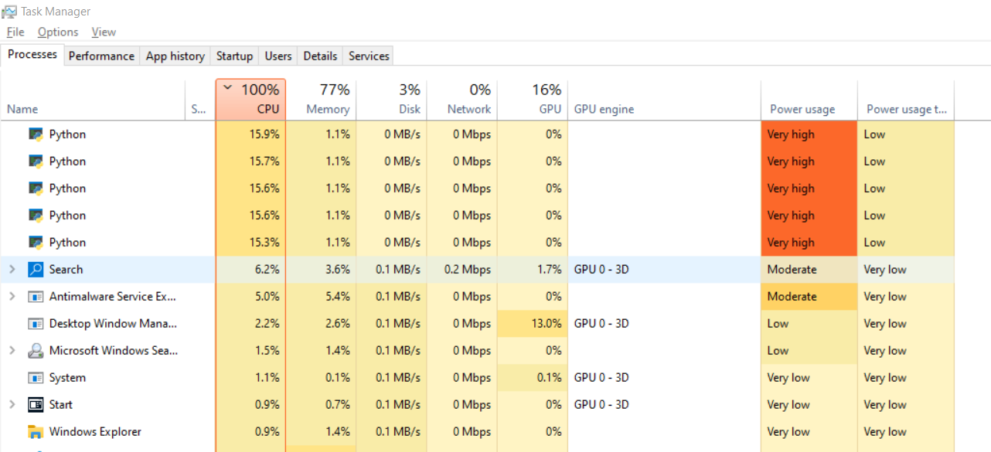

Here you can see that a parallel minimax search of depth 2 of the starting positions has created 5 independent python instances in the task manager. These instances are using almost all the CPU’s power and are each performing a Minimax_Sub_Job function on a different segment of the legal moves.

The Move_Engine_Timed was my final iteration of the minimax algorithm. It features all the optimisations that I planned in my design section. This means that it is efficient and controllable as I can now more easily limit how much it can explore the decision tree. This allow me to make more difficulty setting and to make the algorithm more consistent and predictable in how long it takes.

### Game Manager

I added to the main Game class from prototype 2. The main edition was code to more easily represent a console game of chess. This was used in the console chess program as well as in unit tests.

# import other modules

from chess_functions import Board_State, Vector

from move_engine import Move_Engine_Timed

from assorted import NotUserTurn, NotComputerTurn, InvalidMove, safe_hash

from time import perf_counter

import os

# this function wipes the console to allow the updated board to be displayed

def clear_console():

    #  https://stackoverflow.com/questions/517970/how-to-clear-the-interpreter-console

    os.system('cls')

# this function allows a function's execution time to be measured

def time_function(function):

    start = perf_counter()

    result = function()

    end = perf_counter()

    time_delta = end - start

    return result, time_delta

# the game class is used to keep track of a chess game between a user and the computer

class Game(object):

    # constructor for game object

    def __init__(self, time=10, user_color="W", echo=False) -> None:

        # based on user's color, determine color key

        self.player_color_key = {

            "W": 1 if user_color=="W" else -1,

            "B": -1 if user_color=="W" else 1

        }

        # set depth property from parameters

        self.time = time

        self.echo = echo

        # set attributes for game at start

        self.board_state = Board_State()

        self.move_counter = 0

        self.move_engine = Move_Engine_Timed()

        self.game_history_output = ()

    # hash function describes all unique properties of the game as a unique number

    def __hash__(self):

        return hash(safe_hash((

            "Game",

            self.player_color_key,

            self.time,

            self.echo,

            self.board_state,

            self.move_counter,

            self.move_engine,

            self.game_history_output,

        )))

    # thi function determines if 2 game objects are equal

    def __eq__(self, other: object) -> bool:

        if not isinstance(other, Game):

            return False

        return hash(other) == hash(other)

    @staticmethod

    def create_row(moving_player, time_delta, move_count, new_utility, future_utility, move_description, white_pieces_taken, black_pieces_taken, number_legal_moves) -> str:

        # print("(moving_player, time_delta, move_count, new_utility, future_utility, move_description, white_pieces_taken, black_pieces_taken, number_legal_moves)")

        # print((moving_player, time_delta, move_count, new_utility, future_utility, move_description, white_pieces_taken, black_pieces_taken, number_legal_moves))

        # this function creates formatted string that represents a row in a table and contains all the data provided as parameters

        if time_delta is None:

            time_delta = ""

        if future_utility is None:

            future_utility = ""

        return f"| {move_count:^14} | {moving_player:^15} | {new_utility:^15}  | {future_utility:^15}  | {time_delta:^15} | {number_legal_moves:^15} | {move_description:<40} | {white_pieces_taken:<35} | {black_pieces_taken:<35} |"

    def print_game_history(self):

        # this function clears the console and then print out a table that contains the history of the game

        clear_console()

        # https://www.geeksforgeeks.org/string-alignment-in-python-f-string/

        print("Moves History:")

        print()

        # print table header

        # print(self.create_row('Moving Color', 'Move Count', 'Time Taken (sec)', 'New Utility', 'Move', 'White Pieces Taken', 'Black Pieces Taken'))

        print(

            self.create_row(

                moving_player="Moving Color",

                time_delta="Time Taken",

                new_utility="New Utility",

                future_utility="Future Utility",

                move_description="Move Description",

                white_pieces_taken="White Pieces Taken",

                black_pieces_taken="Black Pieces Taken",

                move_count="Move Number",

                number_legal_moves="NO legal moves"

            )

        )

        # print each row

        for item in self.game_history_output:

            print(item)

        print()

        # print the board

        self.board_state.print_board()

    def make_move(self, move, time_delta, future_utility):

        # if echo, gather some data before the move

        if self.echo:

            color_moving = "White (+)" if self.board_state.next_to_go == "W" else "Black (-)"

            # print({"move": move})

            position_vector: Vector = move[0]

            resultant_vector: Vector = move[0] + move[1]

            moving_piece, taken_piece = self.board_state.get_piece_at_vector(position_vector), self.board_state.get_piece_at_vector(resultant_vector)

            from_square, to_square = position_vector.to_square(), resultant_vector.to_square()

            no_legal_moves = self.board_state.number_legal_moves

        # adjust properties that keep track of the game state

        # implement the move on the board state

        self.board_state = self.board_state.make_move(*move)

        # print(f"self.board_state.next_to_go   -->   {self.board_state.next_to_go}")

        self.move_counter += 1

        # if echo, gather move data, format and create a row and then print out the move history

        if self.echo:

            # find various data points

            utility_score = self.board_state.static_evaluation()

            move_number = self.move_counter

            if taken_piece is None:

                move_description = f"{moving_piece} moved from {from_square} to {to_square}"

            else:

                move_description = f"{moving_piece} moved from {from_square} to {to_square}, taking piece {taken_piece}"

            def pieces_missing_characters(color):

                return list(map(

                    str,

                    self.board_state.generate_pieces_taken_by_color(color)

                ))

            white_pieces_taken = " ".join(pieces_missing_characters("W"))

            # white_pieces_taken = "(No pieces taken)" if white_pieces_taken == "" else white_pieces_taken

            black_pieces_taken = " ".join(pieces_missing_characters("B"))

            # black_pieces_taken = "(No pieces taken)" if black_pieces_taken == "" else black_pieces_taken

            if time_delta is not None:

                time_delta = f"{round(time_delta, 2)} sec"

            # else:

            #     time_delta = ""

            # create a row

            new_row = self.create_row(

                moving_player=color_moving,

                time_delta=time_delta,

                move_count=move_number,

                new_utility=utility_score,

                move_description=move_description,

                white_pieces_taken=white_pieces_taken,

                black_pieces_taken=black_pieces_taken,

                number_legal_moves=no_legal_moves,

                future_utility=future_utility,

            )

            # add the row to the history

            self.game_history_output = tuple(list(self.game_history_output) + [new_row])

            # create a now row to show check if appropriate

            if self.board_state.color_in_check():

                check_msg = f"CHECK:  {self.board_state.next_to_go} in check"

                new_row = self.create_row(

                    moving_player="-",

                    time_delta="-",

                    move_count="-",

                    new_utility="-",

                    move_description=check_msg,

                    white_pieces_taken="-",

                    black_pieces_taken="-",

                    number_legal_moves="-",

                    future_utility="-",

                )

                self.game_history_output = tuple(list(self.game_history_output) + [new_row])

            # create a new row to show game over if appropriate

            over, winner = self.board_state.is_game_over_for_next_to_go()

            if over:

                how = "Stalemate" if winner is None else "Checkmate"

                winning_color = "White" if winner == "W" else "B"

                if how == "Stalemate":

                    if self.board_state.is_3_board_repeats_in_game_history():

                        game_over_msg = "Stalemate: both players draw (3 repeats of the board state)"

                    else:

                        game_over_msg = "Stalemate: both players draw (no legal moves and not in check)"

                else:

                    game_over_msg = f"Checkmate: {winning_color} wins"

                new_row = self.create_row(

                    moving_player="-",

                    time_delta="-",

                    move_count="-",

                    new_utility="-",

                    move_description=game_over_msg,

                    white_pieces_taken="-",

                    black_pieces_taken="-",

                    number_legal_moves="-",

                    future_utility="-",

                )

                self.game_history_output = tuple(list(self.game_history_output) + [new_row])

            # print the game history

            self.print_game_history()

    # this function validates if the user's move is allowed and if so, makes it

    def implement_user_move(self, from_square, to_square, time_delta=None, estimated_utility=None) -> None:

        # check that the user is allowed to move

        which_player_next_to_go = self.player_color_key.get(

            self.board_state.next_to_go

        )

        if which_player_next_to_go != 1:

            raise NotUserTurn(game=self)

        # unpack move into vector form

        # invalid square syntaxes will cause a value error here

        try:

            position_vector = Vector.construct_from_square(from_square)

            movement_vector = Vector.construct_from_square(to_square) - position_vector

        except Exception:

            raise ValueError("Square's not in valid format")

        move = (position_vector, movement_vector)

        # if the move is not in the set of legal moves, raise and appropriate exception

        if move not in self.board_state.generate_legal_moves():

            raise InvalidMove(game=self)

        self.make_move(move, time_delta, estimated_utility)

        return move, self.board_state.static_evaluation()

    # this function determines if the game is over and if so, what is the nature of the outcome

    def check_game_over(self) -> list[bool, str, str]:

        # returns: over: bool, winning_player: (1/-1), classification: str

        # determine if board state is over for next player

        over, winner = self.board_state.is_game_over_for_next_to_go()

        # switch case statement to determine the appropriate values to be returned in each case

        match (over, winner):

            case False, _:

                victory_classification = None

                winning_player = None

            case True, None:

                if self.board_state.is_3_board_repeats_in_game_history():

                    victory_classification = "stalemate board repeat"

                else:

                    victory_classification = "stalemate no legal moves"

                winning_player = None

            case True, winner:

                victory_classification = "checkmate"

                winning_player = self.player_color_key[winner]

        # return appropriate values

        return over, winning_player, victory_classification

    # this function determines and implements the computer move

    def implement_computer_move(self, best_move_function=None):

        # for use with testing bots, a best move function can be provided for use, but minimax if the default

        # get next to go player (1/-1)

        which_player_next_to_go = self.player_color_key.get(

            self.board_state.next_to_go

        )

        # check that is it the computer's turn

        if which_player_next_to_go != -1:

            raise NotComputerTurn()

            # raise ValueError(f"Next to go is user: {self.board_state.next_to_go} not computer")

        # if no function provided, default to minimax

        if best_move_function is None:

            def best_move_function(self):

                return self.move_engine(

                    board_state = self.board_state,

                    # depth is based of difficulty of game based on depth parameter

                    time = self.time,

                )

        # otherwise use provided function,

        # the provided function should take game as an argument and then return data in the same format as the minimax function

        result, time_delta = time_function(

            lambda: best_move_function(self)

        )

        # print({"result": result})

        score, best_move = result

        # best_move, score = result

        # print({"best_move": best_move})

        # print({"score": score})

        assert best_move is not None

        self.make_move(best_move, time_delta, score)

        # incase is it wanted for a print out ect, return move and score

        return best_move, score

Below is an example of the additional functionality being used to show what is happening in a unit test of depth 3 bot playing a depth 2 bot

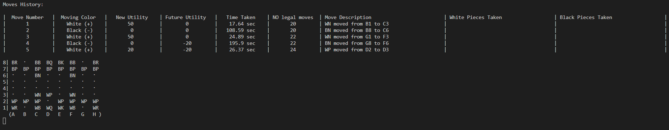

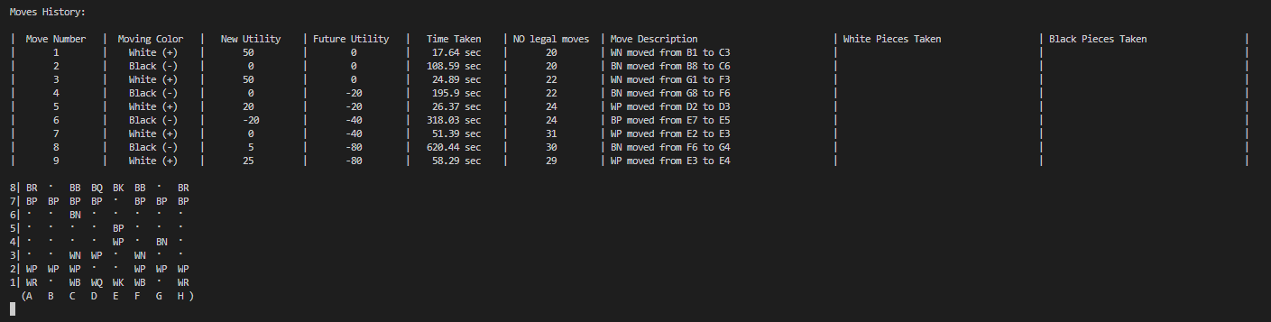

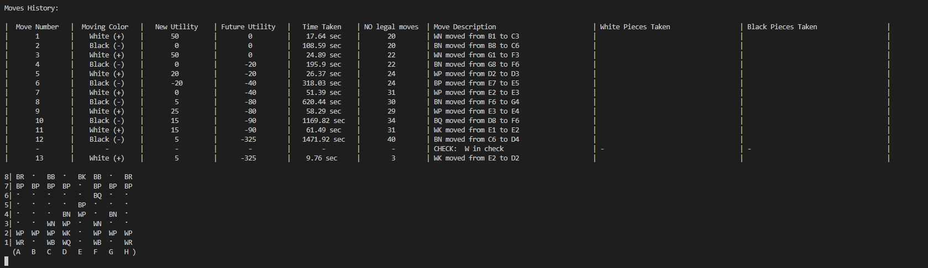

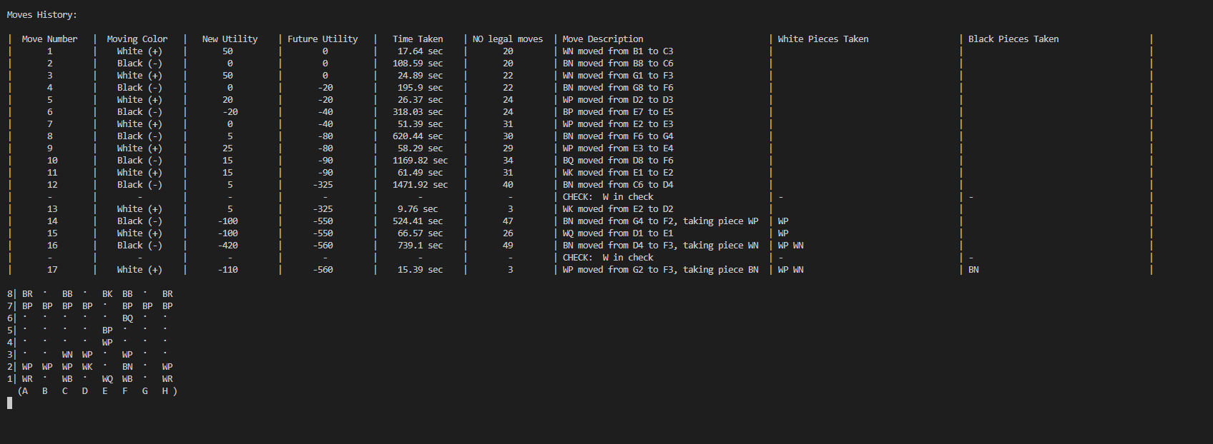

I then created a new class called Game_Website. It is responsible to keep track of a chess game that is going in on the client side on my webpage user interface. It originally inherited from the Game class but then I began overwriting so many methods that it was complicating the class. As a result the Game_Website class is similar but separate from the game class.

Game_web.py

# this class is a variant of the game class that is to be used in a web game of chess

# it originally inherited from the game class but then it became to different so I no longer made it inherit from the game class

# from .game import Game

from assorted import safe_hash

from chess_functions import Board_State, Vector

from move_engine import Move_Engine_Timed

from schemas import serialize_piece, serialize_move

# import other modules

from chess_functions import Board_State, Vector

from move_engine import Move_Engine_Timed

from assorted import NotUserTurn, NotComputerTurn, InvalidMove, safe_hash

from time import perf_counter

import os

# # this function clears the console

# def clear_console():

#     #  https://stackoverflow.com/questions/517970/how-to-clear-the-interpreter-console

#     os.system('cls')

# # this function allows for a functions performance to be measured

# def time_function(function):

#     start = perf_counter()

#     result = function()

#     end = perf_counter()

#     time_delta = end - start

#     return result, time_delta

# the game class is used to keep track of a chess game between a user and the computer

class Game_Website(object):

    # # it keeps track of:

    # # the player's color's

    # player_color_key: dict

    # # the difficulty or depth of the game

    # depth: int

    # # the current board state

    # board_state: Board_State

    # # the number of moves so far

    # move_counter: int

    # move_engine: Move_Engine

    # game_history_output: tuple[str]

    # constructor for game object

    # def __init__(self, time, user_color="W", echo=True) -> None:

    def __init__(self, difficulty="medium", user_color="W") -> None:

        self.difficulty = difficulty.strip().lower()

        # based on user's color, determine color key

        self.player_color_key = {

            "W": 1 if user_color == "W" else -1,

            "B": -1 if user_color == "W" else 1

        }

        # set depth property from parameters

        # set attributes for game at start

        # start with a blank board

        self.board_state = Board_State()

        self.move_counter = 0

        # use the timed move engine to find moves

        self.move_engine = Move_Engine_Timed()

        self.move_history_output = []

    # the time function is treated as a property to emulate how it was before when it was a property (before difficulty)

    @property

    def time(self):

        # return 0.5

        match self.difficulty:

            case "really_easy": return 1

            case "easy": return 2

            case "medium": return 5

            case "hard": return 10

            case "really_hard": return 15

            case "extreme": return 30

            case "legendary": return 60

        raise ValueError(f"Difficulty {self.difficulty} not recognised")

    # this functions adds a move to the move history,

    # it doesn't make the move

    def add_move_to_history(self, move):

        # should be called pre move

        # color_moving = "White" if self.board_state.next_to_go == "W" else "Black"

        # print({"move": move})

        # unpack move and determine squares and relevant pieces

        position_vector: Vector = move[0]

        resultant_vector: Vector = move[0] + move[1]

        moving_piece, taken_piece = self.board_state.get_piece_at_vector(position_vector), self.board_state.get_piece_at_vector(resultant_vector)

        from_square, to_square = position_vector.to_square(), resultant_vector.to_square()

        # increment move count

        self.move_counter += 1

        # generate string move description using this data

        if taken_piece is None:

            # move_description = f"Move {self.move_counter}: {color_moving} moved {moving_piece} from {from_square} to {to_square}"

            # move_description = f"{self.move_counter}: {color_moving} moved {moving_piece} from {from_square} to {to_square}"

            move_description = f"{self.move_counter}: {moving_piece} from {from_square} to {to_square}"

        else:

            # move_description = f"Move {self.move_counter}: {color_moving} moved {moving_piece} from {from_square} to {to_square}, taking piece {taken_piece}"

            # move_description = f"{self.move_counter}: {color_moving} moved {moving_piece} from {from_square} to {to_square}, taking piece {taken_piece}"

            move_description = f"{self.move_counter}: {moving_piece} from {from_square} to {to_square}, taking piece {taken_piece}"

        # append this string to the move history list

        self.move_history_output.append(move_description)

    # this function makes a move on the board state and logs this in the game history

    def make_move(self, move):

        assert not self.board_state.is_game_over_for_next_to_go()[0], "Cannot make move if game is over"

        assert move is not None, "Cannot move as move parameter not valid"

        self.add_move_to_history(move)

        # adjust properties that keep track of the game state

        self.board_state = self.board_state.make_move(*move)

    # this function validates if the user's move is allowed and if so, makes it

    # input form javascript is a move in terms of vectors

    def implement_user_move(self, move: list[Vector]) -> None:

        assert not self.board_state.is_game_over_for_next_to_go()[0], "Cannot make move if game is over"

        # check that the user is allowed to move

        which_player_next_to_go = self.player_color_key.get(

            self.board_state.next_to_go

        )

        # check it is the user's go

        if which_player_next_to_go != 1:

            raise NotUserTurn(game=self)

        # if the move is not in the set of legal moves, raise and appropriate exception

        if move not in self.board_state.generate_legal_moves():

            self.board_state.print_board()

            print(f"Move  {move} not in legal moves")

            raise InvalidMove(game=self)

        # make the move

        self.make_move(move)

        # no return data needed

        # return move, self.board_state.static_evaluation()

    # this function determines if the game is over and if so, what is the nature of the outcome

    def check_game_over(self):

        # returns: over: bool, winning_player: (W / B), classification: str

        # determine if board state is over for next player

        over, winner = self.board_state.is_game_over_for_next_to_go()

        # switch case statement to determine the appropriate values to be returned in each case

        match (over, winner):

            case False, _:

                victory_classification = None

                winning_player = None

            case True, None:

                if self.board_state.is_3_board_repeats_in_game_history():

                    victory_classification = "stalemate board repeat"

                else:

                    victory_classification = "stalemate no legal moves"

                winning_player = None

            case True, winner:

                victory_classification = "checkmate"

                winning_player = self.player_color_key[winner]

        # return appropriate values

        return over, winning_player, victory_classification

    # this function is used to determine the AI's move

    # the time delta can be explicitly given or it can use the time provided manually as a parameter

    def best_move_function(self, time):

        if time is None:

            time = self.time

        # returns just the move

        return self.move_engine(

            board_state=self.board_state,

            # depth is based of difficulty of game based on depth parameter

            time=time,

        )[1]

    # this function is used to generate a description of the move that the computer has completed for the client side GUI

    # it is needed to provide highlighting ect.

    # it doesn't make the computer move

    def generate_computer_move_description(self, move, previous_board_state):

        # determine various qualities about the move

        position_vector, movement_vector = move

        resultant_vector = position_vector + movement_vector

        moved_piece = previous_board_state.get_piece_at_vector(position_vector)

        taken_piece = previous_board_state.get_piece_at_vector(resultant_vector)

        from_square = position_vector.to_square()

        to_square = resultant_vector.to_square()

        # return dictionary of this data ready for json serialization

        # to do this, ensure all objects such as pieces and vectors are serialized.

        move_description = {

            "moved_piece": serialize_piece(moved_piece),

            "taken_piece": serialize_piece(taken_piece),

            "from_square": from_square,

            "to_square": to_square,

            "move": serialize_move(move)

        }

        return move_description

    # this function completed the computer's move in a given time delta and returns a description

    def implement_computer_move_and_report(self, time=None):

        previous_board_state = self.board_state

        # get next to go player (1/-1)

        which_player_next_to_go = self.player_color_key.get(

            self.board_state.next_to_go

        )

        # check that is it the computer's turn

        if which_player_next_to_go != -1:

            raise NotComputerTurn()

            # raise ValueError(f"Next to go is user: {self.board_state.next_to_go} not computer")

        # get the computer's move

        best_move = self.best_move_function(time=time)

        # defensive design to detect issues, ensure a move has been calculated

        assert best_move is not None

        # implement the move and return a description

        self.make_move(best_move)

        return self.generate_computer_move_description(best_move, previous_board_state)

    def __eq__(self, other: object) -> bool:

        # this method used the hash function to determine if 2 of these objects are the same

        if not isinstance(other, Game_Website):

            return False

        return hash(self) == hash(other)

    def __hash__(self):

        # this function encodes all the data that makes a game unique in a hash to be stored in a database

        return hash(safe_hash((

            "Game_Website",

            self.player_color_key,

            self.time,

            self.board_state,

            self.move_counter,

            # self.move_engine,

            self.move_history_output,

            self.difficulty

        )))

The main changes are:

* It has no functionality to log the game to the console.
* It also produces a different game history array designed for the client side JavaScript to use
* It produces a description of the computer’s move to allow the client side JavaScript to display the move properly with highlighting. This description is in the form of a dictionary that includes pieces and vectors involved in the move.
* It uses the timed minimax algorithm to produce the computer move
* It also features different difficulty setting which correspond to a different exploration time by the timed minimax algorithm.
* The resulting object can also be hashed and pickled to binary form in order to be stored in a database.

The chess game (Game Manager) module export the following objects through its __init__.py file:

from .game import Game

# from .game_with_difficulty import Game_With_Difficulty

from .game_web import Game_Website

It exports the Game class and the Game_Website class.

## Database module:

The database module is responsible for setting up and managing the database that the save game feature and minimax cache use.

The __init__.py file for the database module is unusual as it includes some logic:

# this file does 2 things:

# it decides which objects should be exported as part of the database module

# it initialise the database (creates a connection and creates all tables)

# objects to export

from .create_database import create_session, end_session, create_engines, end_engines

from .models import Minimax_Cache_Item, create_tables

from .handle_games import get_saved_game, save_game

# initialise database

engines_dict = create_engines(echo=False)

create_tables(engines_dict)

persistent_DB_engine = engines_dict["persistent_DB_engine"]

volatile_RAM_engine = engines_dict["volatile_RAM_engine"]

Its main responsibilities are to:

* Export the relevant functions and classes to allow the rest of the program to access the database
* Create the database connection and all the tables that should exist (if they don’t already).

### Create_database.py

# external modules used

import os

import sqlalchemy as sqla

from sqlalchemy.orm import scoped_session, sessionmaker

from sqlalchemy.pool import QueuePool

# path to database file

DB_path = os.path.join(os.getcwd(), 'database', 'database.db')

# this function creates 2 database engines, one in RAM and one is secondary storage

def create_engines(echo):

    # echo means, should all the queries be printed out

    # caution with below code, could cause unexpected behavior if not thread safe, further research needed

    # I don't know much about threading in python, I find it confusing due to complexities around the global interpreter lock

    # as a result I had to just try various arguments to create these engines in a way that allowed me to use them with my flask server

    persistent_DB_engine = sqla.create_engine(

        'sqlite:///' + DB_path,

        echo=echo,

        poolclass=QueuePool,

        connect_args={'check_same_thread': False}

    )

    volatile_RAM_engine = sqla.create_engine(

        "sqlite:///:memory:",

        echo=echo,

        poolclass=QueuePool,

        connect_args={'check_same_thread': False}

    )

    return {

        "persistent_DB_engine": persistent_DB_engine,

        "volatile_RAM_engine": volatile_RAM_engine

    }

# this function safely terminates the database connection

def end_engines(engines):

    for engine in engines.values():

        engine.dispose()

# this function creates a session to access the database

def create_session(engine):

    return scoped_session(sessionmaker(bind=engine))

# this function safely ends a session

def end_session(session):

    session.commit()

    session.close()

this file contains the relevant functions to create and safely destroy both engine objects (the master connection to the data base) and session objects (a temporary connection used when actively querying that database).

It creates an engine corresponding to both a persistent database in a “database.db” file and a volatile database in RAM.

### Models.py

# import external modules

import sqlalchemy as sqla

from sqlalchemy.ext.declarative import declarative_base

import pickle

# cannot be used for type hings as it has a high risk of causing a circular import

# from chess_game import Game_Website

# create a base object with which I will make my database tables (part of the ORM)

Base = declarative_base()

# create an object and a table (ORM used) to represent a cached minimax call

class Minimax_Cache_Item(Base):

    # here is the metadata and the columns of the database

    __tablename__ = "Minimax_Cache"

    primary_key = sqla.Column(sqla.Integer, primary_key=True)

    board_state_hash = sqla.Column(sqla.String())

    depth = sqla.Column(sqla.INT())

    score = sqla.Column(sqla.INT())

    # 4 character move string encoded by the 4 digits of the from and movement vectors

    move = sqla.Column(sqla.String)

    # a single entry can be created by initializing an object with this class

    def __init__(self, board_state_hash: str, depth, move: str, score: int):

        # hash board state

        self.board_state_hash = str(board_state_hash)

        self.depth = depth

        self.move = move

        self.score = score

    # string description of object

    def __repr__(self) -> str:

        return f"Minimax_Cache_Item(board_state_hash='{self.board_state_hash}', depth={self.depth}, move='{self.move}', score={self.score})"

# this object represents an entry in a database table that saves games for later reloading

class Saved_Game(Base):

    # metadata as well as columns defined here

    __tablename__ = "Saved_Games"

    primary_key = sqla.Column(sqla.Integer, primary_key=True)

    # game_hash = sqla.Column(sqla.String())

    cookie_key = sqla.Column(sqla.String())

    raw_game_data = sqla.Column(sqla.BINARY())

    # initializing an object from this class allow a new entry in the database to be made

    def __init__(self, game, cookie_key):

        self.cookie_key = str(cookie_key)

        self.raw_game_data = bytes(

            pickle.dumps(

                game

            )

        )

    # string description of object

    def __repr__(self) -> str:

        return f"Saved_Game(cookie_key='{self.cookie_key}')"

# create indexes on cookie key and board state hash as these are the columns that I will use to search for a specific entry

sqla.schema.Index("board_state_hash", Minimax_Cache_Item.board_state_hash)

sqla.schema.Index("cookie_key", Saved_Game.cookie_key)

# for each engine, build these tables

def create_tables(engines_dict):

    for engine in engines_dict.values():

        Base.metadata.create_all(engine, checkfirst=True)

This file contains a pair of classes that represent a single database entry within each of my 2 database table respectively. As the classes have been created using the SQL-Alchemy ORM, I can directly interact with the database by interacting with these objects.

After the tables are defined using the schema classes I then create and index for each table to set one of the columns to be a secondary key. I cannot create the tables without a standard incrementing primary key but I intend to use these secondary keys to query the tables.

The Saved_Game table does store binary data as one of the columns. While in principle this can be inefficient, the binary data stored is very small (2-4 kb). This means it can be stored directly in the database without significant scalability issues.

The create tables function will create the relevant tables in each of the engines, once the engines are created.

### handle_games.py

# import external modules and local models

import pickle

from .models import Saved_Game

# cannot import for type hint due to high risk of circular imports

# from chess_game import Game_Website

# this method queries the database for a game by cookie id

# and then deserializes the binary data to restore the game

def get_saved_game(cookie_key, session):

    # query database for game by cookie key

    result: Saved_Game = session.query(Saved_Game)\

        .where(

            # Saved_Game.game_hash == str(hash(game_hash))

            Saved_Game.cookie_key == str(cookie_key)

        )\

            .first()

    # if the result is none (possible if browser has cookie that is invalid) then return none

    if result is None:

        # print(f"get_saved_game game not in database so returning none")

        return None

    # now deserialize the game from the binary data

    game = pickle.loads(

        result.raw_game_data

    )

    # print(f"this game recovered from database under cookie_key:  {cookie_key}")

    # game.board_state.print_board()

    # print(f"game recovered from database:  {hash(game)}")

    # return the game

    return game

# this function saves a game to the database under a certain cookie ID.

def save_game(game, cookie_key, session):

    # print("saving this game into database")

    # game.board_state.print_board()

    # print(f"saving game in database game with hash {hash(game)} under cookie_key:  {cookie_key}")

    # delete any old games with the same cookie id

    session.query(Saved_Game)\

        .where(

            # Saved_Game.game_hash == str(hash(game_hash))

            Saved_Game.cookie_key == str(cookie_key)

        )\

        .delete()

    # create a new entry in the database and commit

    session.add(

        Saved_Game(game, cookie_key)

    )

    session.commit()

It contains a pair of function that are able to save a Game_Website object to the database as binary and the query and deserialize it to restore the Game_Website object.

I have used the pickle library to convert my python object to and from binary.

We can also see that I can execute SQL queries in a pythonic way thanks to the use of an ORM framework. This adds validation to prevent SQL injection attacks. This is because, whatever the malicious code stored in the cookie, it will not be executed an will be treated as a sting due to the type definition in the Saved_Game class.

## Schema Module:

The schema module is responsible for serialisation and serialisation processes. This is used to serialise python objects’ data into a form that can be stored in a database or sent to a client’s browser. The python objects can also be restored using the corresponding deserialization functions if needed.

The schema module’s __init__.py file exports for following functions:

from .cache_item_schema import minimax_cache_item_schema

from .socket_schemas import serialize_legal_moves, serialize_pieces_matrix, deserialize_move, serialize_piece, serialize_move, deserialize_pieces_matrix

Here is cache_item_schema.py:

# import external and external modules

from marshmallow import Schema, fields, pre_load, pre_dump, post_load, post_dump

from chess_functions import Vector

from database import Minimax_Cache_Item

# the vector schema describes how to serialize and deserialize a vector object

# it converts between Vector(i=a, j=b) and [a, b]

class Vector_Schema(Schema):

    i = fields.Integer(required=True)

    j = fields.Integer(required=True)

    @pre_load

    def pre_load(self, vector, **kwargs):

        data = {}

        data["i"] = vector.i

        data["j"] = vector.j

        return data

    @post_dump

    def post_dump(self, data, **kwargs):

        return Vector(

            i=data["i"],

            j=data["j"]

        )

# this move schema is for database cache

# it converts between [Vector(a, b), Vector(c, d)] and [[a,b], [c,d]]

# is used the nested Vector Schema to do this

class Move_Schema(Schema):

    from_vector = fields.Nested(Vector_Schema, required=True)

    movement_vector = fields.Nested(Vector_Schema, required=True)

    @pre_load

    def pre_load(self, vector_tuple, **kwargs):

        # print({"vector_tuple": vector_tuple})

        from_vector, movement_vector = vector_tuple

        data = {}

        data["from_vector"] = from_vector

        data["movement_vector"] = movement_vector

        return data

    @post_dump

    def post_dump(self, data, **kwargs):

        return (

            data["from_vector"],

            data["movement_vector"]

        )

# this method deserializes a move string into a pair of Vectors stored in a dictionary

def get_deserialized_move(move):

    # assert len(move) == 4

    # if move == "None":

    if move == None:

        return None

    move = move[1:-1]

    move = move.split(", ")

    from_vector = Vector(

        i=move[0],

        j=move[1]

    )

    movement_vector = Vector(

        i=move[2],

        j=move[3]

    )

    return dict(

        from_vector=from_vector,

        movement_vector=movement_vector

    )

# this method converts a pair of vectors stored in a dictionary to a string representation of the move

def get_serialised_move(move):

    if move is None:

        # return "None"

        return None

    return str((

        move["from_vector"]["i"],

        move["from_vector"]["j"],

        move["movement_vector"]["i"],

        move["movement_vector"]["j"],

    ))

# this class uses the move schema and the above methods to serialize and deserialize a move so that it can be stored in a database

class Minimax_Cache_Item_Schema(Schema):

    board_state_hash = fields.String(required=True, load_only=True)

    depth = fields.Integer(required=True)

    score = fields.Integer(required=True)

    move = fields.Nested(Move_Schema, required=True, allow_none=True)

    @post_load

    def post_load(self, data, **kwargs):

        # assert isinstance(data["depth"], int)

        # assert isinstance(data["score"], int)

        # print(f"post_load: serializing move form {data['move']} to {get_serialised_move(data['move'])}")

        return Minimax_Cache_Item(

            board_state_hash=data["board_state_hash"],

            depth=data["depth"],

            score=data["score"],

            move=get_serialised_move(

                data["move"]

            )

        )

    @pre_dump

    def pre_dump(self, minimax_cache_item: Minimax_Cache_Item, **kwargs):

        # print(f"pre_dump: deserializing move form {minimax_cache_item.move} to {get_deserialized_move(minimax_cache_item.move)}")

        return dict(

            depth=minimax_cache_item.depth,

            move=get_deserialized_move(

                minimax_cache_item.move

            ),

            score=minimax_cache_item.score

        )

# this object can be used to serialize and deserialize moves to be stored in the database

# it is the final product of this file and the object that will be exported

minimax_cache_item_schema = Minimax_Cache_Item_Schema()

This code will allow me to convert a dictionary description of all the properties of a minimax search to a Minimax_Cache_Item object that can be used as an entry in a database.

I also use schemas to serialise data for sending to the client:

### Socket_shemas.py:

from marshmallow import Schema, fields, pre_load, pre_dump, post_load, post_dump

from chess_functions import Vector, Piece, PIECE_TYPES

# different schema to serialize and deserialize a vector

class Vector_Schema(Schema):

    i = fields.Integer(required=True)

    j = fields.Integer(required=True)

    @post_load

    def get_vector_from_internal_data(self, internal_data, **kwargs):

        # print({"internal_data": internal_data})

        return Vector(**internal_data)

    @pre_load

    def get_internal_data_from_list(self, list_data, **kwargs):

        return {"i": list_data[0], "j": list_data[1]}

    @post_dump

    def make_list_from_internal_data(self, internal_data, **kwargs):

        return [internal_data['i'], internal_data['j']]

letter_symbol_pairs = (

    ("P", "♟︎"),

    ("K", "♚"),

    ("Q", "♛"),

    ("R", "♜"),

    ("B", "♝"),

    ("N", "♞"),

)

# these functions get the symbol or letter associated with each piece by searching the above tuple

def get_symbol_from_letter(target_letter):

    for letter, symbol in letter_symbol_pairs:

        if letter == target_letter.strip().upper():

            return symbol

    raise ValueError(f"letter  '{letter}'  not found")

def get_letter_from_symbol(target_symbol):

    for letter, symbol in letter_symbol_pairs:

        if symbol == target_symbol.strip():

            return letter

    raise ValueError(f"symbol  '{symbol}'  not found")

# this schema serialised and deserializes between the Pieces object and format use in JSON sent to the client

class Piece_Schema(Schema):

    color = fields.String(required=True)

    letter = fields.String(required=True)

    @pre_load

    def pre_load(self, data, **kwargs):

        color, symbol = data

        letter = get_letter_from_symbol(symbol)

        return {

            "color": color,

            "letter": letter,

        }

    @post_load

    def post_load(self, data, **kwargs):

        color, letter = data["color"], data["letter"]

        Piece_Type = PIECE_TYPES[letter]

        return Piece_Type(color)

    @pre_dump

    def pre_dump(self, piece: Piece, **kwargs):

        color, letter = piece.symbol()

        return {

            "color": color,

            "letter": letter,

        }

    @post_dump

    def post_dump(self, data, **kwargs):

        color, letter = data["color"], data["letter"]

        symbol = get_symbol_from_letter(letter)

        return [color, symbol]

# these function are utility function that can map a function across a 1d or 2d array, transforming all the elements

def list_map(some_function, array):

    return list(map(some_function, array))

def two_d_list_map(some_function, two_d_array):

    return list_map(

        lambda one_d_array: list_map(

            some_function,

            one_d_array

        ),

        two_d_array

    )

# create objects form the schemas with which to serialize and deserialize

vector_schema = Vector_Schema()

piece_schema = Piece_Schema()

# here are functions that use thee schemas to serialize and deserialize key data points to and from a dictionary (JSON like) format

def serialize_legal_moves(legal_moves):

    return two_d_list_map(vector_schema.dump, legal_moves)

def deserialize_legal_moves(legal_moves):

    return two_d_list_map(vector_schema.load, legal_moves)

def serialize_move(move):

    return list_map(vector_schema.dump, move)

def deserialize_move(move):

    return list_map(vector_schema.load, move)

def serialize_piece(piece):

    if piece is None:

        return [None, None]

    else:

        return piece_schema.dump(piece)

def deserialize_piece(piece):

    # print(piece, end=";   ")

    if piece == [None, None]:

        return None

    else:

        return piece_schema.load(piece)

def serialize_pieces_matrix(pieces_matrix):

    return two_d_list_map(serialize_piece, pieces_matrix)

def deserialize_pieces_matrix(pieces_matrix):

    # print("deserialize_pieces_matrix   called")

    return two_d_list_map(deserialize_piece, pieces_matrix)

Here is a jupyter notebook where I show what each of these schemas does:

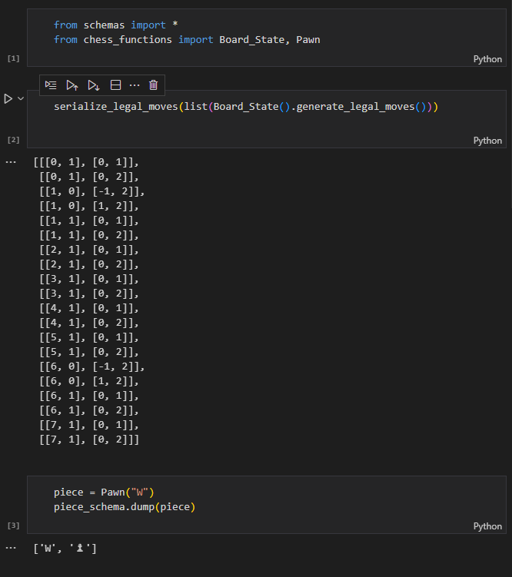

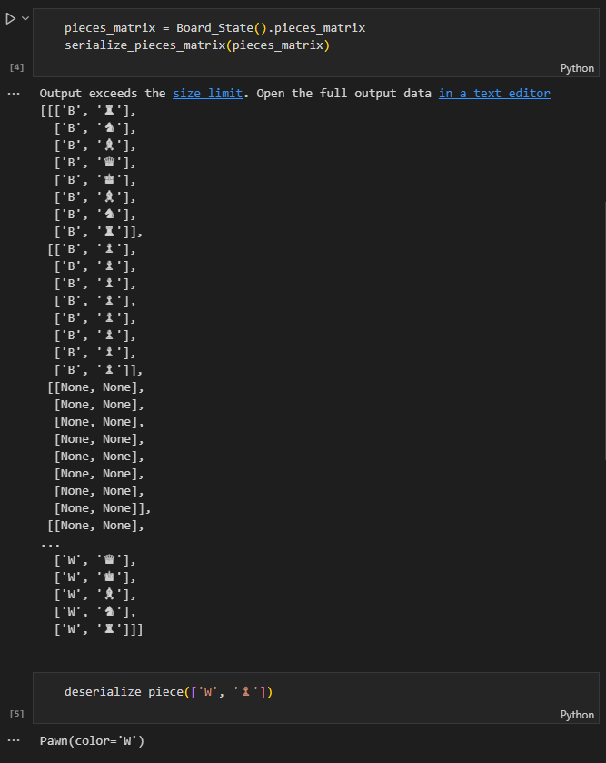

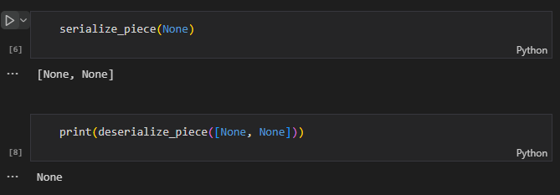

These functions will be used as shown to format data form python objects to data structures like dictionaries that can be easily converted to JSON.

## Website Module:

This module is responsible for creating a webserver to how the webpage and for handling all the client page’s requests.

Here is the __init__.py file:

from .flask_server import app

As we can see, the only component that is exported is called app. This is a flask object that has been given all the functionality we want in out webserver / socket server.

The website is run by a file in the root directory called app.py

### app.py

from website import app

from database import persistent_DB_engine, volatile_RAM_engine, end_engines

# from geventwebsocket.server import WSGIServer

# import socketio

# import flask

host = '127.0.0.1'

port_num = 5000

url = f"http://{host}:{port_num}"

def run_app():

    print(url)

    try:

        app.run(

            host=host,

            port=port_num,

            debug=True

        )

    except KeyboardInterrupt:

        end_engines([persistent_DB_engine, volatile_RAM_engine])

# def run_app():

#     print(url)

#     try:

#         socketio.run(app)

#     except KeyboardInterrupt:

#         pass

# def run_app():

#     http_server = WSGIServer(('0.0.0.0', 5000), app)

#     http_server.serve_forever()

# def run_app():

#     # socketio.run(app, host='0.0.0.0', port=5000, debug=True, use_reloader=False)

#     # flask.run(app, host='0.0.0.0', port=5000, debug=True, use_reloader=False)

#     app.run(host=host, port=port_num, debug=True, use_reloader=False)

# use python -m flask run to stop it raising warnings about how it should be deployed

if __name__ == "__main__":

    run_app()

from website import app

from database import persistent_DB_engine, volatile_RAM_engine, end_engines

# variables to decide the URL of the website

host = '127.0.0.1'

port_num = 5000

url = f"http://{host}:{port_num}"

# this function runs the flask server (hosting the website)

# to close the server, use ctrl + c to create a keyboard interrupt,

# this will safely destroy all engine connections to the database

def run_app():

    print(url)

    try:

        app.run(

            host=host,

            port=port_num,

            debug=True

        )

    except KeyboardInterrupt:

        end_engines([persistent_DB_engine, volatile_RAM_engine])

# use python -m flask run to stop it raising warnings about how it should be deployed

if __name__ == "__main__":

    run_app()

the website is run with the following command:

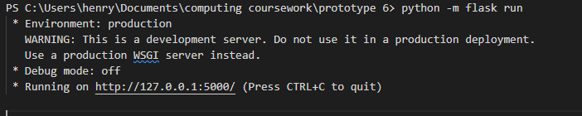

The python file flask_server.py contains all the server side logic of the webserver and socket server:

# import external modules

import flask

import os

from flask_socketio import SocketIO

import datetime

import pickle

# import local modules

from assorted import safe_hash

from database import save_game, get_saved_game, persistent_DB_engine, create_session, end_session

from chess_game import Game_Website

from schemas import serialize_legal_moves, deserialize_move, serialize_pieces_matrix, serialize_piece

# fix tabes don't exist on reload bug: https://stackoverflow.com/questions/44531360/flask-blogging-error-table-doesnt-exist-tables-not-being-created

# establish various important directories in variables

basedir = os.getcwd()

static_folder_path = os.path.join(basedir, 'website', 'static')

template_folder_path = os.path.join(basedir, 'website', 'templates')

key_file_path = os.path.join(basedir, 'website', 'secret_key.key')

# retrieve the secret key

with open(key_file_path, "r") as file:

    secret_key = file.read()

# sanitize secret key to remove white space

secret_key = secret_key\

    .replace(" ", "")\

    .replace("\n", "")\

    .replace(chr(13), "")

# create an app object and configure it

app = flask.Flask(

    __name__,

    static_folder=static_folder_path,

    template_folder=template_folder_path,

)

# app.config['SEND_FILE_MAX_AGE_DEFAULT'] = 0

app.secret_key = secret_key

# create the socketio object (bound to the app object)

# socketio = SocketIO(app, async_mode=None)

# socketio = SocketIO(app, async_mode="gevent")

socketio = SocketIO(app, async_mode=None, threaded=True, echo=False)

@app.route("/")

def index():

    # this is the only http endpoint,

    # it renders the appropriate html file

    response = flask.make_response(

        flask.render_template("chess_game.html")

    )

    # ot then adds a cookie to the response that contains a cookie key corresponding to the game in the session

    expires = datetime.datetime.now() + datetime.timedelta(hours=48)

    cookie_key = flask.session["cookie_key"]

    cookie_formatted = str(cookie_key).encode("utf-8")

    response.set_cookie(

        "chess_game_cookie_key",

        cookie_formatted,

        expires=expires

    )

    # print(f"index: cookie created: {cookie_key}")

    # the response is returned, creating the cookie and providing the html file for the webpage

    return response

# the below functions both get and save a Game_Website object to the flask session as a binary blob

# this prevent issues that can occur when python objects are saved directly in the flask session

def get_game_in_session() -> Game_Website:

    # print(repr(flask.session["game"]))

    # print(repr(pickle.loads(flask.session["game"])))

    return pickle.loads(

        flask.session["game"]

    )

def set_game_in_session(game: Game_Website):

    flask.session["game"] = pickle.dumps(

        game

    )

# def get_game_in_session() -> Game_Website:

#     return flask.session["game"]

# def set_game_in_session(game: Game_Website):

#     flask.session["game"] = game

# this handler function is responsible for initializing a flask session

def create_flask_session():

    # if flask.session.get("session_setup_complete"):

    #     return None

    # else:

    #     flask.session["session_setup_complete"] = True

    # it first checks the cookies

    # print("Creating session")

    # check cookies

    # game_hash_cookie = flask.request.cookies.get("chess_game_hash")

    game_cookie = flask.request.cookies.get("chess_game_cookie_key")

    # print(f"In creating session, cookie chess_game_cookie_key fetched, it contains:   {game_cookie}")

    # if the appropriate cookie doesn't exist, a random number is used as the cookie key,

    # and a fresh game is created

    if game_cookie is None:

        print("Cookie was none / doesn't exist")

        game = Game_Website()

        cookie_key = safe_hash(os.urandom(32))

    # if a cookie id was recovered

    else:

        # the id is converted into a python sting that contains hexadecimal characters

        hex_string = game_cookie.encode("utf-8").hex()

        cookie_key = bytes.fromhex(hex_string).decode('utf-8')

        print(f"flask cookie contained hash: {cookie_key}")

        # a database session is created

        session_DB = create_session(persistent_DB_engine)

        # the game object is retrieved from the database

        # database_lookup_result: Game_Website = get_saved_game(game_hash=game_hash, session=session)

        database_lookup_result: Game_Website = get_saved_game(cookie_key=cookie_key, session=session_DB)

        # print("database_lookup_result")

        # print(database_lookup_result)

        # the session is disposed of

        end_session(session_DB)

        session_DB = None

        # if the game was found in the database, use it, else create a new game

        if database_lookup_result is None:

            print(f"game: NOT successfully read from database (returned None)")

            game = Game_Website()

        else:

            print(f"game successfully read from database")

            game = database_lookup_result

            print(f"game with hash {hash(game)} successfully read from database")

    # now that a game object and a cookie_key have been determined, store these in the session object

    # the index http route will create the appropriate cookie using this id

    # print(repr(game))

    set_game_in_session(game)

    # print(f"At the end of create_flask_session, setting cookie_key to :  {cookie_key}")

    flask.session["cookie_key"] = cookie_key

    # print(f"At the end of create_flask_session, game used has ID:  {hash(game)}")

# this handler function is responsible for clearing up a flask session

# this involves saving the game to the database

def close_flask_session():

    # if flask.session.get("session_setup_complete"):

    #     flask.session["session_setup_complete"] = False

    # else:

    #     return None

    # print("Closing session")

    # game: Game_Website = get_game_in_session()

    # get tha game from the database

    game: Game_Website = pickle.loads(

        flask.session["game"]

    )

    # if the window was closed part way though the computer move

    # quickly decide the computers move (time=0) so that game can be resorted on the user's turn

    if game.board_state.next_to_go == "B":

        game.implement_computer_move_and_report(0)

    # print("close_flask_session, game in session is: ")

    # game.board_state.print_board()

    # game = session["game"]

    # get the cookie id,

    cookie_key = flask.session["cookie_key"]

    # make a database session and save the game to the database using the cookie id

    session_DB = create_session(persistent_DB_engine)

    save_game(game=game, cookie_key=cookie_key, session=session_DB)

    end_session(session_DB)

    session_DB = None

@app.before_request

def handle_create_session(*args, **kwargs):

    # this runs the handler function to create a session before the first request (using the session created flag)

    if not flask.session.get("session_created"):

        flask.session["session_created"] = True

        # print("before_request, session:")

        # print(flask.session)

        return create_flask_session()

# unfortunately I needed to use 2 separate events to fully close the flask session

# the on socket disconnect event allows me to access the session data but not change it

# the on http request stop_and_save_game event runs after the session data is deleted,

# it allow me to change the session data and set the session created flag to false

@socketio.on("disconnect")

def handle_close_session(*args, **kwargs):

    # this runs the handler to dispose of the session when the socket connection breaks

    close_flask_session()

@app.route('/stop_and_save_game')

def handle_close_session(*args, **kwargs):

    # this function sets the flag to indicate that the session needs to be reinitialized

    flask.session["session_created"] = False

    return "session closed"

# here I have created a socket handler function

# it is a decorator as it takes a function as a parameter and returns a modified function with additional functionality

def bind_socket_handler(event_name, respond=True):

    def decorator(function):

        request_event = f"{event_name}_request"

        response_event = f"{event_name}_response"

        # new function to be returned takes incoming payload as an argument

        def wrapper(incoming_payload: dict | None = None):

            # print(f"Handling event: {request_event}")

            # if there was an incoming payload, this is given to the original function as an argument after being deserialized

            if incoming_payload is None:

                result = function()

            else:

                # print({"incoming_payload": incoming_payload})

                if not isinstance(incoming_payload, dict):

                    raise TypeError(f"incoming payload of unexpected type:   {type(incoming_payload)}")

                result = function(incoming_payload)

            # if the respond flag is true, the return value of the function is send back to the client

            if respond:

                outgoing_payload: dict = result

                # print(f"Sending response payload by event {response_event}")

                # print({"outgoing_payload": outgoing_payload})

                if not isinstance(outgoing_payload, dict):

                    raise TypeError(f"outgoing payload of unexpected type:   {type(outgoing_payload)}")

                socketio.emit(response_event, outgoing_payload)

        # the wrapper function name is set to the name of the original function

        wrapper.__name__= function.__name__

        # bind wrapper function to happen when request corresponding to the event is received

        # use decorator in manual way to not overwrite wrapper

        socketio.on(request_event)(wrapper)

        # return wrapper for any further use

        return wrapper

    return decorator

# the below function accesses the game object in the session

# it returns a dictionary of serialized data about this game object

def generate_game_update_data():

    game: Game_Website = get_game_in_session()

    # collect various data point from the game object and serialize as necessary

    next_to_go = game.board_state.next_to_go

    difficulty = game.difficulty

    legal_moves = list(game.board_state.generate_legal_moves())

    legal_moves_serialised = serialize_legal_moves(legal_moves)

    pieces_matrix = game.board_state.pieces_matrix

    pieces_matrix_serialised = serialize_pieces_matrix(pieces_matrix)

    next_to_go_in_check = game.board_state.color_in_check()

    over, winning_player, victory_classification = game.check_game_over()

    game_over_data =  {

        "over": over,

        "winning_player": winning_player,

        "victory_classification": victory_classification,

    }

    pieces_missing = {}

    for color in ("B", "W"):

        pieces_missing[color] = list(map(

            serialize_piece,

            game.board_state.generate_pieces_taken_by_color(color)

        ))

    move_history = game.move_history_output

    # this is the format of the outgoing payload,

    # flask will convert it to JSON automatically

    # this payload contains all the data that the client needs to be updated about the game state

    payload = {

        "difficulty": difficulty,

        "next_to_go":  next_to_go,

        "game_over_data":  game_over_data,

        "legal_moves":  legal_moves_serialised,

        "pieces_matrix": pieces_matrix_serialised,

        "check": next_to_go_in_check,

        "pieces_taken": pieces_missing,

        "move_history": move_history,

    }

    return payload

# using my custom socket decorator greatly simplifies the process of using sockets

# on request get update from the client, return the generic payload of game data

@bind_socket_handler("get_update")

def get_update():

    """Sends all data from game object to client to update chess game

    This data is also updated after the user move and after the computer move"""

    result = generate_game_update_data()

    # print(f"Update payload for game with hash  {hash(get_game_in_session())}")

    # print(result)

    return result

# on request to implement the computer move

@bind_socket_handler("implement_computer_move")

def implement_computer_move():

    # get the game and validate that the computer can go

    game = get_game_in_session()

    assert game.board_state.next_to_go == "B"

    assert not game.board_state.is_game_over_for_next_to_go()[0]

    # generate the move and a dictionary of data about it for the client

    # print("generating move")

    move_description = game.implement_computer_move_and_report()

    # update the session with the new mutated game object

    set_game_in_session(game)

    # print("after computer move: game in session is:")

    # get_game_in_session().board_state.print_board()

    # generate a generic update payload and add teh move description before returning

    outgoing_payload = generate_game_update_data()

    outgoing_payload["computer_move_description"] = move_description

    # print(outgoing_payload)

    return outgoing_payload

# when a request comes to reset the game

# (no response needed)

@bind_socket_handler("reset_game", respond=False)

def reset_game():

    # preserve the difficulty setting

    old_game = get_game_in_session()

    # difficulty preserved

    difficulty = old_game.difficulty

    # create a new game object with the old difficulty and update the session

    new_game = Game_Website(difficulty=difficulty)

    set_game_in_session(new_game)

    # return generate_game_update_data()

# takes input from client about the user's move

@bind_socket_handler("implement_user_move")

def implement_user_move(incoming_payload):

    game = get_game_in_session()

    # validate that the user can move

    assert game.board_state.next_to_go == "W"

    assert not game.board_state.is_game_over_for_next_to_go()[0]

    # print("python function called: implement_user_move")

    # deserialize the user's move into vectors

    user_move = tuple(

        deserialize_move(

            incoming_payload["user_move"]

        )

    )

    # implement the move on the game object

    game.implement_user_move(user_move)

    # print("python function finished: implement_user_move")

    # update the session with the new mutated game object

    set_game_in_session(game)

    # print("after user move: game in session is:")

    # get_game_in_session().board_state.print_board()

    # generate and return an update payload

    return generate_game_update_data()

# on request to change difficulty

@bind_socket_handler("change_difficulty", respond=False)

def change_difficulty(incoming_payload):

    game = get_game_in_session()

    # get the new difficulty form the payload

    new_difficulty = incoming_payload["new_difficulty"]

    # print(f"Changing difficulty to {new_difficulty}")

    # mutate the game object and save it to the session

    game.difficulty = new_difficulty

    set_game_in_session(game)

    # doesn't return an update

    # return generate_game_update_data()

# this code below was used to generate the initial game data json file that I no longer use

# before the reload game feature, this prevented the client needing to request the initial game data immediately on loading

# app = None

# if __name__ == "__main__":

#     import json

#     game: Game_Website = Game_Website()

#     next_to_go = game.board_state.next_to_go

#     difficulty = game.difficulty

#     legal_moves = list(game.board_state.generate_legal_moves())

#     legal_moves_serialised = serialize_legal_moves(legal_moves)

#     pieces_matrix = game.board_state.pieces_matrix

#     pieces_matrix_serialised = serialize_pieces_matrix(pieces_matrix)

#     next_to_go_in_check = game.board_state.color_in_check()

#     over, winning_player, victory_classification = game.check_game_over()

#     game_over_data =  {

#         "over": over,

#         "winning_player": winning_player,

#         "victory_classification": victory_classification,

#     }

#     pieces_missing = {}

#     for color in ("B", "W"):

#         pieces_missing[color] = list(map(

#             serialize_piece,

#             game.board_state.generate_pieces_taken_by_color(color)

#         ))

#     move_history = game.move_history_output

#     payload = {

#         "difficulty": difficulty,

#         "next_to_go":  next_to_go,

#         "game_over_data":  game_over_data,

#         "legal_moves":  legal_moves_serialised,

#         "pieces_matrix": pieces_matrix_serialised,

#         "check": next_to_go_in_check,

#         "pieces_taken": pieces_missing,

#         "move_history": move_history,

#     }

#     with open("./website/static/initial_game_data.json", "w") as file:

#         file.write(

#             json.dumps(payload)

#         )

The above code contains:

* A http route to set a cookie and give the webpage html
* Many socket event handlers to allow the client and the server to communicate
* Functions for saving the game in the session to the database and reloading it into the session from the id in the client’s cookie.

Due to the fact that I couldn’t set cookies to the client browser in any method other that the index http handler (only http request direct from browser) I needed to decide the cookie key that I would use before the final game was saved. This means that I had to use a large random number and couldn’t use the hash of the game state. This is because the handle session close method couldn’t set cookies.

I then used client side HTML, CSS and JavaScript for the front end component of the website:

### Chess_game.html:

<!DOCTYPE html>

<html lang="en">

<head>

    <meta charset="UTF-8">

    <meta http-equiv="X-UA-Compatible" content="IE=edge">

    <meta name="viewport" content="width=device-width, initial-scale=1.0">

    <title>Chess Game</title>

    <script src="https://cdnjs.cloudflare.com/ajax/libs/socket.io/4.5.1/socket.io.js"

        integrity="sha512-9mpsATI0KClwt+xVZfbcf2lJ8IFBAwsubJ6mI3rtULwyM3fBmQFzj0It4tGqxLOGQwGfJdk/G+fANnxfq9/cew=="

        crossorigin="anonymous" referrerpolicy="no-referrer"></script>

    <script src="https://cdnjs.cloudflare.com/ajax/libs/crypto-js/4.1.1/crypto-js.min.js"

        integrity="sha512-E8QSvWZ0eCLGk4km3hxSsNmGWbLtSCSUcewDQPQWZF6pEU8GlT8a5fF32wOl1i8ftdMhssTrF/OhyGWwonTcXA=="

        crossorigin="anonymous" referrerpolicy="no-referrer"></script>

    <!-- <script type="application/json" src="{{  url_for('static', filename='initial_game_data.json')  }}"></script> -->

    <script type="text/javascript" src="{{  url_for('static', filename='initial_game_data.js')  }}"></script>

    <script type="text/javascript" src="{{  url_for('static', filename='vector.js')  }}"></script>

    <script type="text/javascript" src="{{  url_for('static', filename='chess_class.js')  }}"></script>

    <link rel="stylesheet" href="{{  url_for('static', filename='style.css')  }}">

    <link rel="shortcut icon" href="{{  url_for('static', filename='favicon.ico')  }}" type="image/x-icon">

</head>

<body>

<div class="centered">

        <h1 id="top_title"></h1>

        <!-- <span class="spacer" style="height: 1vmin;"></span> -->

        <span class="spacer"></span>

        <div id="board"></div>

        <!-- <span class="spacer" style="height: 1vmin;"></span> -->

        <span class="spacer"></span>

        <div class="option_button_container">

            <!-- <button class="option_button" id="concede_button">Concede Game</button> -->

            <button class="option_button" id="concede_button">Concede</button>

            <!-- <button class="option_button" id="restart_button">Restart Game</button> -->

            <button class="option_button" id="restart_button">Restart</button>

        </div>

        <!-- <div class="spacer"></div> -->

        <span class="spacer"></span>

        <span class="spacer"></span>

        <div class="difficulty_form">

            <h1>Change Difficulty: (AI thinking time)</h1>

            <!-- <p>Change Difficulty:</p> -->

            <form id="difficulty_form">

                <label>

                    <input type="radio" name="difficulty" value="really_easy" onclick="handle_radio_button_click(this)">

                    Trivial (1 sec)

                </label>

                <label>

                    <input type="radio" name="difficulty" value="easy" onclick="handle_radio_button_click(this)">

                    Easy (2 sec)

                </label>

                <label>

                    <input type="radio" name="difficulty" value="medium" onclick="handle_radio_button_click(this)">

                    Medium (5 sec)

                </label>

                <br>

                <label>

                    <input type="radio" name="difficulty" value="hard" onclick="handle_radio_button_click(this)">

                    Hard (10 sec)

                </label>

                <label>

                    <input type="radio" name="difficulty" value="really_hard" onclick="handle_radio_button_click(this)">

                    Challenge (15 sec)

                </label>

                <label>

                    <input type="radio" name="difficulty" value="extreme" onclick="handle_radio_button_click(this)">

                    Extreme (30 sec)

                </label>

                <br>

                <label>

                    <input type="radio" name="difficulty" value="legendary" onclick="handle_radio_button_click(this)">

                    Legendary (60 sec)

                </label>

            </form>

        </div>

        <!-- <div class="spacer"></div> -->

        <span class="spacer"></span>

        <span class="spacer"></span>

        <div class="pieces_taken_table">

            <h1>Pieces Taken:</h1>

            <table>

                <tr>

                    <td>White Pieces Taken</td>

                    <td>Black Pieces Taken</td>

                </tr>

                <tr>

                    <th id="num_pieces_taken_white"></th>

                    <th id="num_pieces_taken_black"></th>

                </tr>

                <tr>

                    <th id="which_pieces_taken_white">-</th>

                    <th id="which_pieces_taken_black">-</th>

                </tr>

            </table>

        </div>

        <!-- <div class="spacer"></div> -->

        <span class="spacer"></span>

        <span class="spacer"></span>

        <div class="previous_moves_table">

            <h1>Moves History:</h1>

            <table id="pieces_taken_table_table_tag">

                <tr>

                    <td>

                        White previous moves:

                    </td>

                    <td>

                        Black previous moves:

                    </td>

                </tr>

                <!-- <tr>

                    <td>

                        white move

                    </td>

                    <td>

                        black move

                    </td>

                </tr> -->

            </table>

        </div>

        <span class="spacer"></span>

        <span class="spacer"></span>

</div>

<script type="text/javascript" src="{{  url_for('static', filename='main.js')  }}"></script>

</body>

</html>

The above html contains some bare bones tags with ID’s that allow them to be accessed by JS DOM (document object model) manipulator methods.

The chess board is drawn by JavaScript.

src="{{ url_for('static', filename='main.js') }}"

The strange source and href attributes of script and style tags that link to external files will be overwritten with the dynamic URL of the file by the flak server when the HTML is rendered.

### Main.js

// these constants define the colors of text, squares and text shadow throughout the program

const white_sq_bg_color = '#f5e6bf';

// const white_sq_bg_color = '#d9cba7';

const black_sq_bg_color = '#66443a';

const white_piece_color = '#ffffff';

const black_piece_color = '#000000';

// const white_shadow = '-1px -1px 0 #000, 1px -1px 0 #000, -1px 1px 0 #000, 1px 1px 0 #000'

const black_shadow = '-1px -1px 0 #fff, 1px -1px 0 #fff, -1px 1px 0 #fff, 1px 1px 0 #fff'

const white_shadow = '-2px -2px 0 #000, 2px -2px 0 #000, -2px 2px 0 #000, 2px 2px 0 #000'

// const black_shadow = '-2px -2px 0 #fff, 2px -2px 0 #fff, -2px 2px 0 #fff, 2px 2px 0 #fff'

// this function created a series of div tags that represent the individual squared in the chess board

// it decides their color, position vector and hence their ID and click event functions

function create_board_widget() {

    let board = document.getElementById("board");

    for (let row = 0; row <= 7; row++) {

        for (let col = 0; col <= 7; col++) {

            let i = col;

            let j = 7-row;

            // if row and column are both odd or both even then white, so add together and check if even

            let sum_is_even = ((row + col) % 2 == 0);

            // console.log(`square (${i},${j}), sum is even -->  ${sum_is_even}`)

            let square_bg_color = sum_is_even ? white_sq_bg_color : black_sq_bg_color;

            let square = document.createElement("div");

            // square.textContent = `(${i},${j})`;

            square.id = `square_${i}${j}`;

            square.classList.add("square");

            square.style.backgroundColor = square_bg_color;

            square.addEventListener("click", function(){handle_square_click(i, j)})

            board.append(square)

        }

    }

}

// this function returns the html element of a square given a position vector

function get_square_at_vector(v) {

    let [i, j] = v;

    let id = `square_${i}${j}`;

    let square = document.getElementById(id);

    return square;

}

// this function uses the pieces matrix from the board object to populate the board and its squares with pieces

// it must decide their color and text shadow as well

function add_pieces(board) {

    let pieces_matrix = board.pieces_matrix

    // iterate through rows and columns

    for (let row = 0; row <= 7; row++) {

        for (let col = 0; col <= 7; col++) {

            // get the vector and decide the color

            let [i, j] = [col, 7-row]

            let [color_char, symbol] = pieces_matrix[row][col];

            let color = (color_char == "W") ? white_piece_color : black_piece_color;

            // console.log(`get_square_at_vector([i, j])   --->   get_square_at_vector(${[i, j]})   --->   ${get_square_at_vector([i, j])}`)

            square = get_square_at_vector([i, j]);

            // square.innerText = `(${i}, ${j})`;

            // square.style.fontSize = "20px"

            square.innerText = symbol;

            square.style.color = color;

            square.style.textShadow = (color_char == "W") ? white_shadow : black_shadow;

            square.style.fontSize = "9vmin"

        }

    }

}

// this function uses the highlighted squares method of the board object to add highlighting to the chess board

// this highlights clicked pieces red and squares they can move to green

function add_highlighting(board) {

    let new_highlighting = board.get_highlighted_squares()

    // console.log(`add_highlighting function called with ${new_highlighting}`)

    // iterate through the position vectors and colors form the get_highlighted_squares method

    for (let i in new_highlighting) {

        let [vector, color] = new_highlighting[i];

        // console.log(`Adding ${color} to square at vector ${vector}`);

        square = get_square_at_vector(vector);

        // console.log({ vector })

        // console.log({ square })

        // if (square.innerText == null) {

        // if a square should be highlighted but is empty: add a center dot

        if (square.innerText.trim() == "") {

            square.innerText = "·";

            // square.style.fontSize = "20vmin";

            square.style.fontSize = "10vmin";

        }

        square.style.color = color;

        // square.style.backgroundColor = color;

    }

}

// this function was not needed in the end

// if wipes the board of all pieces and highlighting

function clear_board() {

    for (let i = 0; i <= 7; i++) {

        for (let j = 0; j <= 7; j++) {

            square = get_square_at_vector([i, j]);

            // console.log(`Square at vector (${[i, j]}) is ${square}`);

            square.textContent = "";

            // square.innerText = "";

            square.style.color = "black";

            square.style.textShadow = "";

            square.style.fontSize = "9vmin"

        }

    }

}

// this function updates the main title widget with a new title based on the board object

function update_main_title(board, manual_new_title=null) {

    if (manual_new_title !== null) {

        document.getElementById("top_title").innerText = manual_new_title

        return null;

    }

    let title_msg

    if (board.just_conceded) {

        // console.log({board})

        // console.log(JSON.stringify(board))

        // console.log(board.just_conceded)

        title_msg = "Game Over: You Conceded"

    }

    else {

        title_msg = `${(board.next_to_go === "W") ? "Your Go:" : "Computer's Go... (please wait)"}${(board.check) ? "   (CHECK)" : ""}`

    }

    document.getElementById("top_title").innerText = title_msg

}

// this function adds the pieces taken data (number and specific pieces) to the table

function update_pieces_taken(board) {

    let num_B_taken = board.pieces_taken.B.length

    let num_W_taken = board.pieces_taken.W.length

    let B_pieces_conjugation = (num_B_taken == 1) ? "Piece": "Pieces"

    let W_pieces_conjugation = (num_W_taken == 1) ? "Piece": "Pieces"

    document.getElementById("num_pieces_taken_black").innerText = (num_B_taken > 0) ? `${num_B_taken} ${B_pieces_conjugation} Taken`: "No Pieces Taken";

    document.getElementById("num_pieces_taken_white").innerText = (num_W_taken > 0) ? `${num_W_taken} ${W_pieces_conjugation} Taken` : "No Pieces Taken";

    // document.getElementById("which_pieces_taken_black").innerText = (board.pieces_taken.B.length > 0) ? `Pieces Lost: ${board.pieces_taken.B.map(x => x[1]).join(", ")}`: "-";

    document.getElementById("which_pieces_taken_black").innerText = (board.pieces_taken.B.length > 0) ? `${board.pieces_taken.B.map(x => x[1]).join(", ")}`: "-";

    // document.getElementById("which_pieces_taken_white").innerText = (board.pieces_taken.W.length > 0) ? `Pieces Lost: ${board.pieces_taken.W.map(x => x[1]).join(", ")}`: "-";

    document.getElementById("which_pieces_taken_white").innerText = (board.pieces_taken.W.length > 0) ? `${board.pieces_taken.W.map(x => x[1]).join(", ")}`: "-";

}

// this function auto selects one of the difficulty radio buttons

function set_selected_difficulty(board) {

    let difficulty = board.difficulty

    // console.log({difficulty})

    document.querySelector(`input[value=${difficulty}]`).checked = true;

    // document.querySelector(`input[value="${difficulty}"]`).checked = true;

    // document.querySelector(`input[value=${difficulty}]`).checked = true;

}

// this function adds moves to the move history table

function set_widget_move_history(board) {

    let moves = board.move_history.length;

    let rows

    let move_history_output = Array.from(board.move_history)

    // depending on the number of moves made in the game, extra cells may need to be added to make the table look right

    if (moves == 0) {

        rows = 1;

        move_history_output.push("-")

        move_history_output.push("-")

    }

    else if (moves % 2 == 0) {

        rows = moves / 2

    }

    else {

        rows = (moves + 1) / 2

        move_history_output.push("-")

    }

    // console.log({half_moves_rounded_up});

    // have a row for each number in half_moves_rounded_up

    // delete old elements from the table

    let old_rows = Array.from(document.querySelectorAll('.temporary_previous_moves_table_item'));

    if (old_rows.length > 0) {

        for (let i in old_rows) {

            old_rows[i].removeChild(old_rows[i].firstChild);

            old_rows[i].removeChild(old_rows[i].firstChild);

            old_rows[i].parentNode.removeChild(old_rows[i]);

        }

    }

    // iterate through the rows and add new TD tags to add the new row to the table

    table = document.getElementById("pieces_taken_table_table_tag")

    // console.log({table})

    let white_move

    let black_move

    let new_row

    let cells

    for (let r=0; r<rows; r++) {

        white_move = move_history_output[2*r];

        black_move = move_history_output[1+ 2*r];

        new_row = document.createElement("tr")

        cells = [

            document.createElement("td"),

            document.createElement("td")

        ]

        cells[0].innerText = white_move;

        cells[1].innerText = black_move;

        new_row.classList.add("temporary_previous_moves_table_item")

        cells[0].classList.add("small_text")

        cells[1].classList.add("small_text")

        new_row.appendChild(cells[0]);

        new_row.appendChild(cells[1]);

        table.appendChild(new_row)

    }

}

// gets the hash of a given piece of data

// https://stackoverflow.com/questions/54701686/matching-cryptojs-sha256-with-hashlib-sha256-for-a-json

function get_hash_of_data(data, stringify = true) {

    let data_string

    if (stringify) {

        data_string = JSON.stringify(data)

    }

    else {

        data_string = data

    }

    return CryptoJS.SHA256(data_string).toString(CryptoJS.enc.Base64);

}

// holds a table that keep track of the hashes of various items of data

// includes data item name as a key and current hash + function to find hash as values

previous_data_hashes = {

    pieces_taken: [null, (board) => get_hash_of_data(board.pieces_taken)],

    move_history: [null, (board) => get_hash_of_data(board.move_history)],

    piece_layout: [null, (board) => get_hash_of_data([board.pieces_matrix, board.possible_to_vectors, board.selected_from_vector])],

    highlighting: [null, (board) => get_hash_of_data([board.possible_to_vectors, board.selected_from_vector])],

    difficulty: [null, (board) => get_hash_of_data(board.difficulty, stringify=false)]

};

// this function only runs the DOM update method given if the data to display changed

function update_as_necessary(board, update_function, hashes_table_key) {

    // create a new hash

    // only if it is different from the old hash, then update the board and the hash in the data previous_data_hashes object

    // console.log(previous_data_hashes[hashes_table_key])

    let [old_hash, compute_hash] = previous_data_hashes[hashes_table_key];

    let new_hash = compute_hash(board);

    if (new_hash !== old_hash) {

        // console.log(`hashes are different, updating ${hashes_table_key}`)

        previous_data_hashes[hashes_table_key][0] = new_hash

        update_function(board)

    }

    // else {

    //     console.log(`hashes the same, NOT updating ${hashes_table_key}`)

    // }

}

// update all dom widgets as necessary, always update title

function update_board_widget(board) {

    // clear_board();

    // console.log("board.pieces_matrix")

    // console.log(board.pieces_matrix)

    // add_pieces(board);

    // add_highlighting(board);

    // update_main_title(board);

    // set_selected_difficulty(board);

    // update_pieces_taken(board);

    // set_widget_move_history(board);

    update_main_title(board);

    update_as_necessary(board, add_pieces, "piece_layout")

    update_as_necessary(board, add_highlighting, "highlighting")

    update_as_necessary(board, set_selected_difficulty, "difficulty")

    update_as_necessary(board, update_pieces_taken, "pieces_taken")

    update_as_necessary(board, set_widget_move_history, "move_history")

}

// calls teh appropriate square click function on the board and then updates the DOM

function handle_square_click(i, j) {

    // board is a global variable

    // console.log(`Square at (${i}, ${j}) has been clicked`);

    board.handle_square_click([i, j]);

    // console.log(board.pieces_matrix);

    update_board_widget(board);

    // alert("about to clear board");

    // clear_board();

}

// whole file loads after html

// create chess board html elemtent

create_board_widget();

// create board class

let board = new Chess_Board(

    update_board_widget,

    update_main_title

);

// bind buttons to methods of the board class

document.getElementById("restart_button").addEventListener("click", function () {

    board.reset_game()

})

document.getElementById("concede_button").addEventListener("click", function () {

    // update_main_title(null, "You Conceded The Game")

    board.concede_game()

})

// bind a change to the radio buttons to a handler method in the board class

function handle_radio_button_click(radio_button) {

    let new_difficulty = radio_button.value;

    if (new_difficulty !== board.difficulty) {

        // console.log(`Setting new difficulty to ${new_difficulty}`)

        board.change_difficulty(new_difficulty);

    }

}

// before letting the window close, send the server a warning so it can save the game

// also produces a pop up box to prevent accidental closing of the game

window.onbeforeunload = () => fetch('/stop_and_save_game');

The main function of this file is to:

* Define methods that can affect the DOM to display outputs (changes in the Chess_Board object)
* Create the chess board widget.
* Create an instance of the Chess_Board class that is held in global variable called board.
* Tie together button click events to the board objects handlers and also provide the board with functions needed to update the html widgets.

The other main JavaScript file is the chess_class.js file:

// utility functions for use in the program

function arrays_are_equal(a1, a2) {

    return JSON.stringify(a1) == JSON.stringify(a2)

}

function two_d_array_contains_sub_array(two_d_array, sub_array) {

    for (let i in two_d_array) {

        if (arrays_are_equal(two_d_array[i], sub_array)) {

            return true;

        }

    }

    return false;

}

function assert(condition, message) {

    if (!condition) {

        message = (message === null? "Assertion error": message);

        throw new Error(message);

    }

}

// socket object to manage socket connection

let socket = io();

// this is a factory function that takes an event and returns an asynchronous function

// the function will send a request to the server and then await and return the server's resonance

function async_function_factory_send_and_receive(event_name) {

    // returns an async function

    async function external_get_response(outgoing_payload = null) {

        // this promise resolves then a response from the server is received, the response is given

        const server_response_promise = new Promise(function (resolve) {

            socket.on(`${event_name}_response`, function (data) {

                resolve(data);

            })

        });

        // the request is sent to the server, along with an outgoing payload if appropriate

        if (outgoing_payload === null) {

            socket.emit(`${event_name}_request`);

        }

        else {

            socket.emit(

                `${event_name}_request`,

                outgoing_payload

            );

        }

        // the server's response is then awaited

        let response_payload = await server_response_promise

        // console.log({ response_payload })

        // if the response contains any actual data then it is returned

        var is_null = (response_payload === null)

        var is_empty_sting = (response_payload === "")

        var is_empty_dict = (Object.keys(response_payload).length === 0)

        if (is_null || is_empty_sting || is_empty_dict) {

            return null;

        }

        else {

            return response_payload

        }

    // the async function with this behaviour is returned to be reused

    }

    return external_get_response

}

// define async functions to make requests to server

// simpler functions that don't need to send and data to the server

external_get_update = async_function_factory_send_and_receive("get_update");

external_implement_computer_move_and_update = async_function_factory_send_and_receive("implement_computer_move")

external_reset_game = async_function_factory_send_and_receive("reset_game")

// more complex functions that must create an outgoing payload and send it to the server, then return the response

async function external_implement_user_move_and_update(from_vector, to_vector) {

    movement_vector = subtract_vectors(to_vector, from_vector);

    outgoing_payload = {

        "user_move": [from_vector, movement_vector],

    };

    data_exchange_handler_function = async_function_factory_send_and_receive("implement_user_move")

    server_data = await data_exchange_handler_function(outgoing_payload);

    return server_data;

}

async function external_change_difficulty(new_difficulty) {

    // console.log(`sending server new difficulty of ${new_difficulty}`)

    outgoing_payload = { "new_difficulty": new_difficulty }

    external_reset_game = async_function_factory_send_and_receive("reset_game")

    data_exchange_handler_function = async_function_factory_send_and_receive("change_difficulty")

    await data_exchange_handler_function(outgoing_payload);

}

// this class contains all the data and behaviour of the client side chess game

class Chess_Board {

    // before reload feature, constructor just used initial game data

    // constructor(update_board_widget_function) {

    //     this.update_board_widget = function () {

    //         update_board_widget_function(this)

    //     }

    //     this.update_from_server_data(INITIAL_GAME_DATA)

    //     this.just_reset = true

    //     this.just_conceded = false

    // };

    // new constructor sets dom manipulation as properties

    // then makes a request to the server to determine it properties

    constructor(update_board_widget_function, update_main_title_widget) {

        this.update_board_widget = function () {

            update_board_widget_function(this)

        }

        this.update_main_title_widget = function (msg) {

            update_main_title_widget(this, msg)

        }

        // this.update_from_server_data(INITIAL_GAME_DATA)

        this.direct_server_grand_update()

    };

    // this updates the board with the server's data but also sets reset flags to false

    async direct_server_grand_update() {

        let server_data = await external_get_update();

        this.update_from_server_data(server_data);

        this.just_reset = false

        this.just_conceded = false

        assert(this.next_to_go !== "B")

    }

    // this function takes server data and unpacks it,

    // the properties of the board object are then updated with this new server data

    // the board widget is then redrawn

    update_from_server_data(server_data, user_input_disabled = false) {

        this.possible_to_vectors = [];

        this.selected_from_vector = null;

        this.user_input_disabled = user_input_disabled

        this.pieces_matrix = server_data.pieces_matrix;

        this.legal_moves = server_data.legal_moves;

        this.next_to_go = server_data.next_to_go;

        this.check = server_data.check;

        this.just_reset = false

        // console.log("server_data")

        // console.log(server_data)

        // console.log("server_data.game_over_data")

        // console.log(server_data.game_over_data)

        this.game_over = server_data.game_over_data.over;

        delete server_data.game_over_data.over;

        this.over_data = server_data.game_over_data;

        this.pieces_taken = server_data.pieces_taken;

        this.move_history = server_data.move_history;

        this.difficulty = server_data.difficulty;

        this.update_board_widget();

    }

    // these 3 functions are run when certain buttons are clicked

    // changes difficulty property and conveys the change to the server

    change_difficulty(new_difficulty) {

        this.difficulty = new_difficulty

        external_change_difficulty(new_difficulty);

    }

    // simply disables the game, the only option now it to restart

    concede_game() {

        this.just_conceded = true

        this.user_input_disabled = true;

        this.over = true;

        this.highlighted_squares = []

        this.selected_from_vector = null

        this.update_board_widget()

    }

    // this function resets the board properties to the initial game data and then informs the server of this change

    reset_game() {

        let temp_difficulty = this.difficulty;

        this.update_from_server_data(INITIAL_GAME_DATA);

        this.difficulty = temp_difficulty;

        this.just_reset = true

        this.just_conceded = false

        this.update_board_widget()

        external_reset_game();

    }

    // this function handles implementing a user move

    // it validates that the user can go

    // it then updates board's properties with the new board data from the server

    async make_user_move(from_vector, to_vector) {

        assert(

            this.next_to_go == "W",

            "User must be next to go in order to implement a user move"

        )

        // console.log("make_user_move called")

        let server_data = await external_implement_user_move_and_update(from_vector, to_vector);

        // console.log("updating the board with this server data")

        // console.log({server_data})

        this.update_from_server_data(server_data, true)

    }

    // this function implements a computer move

    async make_computer_move() {

        console.log("make_computer_move called")

        // validates that it is the computer's turn

        assert(

            this.next_to_go == "B",

            "User must be next to go in order to implement a user move"

        )

        // created a promise to wait some amount of time (1 sec)

        const wait_before_displaying_promise = new Promise((resolve) => setTimeout(resolve, 1000))

        // const wait_a_second_promise = new Promise((resolve) => setTimeout(resolve, 0))

        // gets the new server data after computer move

        let server_data = await external_implement_computer_move_and_update();

        // console.log({server_data})

        // get and remove move special data

        let move_description = server_data["computer_move_description"];

        delete server_data["computer_move_description"];

        // console.log({ move_description })

        // move description unpacked

        let [from_vector, movement_vector] = move_description.move

        let resultant_vector = add_vectors(from_vector, movement_vector)

        // no change made for a second to the user can see the board after their move

        await wait_before_displaying_promise

        // of the game is reset of conceded in that time, abort the function

        if (this.just_reset || this.just_conceded) {

            return null

        }

        // the relevant highlighting is applied to show the computer's move

        this.selected_from_vector = from_vector

        this.possible_to_vectors = [resultant_vector,]

        this.update_board_widget()

        // the move is highlighted for 0.8 seconds before the new board state is shown

        const wait_to_show_move_highlights = new Promise((resolve) => setTimeout(resolve, 800));

        await wait_to_show_move_highlights

        // again, abort function if game reset / conceded in that time

        if (this.just_reset || this.just_conceded) {

            return null

        }

        // console.log(`Implementing computer move:`)

        // console.log(JSON.stringify(move_description))

        // console.log(`Updating board to:`)

        // console.log(JSON.stringify(server_data.pieces_matrix))

        // show the new board positions after the computer's move

        this.update_from_server_data(server_data, true);

        // console.log("move_description.taken_piece")

        // console.log(move_description.taken_piece)

        // if (arrays_are_equal(move_description.taken_piece, [null, null])) {

        //     alert(`Computer moved ${move_description.moved_piece[1]} from ${move_description.from_square} to ${move_description.to_square}`)

        // }

        // else {

        //     alert(`Computer moved ${move_description.moved_piece[1]} from ${move_description.from_square} to ${move_description.to_square} taking ${move_description.taken_piece}`)

        // }

    }

    // this function choreographs implementing the user move and then the computer move

    // if checks if the game is over after each one

    async user_move_and_computer_move_cycle(from_vector, to_vector) {

        await this.make_user_move(from_vector, to_vector)

        if (this.game_over) {

            this.handle_game_over()

            return null

        }

        // if (this.check) {

        //     alert("CHECK");

        // }

        await this.make_computer_move()

        if (this.game_over) {

            this.handle_game_over()

            return null

        }

        // if (this.check) {

        //     alert("CHECK");

        // }

        // the user can now access the board to input another move

        this.user_input_disabled = false

    }

    // this function displays the appropriate output when the game is over

    handle_game_over() {

        // make sure the game is over

        assert(this.game_over)

        let winning_player = this.over_data.winning_player;

        let victory_classification = this.over_data.victory_classification;

        // manually set the title message to show this

        let msg;

        switch (victory_classification) {

            case "checkmate":

                msg = (winning_player == 1) ? "Checkmate: congratulations, you won!" : "Checkmate: you lost, better luck next time"

                break

            case "stalemate board repeat":

                msg = "Stalemate: Threefold Repetition (Draw)"

                break

            case "stalemate no legal moves":

                msg = "Stalemate (Draw)"

                break

            default:

                throw new error("Invalid victory classification")

        }

        // update the title message

        this.update_main_title_widget(msg);

        // the board remains disabled

        // alert(msg)

        // this.reset_game();

    }

    // this handler function responds to the user clicking a certain square

    handle_square_click(vector) {

        // if user input is disabled, ignore the click

        if (this.user_input_disabled) {

            // alert("board disabled")

            // console.log("board disabled")

            return null;

        }

        // else disable the board and decide what to do

        this.user_input_disabled = true;

        // check if they have clicked a green highlighted square they could move to,

        // let from_square_already_selected = this.selected_from_vector !== null;

        let is_valid_move = two_d_array_contains_sub_array(this.possible_to_vectors, vector);

        // console.log(`Checking if  [${vector}]  in  ${JSON.stringify(this.possible_to_vectors)}  -->  result was  ${is_valid_move}`);

        // if they have, cause the appropriate user then computer move

        if (is_valid_move) {

            // async function call

            // console.log("about to call make_user_move")

            // this.make_user_move(this.selected_from_vector, vector);

            this.user_move_and_computer_move_cycle(this.selected_from_vector, vector);

        }

        // else if not valid or no piece already selected then reselect

        else {

            // get piece at vector clicked

            let [i, j] = vector;

            let [row, col] = [7 - j, i];

            let [color, _] = this.pieces_matrix[row][col];

            // if the piece is one of the users then highlight red

            if (color == this.next_to_go) {

                this.selected_from_vector = vector;

            }

            else {

                this.selected_from_vector = null;

            }

            // then iterate through the legal moves and identify any squares that the user could move the selected piece to

            // if there are any, highlight green

            // if (color == this.next_to_go) {

            if (color == "W") {

                let position_vector; let movement_vector; let resultant_vector;

                this.possible_to_vectors = [];

                for (let i in this.legal_moves) {

                    [position_vector, movement_vector] = this.legal_moves[i];

                    if (arrays_are_equal(position_vector, vector)) {

                        resultant_vector = add_vectors(position_vector, movement_vector);

                        this.possible_to_vectors.push(resultant_vector);

                    }

                }

            }

            // update the board to show any highlighting changes

            this.update_board_widget()

        }

        this.user_input_disabled = false

    }

    // this method returns an array of position vectors of squares and there color

    // it highlights the selected from vector red and all selected to vectors green

    get_highlighted_squares() {

        // returns a 2d array of vector and then color

        let highlighted_squares = [];

        if (this.selected_from_vector !== null) {

            highlighted_squares.push([

                this.selected_from_vector,

                "red"

            ]);

            for (let i in this.possible_to_vectors) {

                highlighted_squares.push([

                    this.possible_to_vectors[i],

                    "green"

                ]);

            }

        }

        // console.log({highlighted_squares})

        return highlighted_squares;

    }

}

The main functions of this file are:

* Define 5 asynchronous functions that can be used to communicate with the server. To do this I created a general promised factory to ensure that I kept repeat logic to a minimum
* Define the Chess_Board class.
  + This will contain data about the current chess board state in public properties. These properties will be accessed by the DOM manipulation methods.
  + It will contain handler functions for the 4 main inputs, square click, reset or concede button click and difficulty radio button change
  + It uses internal variables to keep track of the 2 square clicks needed to input a move and to produce the relevant highlighting in the process
  + It will be able to orchestrate the execution of a user’s move and then the computer move. This is in addition to checking if the game is over, and if so producing the correct output, after each move

I also used a small file called vector.js that contained some logic around adding vectors:

// the following functions execute add or subtract operations on a pair of vectors

function add_vectors(v1, v2) {

    // v1 + v2

    return [

        v1[0] + v2[0],

        v1[1] + v2[1],

    ]

}

function subtract_vectors(v1, v2) {

    // v1 - v2

    return [

        v1[0] - v2[0],

        v1[1] - v2[1],

    ]

}

// use arrays are equal method instead

// function vectors_are_equal(v1, v2) {

//     return JSON.stringify(v1.map(Number)) == JSON.stringify(v2.map(Number))

// }

The only remaining component of the frontend was the CSS:

#board {

    width: 80vmin;

    height: 80vmin;

    /* width: 800px;

    height: 800px; */

    /* margin-top: 10vmin;

    margin-bottom: 5vmin; */

    /* margin-top: 0;

    margin-bottom: 0; */

    /* margin-top: 2vmin;

    margin-bottom: 2vmin; */

    margin-left: auto;

    margin-right: auto;

    display: flex;

    flex-wrap: wrap;

    border: 2px solid black;

    border-collapse: collapse;

}

.square {

    width: 10vmin;

    height: 10vmin;

    /* width: 100px;

    height: 100px; */

    display: flex;

    align-items: center;

    justify-content: center;

    font-size: 9vmin;

    /* text-shadow: -1px -1px 0 #000, 1px -1px 0 #000, -1px 1px 0 #000, 1px 1px 0 #000; */

}

#top_title {

    /* height: 8vh; */

    height: 6vmin;

    width: 80vw;

    font-size: 6vmin;

    margin: 0 auto;

    text-align: center;

    /* border: 2px solid red; */

    padding-top: 0;

    margin-top: 0;

    border-top: 0;

      /* clip-path: polygon(0 0, 100% 0, 100% 30%, 0 100%); */

}

body {

    width: 100%;

    height: 100%;

    margin: 0 auto;

    text-align: center;

}

/* .button_wrapper { */

.centered {

    display: flex;

    align-items: center;

    justify-content: center;

    flex-direction: column;

}

.option_button_container {

    display: flex;

    justify-content: space-between;

    /* width: 100vmin; */

    width: 60vmin;

    /* margin-top: 2vh; */

}

.option_button {

    /* height: 6vmin;

    width: 8vmin;

    min-height: 4.5ch;

    min-width: 8ch;

    font-size: 5vmin; */

    /* height: 6vmin;

    width: 8vmin;

    min-width: 14ch;

    font-size: 5vmin; */

    height: 6vmin;

    width: 8vmin;

    min-width: 8ch;

    font-size: 4vmin;

    text-align: center;

    /* font-size: 5vmin; */

    /* margin-top: 2vh; */

    /* border: 2px  solid green; */

    /* margin-left: 5vw;

    margin-right: 5vw; */

}

.option_button:first-child {

    margin-left: 0;

    /* margin-right: 2ch; */

}

.option_button:last-child {

    /* margin-left: 2ch; */

    margin-right: 0;

}

.pieces_taken_table th, td {

    width: 35vw;

    border: 2px solid black;

    font-size: 28px;

}

.spacer {

    display: block;

    /* height: 5vh; */

    /* height: 3vmin; */

    height: 2.5vmin;

    width: 100%;

    margin: 0;

    padding: 0;

    border: none;

    overflow: hidden;

    font-size: 0;

    line-height: 0;

}

/*

.small_text {

    font-size: 4vmin;

} */

#difficulty_form form {

    display: inline-flex;

    flex-direction: row;

}

.difficulty_form div{

    /* width: 80vh; */

    width: 80vmin;

    /* width: 100vmin; */

    /* background-color: orange; */

    /* border: 2px solid orange; */

}

.difficulty_form label {

    margin-right: 6vw;

    width: 10vh;

    height: 5vh;

    /* font-size: 4vh; */

    font-size: 4vmin;

    /* margin: 5vh, auto; */

}

h1 {

    font-size: 4vmin;

    padding-top: 0;

    padding-bottom: 0;

    margin-top: 0;

    margin-bottom: 0;

    border-top: 0;

    border-bottom: 0;

}

#which_pieces_taken_white {

    background-color: #66443a;

    font-size: 4vmin;

    color: white;

    text-shadow: -2px -2px 0 #000,

        2px -2px 0 #000,

        -2px 2px 0 #000,

        2px 2px 0 #000;

}

#which_pieces_taken_black {

    background-color: #fae09f;

    font-size: 4vmin;

    color: black;

    /* text-shadow: -1px -1px 0 #fff,

        1px -1px 0 #fff,

        -1px 1px 0 #fff,

        1px 1px 0 #fff; */

}

/* body {background-color: red} */

It took a lot of experimentation but the resulting CSS is able to dictate the layout of each widget on the board, the widgets relative dimensions and its aesthetics such as color and text size.

The other design objective that the CSS archives is ensuring that the webpage woks on a range of aspect ratios.

This was done through the use of CSS properties like:

* Vmin: percentage of height or width, whichever is smaller
* Vmax: percentage of height or width, whichever is larger
* Vh: percentage of view height
* Vw: percentage of view width.

## Demonstrating the end result

Here is the final result:

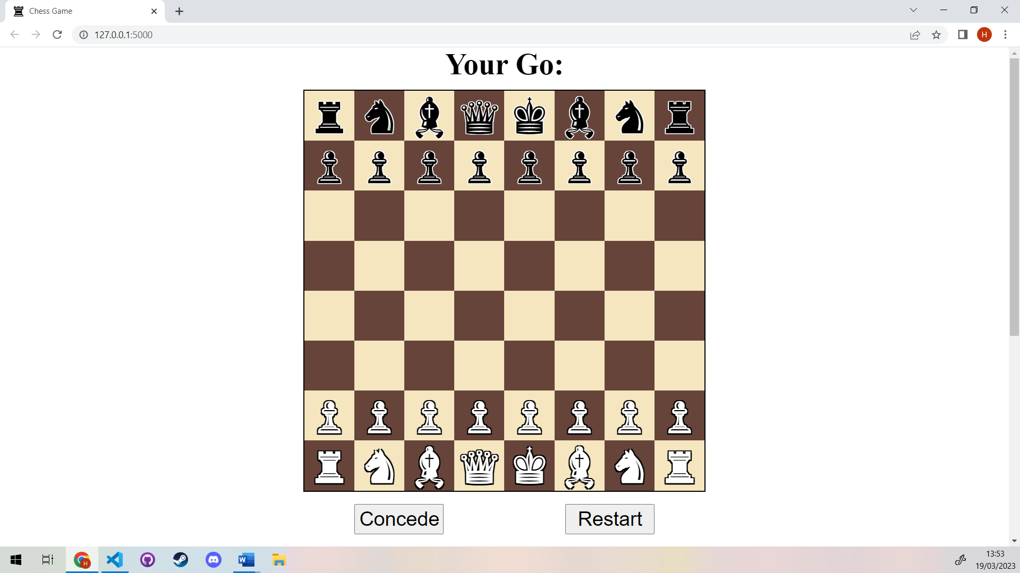

Scrolling down…

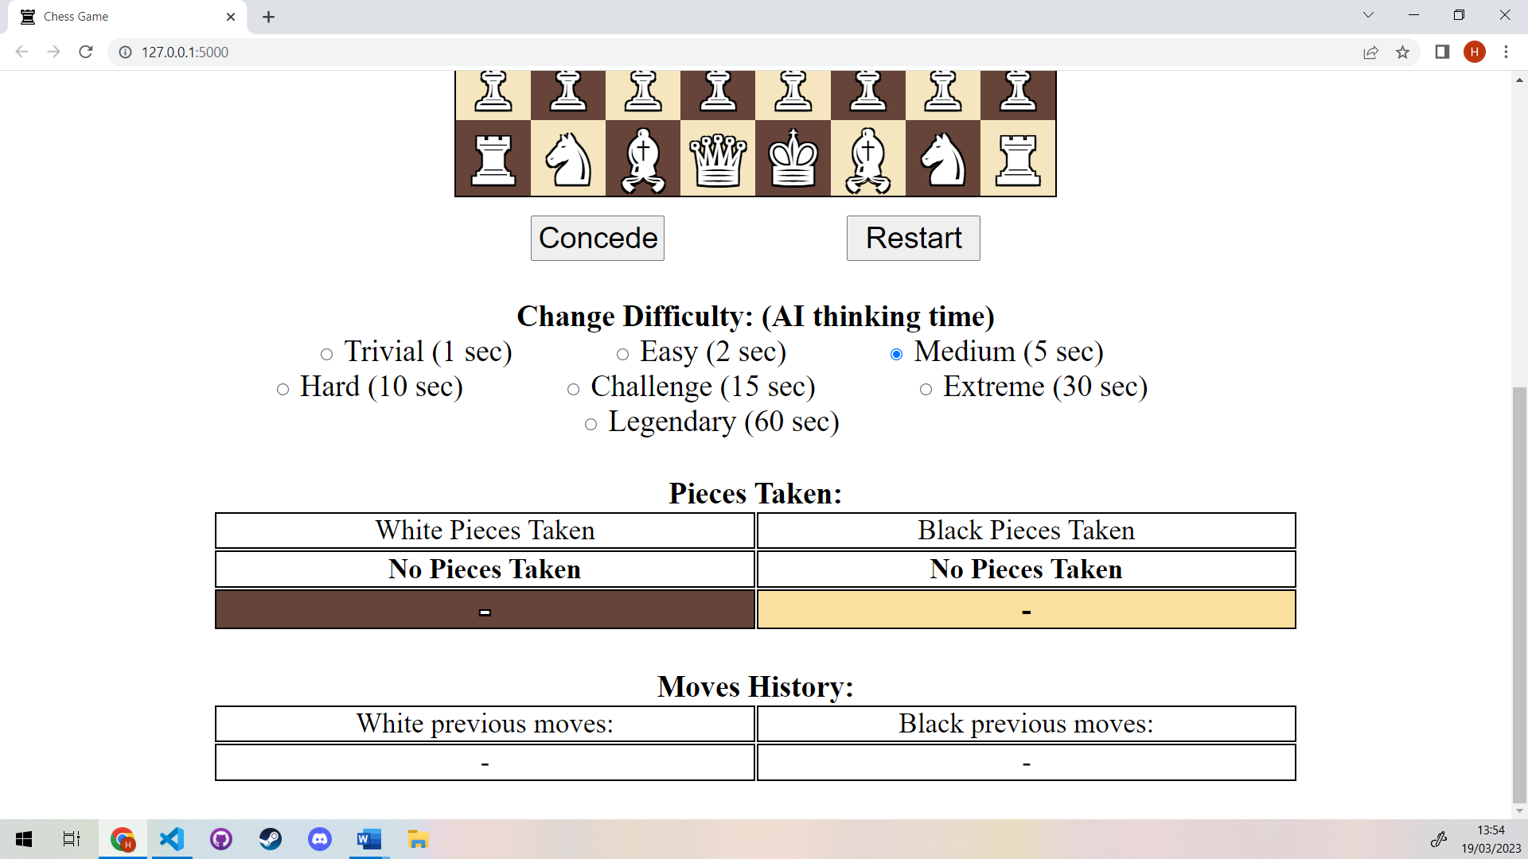

The above 2 screenshots show how the page looks from a landscape orientation with a laptop.

I will now show some other aspect ratios using chrome dev tools:

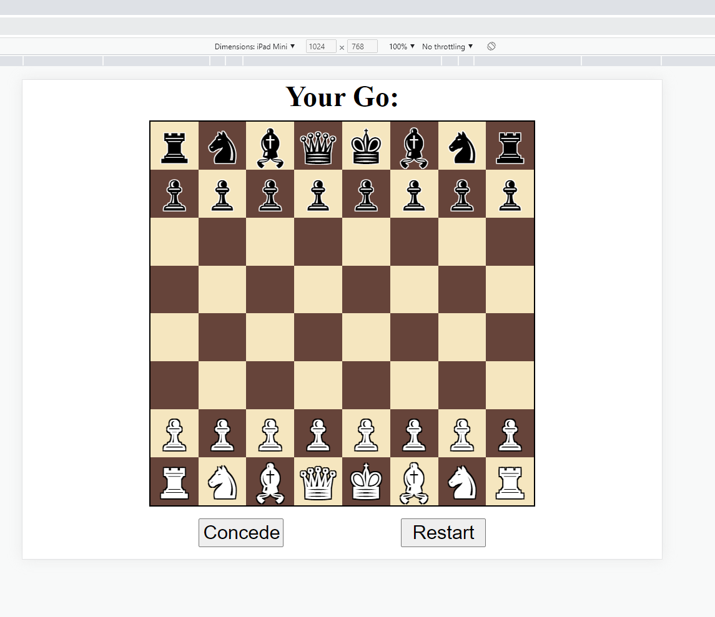 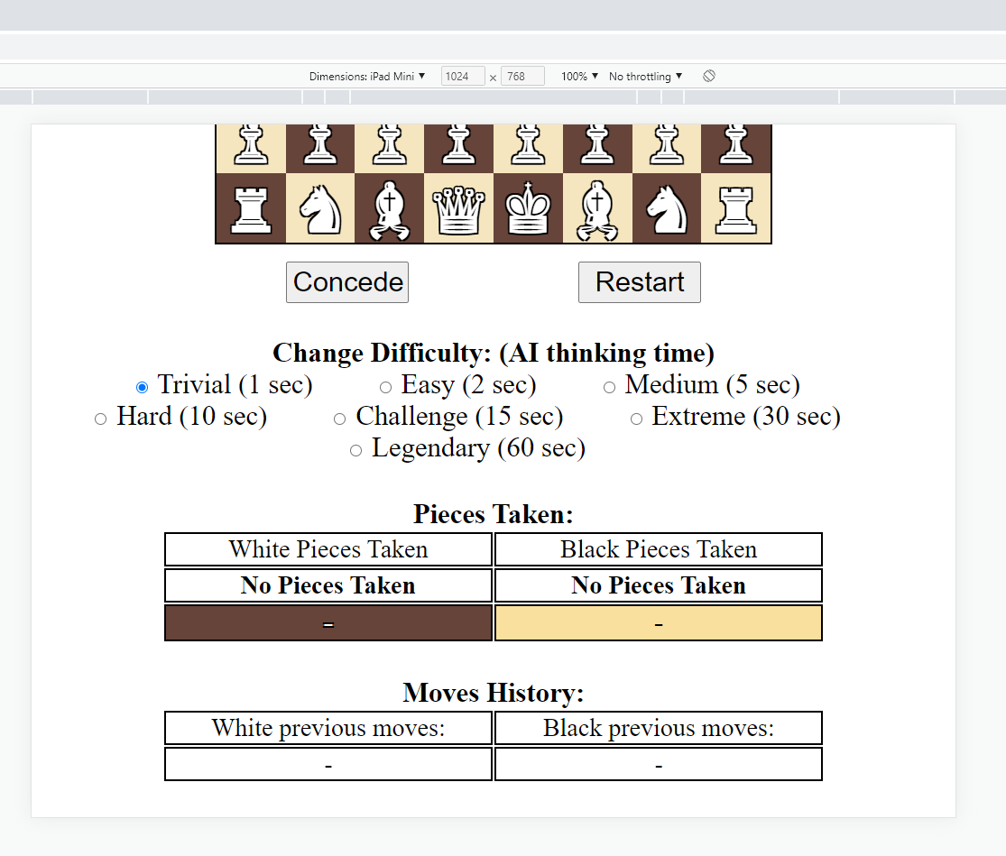

Above is the webpage viewed in a landscap oerentation with the ipad air.

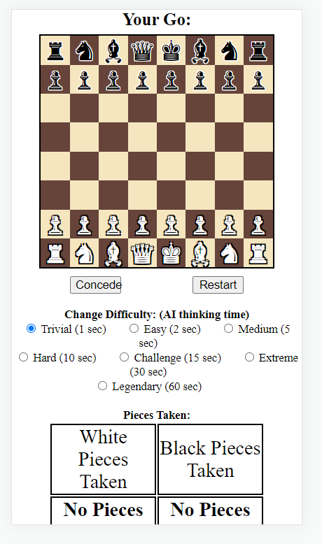 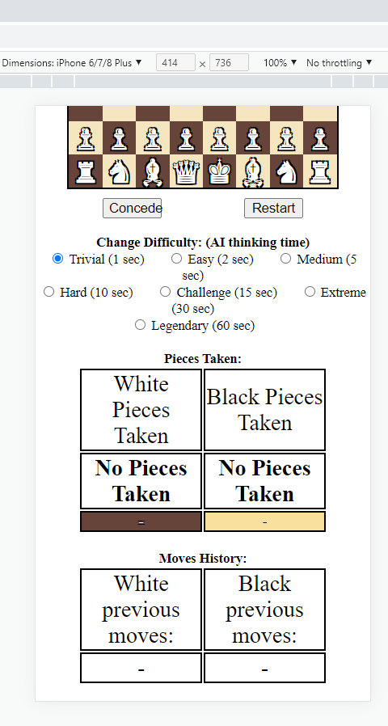

Above you can see the program running in a prtrait iphone 8. As can be seen, some of the elements are overly large. For instance the font size of the pieces taken and moves history tables are very large. However, all the elemets are visible and no are to large or small to see of interact with. This means that even though the sytles do not perfectly translate to every device, the user interface is still perfectly functional and just as usable on a wide range of devices and aspect ratios.

## Example Play

Here are some screenshot of the game as I play the computer:

I have opened a new game on medium difficulty:

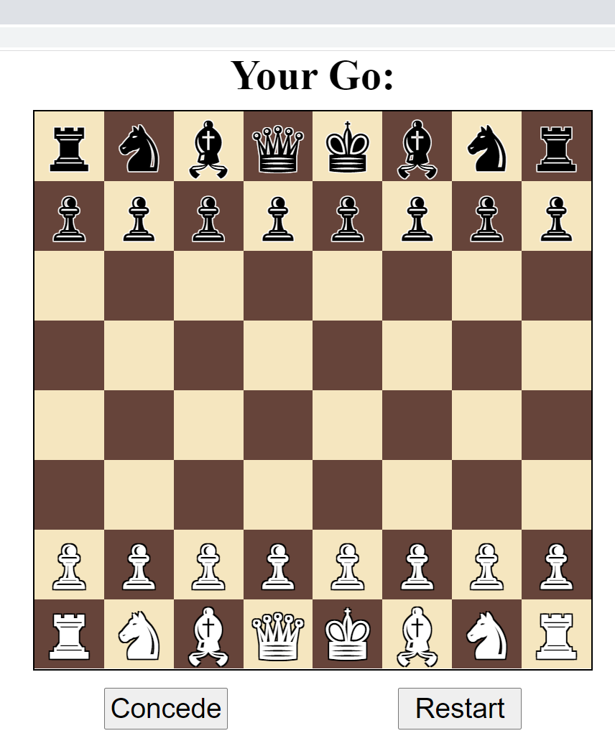

We can see that the computer has prompted me that it is my go. I will not click the white pawn in front of the queen:

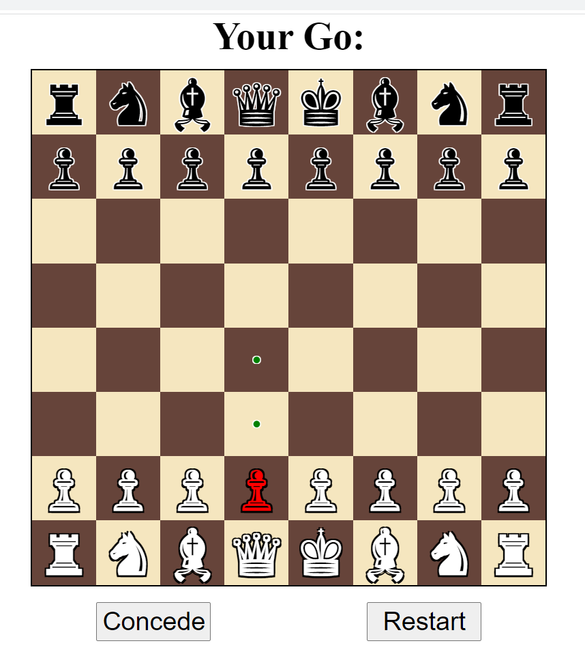

If I click off this square onto another square I get back to the blank board I started with. If I click some of my other pieces they are also highlighted red. If they can make any moves, these are highlighted in green.

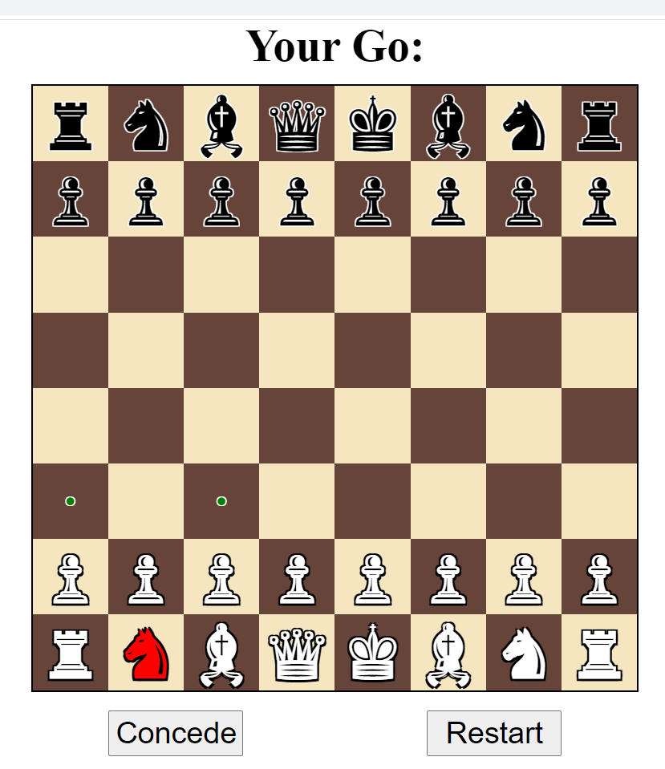

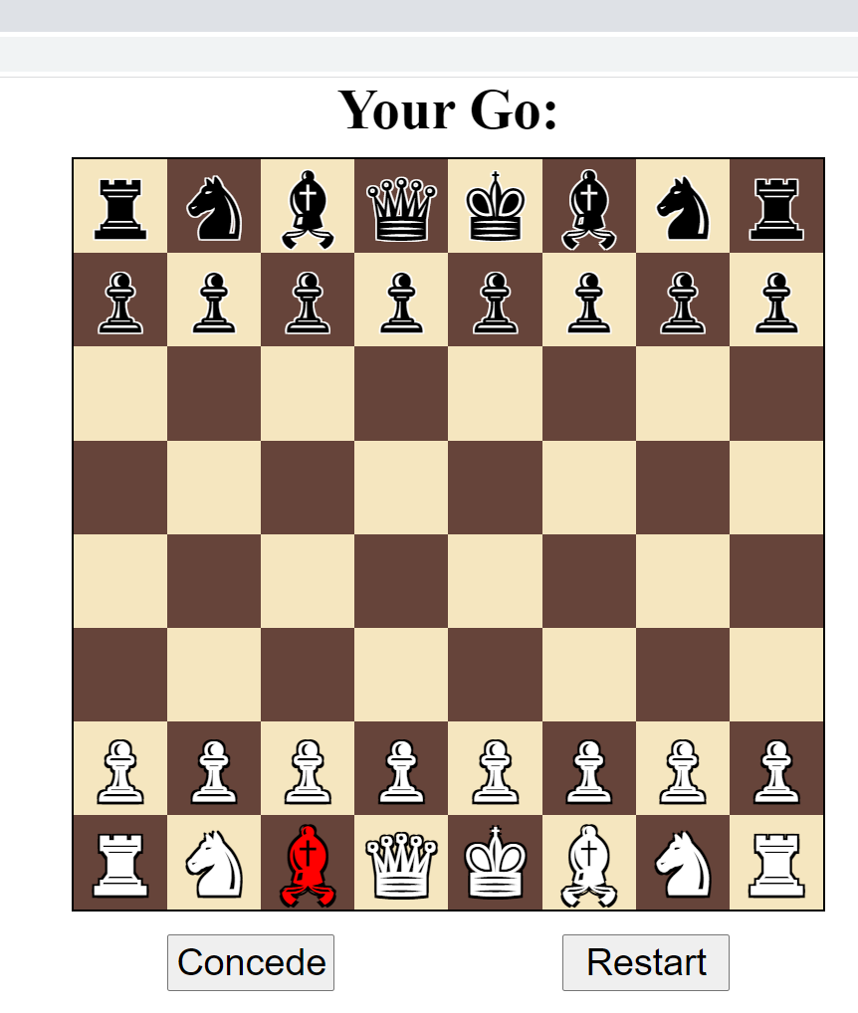

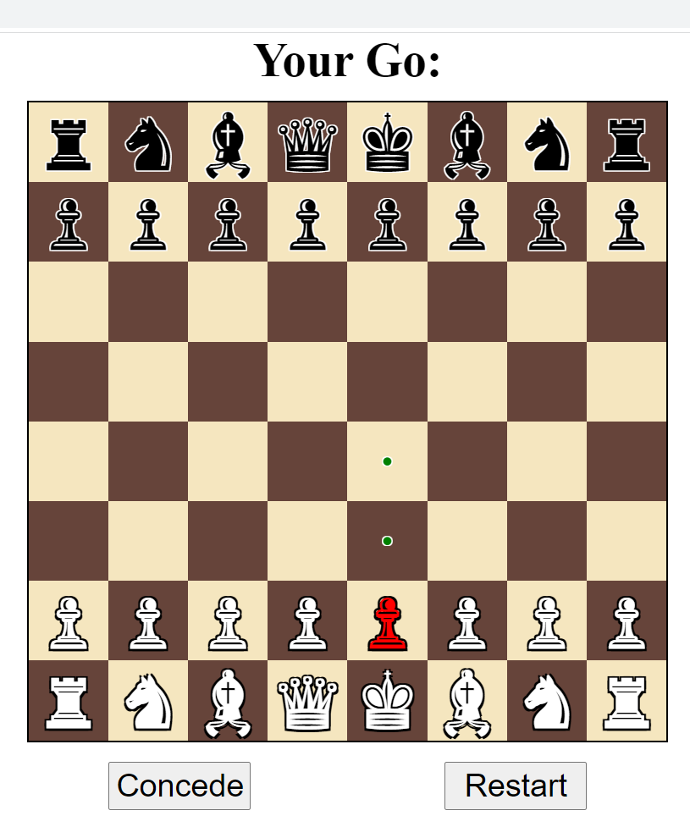

Clicking other squares including the computers squares remove the highlighting but doesn’t cause any unexpected behaviours (such as moving for the computer or moving my piece to that square).

I will click the front most green square. I have set the difficulty to be higher to slow the program down and allow me to easily capture what happens when the computer moves. Changing the difficulty has not affected the highlighting.

And here is a screenshot of the below widgets before I move:

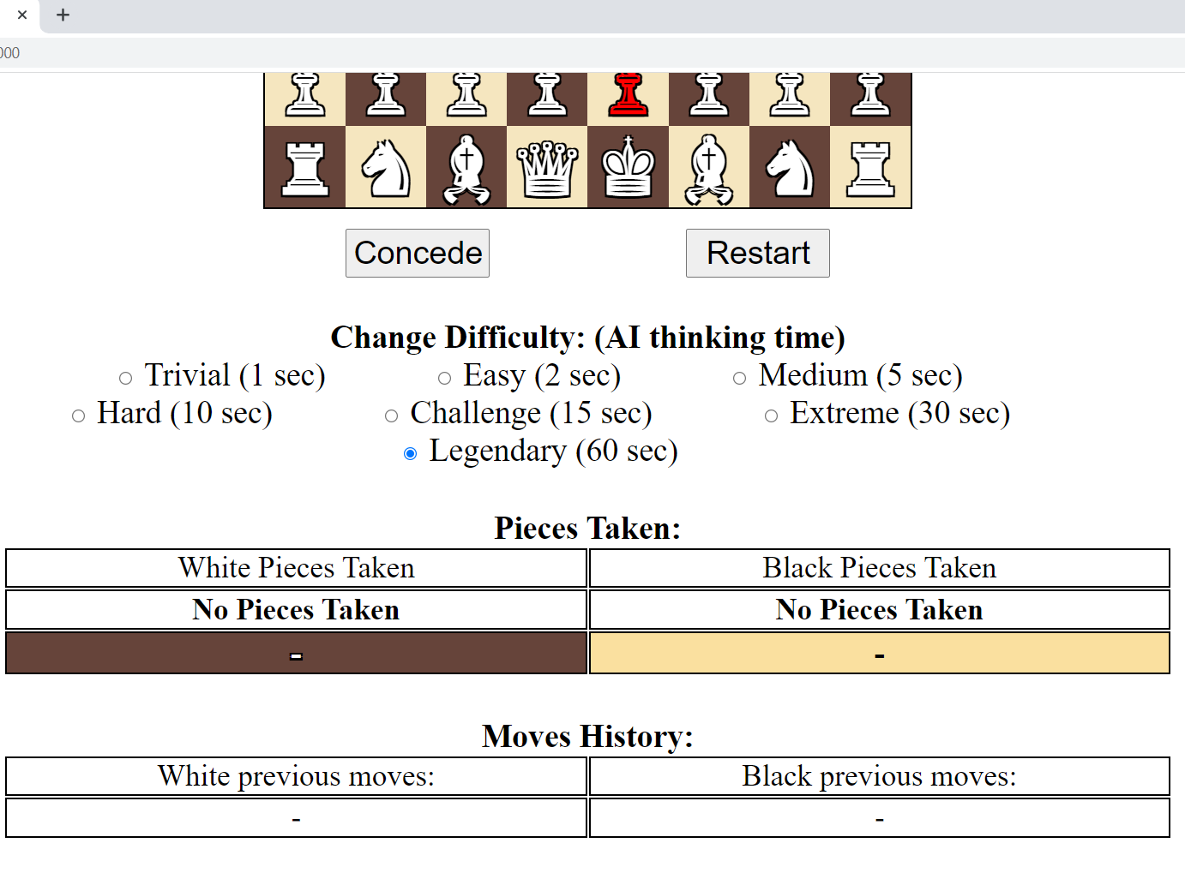

Then I clicked the front most green square and saw:

That my pawn has moved forwards, the title element had changed and the move history had changed.

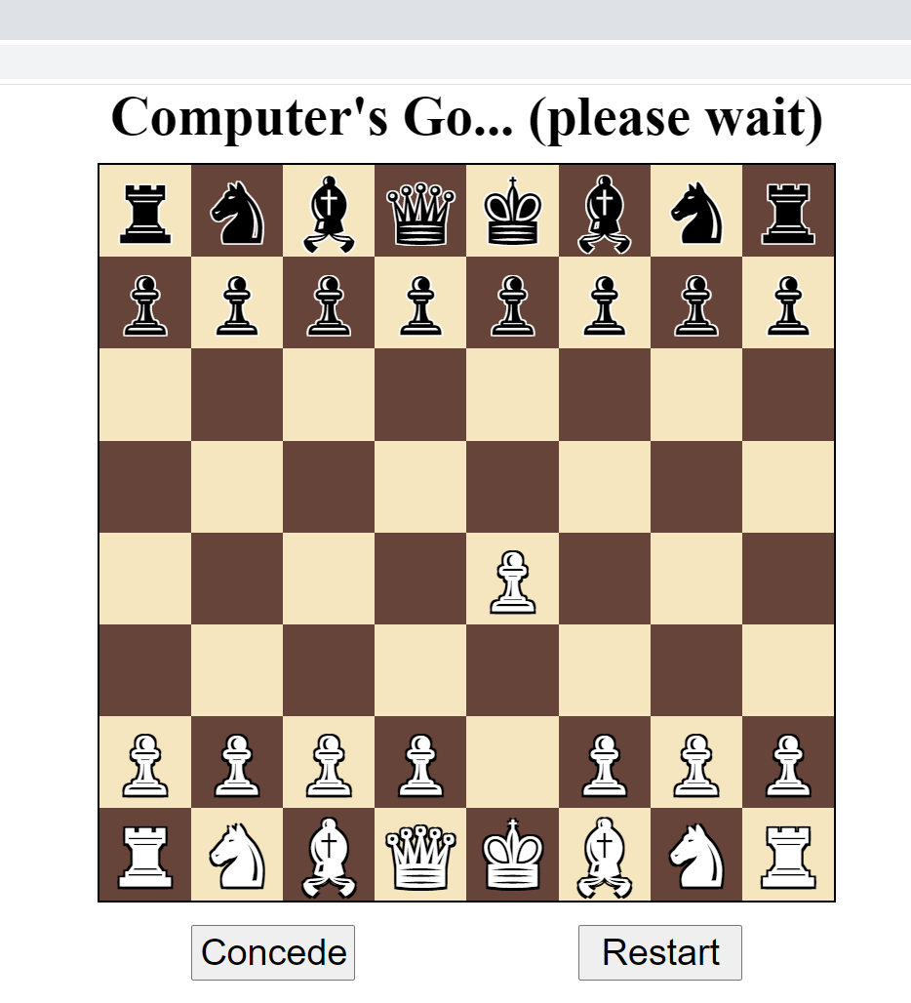

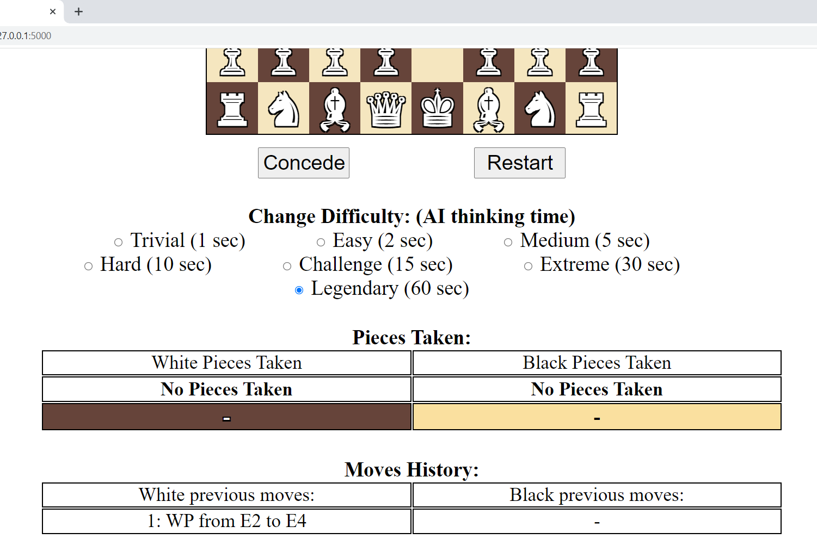

I then saw that after my move, the computer made its move. This was show by the following highlighting for 0.8 seconds

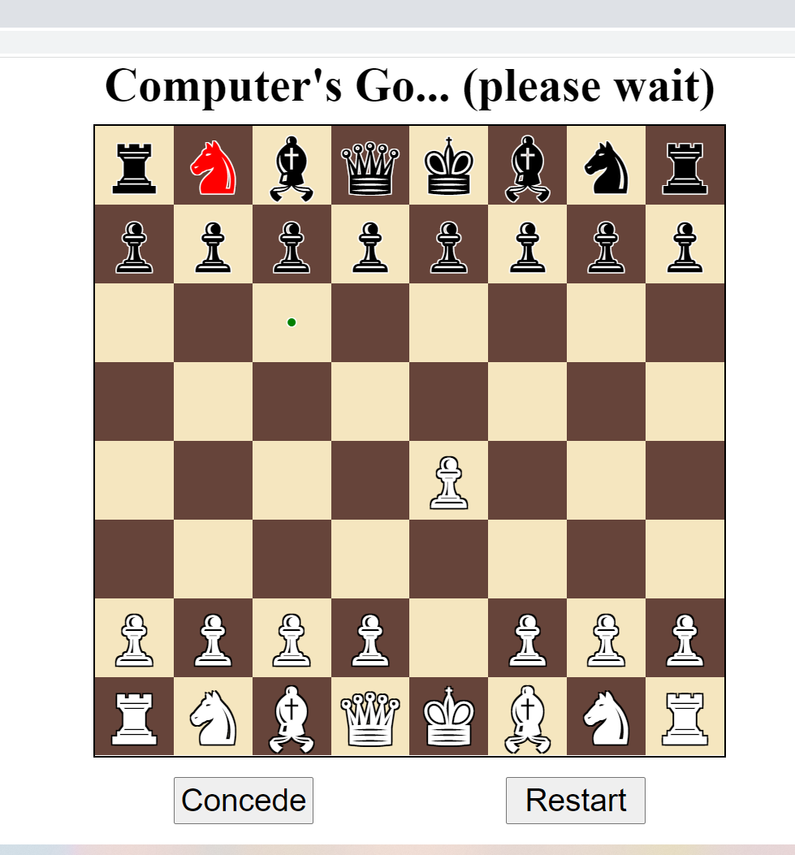

Then the board updated again to show the computer’s move and the main title told me it was my turn:

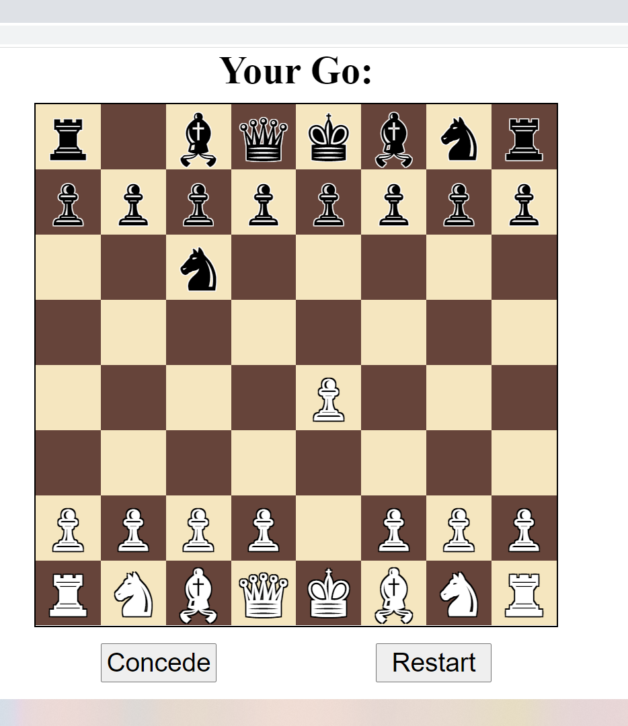

The move history widget had updated:

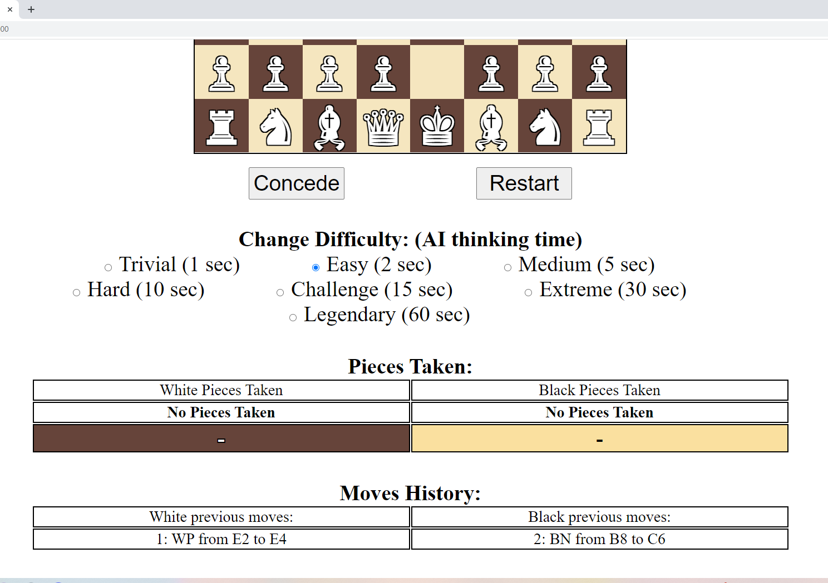

I was able to click to move another piece, one of my knights forward:

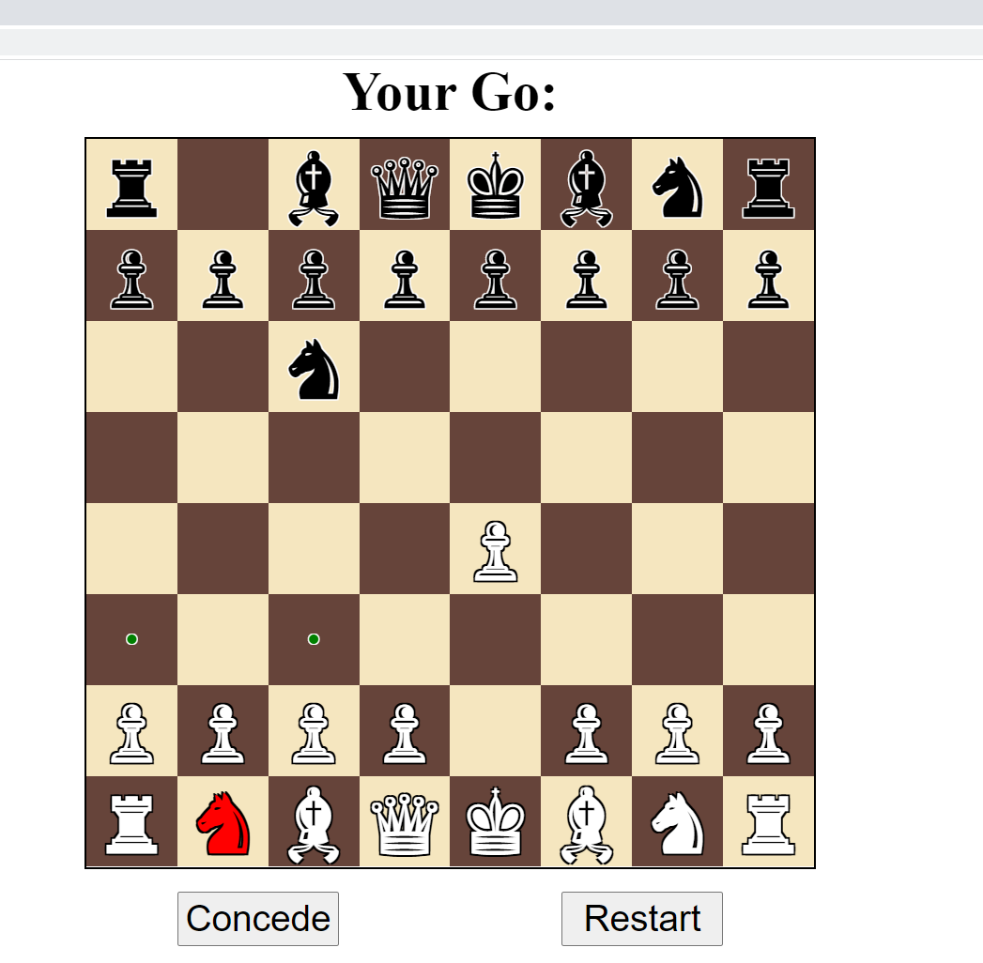 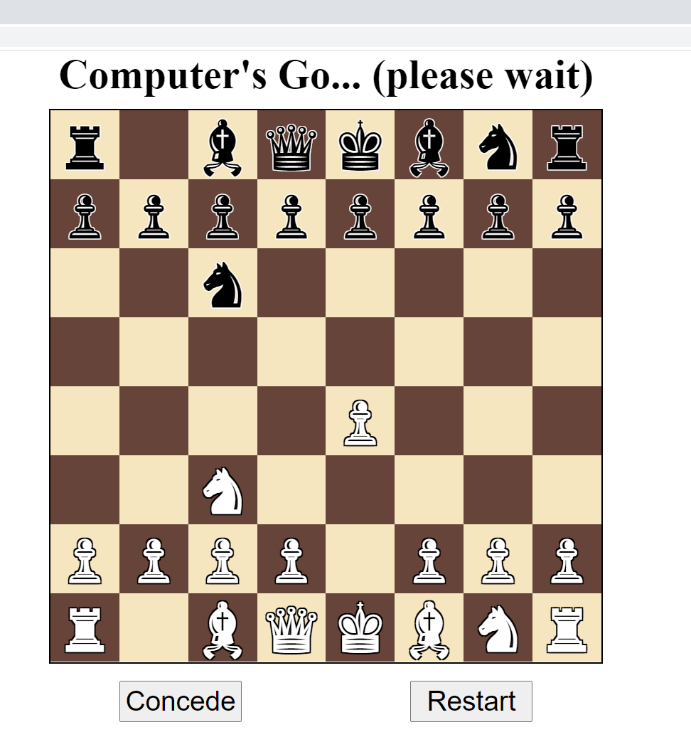

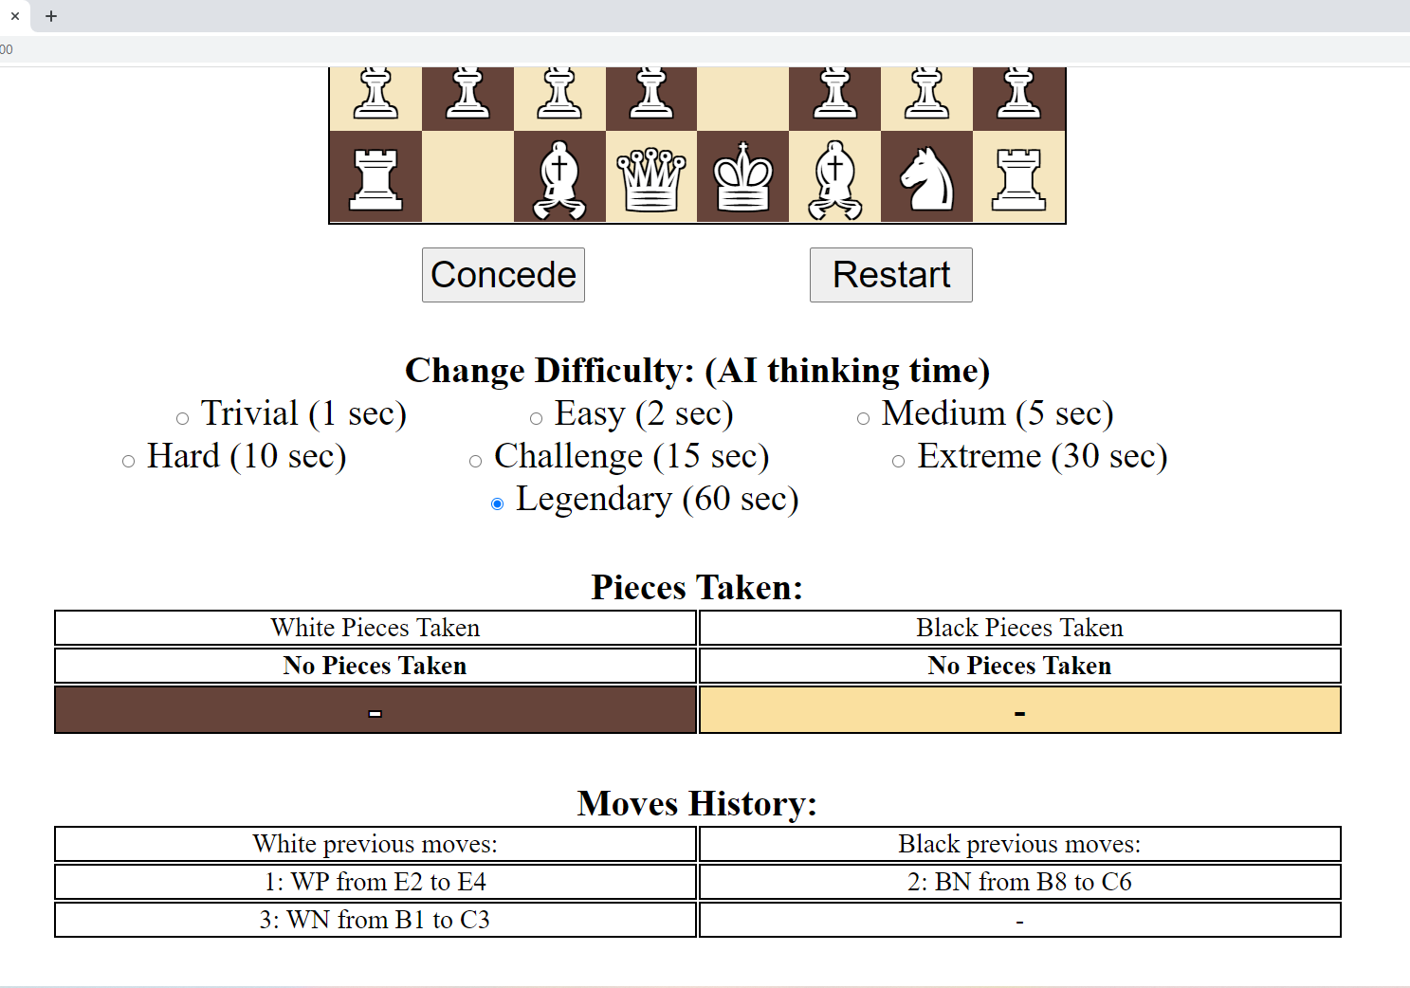

Then the computer moved again:

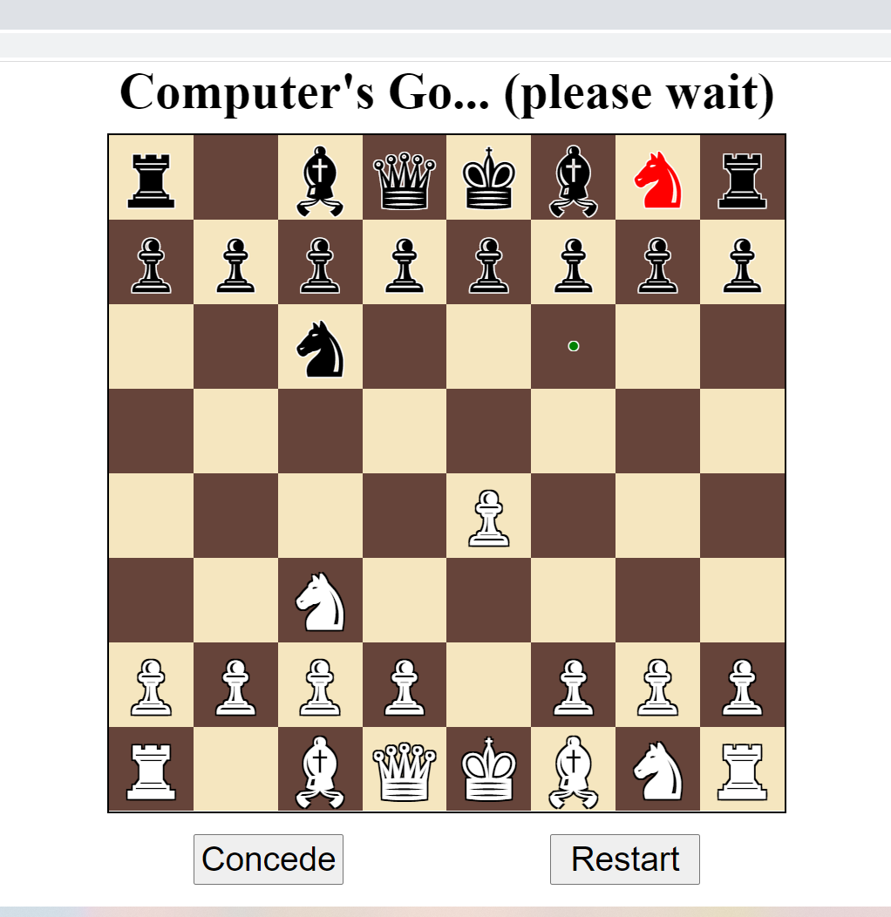

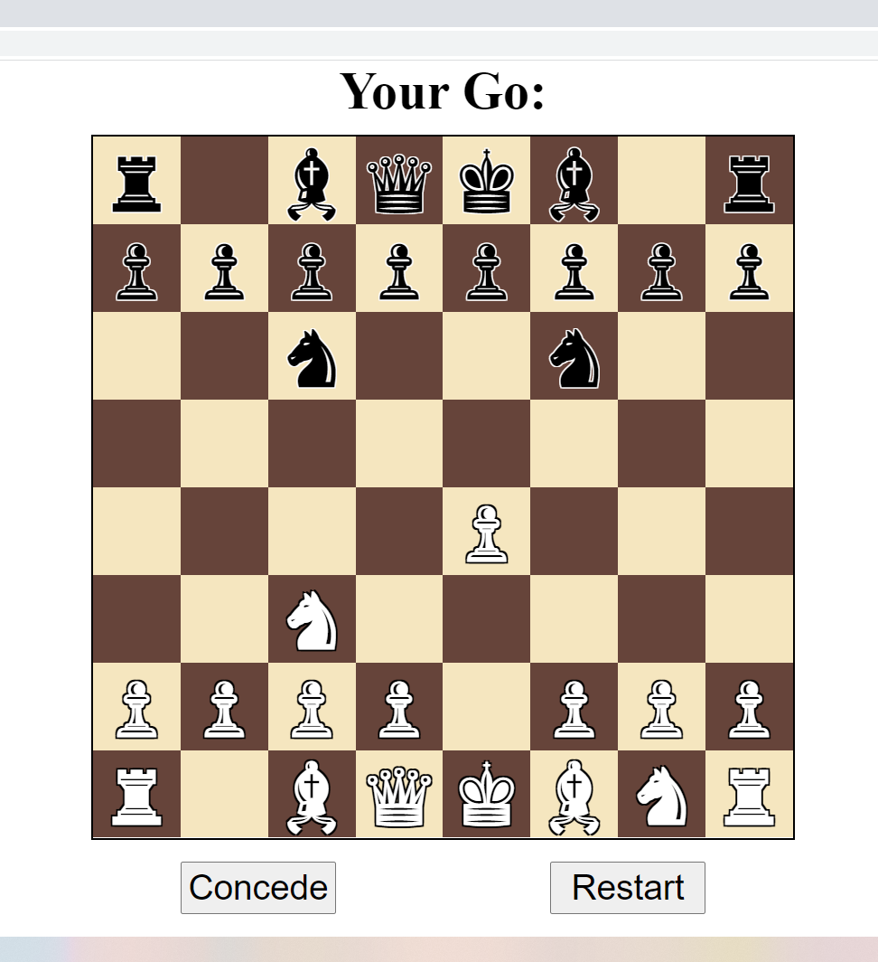

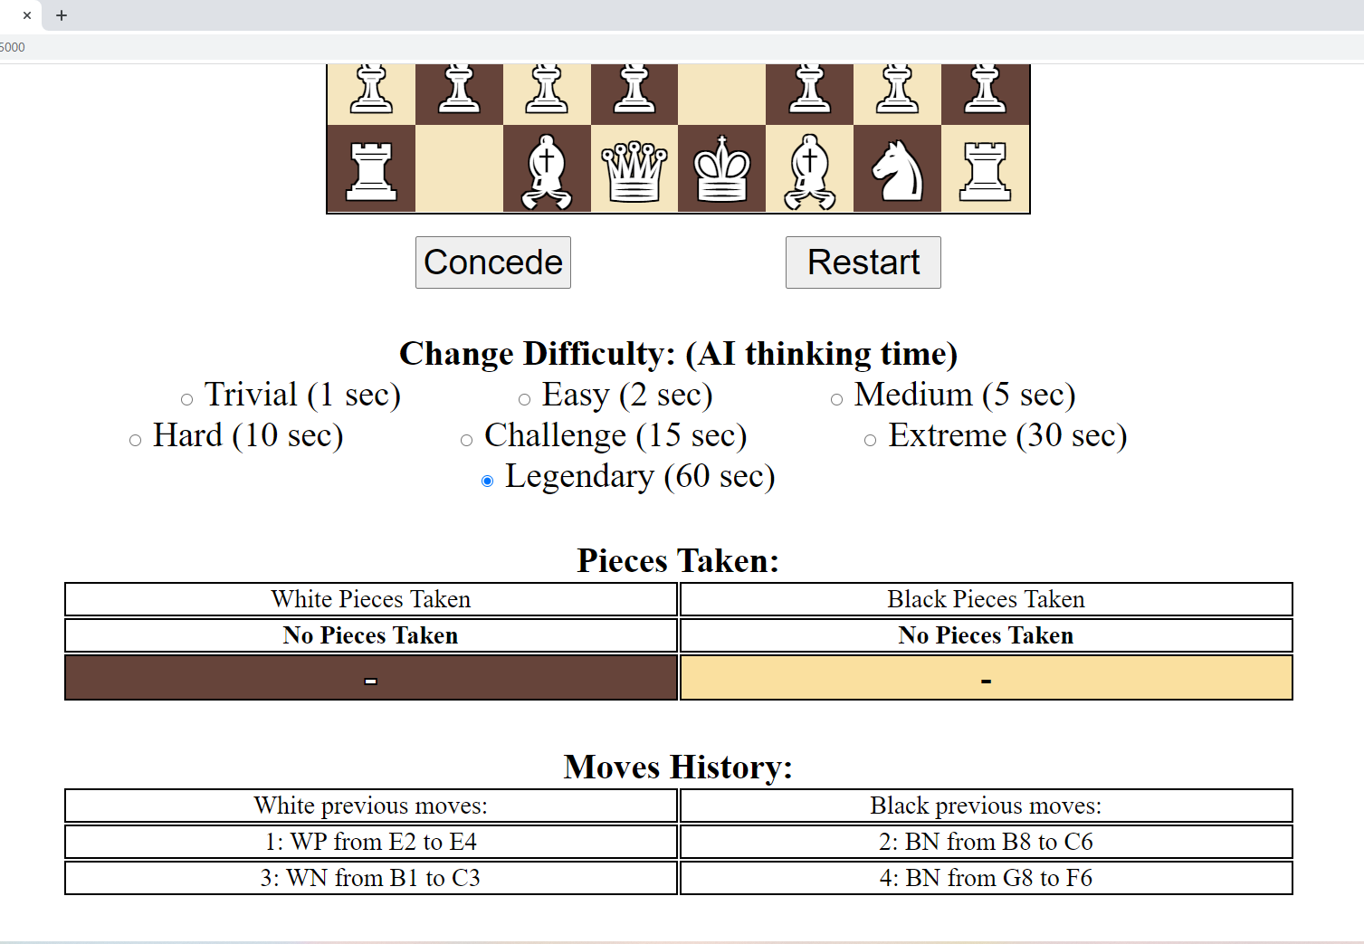

I was then able to close the tab and reopen it to the exact same game.

I saw this notice:

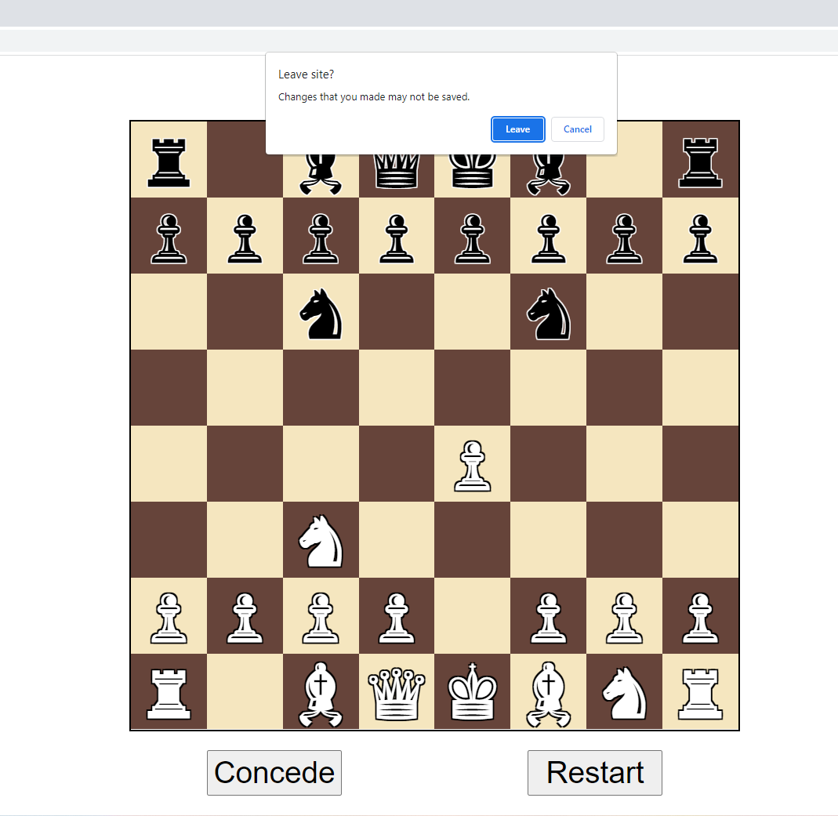

Then the tab closed and I reopened it on the same chess game. It realise the message may be a little misleading but I am not sure how to change it.

I wat then able to click the concede button.

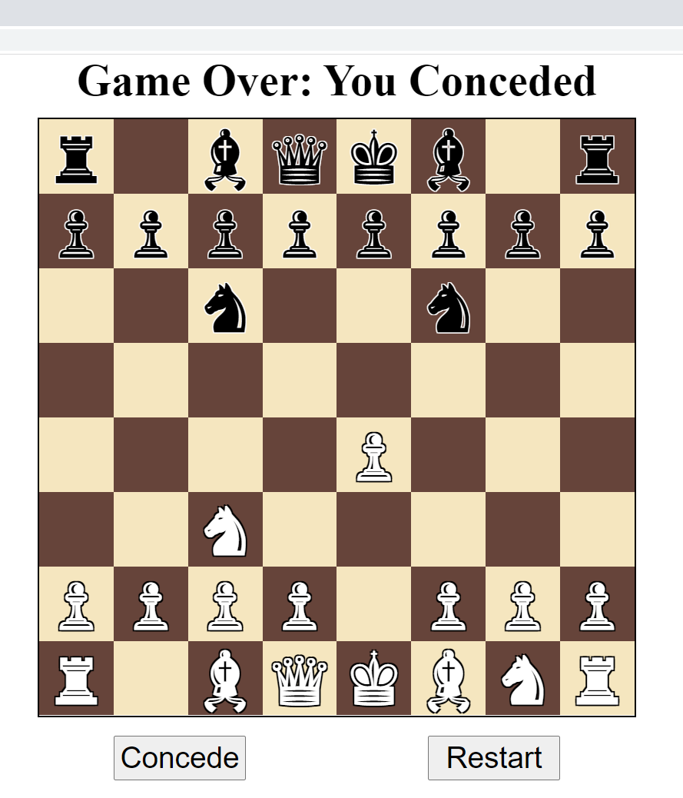

This caused the main message at the top to update and the board to become non-interactable.

I was able to change the game’s difficulty an then press restart to revert the game to the starting board positions and a blank move history:

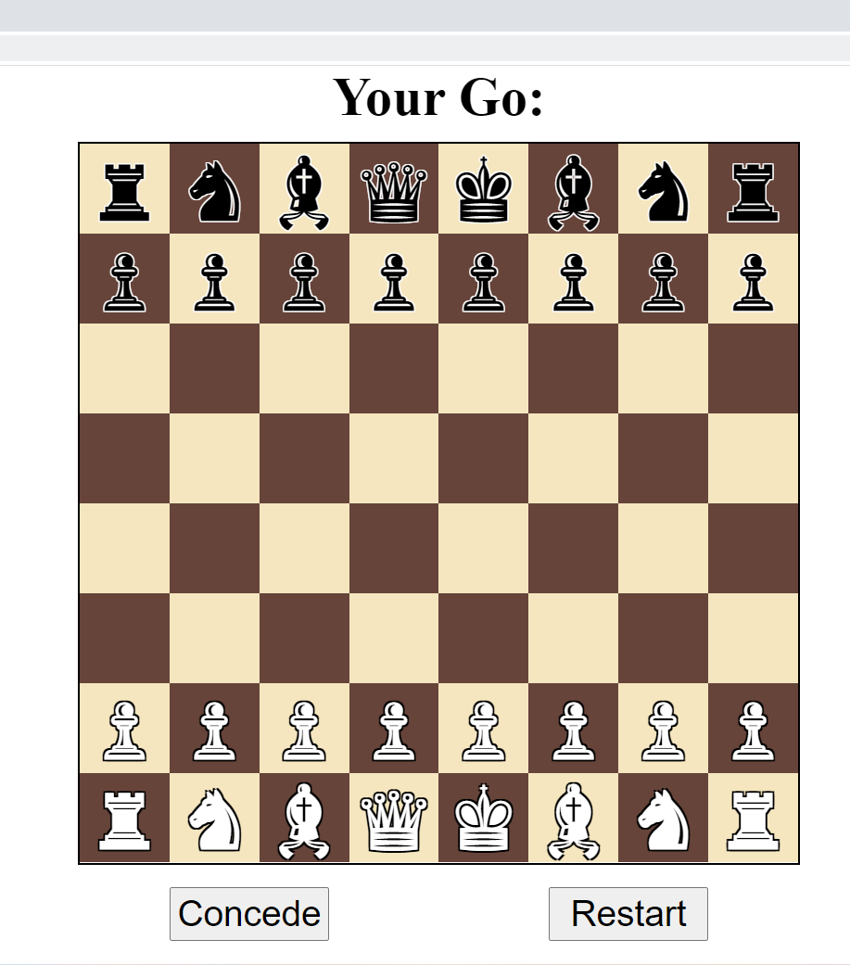

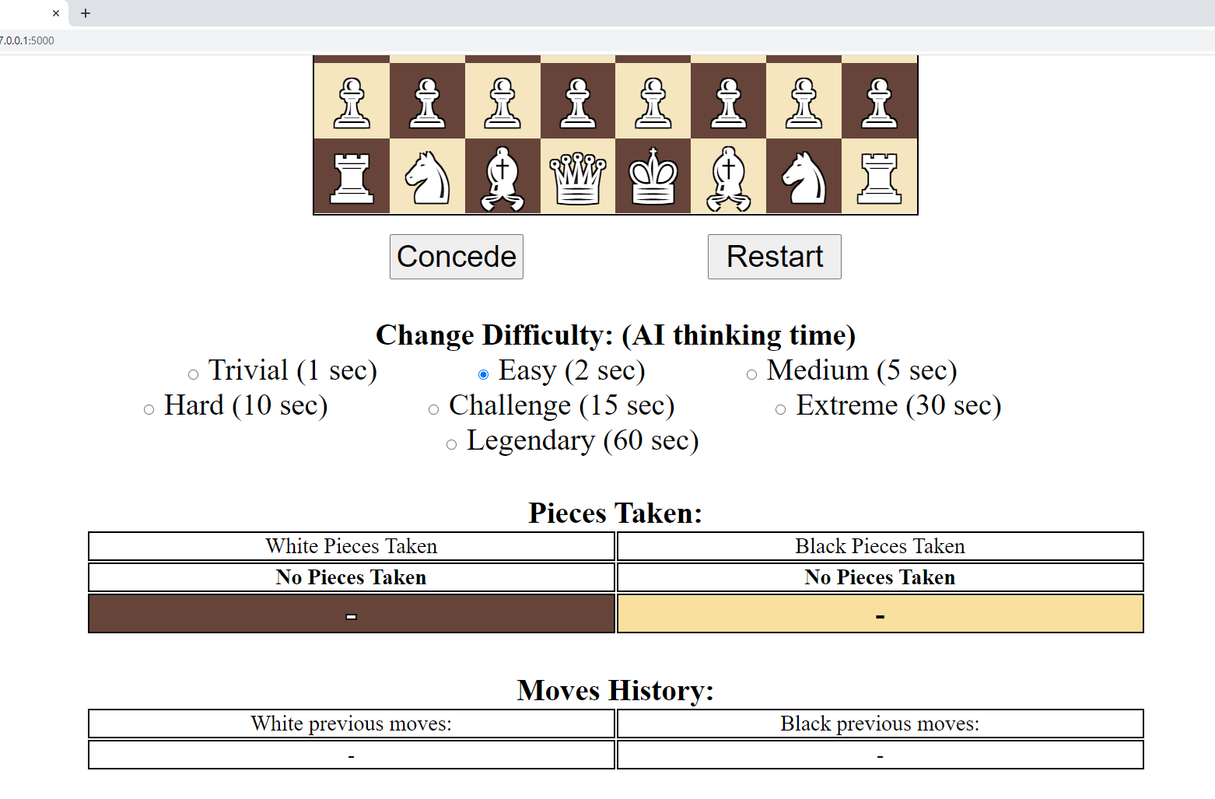

The new difficulty I set before restarting the game was preserved

## Testing:

To test the program I first added to my automated tests to add functionality to test some of the additional modules and features created. I then tested the program by running the website and playing chess against it. By testing the program as if I were a user, using the program I was able to identify various issues. I then created unit tests to identify some of the issues and then fixed my code to prevent the issue. I was then able to run the unit test again to verify that the issue had been solved.

### Automated unit tests:

Firstly I created additional minimax tests and combined together all minimax tests into one test file:

# this test is responsible for testing various mutations of the minimax function and how they play, it is not a data driven test

# imports of external modules.

from random import choice as random_choice, randint

# from itertools import product as iter_product

import pickle

import unittest

# from functools import wraps

import multiprocessing

import os

import csv

from time import perf_counter

# imports of local modules

from chess_game import Game

# from chess_functions import Board_State

# from minimax import Move_Engine

from move_engine import Move_Engine_Timed, Move_Engine_Prime

from chess_functions import random_board_state

# from assorted import ARBITRARILY_LARGE_VALUE

# from board_state import Board_State

# from vector import Vector

# # was not needed in the end, this decorator would have repeated a given function a given number of times

# def repeat_decorator_factory(times):

#     def decorator(func):

#         @wraps(func)

#         def wrapper(*args, **kwargs):

#             for _ in range(times):

#                 func(*args, **kwargs)

#         return wrapper

#     return decorator

# this is a utility function that maps a function across an iterable but also converts the result to a list data structure

def list_map(func, iter):

    return list(map(func, iter))

# this function is used to serialize a pieces matrix for output in a message

# it converts pieces to symbols it they are not none

def map_pieces_matrix_to_symbols(pieces_matrix):

    return list_map(

        lambda row: list_map(

            lambda square: square.symbol() if square else None,

            row

        ),

        pieces_matrix

    )

# this functions updates a CSV file with the moves and scores of a chess game for graphical analysis in excel

# each move in the game causes a new row to be added

def csv_write_move_score(file_path,  move_counter, move, score):

    # convert move to a pair of squares

    position_vector, movement_vector = move

    resultant_vector = position_vector + movement_vector

    from_square = position_vector.to_square()

    to_square = resultant_vector.to_square()

    # # if file doesn't exist, create is and add the headers

    # if not os.path.exists(file_path):

    #     with open(file_path, "w", newline="") as file:

    #         writer = csv.writer(file, delimiter=",")

    #         writer.writerow(("from_square", "to_square", "score"))

    # add data as a new row

    with open(file_path, "a", newline="") as file:

        writer = csv.writer(file, delimiter=",")

        # writer.writerow(("Move_counter", "B_score", "from_square", "to_square", "W_score"))

        writer.writerow((move_counter, -score, from_square, to_square, score))

# this function is used to time another function to allow for performance testing

def time_function(function):

    start = perf_counter()

    result = function()

    end = perf_counter()

    time_delta = end - start

    return result, time_delta

# this function aims to save games to a file as part of an unfinished feature

def save_games(games: tuple, file_path):

    with open(file_path, "wb") as file:

        file.write(

            pickle.dumps(

                games

            )

        )

# this method aims to load a game from a file as part of another unfinished feature

def load_games(file_path):

    if not os.path.exists(file_path):

        return dict()

    with open(file_path, "rb") as file:

        return pickle.loads(

            file.read()

        )

# the below function contains the logic to perform a test between 2 minimax bots to assert that the good bot is better

# this contains the majority of the logic to do a bot vs bot test with the game class

# it is a component as it isn't the whole test

def minimax_test_component(description, good_bot, bad_bot, success_criteria, write_to_csv, csv_folder, csv_file_name, load_game=False, save_game=False):

    # print(f"CALL minimax_test_component(description={description}, write_to_csv={write_to_csv})")

    # sourcery skip: extract-duplicate-method

    # good bot and bad bot make decisions about moves,

    # the test is designed to assert that good bot wins (and or draws in some cases)

    # if the write to csv file it enabled

    # generate csv path

    if write_to_csv:

        # not sure why but the description sometimes contains an erroneous colon, this is caught and removed

        # was able to locate bug to here, as it is a test I added a quick fix

        # bug located, some description stings included them

        # create folders

        if not os.path.exists(csv_folder):

            os.makedirs(csv_folder)

        # create file with headers if is doesn't exist

        csv_path = f"{csv_folder}/{csv_file_name}.csv"

        # overwrite so it is blank

        with open(csv_path, "w", newline="") as file:

            writer = csv.writer(file, delimiter=",")

            writer.writerow(("Move_counter", "B_score", "from_square", "to_square", "W_score"))

    # pickle_file_path = f"{csv_folder}/{csv_file_name}.games"

    # if load_game and os.path.exists(pickle_file_path):

    #     print("Attempting to load game")

    #     indexes = (-1, -2)

    #     games = load_games(pickle_file_path)

    #     for game in games:

    #         print(hash(game))

    #         print(game.board_state.next_to_go)

    #     for index in indexes:

    #         try:

    #             game = games[index]

    #             assert game.board_state.next_to_go == "W", "next to go wasn't user so use other game"

    #         except Exception as e:

    #             print(e)

    #             continue

    #         else:

    #             print(f"Using game {hash(game)} at index {index}")

    #             games = games[:index]

    # else:

    # create a new game

    print("Creating new game")

    game: Game = Game(echo=True)

        # games = tuple()

    # start a new blank game

    # depth irrelevant as computer move function passed as parameter

    print()

    print(f"Beginning test game:   {description}")

    # def record_new_game(games, new_game):

    #     games = tuple(list(games) + [new_game])

    #     save_games(games, pickle_file_path)

    #     return games

    # if save_game:

    #     games = record_new_game(games, game)

    # keep them making moves until return statement breaks loop

    while True:

        # print()

        # game.board_state.print_board()

        # print()

        # get move choice from bad bot

        # the bad bots move is implemented as the user as the user plays as white (advantage)

        result, time_delta = time_function(

            lambda: bad_bot(game)

        )

        score, move_choice = result

        # print({"move_choice": move_choice})

        # serialised to is can be passed as a user move (reusing game class)

        position_vector, movement_vector = move_choice

        resultant_vector = position_vector + movement_vector

        from_square, to_square = position_vector.to_square(), resultant_vector.to_square()

        # implement bad bot move and update csv

        # move, score = game.implement_user_move(from_square=from_square, to_square=to_square, time_delta=time_delta)

        move, _ = game.implement_user_move(from_square=from_square, to_square=to_square, time_delta=time_delta, estimated_utility=score)

        # games = record_new_game(games, game)

        if write_to_csv:

            csv_write_move_score(

                file_path=csv_path,

                move=move,

                score=game.board_state.static_evaluation(),

                move_counter=game.move_counter

            )

        # piece_moved = game.board_state.get_piece_at_vector(resultant_vector)

        # print(f"Move {game.move_counter}: bad bot moved {piece_moved} from {from_square} to {to_square} with a score perceived of {score}")

        # if game.board_state.color_in_check():

        #    print(f"CHECK:  {game.board_state.next_to_go} in check")

        # see if this move causes the test to succeed or fail or keep going

        # use the provided success criteria to determine if the game should be over.

        success, msg, board_state = success_criteria(game, description=description)

        # result = success_criteria(game, description=description)

        # print({"result": result})

        # success, msg, board_state = result

        if success is not None:

            # game.board_state.print_board()

            return success, msg, board_state

        # repeat for the good bot

        # providing good bot function, implement good bot move and update csv

        move, score = game.implement_computer_move(best_move_function=good_bot)

        # games = record_new_game(games, game)

        # update CSV

        if write_to_csv:

            csv_write_move_score(

                file_path=csv_path,

                move=move,

                score=game.board_state.static_evaluation(),

                move_counter=game.move_counter

            )

        # unpack move in terms of to and from squares

        position_vector, movement_vector = move

        resultant_vector = position_vector + movement_vector

        # piece_moved = game.board_state.get_piece_at_vector(resultant_vector)

        from_square, to_square = position_vector.to_square(), resultant_vector.to_square()

        # print(f"Move {game.move_counter}: good bot moved {piece_moved} from {from_square} to {to_square} with a score perceived of {score}")

        # if game.board_state.color_in_check():

        #    print(f"CHECK:  {game.board_state.next_to_go} in check")

        # again check if this affects the test

        success, msg, board_state = success_criteria(game, description=description)

        if success is not None:

            # game.board_state.print_board()

            return success, msg, board_state

        # # if needed provide console output to clarify that slow bot hasn't crashed

        # if game.move_counter % 10 == 0 or depth >= 3:

        # print(f"Moves {game.move_counter}:  static evaluation -> {game.board_state.static_evaluation()}, Minimax evaluation -> {score} by turn {description}")

# below are some function that have been programmed as classes with a __call__ method.

# these are basically fancy functions that CAN BE HASHED.

# I had to manually do this under the hood hashing as it is needed to allow communication between the threads

# a job must be hashable to be piped to a thread (separate python instance)

# this is a pipe-able object that makes a random move

class Random_Bot():

    # picks a random move

    def __call__(self, game):

        # determine move at random

        legal_moves = list(game.board_state.generate_legal_moves())

        assert len(legal_moves) != 0

        # match minimax output structure

        # score, best_move

        return None, random_choice(legal_moves)

    def __hash__(self) -> int:

        return hash("I am random bot, I am a unique singleton so each instance can share a hash")

# this bot picks a good move

# it exploration is limited by time

# has constructor to allow for configuration

class Bot_By_Time():

    # configure for depth and allow variable depth

    def __init__(self, time, cache_allowed=False):

        self.time = time

        self.move_engine = Move_Engine_Timed()

        self.move_engine.cache_allowed = cache_allowed

    # make minimax function call given config

    def __call__(self, game):

        return self.move_engine(

            board_state=game.board_state,

            time=self.time

        )

        # result = self.move_engine(

        #     board_state=game.board_state,

        #     time=self.time

        # )

        # print(f"Bot_By_Time:   result={result}")

        # return result

    def __hash__(self) -> int:

        return hash(f"Bot_By_Time(time={self.time})")

# this is a bot that has its exploration limited by depth

class Bot_By_Depth():

    # configure for depth and allow variable depth

    def __init__(self, depth, cache_allowed=False):

        self.depth = depth

        self.move_engine = Move_Engine_Prime()

        self.move_engine.cache_allowed = cache_allowed

    # make minimax function call given config

    def __call__(self, game):

        return self.move_engine(

            board_state=game.board_state,

            depth=self.depth

        )

        # result = self.move_engine(

        #     board_state=game.board_state,

        #     depth=self.depth

        # )

        # print(f"Bot_By_Depth:   result={result}")

        # return result

    def __hash__(self) -> int:

        return hash(f"Bot_By_Depth(depth={self.depth})")

# used to look at a game and decide if the test should finish

class Success_Criteria():

    # constructor allow config for stalemates to sill allow test to pass

    def __init__(self, allow_stalemate_3_states_repeated: bool):

        self.allow_stalemate_3_states_repeated = allow_stalemate_3_states_repeated

    def __call__(self, game: Game, description):

        # returns: success, message, serialised pieces matrix

        # call game over and use a switch case to decide what to do

        match game.check_game_over():

            # if 3 repeat stalemate, check with config wether is is allows

            # case True, None, "Stalemate":

            case True, None, _:

                # game.board_state.print_board()

                if game.board_state.is_3_board_repeats_in_game_history() and self.allow_stalemate_3_states_repeated:

                    # game.board_state.print_board()

                    # print(f"Success: Stalemate at {game.move_counter} moves in test {description}: 3 repeat board states, outcome specify included in allowed outcomes")

                    # return True, f"Success: Stalemate at {game.move_counter} moves in test {description}: 3 repeat board states, outcome specify included in allowed outcomes", map_pieces_matrix_to_symbols(game.board_state.pieces_matrix)

                    return (

                        True,

                        f"Success: Stalemate at in test {description}: 3 repeat board states, outcome specify included in allowed outcomes",

                        map_pieces_matrix_to_symbols(game.board_state.pieces_matrix),

                    )

                else:

                    # game.board_state.print_board()

                    # print(f"FAILURE: ({description}) stalemate caused (3 repeats?  -> {game.board_state.is_3_board_repeats_in_game_history()})")

                    return (

                        False,

                        f"FAILURE: ({description}) stalemate caused (3 repeats?  -> {game.board_state.is_3_board_repeats_in_game_history()})",

                        map_pieces_matrix_to_symbols(game.board_state.pieces_matrix),

                    )

            # good bot loss causes test to fail

            # case True, 1, "Checkmate":

            case True, 1, _:

                # game.board_state.print_board()

                # print(f"Failure: ({description}) computer lost")

                return (

                    False,

                    f"Failure: ({description}) computer lost",

                    map_pieces_matrix_to_symbols(game.board_state.pieces_matrix),

                )

            # good bot win causes test to pass

            # case True, -1, "Checkmate":

            case True, -1, _:

                # game.board_state.print_board()

                # print(f"SUCCESS: ({description}) Game has finished and been won in {game.move_counter} moves")

                return (

                    True,

                    f"SUCCESS: ({description}) Game has finished and been won in {game.move_counter} moves",

                    map_pieces_matrix_to_symbols(game.board_state.pieces_matrix),

                )

            # if the game isn't over, return success as none and test will continue

            case False, _, _:

                return (

                    None,

                    None,

                    None,

                )

    def hash(self):

        return hash(f"Success_Criteria(allow_stalemate_3_states_repeated={self.allow_stalemate_3_states_repeated})")

# given a test package (config for one test), carry it out

def execute_test_job(test_data_package):

    # deal with unexplained bug where argument is tuple / list length 1 containing relevant dict (quick fix as only a test)

    # I was able to identify that this is where it occurs and add a correction but I am not sure what the cause of the bug is

    if any(isinstance(test_data_package, some_type) for some_type in (tuple, list)):

        if len(test_data_package) == 1:

            test_data_package = test_data_package[0]

    # print(f"test_data_package   -->   {test_data_package}")

    # really simple, call minimax test component providing all keys in package as keyword arguments

    return minimax_test_component(**test_data_package)

# this pool jobs function for completing tests in parallel is not needed when the move engine is parallelized

# this function takes an iterable of hashable test_packages

# it all 8 logical cores on my computer to multitask to finish the test sooner

def pool_jobs(test_data):

    # counts logical cores

    # my CPU is a 10th gen i7

    # it has 4 cores and 8 logical cores due to hyper threading

    # with 4-8 workers I can use 100% of my CPU

    cores = multiprocessing.cpu_count()

    # create a pool

    with multiprocessing.Pool(cores) as pool:

        # map the execute_test_job function across the set of test packages using multitasking

        # return the result

        # return pool.map(

        #     func = execute_test_job,

        #     iterable = test_data

        # )

        yield from pool.map(

            func=execute_test_job,

            iterable=test_data

        )

# test case contains unit tests

# multitasking only occurs within a test, tests are themselves executed sequentially

# I could pool all tests into one test function but this way multiple failures can occur in different tests

# (one single test would stop at first failure)

overnight = False

RANDOM_TRIAL_NUM = 3

# this function asserts that are elements in a list are the same

def test_same(some_list):

    assert len(some_list) > 0

    return all(some_list[0] == element for element in some_list)

# @unittest.skip("Takes too long")

class Test_Case(unittest.TestCase):

    # this function takes the results of the tests from the test pool and checks the results with a unittest

    # a failure is correctly identified to correspond to the function that called this function

    # reduces repeated logic

    def check_test_results(self, test_results):

        # for success, msg, final_pieces_matrix in test_results:

        for success, msg, _ in test_results:

            # print()

            # for row in final_pieces_matrix:

            #     row = "  ".join(map(

            #         lambda square: str(square).replace("None", ". "),

            #         row

            #     ))

            #     print(row)

            # print(msg)

            # i choose to iterate rather than assert all as this allows me to have the appropriate message on failure

            self.assertTrue(

                success,

                msg=msg

            )

    # this function tests that a cached call always produces the same result as one without caching

    # it also ensures that the second cache call for the same search is much faster

    # this test is completed on many random board states

    def test_cache_is_faster(self):

        trials = 40

        # trials = 5

        # create and configure move engines

        move_engine_with_cache = Move_Engine_Prime()

        move_engine_without_cache = Move_Engine_Prime()

        move_engine_without_cache.cache_allowed = False

        for move_engine in (move_engine_with_cache, move_engine_without_cache):

            move_engine.depth = 2

            move_engine.cache_manager.allow_greater_depth = False

        # repeat test for many trials

        for _ in range(trials):

            # note random_board_state as a function is inefficient as it is used for testing only, takes a while

            # generate a random board state

            board_state = random_board_state(60)

            # turn of 3 repeat stalemates so cache and without behave the same

            board_state.three_repeat_stalemates_enabled = False

            # board_state.print_board()

            # check result with out cache

            true_result = move_engine_without_cache(board_state)

            true_result = list(true_result)

            true_result[1] = list(true_result[1])

            # attempt 1 with cache

            first_cache_result, first_cache_time_delta = time_function(

                lambda: move_engine_with_cache(board_state)

            )

            first_cache_result = list(first_cache_result)

            first_cache_result[1] = list(first_cache_result[1])

            # check that the results were the same

            self.assertEqual(

                first_cache_result,

                true_result,

                "The first cache call should give the same result as without cache"

            )

            # attempt 2 with cache

            second_cache_result, second_cache_time_delta = time_function(

                lambda: move_engine_with_cache(board_state)

            )

            second_cache_result = list(second_cache_result)

            second_cache_result[1] = list(second_cache_result[1])

            # check that the results were again the same

            self.assertEqual(

                first_cache_result,

                true_result,

                "The second cache call should give the same result as without cache"

            )

            # check that with cache was much faster

            self.assertLessEqual(

                second_cache_time_delta,

                0.2 * first_cache_time_delta,

                "When using database cache, the lookup should be at least 5 times quicker than calculation"

            )

    # tests basic minimax vs random moves

    def test_timed_vs_randotron(self):

        trials = RANDOM_TRIAL_NUM

        # test package generated to include relevant data and logic (bots and success criteria)

        def generate_jobs():

            for num in range(1, trials+1):

                for time in [2, 5, 10, 20]:

                    yield {

                        "description": f"test: {time}s timed move engine vs randotron",

                        "good_bot": Bot_By_Time(time=time),

                        "bad_bot": Random_Bot(),

                        "success_criteria": Success_Criteria(allow_stalemate_3_states_repeated=False),

                        "write_to_csv": True,

                        "csv_folder": "./test_reports/test_timed_vs_randotron",

                        "csv_file_name": f"test_timed_{time}s_num_{num}"

                    }

        def generate_test_results():

            for test_specs in generate_jobs():

                yield minimax_test_component(**test_specs)

        self.check_test_results(

            generate_test_results()

        )

    # tests basic minimax vs random moves

    @unittest.skip("takes too long")

    def test_depth_vs_randotron(self):

            trials = RANDOM_TRIAL_NUM

            # test package generated to include relevant data and logic (bots and success criteria)

            def generate_jobs():

                for num in range(1, trials+1):

                    # for depth in range(4):

                    for depth in [1, 2]:

                        yield {

                            "description": f"test: depth {depth} move engine vs randotron",

                            "good_bot": Bot_By_Depth(depth=depth),

                            "bad_bot": Random_Bot(),

                            "success_criteria": Success_Criteria(

                                allow_stalemate_3_states_repeated=(depth<=1)

                            ),

                            "write_to_csv": True,

                            "csv_folder": "./test_reports/test_depth_vs_randotron",

                            "csv_file_name": f"test_depth_{depth}_num_{num}"

                        }

            def generate_test_results():

                for test_specs in generate_jobs():

                    yield minimax_test_component(**test_specs)

            self.check_test_results(

                generate_test_results()

            )

    # test that bots that can explore more are better

    # @unittest.skip("takes too long")

    def test_bots_by_depth(self):

        # test package generated to include relevant data and logic (bots and success criteria)

        def generate_jobs():

            # don't do depth 0s as they cannot decide a move

            for depth_greater in (3,):

            # for depth_greater in (2, 3):

                # ensure depth_a >= depth_b

                # for depth_lesser in range(1, depth_greater):

                # for depth_lesser in range(1, depth_greater+1):

                # allow_draw = (depth_lesser == depth_greater)

                depth_lesser = depth_greater - 1

                yield {

                    "description": f"test: depth {depth_greater} bot vs depth {depth_lesser} bot",

                    "good_bot": Bot_By_Depth(depth=depth_greater),

                    "bad_bot": Bot_By_Depth(depth=depth_lesser),

                    "success_criteria": Success_Criteria(allow_stalemate_3_states_repeated=False),

                    # "success_criteria": Success_Criteria(allow_stalemate_3_states_repeated=allow_draw),

                    "write_to_csv": True,

                    "csv_folder": "./test_reports/test_bots_by_depth",

                    "csv_file_name": f"test_depth_{depth_greater}_vs_depth_{depth_lesser}"

                }

        def generate_test_results():

            for test_specs in generate_jobs():

                yield minimax_test_component(**test_specs)

        self.check_test_results(

            generate_test_results()

        )

    # test that bots that can explore more are better

    def test_bots_by_time(self):

        # test package generated to include relevant data and logic (bots and success criteria)

        def generate_jobs():

            time_deltas = [2, 5, 10, 15, 20]

            for time_delta_lesser in time_deltas:

                time_delta_greater = max(1.4*time_delta_lesser, 4+time_delta_lesser)

                # time_delta_greater = max(2*time_delta_lesser, 10+time_delta_lesser)

                # time_delta_greater = max(4*time_delta_lesser, 15+time_delta_lesser)

                yield {

                    "description": f"test: {time_delta_greater}s timed bot vs {time_delta_lesser}s timed bot",

                    "good_bot": Bot_By_Time(time=time_delta_greater),

                    "bad_bot": Bot_By_Time(time=time_delta_lesser),

                    # "success_criteria": Success_Criteria(allow_stalemate_3_states_repeated=False),

                    "success_criteria": Success_Criteria(allow_stalemate_3_states_repeated=True),

                    "write_to_csv": True,

                    "csv_folder": "./test_reports/test_bots_by_time",

                    "csv_file_name": f"test_{time_delta_greater}s_timed_bot_vs_{time_delta_lesser}s_timed_bot"

                }

        def generate_test_results():

            for test_specs in generate_jobs():

                yield minimax_test_component(**test_specs)

        self.check_test_results(

            generate_test_results()

        )

    # test what the parallel move engine doesn't produce a different output

    def test_deterministic_outcomes_parallel(self):

        # create move engines and configures them

        with_parallel_engine = Move_Engine_Prime()

        without_parallel_engine = Move_Engine_Prime()

        for engine in (with_parallel_engine, without_parallel_engine):

            engine.cache_allowed = False

            engine.additional_depth = 0

        with_parallel_engine.parallel = True

        without_parallel_engine.parallel = False

        def always(*args, **kwargs): return True

        def never(*args, **kwargs): return False

        with_parallel_engine.should_use_parallel = always

        without_parallel_engine.should_use_parallel = never

        # generate a large number of random board states

        def gen_random_board_states():

            for _ in range(40):

                yield random_board_state(moves=randint(0, 10))

            for _ in range(20):

                yield random_board_state(moves=randint(0, 20))

            for _ in range(10):

                yield random_board_state(moves=randint(0, 40))

        # test that for each board state, the move engines produce the same deterministic outcome

        for board_state in gen_random_board_states():

            score_parallel, move_parallel = with_parallel_engine(board_state)

            score_non_parallel, move_non_parallel = without_parallel_engine(board_state)

            fail_msg = f"Test hash={hash(board_state)}: score parallel != without -->  {score_parallel} != {score_non_parallel}"

            # assert score_parallel == score_non_parallel, fail_msg

            self.assertEqual(

                score_parallel, score_non_parallel, fail_msg

            )

            fail_msg = f"Test hash={hash(board_state)}: move parallel != without -->  {move_parallel} != {move_non_parallel}"

            # assert move_parallel == move_non_parallel, fail_msg

            self.assertEqual(

                move_parallel, move_non_parallel, fail_msg

            )

        # for trial in range(1, 101):

        #     try:

        #         moves = random_choice(range(10, 50))

        #         board_state = random_board_state(moves)

        #         score_parallel, _ = with_parallel_engine(board_state)

        #         score_non_parallel, _ = without_parallel_engine(board_state)

        #         fail_msg = f"Test moves={moves} hash={hash(board_state)}: score parallel != without -->  {score_parallel} != {score_non_parallel}"

        #         assert score_parallel == score_non_parallel, fail_msg

        #     except AssertionError as e:

        #         print(f"TEST FAILURE: (trial={trial})")

        #         board_state.print_board()

        #         print(repr(board_state))

        #         self.fail(str(e))

        #     except Exception as e:

        #         self.fail(f"UNEXPECTED ERROR (trial = {trial}):   {str(e)}")

if __name__ == '__main__':

    unittest.main()

I added tests to verify that the minimax algorithm was faster when if encountered a board state that was in the cache.

I also added a test to verify that the output produced by the new improved parallel minimax algorithm was the same when the completing the search in parallel and when completing the search without any concurrency.

The final test I added were to test the time limited minimax algorithm by checking that bots given move time to explore the tree did better than those given less time.

These tests allowed me to verify that my minimax algorithm was still working after I modified it. It was immediately apparent if the change caused the algorithm to crash of produce random moves.

I also created some new tests for the game class:

import unittest

import pickle

from .game import Game

from assorted import NotComputerTurn, NotUserTurn

from chess_functions import King, Queen, Rook, Bishop, Pawn, Board_State, Vector

from move_engine import Move_Engine_Prime

class Test_Case(unittest.TestCase):

    # this test checks that a game object can be preserved when it is encoded to binary and then loaded back

    def test_save_and_restore(self):

        game = Game(

            echo=False,

            time=10,

        )

        # make a load of changes to the game object

        game.implement_user_move(from_square="A2", to_square="A4")

        game.implement_computer_move(best_move_function=lambda *arg, **kwargs: [0, [Vector(0, 6), Vector(0, -2)]])

        game.implement_user_move(from_square="B2", to_square="B4")

        game.implement_computer_move(best_move_function=lambda *arg, **kwargs: [0, [Vector(1, 6), Vector(0, -2)]])

        game.implement_user_move(from_square="C2", to_square="C4")

        game.implement_computer_move(best_move_function=lambda *arg, **kwargs: [0, [Vector(2, 6), Vector(0, -2)]])

        original_game = game

        pickle_file_path = "chess_game/test_data/test_save_and_restore/saved_game.game"

        # dump it to binary and save to a file

        with open(pickle_file_path, "wb") as file:

            file.write(

                pickle.dumps(

                    game

                )

            )

        # read the binary and load it back into an object

        with open(pickle_file_path, "rb") as file:

            reloaded_game = pickle.loads(

                file.read()

            )

        # check that the games are the same

        self.assertTrue(

            original_game == reloaded_game,

            "The original game was not the same as the saved and reloaded game"

        )

These were used to check that I could save a game object to binary and then restore it without its contents being changed.

    def test_whose_go(self):

        # this function tests that the validation present can stop a player going twice in a row

        game = Game(time=2)

        game.implement_user_move(from_square="A2", to_square="A4")

        def try_to_make_user_move(*args, **kwargs):

            game.implement_user_move(from_square="B2", to_square="B4")

        def try_to_make_computer(*args, **kwargs):

            game.implement_computer_move()

        self.assertRaises(

            NotUserTurn,

            try_to_make_user_move,

            "The user shouldn't be able to make 2 consecutive turns"

        )

        game.implement_computer_move()

        self.assertRaises(

            NotComputerTurn,

            try_to_make_computer,

            "The computer shouldn't be able to make 2 consecutive turns"

        )

I also created the above test to ensure the validation of the Game class was working and that it wouldn’t let the wrong player go. To do this I asserted that it raised the appropriate errors.

Here are some screenshots as evidence that the old tests and my new tests are able to run successfully:

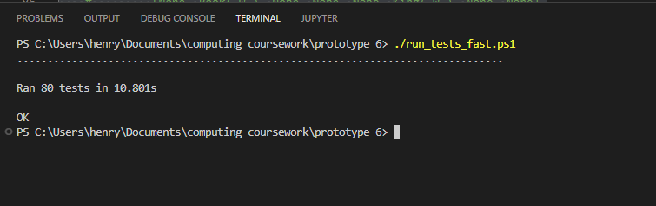

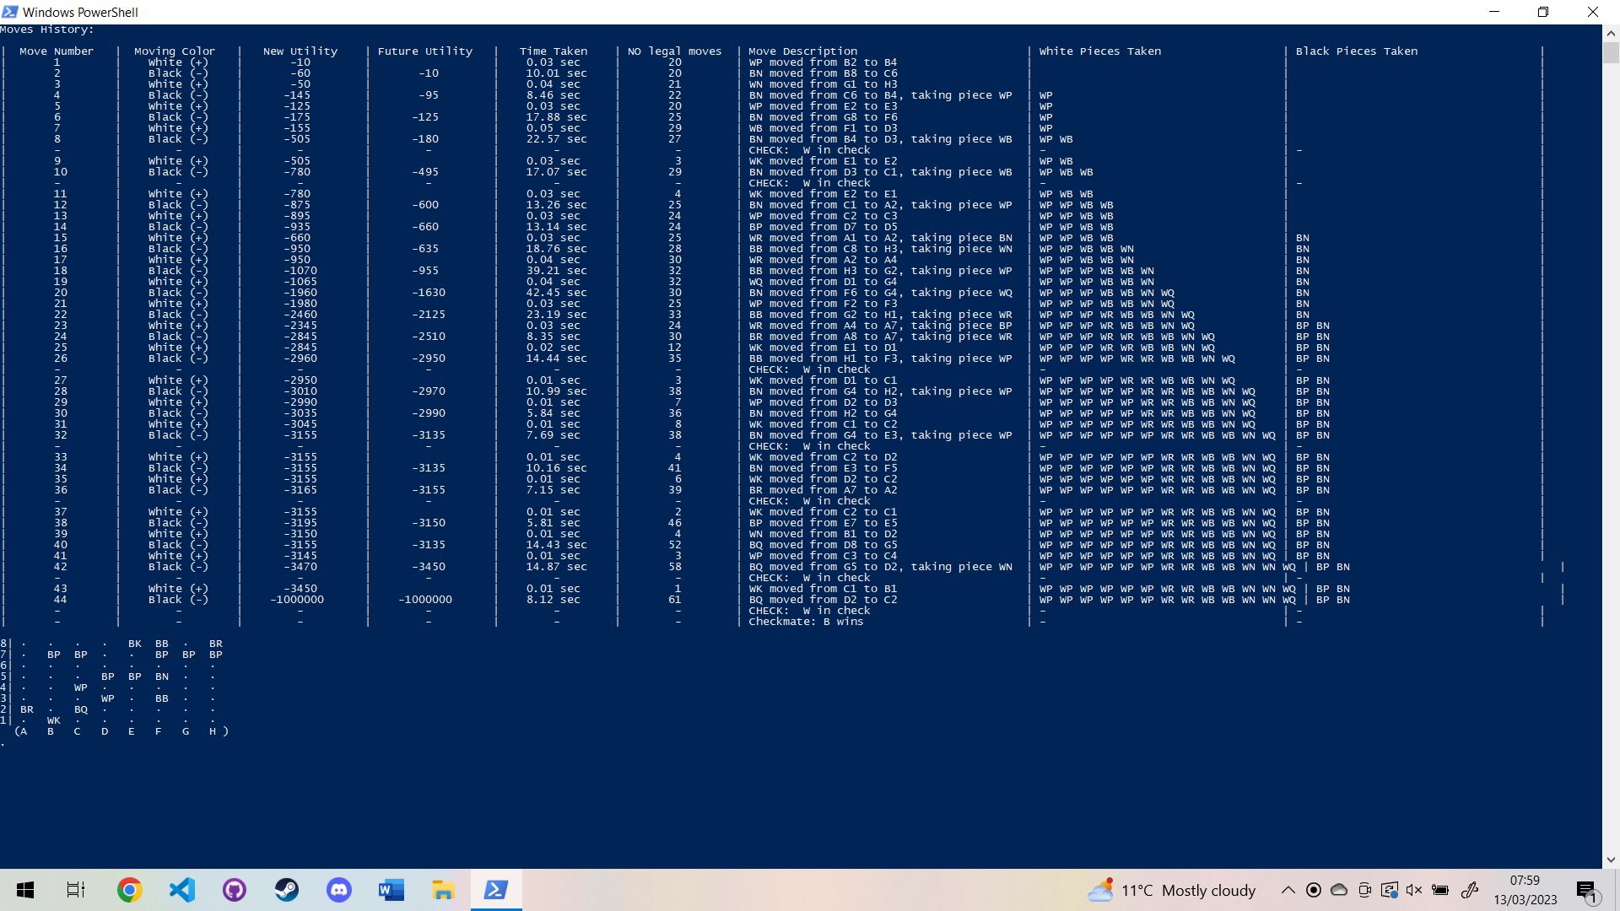

The dots represent completed test. The first image show all 80 of the fast test have been completed. The second image shows the last test to finish form the slow minimax test (which I ran overnight). As the game output function has repeatedly cleared the terminal we cannot see the dots for the rest of the test. I could tell that the tests were finished as there was no python task in the task manager and as this test hadn’t been cleared away as another test was completed.

In the process of getting these test to run successfully I identified various issues due to initially failing test which were later fixed

I then tested the website and the program as a whole (black box testing) by playing games of chess against it. This helped me identify more issues that I was able to fix.

### Here are the main issues that were detected by the automated unit tests:

### Timed Minimax not working:

From the automated testing of the timed minimax function I realised that the function was not consistently interrupting itself and sticking to the provided maximum time.

I considered this a failed test as the expected outcome was the at the time column in the automated unit test would show a consistent amount of time taken by each bot.

Here is the screenshot evidence of the failed test:

This shows a test of a 2 second bot vs a 6 second bot. We can see that there is significant variance in the times shown and that on average, they are longer than the permitted max time:

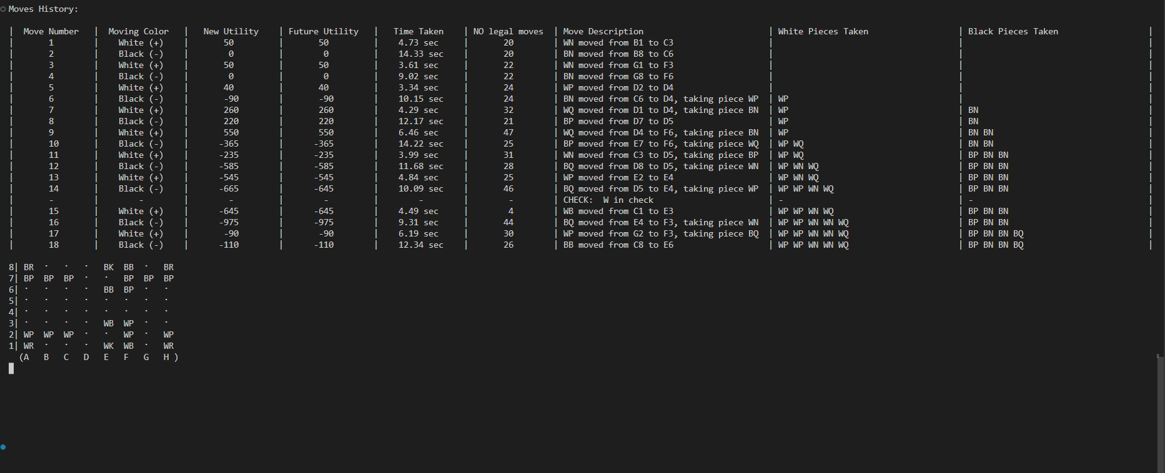

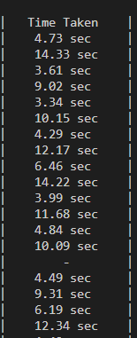

This was because I not checking the time and interrupting the function frequently enough. When I completed a depth 3 call, I was only checking the time after pre-sorting the moves and after each depth 2 recursive call was completed. To fix this I added a max time argument to the main minimax method of the original Move Engine class.

def minimax(self, board_state: Board_State, depth, alpha=0-(ARBITRARILY_LARGE_VALUE+1), beta=ARBITRARILY_LARGE_VALUE+1, variable_depth: bool | None = None, part_of_presort=False, legal_moves_to_examine: Iterable | None = None, max_time=None) -> tuple[int, tuple[Vector, Vector]]:

It had a default value of None which meant that there was no max time. This meant that previous code that called the minimax function without a max time parameter was unaffected. I then added a relevant function to interrupt the minimax function:

# this function is used to ensure that the minimax function can be self interrupting

def is_time_expired(max_time):

    if max_time is None:

        return False

    # print("🕰️", end="")

    return perf_counter() >= max_time

and regularly checked if the max time had been exceeded throughout the minimax function:

        # self interrupting

        if is_time_expired(max_time):

           raise TimeOutError()

I also passed on this max time argument on to all recursive calls

                # recursive minimax call with depth n-1 to evaluate child

                score, _ = self.minimax(

                    board_state=child_board_state,

                    depth=depth-1,

                    alpha=alpha,

                    beta=beta,

                    # is_time_expired=is_time_expired,

                    max_time=max_time,

                )

This meant that the minimax timed call now more reliably stuck to its designated max time.

Here is a screen shot of a unit test to show that the issue was fixed:

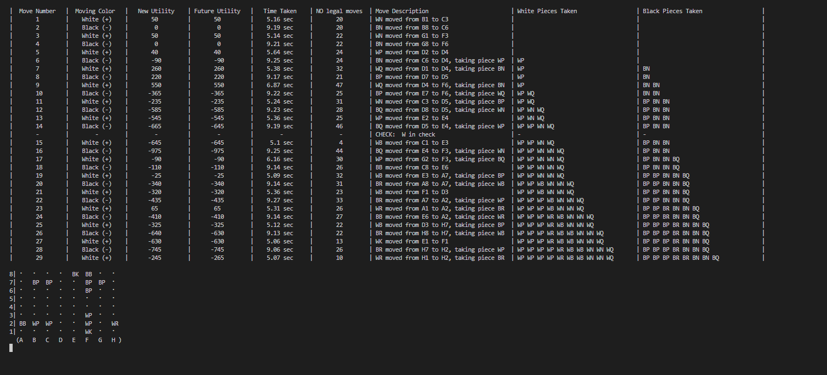

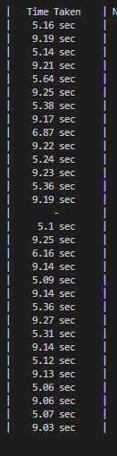

The above screenshot were for a game where a 5 second bot played against a 9 second bot. The times column show that now, the bots are able to stick to their specified time with only a few small exceptions

Some test were written as I wrote the code or even before. This test driven development meant that I aimed to write the code to make the test work. For instance when I created the test to check if game objects could be pickled:

    def test_save_and_restore(self):

it failed the first time. This prompted me to define a __eq__ method for the Game_Webiste class which caused it to then work.

### Tests completed on final product:

|  |  |  |  |  |  |
| --- | --- | --- | --- | --- | --- |
| **Test No.** | **Aspect Being Tested** | | **Type of test** | **Test Data Used** | **Expected Result** |
| 1 | The chess board and website renders correctly | | Valid | I loaded the page in my browser | The webpage load and the chess board is drawn |
| **Actual Result** | **Evidence** | | | **Success?** |
| As expected |  | | | Full Success |

|  |  |  |  |  |  |
| --- | --- | --- | --- | --- | --- |
| **Test No.** | **Aspect Being Tested** | | **Type of test** | **Test Data Used** | **Expected Result** |
| 2 | I can, the user can move my pieces and will the computer respond with a move | | Valid | I clicked a piece to move it forward | I should be able to move my pieces and I should see the computer move its pieces |
| **Actual Result** | **Evidence** | | | **Success?** |
| As expected |  | | | Full Success |

|  |  |  |  |  |  |
| --- | --- | --- | --- | --- | --- |
| **Test No.** | **Aspect Being Tested** | | **Type of test** | **Test Data Used** | **Expected Result** |
| 3 | I should be able to make all legal move and shouldn’t be able to make and illegal moves | | Valid (I can make legal moves) and then Invalid (I can’t make illegal moves) | I will try to move various pieces | I should be able to try to move a variety of pieces and they should move as expected, no missing legal moves and not extra legal moves. |
| **Actual Result** | **Evidence** | | | **Success?** |
| I was not able to move 2 pieces correctly. My pawns couldn’t move forward 2 and I couldn’t take pieces with a knight | Screenshot where it won’t let me move a pawn foreward 2: (clicking even when the highlight was wrong did nothing)    Screenshot where it won’t let me take with a knight: Clicking to take the pawn anyway did nothing | | | FAILURE |

|  |  |  |  |  |  |
| --- | --- | --- | --- | --- | --- |
| **Test No.** | **Aspect Being Tested** | | **Type of test** | **Test Data Used** | **Expected Result** |
| 4 | Test that the game over functionality works: I will test trying to loose to the program and then trying to beat it in checkmate. I will check that it works as expected and produces the correct output | | Valid extreme | I tried to loose and then I tried to win | When the game is over (for both winners), the board should be disabled and the title message should explain that the game is over. |
| **Actual Result** | **Evidence** | | | **Success?** |
| When I lost, the outputs were as expected, when I tried to win, the game crashed when the computer was near to loosing. This is a huge issue as it left the webpage broken as it was waiting for the server move and server had had an error when it tried to for fill the move request | Here is the screenshot of me loosing where everything is as expected.  Evidence of the issue when I tried to win  Graphical user interface  Description automatically generatedGraphical user interface  Description automatically generated  Above you can see an erroneous result in the database | | | FAILURE |

|  |  |  |  |  |  |
| --- | --- | --- | --- | --- | --- |
| **Test No.** | **Aspect Being Tested** | | **Type of test** | **Test Data Used** | **Expected Result** |
| 5 | The database cache is being build up after each minimax search the computer completes | | Valid | I played the AI on various difficulties and checked that database as I did | I should add a small amount of depth 1 cache to the database on a low difficulty. It should produce a large amount of depth 1 cache with come depth 2 cache at a high difficulty |
| **Actual Result** | **Evidence** | | | **Success?** |
| When operating concurrently on a depth 2 call, the algorithm didn’t add all its depth 1 cache to the database | Below is a screenshot of the database’s content after it searched the board state at depth 2. We can see that it hasn’t logged the depth 1 cahce: | | | Failure |

### Knights cannot take pieces

One of the issue that was identified by test 3 was that my knights couldn’t take enemy pieces. I believe that I must have broken the code at some point at certainly could take pieces at the end of prototype 2.

I created an automated unit test where I replicated the chess game that I had played and asserted that the move I was expecting (knight takes a piece) was in the legal move:

# this tests for a bug I encountered where a knight couldn't take a piece,

    # I created this test to identify the bug

    # I then modified the knight pieces class and used this test to show that the bug was fixed

    def test_troubleshoot_bug_legal_moves(self):

        # replicate the previous situation

        board_state = Board_State()

        board_state = board_state.make_move(

            Vector(1, 0), Vector(1, 2)

        )

        board_state = board_state.make_move(

            Vector(1, 7), Vector(1, -2)

        )

        board_state = board_state.make_move(

            Vector(6, 0), Vector(-1, 2)

        )

        board_state = board_state.make_move(

            Vector(6, 7), Vector(-1, -2)

        )

        board_state = board_state.make_move(

            Vector(4, 1), Vector(0, 1)

        )

        board_state = board_state.make_move(

            Vector(3, 6), Vector(0, -2)

        )

        # board_state.print_board()

        legal_moves = board_state.generate_legal_moves()

        # check that the knight can make the move

        self.assertTrue(

            (Vector(2, 2), Vector(1, 2)) in legal_moves

        )

This test failed which confirmed that I could recreate the logic error. I then fixed the issue by modifying the below code form the Knight Class

    def generate_movement_vectors(self, pieces_matrix, position_vector):

        # this function yields all 8 possible vectirs

        def possible_movement_vectors():

            vectors = (Vector(2, 1), Vector(1, 2))

            # for each x multiplier, y multiplier and vector combination

            for i_multiplier, j_multiplier, vector in iter_product((-1, 1), (-1, 1), vectors):

                # yield corresponding vector

                yield Vector(

                    vector.i * i_multiplier,

                    vector.j * j_multiplier

                )

        # iterate through movement vectors

        for movement_vector in possible_movement_vectors():

            # get resultant

            resultant_vector = position_vector + movement_vector

            # look at contents of square

            contents = self.examine_position_vector(position_vector=resultant_vector, pieces_matrix=pieces_matrix)

            # if square is empty yield vector

            # old code that caused the logic error

            # if contents == "empty":

            #     yield movement_vector

            # corrected code to fix knight bug

            if contents in ("empty", "enemy"):

                yield movement_vector

You can see at the bottom that I was only returning the movement vector if the contents of the to square was empty. The below code fixed this issue by also allowing the 2 square to contain an enemy piece.

Here is some screenshot evidence that the bug is fixed meaning the knights can now take pieces:

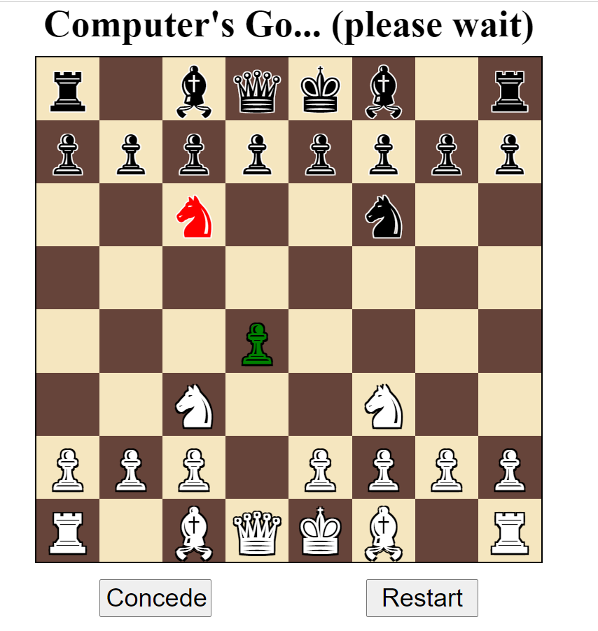

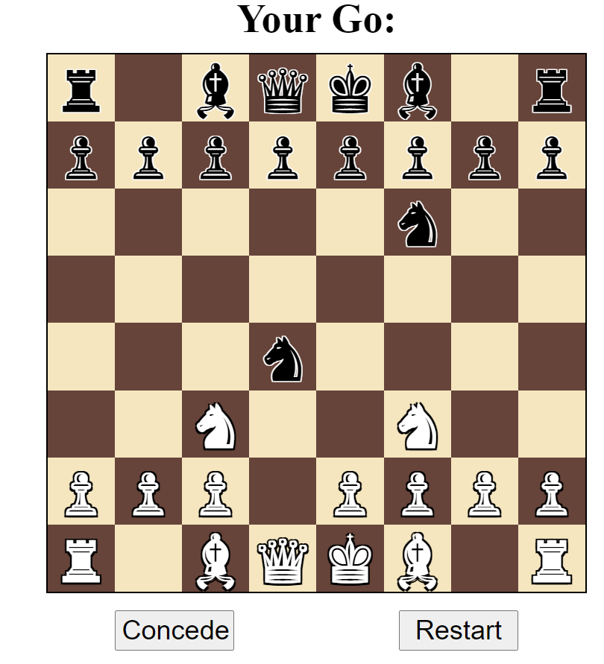

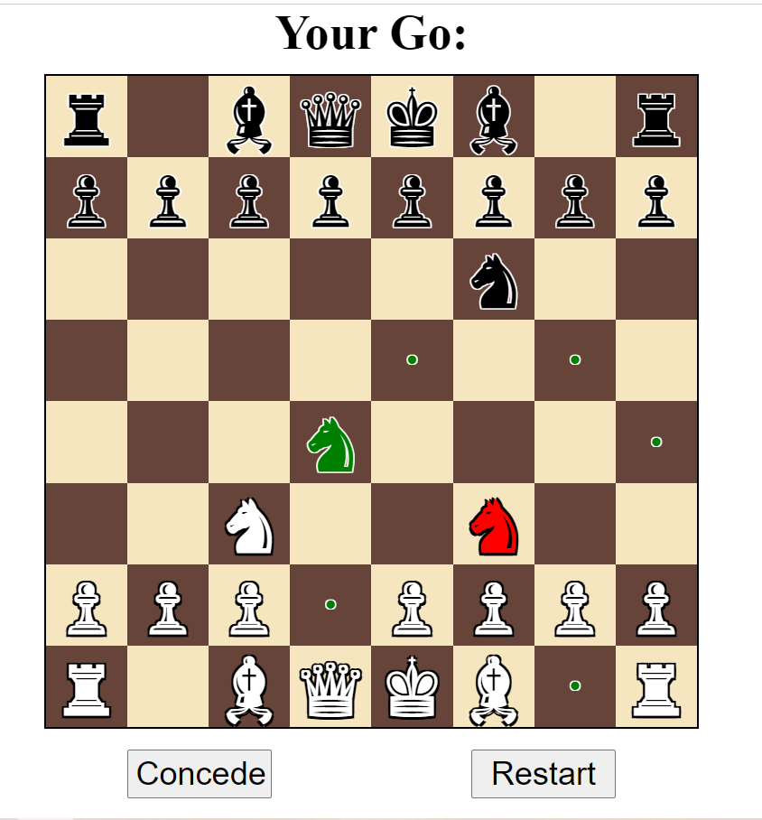

### Pawns cannot move forward 2 places:

I identified that I couldn’t move more than one Pawn forward 2 spaces as part of failed test number 3. Here is how I fixed the issue.:

I identified the issue and was able to fix the code:

STARTING_POSITIONS: tuple[tuple[pieces_mod.Piece]] = (

    (

        pieces_mod.Rook(color="B"),

        pieces_mod.Knight(color="B"),

        pieces_mod.Bishop(color="B"),

        pieces_mod.Queen(color="B"),

        pieces_mod.King(color="B"),

        pieces_mod.Bishop(color="B"),

        pieces_mod.Knight(color="B"),

        pieces_mod.Rook(color="B")

    ),

    # (pieces_mod.Pawn(color="B"),)*8,

    tuple(pieces_mod.Pawn(color="B") for _ in range(8)),

    (None,)*8,

    (None,)*8,

    (None,)*8,

    (None,)*8,

    # (pieces_mod.Pawn(color="W"),)*8,

    tuple(pieces_mod.Pawn(color="W") for _ in range(8)),

    (

        pieces_mod.Rook(color="W"),

        pieces_mod.Knight(color="W"),

        pieces_mod.Bishop(color="W"),

        pieces_mod.Queen(color="W"),

        pieces_mod.King(color="W"),

        pieces_mod.Bishop(color="W"),

        pieces_mod.Knight(color="W"),

        pieces_mod.Rook(color="W")

    )

)

The problematic lines of code are commented out and the fixes are below. It turned out that the issue was that the line:

(pieces_mod.Pawn(color="B"),)*8

Was not making 8 individual pawn objects with there own different last move property.

This meant that all the pawns were the same object passed by reference and so once one piece had moved forward 2, none of them were able to move forward 2.

tuple(pieces_mod.Pawn(color="W") for _ in range(8)),

The above replacement line of code fixed this by making 8 distinct pawn objects.

And here is evidence that the issue is now fixed and that the pawns can each individually move forward 2, but only the first time:

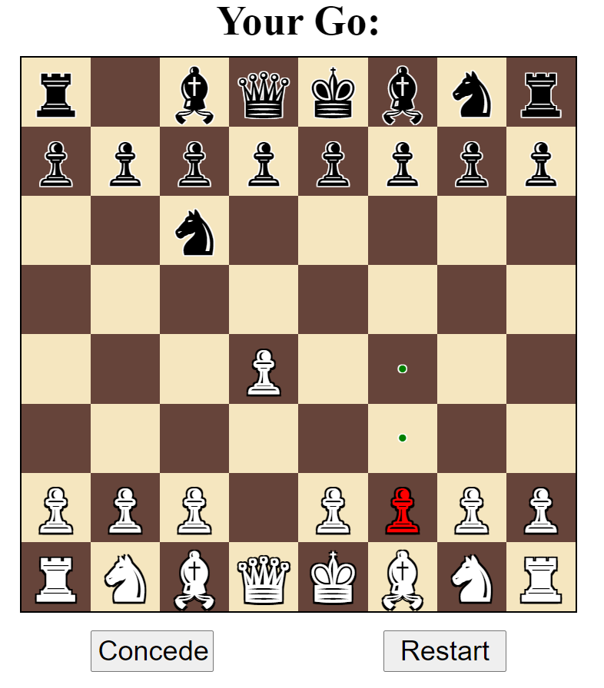

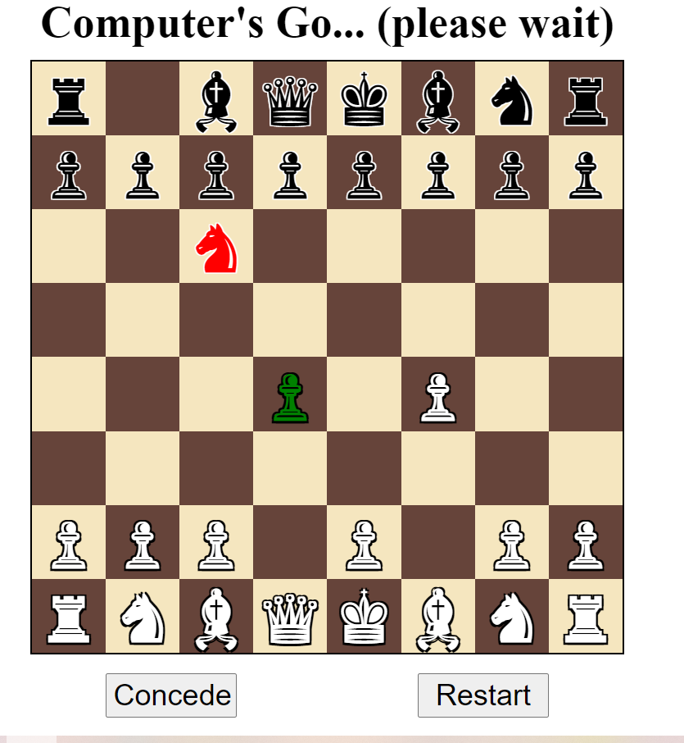

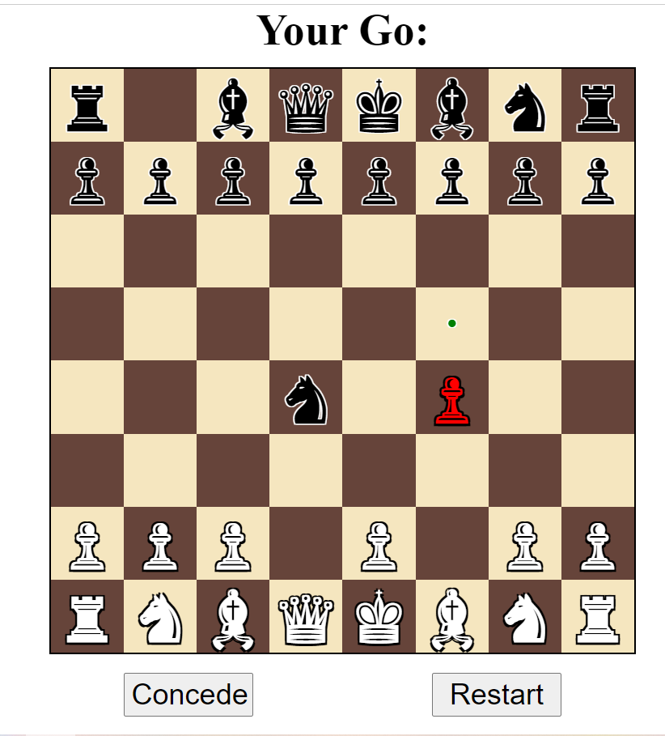

### Concurrent workers not caching

In failed test 4, I identified an issue with the worker functions in the parallel minimax module not each individually adding there searches to the database.

This means that a parallel depth 2 search of the starting positions produced only 1 cache item with a depth of 2 and no additional depth 1 cache.

This would have prevented the chess program being able to learn (one of the items of my design criteria).

I realised that I had forgotten to add the caching to these worker classes. As a result I changed them to add database caching.

# # this object represents a job that a concurrent worker should complete,

# # I used an object as a function cannot be sent between workers

# class Minimax_Sub_Job:

#     # contractor: configure bot by setting these parameters as properties

#     def __init__(self, move_engine, board_state, depth, args, kwargs, max_time=None) -> None:

#         self.move_engine: Move_Engine = move_engine

#         self.board_state: Board_State = board_state

#         # # not sure why depth sometimes is a single length tuple containing an int

#         # # here is a quick fix

#         # if isinstance(depth, tuple):

#         #     if len(depth) == 1:

#         #         depth = depth[0]

#         # assert isinstance(depth, int)

#         self.depth = depth

#         self.max_time = max_time

#         # these are other erroneous argument that could be passed to the minimax call

#         self.args = args

#         self.kwargs = kwargs

#     def __call__(self, legal_moves_sub_array):

#         # perform part of a minimax search using a sub set of legal moves

#         # print(f"running minimax job with legal moves sub array: (hash={hash(str(legal_moves_sub_array))})")

#         # print(f"STARTING sub job on moves segment:   {hash(str(legal_moves_sub_array))}")

#         # print(legal_moves_sub_array),

#         result = self.move_engine.minimax(

#             board_state=self.board_state,

#             depth=self.depth,

#             legal_moves_to_examine=legal_moves_sub_array,

#             # is_time_expired = self.is_time_expired,

#             max_time=self.max_time,

#             *self.args,

#             **self.kwargs

#         )

#       # print(f"FINISHING sub job on moves segment:   {hash(str(legal_moves_sub_array))}")

#         # print(f"Minimax sub job finished (hash={hash(str(legal_moves_sub_array))})")

#         return result

# this object represents a job that a concurrent worker should complete,

# I used an object as a function cannot be sent between workers

class Minimax_Sub_Job:

    # contractor: configure bot by setting these parameters as properties

    def __init__(self, board_state, depth, args, kwargs, additional_depth, cache_allowed, max_time=None) -> None:

        # create a cache manager as necessary

        self.cache_allowed = cache_allowed

        self.cache_manager = DB_Cache() if cache_allowed else None

        # create a move engine as necessary

        self.move_engine: Move_Engine = Move_Engine(

            cache_manager=self.cache_manager,

            cache_allowed=cache_allowed,

            additional_depth=additional_depth,

        )

        # assert isinstance(self.move_engine, Move_Engine), f"Minimax_Sub_Job.__init__    self.move_engine of unexpected type {type(self.move_engine)}\n{self.move_engine!r}"

        # assign parameters as properties

        self.board_state: Board_State = board_state

        self.depth = depth

        self.max_time = max_time

        # these are other erroneous argument that could be passed to the minimax call

        self.args = args

        self.kwargs = kwargs

    def __call__(self, legal_moves_sub_array):

        # perform part of a minimax search using a sub set of legal moves

        # print(f"running minimax job with legal moves sub array: (hash={hash(str(legal_moves_sub_array))})")

        # print(f"STARTING sub job on moves segment:   {hash(str(legal_moves_sub_array))}")

        # print(legal_moves_sub_array)d_state,

        # result = self.move_engine.minimax(

        # assert isinstance(self.move_engine, Move_Engine), f"Minimax_Sub_Job.__call__    self.move_engine of unexpected type {type(self.move_engine)}\n{self.move_engine!r}"

        if self.cache_allowed:

            with self.cache_manager:

                result = self.move_engine.minimax(

                    board_state=self.board_state,

                    depth=self.depth,

                    legal_moves_to_examine=legal_moves_sub_array,

                    # is_time_expired = self.is_time_expired,

                    max_time=self.max_time,

                    *self.args,

                    **self.kwargs

                )

        else:

            result = self.move_engine.minimax(

                board_state=self.board_state,

                depth=self.depth,

                legal_moves_to_examine=legal_moves_sub_array,

                # is_time_expired = self.is_time_expired,

                max_time=self.max_time,

                *self.args,

                **self.kwargs

            )

      # print(f"FINISHING sub job on moves segment:   {hash(str(legal_moves_sub_array))}")

        # print(f"Minimax sub job finished (hash={hash(str(legal_moves_sub_array))})")

        return result

# # this bot is responsible for performing a low depth search of a move to be used to presort the moves

# class Presort_Moves_Sub_Job:

#     # construct object

#     # def __init__(self, depth, board_state: Board_State, move_engine: Move_Engine,max_time=None) -> None:

#         # cache manager parameter may not be needed if the cache manager object is also bound to the move engine

#         self.depth = depth

#         self.board_state = board_state

#         self.move_engine = move_engine

#         self.is_time_expired = is_time_expired

#         self.max_time = max_time

#     def __call__(self, move):

#         # self interrupting

#         if is_time_expired(self.max_time):

#             raise TimeOutError()

#         # score a child, use minimax first call to add caching

#         child = self.board_state.make_move(*move)

#         child_score, _ = self.move_engine.minimax(

#             board_state=child,

#             depth=self.depth,

#             # is_time_expired = self.is_time_expired,

#             max_time=self.max_time,

#         )

#         return (child_score, move)

# this bot is responsible for performing a low depth search of a move to be used to presort the moves

class Presort_Moves_Sub_Job:

    # construct object

    def __init__(self, depth, board_state: Board_State, cache_allowed, max_time=None) -> None:

    # def __init__(self, depth, board_state: Board_State, move_engine: Move_Engine, cache_allowed, cache_manager, max_time=None) -> None:

        # cache manager parameter may not be needed if the cache manager object is also bound to the move engine

        # assign parameters as properties

        self.depth = depth

        self.board_state = board_state

        # create a cache manager as necessary

        self.cache_allowed = cache_allowed

        self.cache_manager = DB_Cache() if cache_allowed else None

        # create a move engine object

        self.move_engine = Move_Engine(

            presort_moves=True,

            additional_depth=0,

            cache_allowed=self.cache_allowed,

            cache_manager=self.cache_manager,

            # cache_allowed=self.cache_allowed,

            # cache_manager=self.cache_manager,

        )

        # self.cache_allowed = cache_allowed

        # self.cache_manager = cache_manager

        self.is_time_expired = is_time_expired

        self.max_time = max_time

    def __call__(self, move):

        # cache manager already built into the minimax move engine first call method

        # print(f"Presort job using cache manager:   {self.cache_manager!r}")

        # with self.cache_manager:

        #     child = self.board_state.make_move(*move)

        #     child_score, _ = self.move_engine.minimax_first_call(

        #         board_state = child,

        #         depth = self.depth

        #     )

        #     # print("Closing cache")

        #     result = (child_score, move)

        # return result

        # self interrupting

        if is_time_expired(self.max_time):

            raise TimeOutError()

        # score a child, use minimax first call to add cache manager being opened twice

        # no need to say no parallel as a basic move engine is used

        child = self.board_state.make_move(*move)

        if self.cache_allowed:

            with self.cache_manager:

                # child_score, _ = self.move_engine.minimax_first_call(

                child_score, _ = self.move_engine.minimax(

                    board_state=child,

                    depth=self.depth,

                    # is_time_expired = self.is_time_expired,

                    max_time=self.max_time,

                )

        else:

            # child_score, _ = self.move_engine.minimax_first_call(

            child_score, _ = self.move_engine.minimax(

                board_state=child,

                depth=self.depth,

                # is_time_expired = self.is_time_expired,

                max_time=self.max_time,

            )

        return (child_score, move)

You can see the old Job classes without caching are commented out. The new Job classes that replaced them were able to concurrently access the database in order to cache their results.

Here is a screenshot of the database after the fix to show that the issue was corrected. This shows that minimax cache items created in extreme difficulty (enough time to perform a depth 2 search). We can see the expected outcome which is a depth 2 search was performed and all the depth 1 searches that were needed to perform it were also saved to the database:

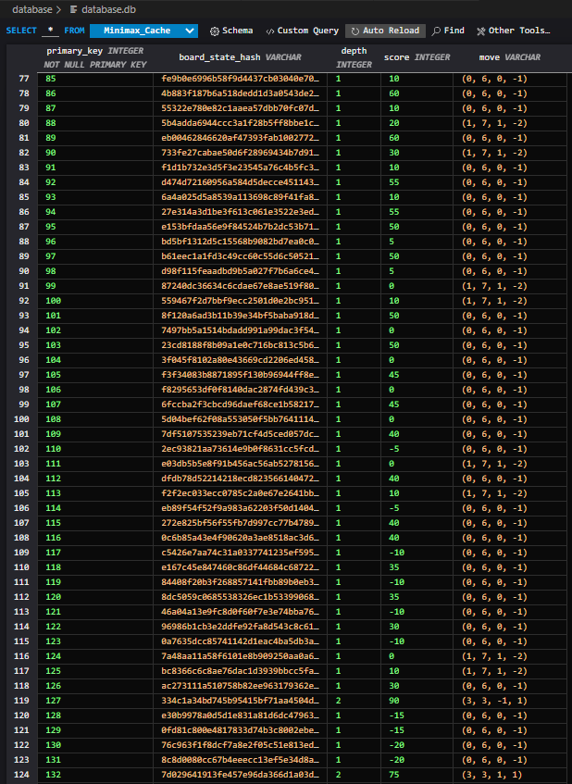



You can see the large amount of depth 1 cache used as part of the depth 2 search and then the single unit of depth 2 cache.

Here is second screen shot of a different move that also shows that the issue is fixed.

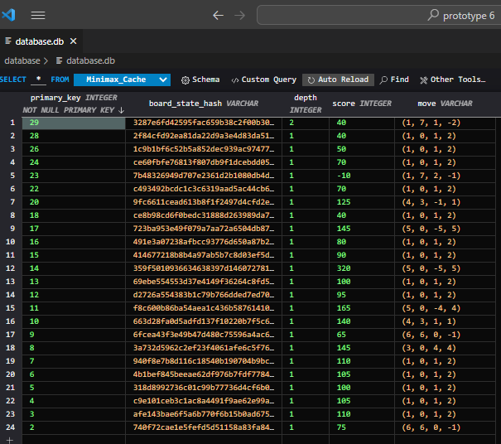

The above database content shows the cache produced by 30 second of thinking by the computer (after I made the first move). As you can now see, the depth 2 search result has been saved to the cache as well as the depth 1 search that were completed in the process.

This means that if instead, 6 users on medium difficulty gave the computer 6 lots of 5 seconds to think about a move, it should now still be able to complete a depth 2 search. This is because it could make progress and by completing a group of depth 1 searches, then stop and start where it left of later. This is why it is important that intermediate searches are preserved as the allow the AI to learn

### Erroneous Results:

In failed test 5, I found an example of an edge case where my minimax function produced an invalid output:

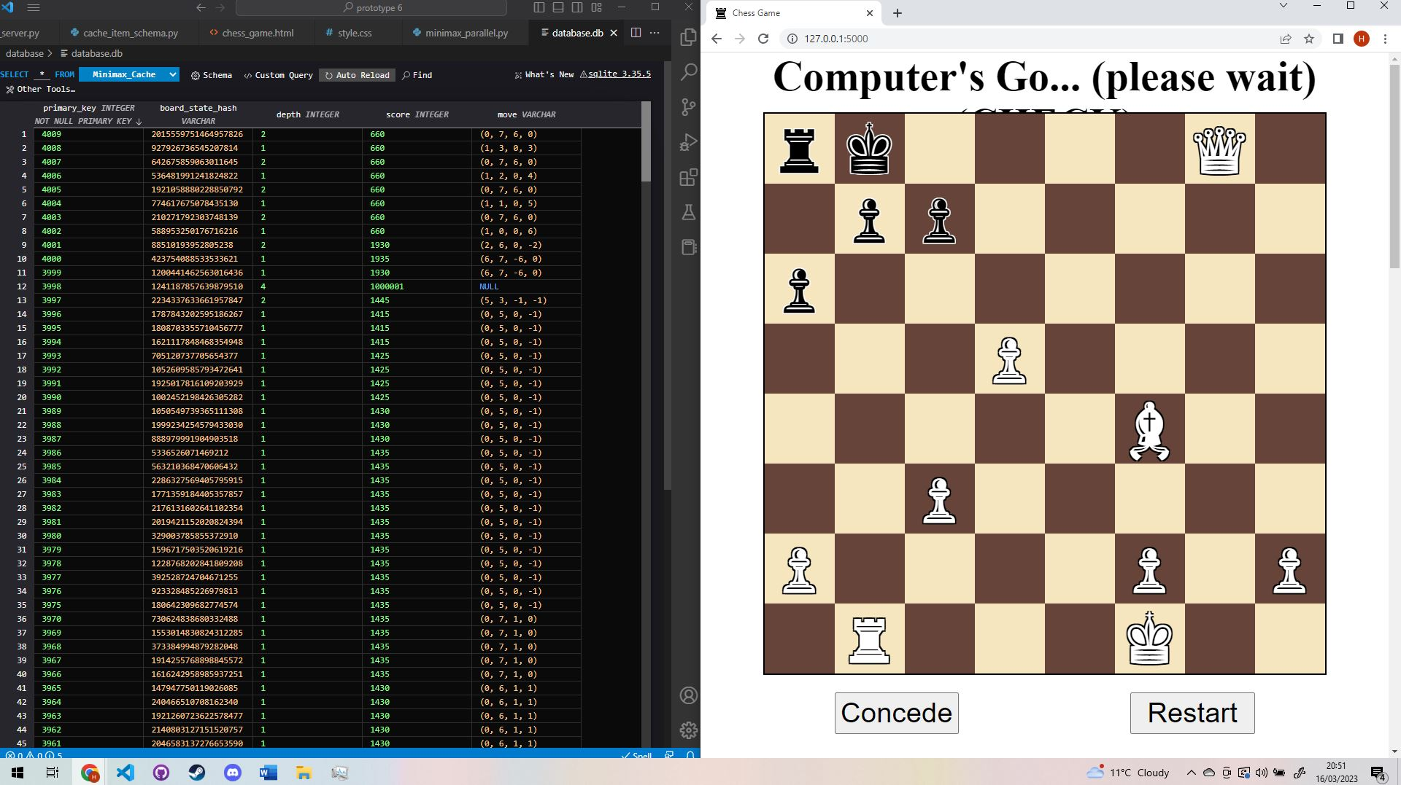

Here you can see that I am playing the chess AI and have got it into check. The AI failed to respond with a move and failed to declare an that the game was over. This was due to an internal server error form the following invalid minimax result:



The value 1_000_001 is used as a starting value for alpha and is an invalid score to return.

I was able to replicate the error by loading the data from the web client into a unit test and repeating the search:

    def test_specific_bug_null_move(self):

        pieces_matrix = [

            [Rook("B"), King("B"), None, None, None, None, Queen("W"), None],

            [None, Pawn("B"), Pawn("B"), None, None, None, None, None],

            [Pawn("B"), None, None, None, None, None, None, None],

            [None, None, None, Pawn("W"), None, None, None, None],

            [None, None, None, None, None, Bishop("W"), None, None],

            [None, None, Pawn("W"), None, None, None, None, None],

            [Pawn("W"), None, None, None, None, Pawn("W"), None, Pawn("W")],

            [None, Rook("W"), None, None, None, King("W"), None, None]

        ]

        next_to_go = "B"

        board_state = Board_State(next_to_go, pieces_matrix)

        print()

        board_state.print_board()

        move_engine = Move_Engine_Prime()

        move_engine.cache_allowed = False

        move_engine.cache_manager = None

        move_engine.parallel = False

        # self.assertRaises(

        #     AssertionError,

        #     lambda: move_engine(board_state, depth=4)

        # )

        def absolute(x): return x if x >= 0 else 0-x

        # _, move = move_engine(board_state, depth=1)

        # self.assertTrue(move is not None)

        # board_state = board_state.make_move(*move)

        # print()

        # board_state.print_board()

        # _, move = move_engine(board_state, depth=1)

        # self.assertTrue(move is not None)

        # board_state = board_state.make_move(*move)

        # print()

        # board_state.print_board()

        # _, move = move_engine(board_state, depth=1)

        # self.assertTrue(move is not None)

        # board_state = board_state.make_move(*move)

        # print()

        # board_state.print_board()

        print(board_state.is_game_over_for_next_to_go())

        print(list(board_state.generate_legal_moves()))

        score, move = move_engine(board_state, depth=4)

        self.assertTrue(

            absolute(score) < 1_000_001 and move is not None,

            msg=repr({"score": score, "move": move})

        )

The following test helped me reproduce the error but not diagnose it.

I then checked that the game wasn’t over in another test (the black king should have one move)

 # this test is to ensure that the game over function can correctly identify a game over situation

    # The program crashed in a way that hasn't happened since (I must have been tinkering with the minimax code)

    # One of my assertion statements triggered and identified that the legal move variable was none.

    # this ensured that the program could successfully identify that the game wasn't over and that the king has one move

    # to correct the believed source of the bug, I ensured timed calls always perform at least a depth 1 search to ensure that a move is always produced.

    def test_troubleshoot_bug_game_over(self):

        pieces_matrix = deserialize_client_pieces_matrix(

            json.loads(

                """

                    [[[null,null],["B","♚"],[null,null],[null,null],[null,null],[null,null],[null,null],["B","♜"]],[["W","♜"],[null,null],[null,null],[null,null],["W","♛"],["B","♟︎"],["B","♟︎"],["B","♟︎"]],[[null,null],[null,null],[null,null],[null,null],[null,null],[null,null],[null,null],[null,null]],[[null,null],[null,null],[null,null],[null,null],[null,null],[null,null],[null,null],[null,null]],[[null,null],[null,null],[null,null],[null,null],["B","♟︎"],["W","♝"],[null,null],[null,null]],[[null,null],[null,null],[null,null],[null,null],[null,null],[null,null],[null,null],[null,null]],[[null,null],["W","♟︎"],[null,null],[null,null],["W","♚"],[null,null],["W","♟︎"],["W","♟︎"]],[[null,null],[null,null],[null,null],[null,null],[null,null],["W","♝"],["W","♜"],[null,null]]]

                """

            )

        )

        board_state = Board_State(

            next_to_go="B",

            pieces_matrix=pieces_matrix,

            check_encountered=True

        )

        # board_state.print_board()

        legal_moves = list(board_state.generate_legal_moves())

        # print({"legal_moves": legal_moves})

        self.assertEqual(

            legal_moves,

            [(Vector(i=1, j=7), Vector(i=1, j=0))]

        )

        over, _ = board_state.is_game_over_for_next_to_go()

        # print(over)

        self.assertTrue(not over)

This test work and passed without issue. This meant that the issue was with the minimax function as my chess engine could successfully identify that there was one remaining legal move.

I didn’t figure out what caused the issue but I added checks within my code as part of a defensive design strategy to prevent the issue causing unexpected behaviour.

I added the following code to the Timed_Move_Engine:

        # while there is time left, keep searching to a greater depth

        while not time_used_up():

            # print(f"Iterating again: time_used_up()   -->   {time_used_up()}")

            try:

                # deepest_result = self.minimax_first_call_parallel(board_state=board_state, depth=depth, is_time_expired=time_used_up)

                # search the tree in parallel if needed

                result = self.minimax_first_call_parallel(board_state=board_state, depth=depth, max_time=self.max_time, variable_depth=0)

                score, move = result

                # if the move or score are invalid then raise the appropriate error

                if absolute(score) == 1_000_001 or move is None:

                    raise UnexplainedErroneousMinimaxResultError()

            except UnexplainedErroneousMinimaxResultError:

                # I don't know the cause of the error but I can catch it here and prevent it causing issues and producing unexpected behaviour

                break

            except TimeOutError:

                # print(f"Breaking: time_used_up()   -->   {time_used_up()}")

                break

            else:

                # print(f"Completes depth={depth} so incrementing depth")

                # print(f"Result at depth {depth}:   {deepest_result}")

                # if neither the time is used up or an erroneous result was produced, keep searching at a greater depth

                deepest_result = result

                depth += 1

The idea was that I would detect this invalid result and not use it, using the previous result.

I also added code to the cache manager to prevent invalid results from being added to the database cache:

    def add_to_cache(self, board_state: Board_State, score, depth, move):

        # this function adds to the cache

        # this function assumes that no move valuable cache already exists (it overwrites all other cache)

        assert self.engaged, "Context manager must be used"

        # this is used to tackle any bugs elsewhere in the program

        # it ensures that no invalid cache items are added to the database

        def absolute(x): return x if x >= 0 else 0-x

        if absolute(score) > 1_000_000 or (move is None and depth > 0):

            # don't add erroneous data to cache

            return None

These 2 combined changes fixed the issue and prevented the unexpected behaviour from causing the program to crash or from producing an invalid output.

I have played many more chess games since and have not encountered this bug again. I tried beating the chess program and I was able to, this made me confident that the issue has been fixed.

Here is screenshot evidence that I can now beat the chess program without this issue occurring.

## Demonstration video of the program working:

Here is a video where I demonstrate the program working and show off all its features:

<https://drive.google.com/file/d/1wlnjgN2fKc8Nz8TxlrZsLWHNT9W8OttP/view?usp=sharing>

If the resolution appears low, please try downloading the file and viewing it locally on a computer. The file has a quality of HD but watching it on google drive can display it at a low resolution.

The demonstrations shows:

* 3 games with 2 wins and a loss
* All widgets demonstrated
* Shows off highlighting and validation on chess board
* Shows off how the program handles check
* Shows off the different difficulty settings
* Shows off the different device aspect ratios that the program works with
* Shows off different behaviour on different difficulties
* Shows off how the program uses its database to learn and improve its chess playing
* Shows off how the program is able to use the database to restore the website after the tab is closed.

## Stakeholder Feedback:

I received feedback on my iteration from my stakeholders. Here is a summary of the feedback:

### GUI:

* They thought that the user interface was clear.
* They could clearly see all the pieces on the board
* They were able to intuitively move a piece.
* They liked the highlighting as it made it clear where the pieces could move and which pieces the opponent was moving
* They thought that it was clear how to change the difficulty and could see a noticeable change to how long the computer was thinking
* They thought it was clear what reset and concede buttons did
* They thought that the information conveyed by the pieces taken and move history tables was clear

### Special Features:

* They appreciated that I had implemented promotion of pawns into queens.
* They thought that the feature to reload the game state after closing the tab was really useful and very convenient

### Reliability (after the fixes from my testing):

* They didn’t encounter any bugs or logic errors.
* The website was able to properly handle check and when the game was over
* The website prevented the user making invalid moves and the computer only made valid moves.

### Suggestions for improvement:

* In landscape, the white space on the left and right of the chess board could be better utilised. For example you could put the move history there.
* In addition, there is no hint to say that you should scroll down for extra content (the move history and pieces taken table)

## Evaluation (just of prototype 3):

Overall, I think that this prototype has been very successful. Despite many of the test of the website failing on the first try, all issues were fixed. My users also didn’t have any issues with the program producing invalid outputs or bugs or any kind. One I had fixed some key bugs, their feedback was that the program was very reliable.

I believe that this iteration meets all the design objectives in their entirety. I therefore believe that this final prototype has met all items of the success criteria that were ladled high-priority, desirable and essential. Considering the time constraints I am very proud of this and believe that the final iteration will serve my stakeholder’s needs well.

Due to the tests that I completed and the corrections made to ensure that all tests passed, I feel confident that this prototype is a success and has met its aims. This means that at this stage, I am confident that I have met all the design goals and the following success criteria items:

All these success criteria items: 1-13, 15, 17, 19, 24-32.

# Evaluation: Evaluative Testing:

## Post-Development Testing

To evidence that I had completed my test I used video clips. This was appropriate as it would have been difficult to show how the game changed in response to each click with screenshots:

**Here is the link to the external folder that contains these video clips:**

<https://drive.google.com/drive/folders/1iYk_W6cmezXJgGBniHZUgc_YrKSGTV7z?usp=sharing>

|  |  |  |  |  |  |
| --- | --- | --- | --- | --- | --- |
| **Test No.** | **Aspect Being Tested** | **Justification of test** | **Type of test** | **Test Data Used** | **Expected Result** |
| 1 | Different Difficulty Settings | Needed for stakeholder (casual chess player). Success criteria item 1 | Valid | Clicked radio buttons then looked for a change in response time for the computer move | The response time should change so that it is approximately the same as the listed time (e.g., medium is 5 seconds) plus an extra second delay. |
|  | **Actual Result** | **Evidence** | | | **Success?** |
|  | This did cause a notable change in response time for the computer move. | I can change the radio button easily as shown. The response time change was noticeable. **See video clip 1**. | | | Full Success |

|  |  |  |  |  |  |
| --- | --- | --- | --- | --- | --- |
| **Test No.** | **Aspect Being Tested** | **Justification of test** | **Type of test** | **Test Data Used** | **Expected Result** |
| 2 | Client-Side Validation | Test that I cannot input an invalid move or move the opponents pieces on my turn.: Success Criteria items: 2 and 28 | Invalid | Clicked on my piece than an invalid square, then tried to click and move the opponent’s pieces | The invalid click events are ignored, they will only affect the highlighting. |
|  | **Actual Result** | **Evidence** | | | **Success?** |
|  | The result was as expected, bogus click events were ignored | **See clip 2** | | | Full Success |

|  |  |  |  |  |  |
| --- | --- | --- | --- | --- | --- |
| **Test No.** | **Aspect Being Tested** | **Justification of test** | **Type of test** | **Test Data Used** | **Expected Result** |
| 3 | Client-Side Validation | To meet success criteria items 3 and 29, the user cannot move when it is not the user’s turn. The move that the computer produces should then be valid | Invalid | Set difficulty to high and then try to move while it is the opponents turn.  The computer then made a move which was valid | These clicks will be ignored and there will be no corresponding output.  The computer’s move should be a valid legal move |
|  | **Actual Result** | **Evidence** | | | **Success?** |
|  | The expected result, invalid inputs were ignored. The move that the computer made was valid | **See clip 3** | | | Full Success |

|  |  |  |  |  |  |
| --- | --- | --- | --- | --- | --- |
| **Test No.** | **Aspect Being Tested** | **Justification of test** | **Type of test** | **Test Data Used** | **Expected Result** |
| 4 | Check: testing that a message is used to show check and testing that the user cannot input invalid moves that cause their king to be in check | To meet success criteria items 4 and 11 and to ensure that the program has the relevant and does not allow invalid inputs | Valid (for message)  And  Invalid (try to make invalid move | I play the game until I had moved my king into check | The computer should make use of the main title to show that it is my go, and I am in check. It should show with highlighting that I cannot make moves that violate the rules of check. When I try to make these moves anyway, they should be ignored |
|  | **Actual Result** | **Evidence** | | | **Success?** |
|  | The title message identified check when if occurred.  I couldn’t move in a way that caused check.  When I was in check, the highlighting showed the correct legal moves, I couldn’t input an invalid legal move | **See clip 4** | | | Full Success |

|  |  |  |  |  |  |
| --- | --- | --- | --- | --- | --- |
| **Test No.** | **Aspect Being Tested** | **Justification of test** | **Type of test** | **Test Data Used** | **Expected Result** |
| 5 | All aspects of highlighting in both the user and computer move.  As well as checking that the user and computer can move | This will indicate if my usability feature to show the moves and legal moves with highlighting is working. I will also see it the computer can make a move and if it shown with highlighting.  This corresponds to items: 5,6,7,8 from the success criteria | Valid | I implemented user moves step by step to see the highlighting at each part of the process. | I can click one of my pieces, it will be highlighted red and everywhere it can move to will be highlighted green. The computer move will be highlighted before it happens. The moving piece will be red and the square it move to will be green. |
|  | **Actual Result** | **Evidence** | | | **Success?** |
|  | Exactly as expected | **See clip 5** | | | Full success |

|  |  |  |  |  |  |  |
| --- | --- | --- | --- | --- | --- | --- |
| **Test No.** | **Aspect Being Tested** | **Justification of test** | **Type of test** | | **Test Data Used** | **Expected Result** |
| 6 | The Chess AI should be capable of making smart moves, it should also be able to learn over time.  I will also try to show that I have improved the algorithms efficiency by using multiple codes | Tests success criteria item 9,26, 27 | Valid | I will make a series of moves to lay a trap where it trades a knight for a pawn | | on trivial difficulty it should fall for the trap. Then on extreme difficulty and all later games it should avoid the trap. I should be able to show this with the database. |
|  | **Actual Result** | **Evidence** | | | | **Success?** |
|  | As expected, at a greater difficulty it avoided the trap. This cache then allowed a low difficulty to also avoid the trap | **See clip 6** | | | | Full Success |

|  |  |  |  |  |  |
| --- | --- | --- | --- | --- | --- |
| **Test No.** | **Aspect Being Tested** | **Justification of test** | **Type of test** | **Test Data Used** | **Expected Result** |
| 7 | Computer’s ability to put me in checkmate. And the appropriate game over output | This will test that the AI is trying to actually win and will test how the program uses outputs to clearly show when the game is over. This corresponds to success criteria items 10, 12, 13 | valid | I will try to put myself in checkmate | The computer should be able to put my king in checkmate. The main title should then show that I am in check mate. The board should then be disabled |
|  | **Actual Result** | **Evidence** | | | **Success?** |
|  | As expected, the AI took the option of putting me in checkmate over other options like trying to take more pieces. Then the title indicate the game was over and the board was disabled | **See clip 7** | | | Full Success |

|  |  |  |  |  |  |
| --- | --- | --- | --- | --- | --- |
| **Test No.** | **Aspect Being Tested** | **Justification of test** | **Type of test** | **Test Data Used** | **Expected Result** |
| 8 | Bulk testing of many features. I will test:  The move history and pieces lost tables work; the reset and concede buttons work and that reloading the webpage restores the game. I will also check that the server connection is fast enough | This will test various features are working as intended. It will test that the program meets success criteria item:  15, 30, 31, 32 | Valid | Checking the contents of the tables and clicking the buttons | The tables should be able to accurately keep track of the chess game (moves and pieces taken) as I make moves. The buttons should be able to end the game and then reset it. This includes resetting the move and pieces tables |
|  | **Actual Result** | **Evidence** | | | **Success?** |
|  | As expected, the tables and buttons all worked | See clip 8 | | | Full success |

|  |  |  |  |  |  |
| --- | --- | --- | --- | --- | --- |
| **Test No.** | **Aspect Being Tested** | **Justification of test** | **Type of test** | **Test Data Used** | **Expected Result** |
| 9 | Bulk testing of many features. I will test:  that reloading the webpage restores the game. I will also check that the server connection is fast enough. I will also verify that the program works in different aspect ratios. | This will test various features are working as intended. It will test that the program meets success criteria item:  17, 19, 25 | Valid | I started a new game, reloaded the tab. Then show the response speed and then different aspect ratios | I expect the response speed to be fast. The game should be reloaded when the tab is reopened.  The website should work on:   * PC / Laptop * Tablet Landscape * Phone portrait |
|  | **Actual Result** | **Evidence** | | | **Success?** |
|  | The reloading of the game worked fully. The latency from the server was low (response times were fast).  Some aspect ratios worked perfectly while others struggled to fully render the move history table but could render everything else. | **Clip 9** | | | Partial success  Some aspect ratios for mobile devices struggled to render the move history table. It was either too large of not fully shown. Other aspect ratios worked perfectly well. Test objectives 17 and 19 were fully achieved but 25 was only partially achieved |

Due to this extensive testing with video evidence, I feel confident that my program meets all the design goals and all the essential, high priority and desirable success criteria items. This means that I am now confident that my final solution has achieved the following:

Completely achieved these success criteria items: 1-13, 15, 17, 19, 24, 26-32.

Partially achieved these success criteria items: 25

Failed to achieve these low priority success criteria items due to lack of time: 14, 16, 18, 20-23

## Usability Survey:

I had an extensive discussion with a stake holder that plays casual chess on a phone regularly. I asked him to play around with the final product and comment on how well it met his needs:

He said:

*“The website has an overall clear appearance, and it is clear what the pieces are.*

*Doing what I would do intuitively, I will click a pawn. It now shows where the pawn can move and after clicking it, it has now moved.*

*The highlighting makes it clear which black piece has moved and how it has moved.*

*I now realise that scrolling down there is extra information*

*It is clear how to change difficulty.*

*The pieces taken and moved history are clear. I understand exactly what they show.*

*I have made another move as expected.*

*I will now try to take a piece. I like how the piece is highlighted green.*

*I like the choice of cream and brown colours for the board, it makes the pieces distinct.*

*I will try conceding.*

*The game has stopped .*

*I will try to restart.*

*It is clear what the buttons are.*

*I will try closing the tab, the game is still there. That is really convenient neat as you can just continue the game.*

*A possible improvement could be to make use of the space either side of the chess board in landscape*

*“*

I found this feedback very useful. It acts as good evidence to suggest that I have succeeded in making the website clear and accessible (success criteria item 24).

I will make sure to use a few of the points that came up in the questionnaire:

* I will ask if it is intuitive: what to do when the website loads.
* I will ask if people immediately noticed the difficulty setting and tables below the buttons.

I used a google form to conduct a questionnaire of stakeholder to get their feedback on the usability features of the chess program:

### Usability Survey Results

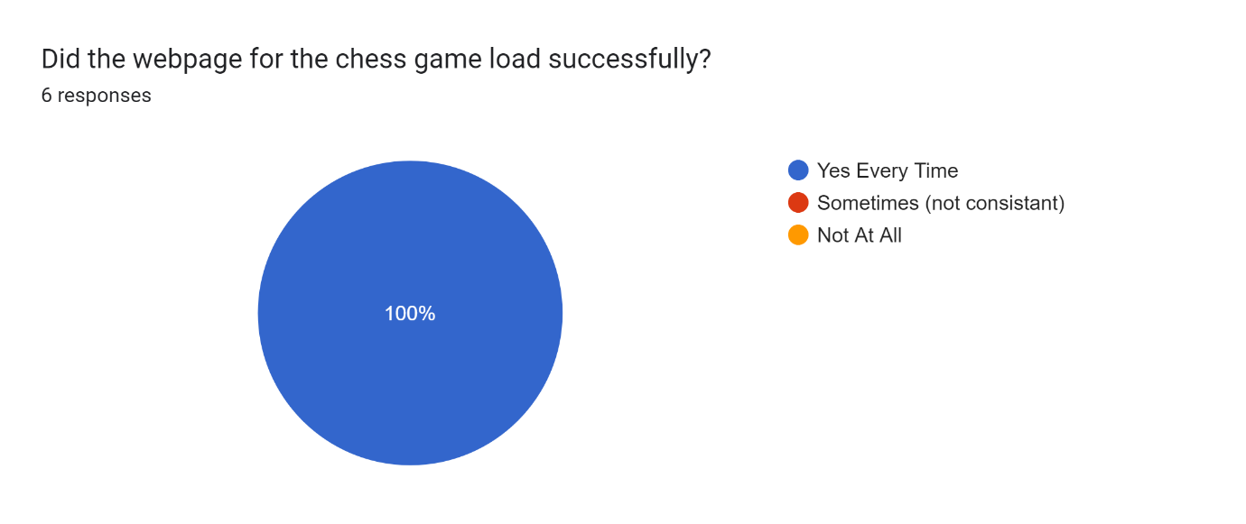

This shows that the webpage is reliable. This is evidence that contributes to my achieving my usability goals of making my program the Efficient and Error Tolerant.

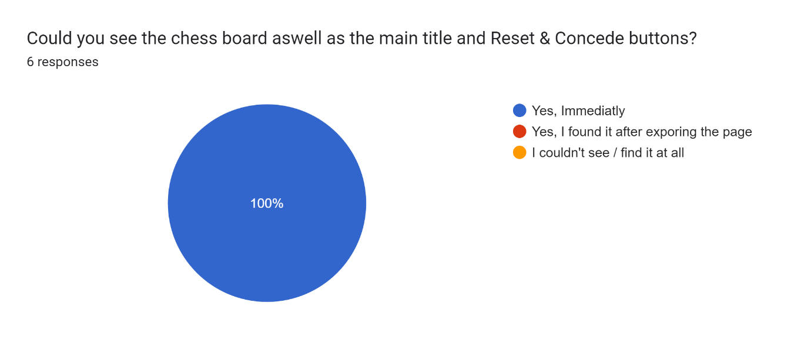

This is expected as I put these elements in immediate view as they were the most important. This is evidence that contributes to my achieving my usability goals of making my program Easy to Learn.

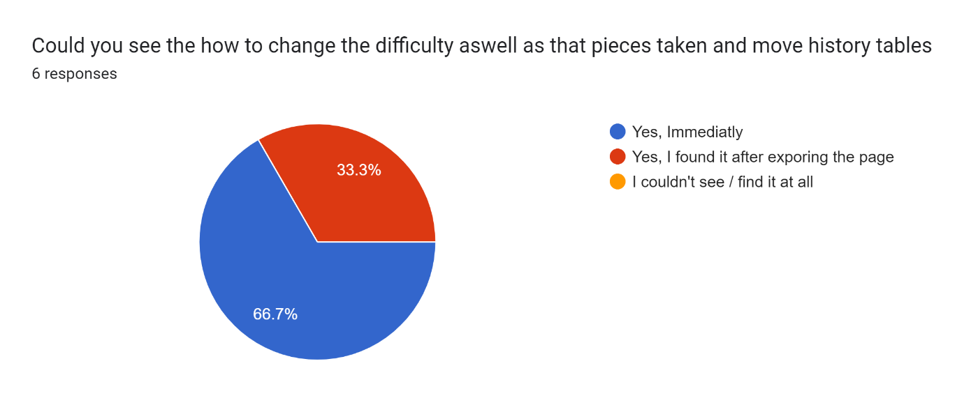

This feedback show that the program would benefit from some kind of text or arrow to show that the use could scroll down for more information and settings. This means that these is still some progress if I am to make changed and try to maximise my usability goal of making the final program easy to learn.

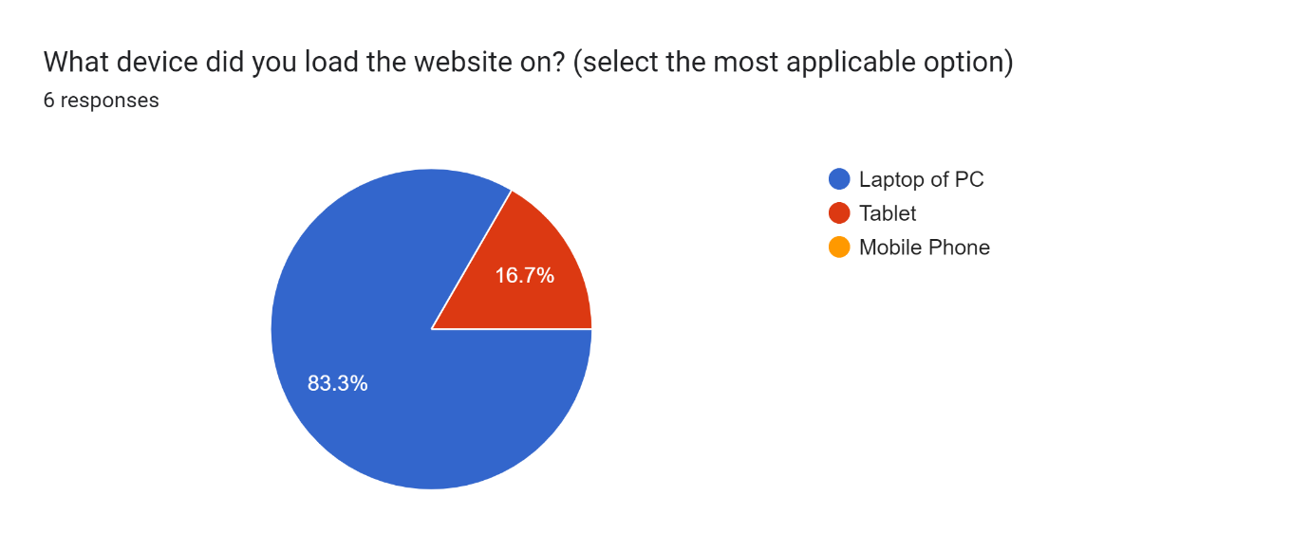

This likely show that the stakeholders I was able to collect data from are not a representative sample of the whole population as they are mostly using laptops to play with the website. A larger sample may show that more users will use tablets. It is encouraging that most users currently use a PC or laptop as these are aspect ratios that are fully implemented. This means that the website should be in its most easy to use layout for the majority of stakeholders. This implies that the negative impact of not fully implementing success criteria item 25 into my final program or my usability goal of making the program easy to use was minimal. The feature likely made the program easier to use as, even though it isn’t perfect, it does allow the website to be used on a phone of tablet in a functional manner.

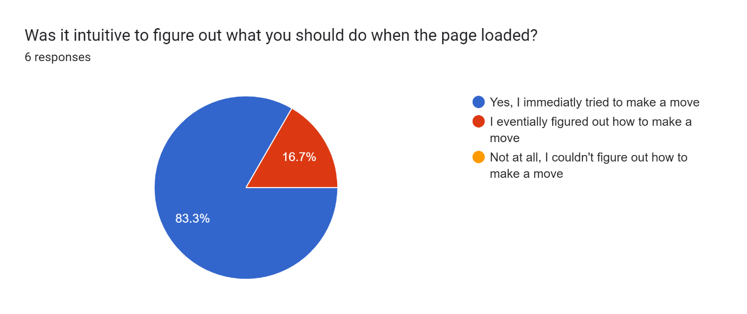

This question shows that the input method for making a move was intuitive. This is likely partly due to the interface is similar to many other chess websites and programs that these stakeholders may have already encountered. It is encouraging as it shows that the program is easy to use. This is evidence that contributes to my achieving my usability goals of making my program Easy to Learn.

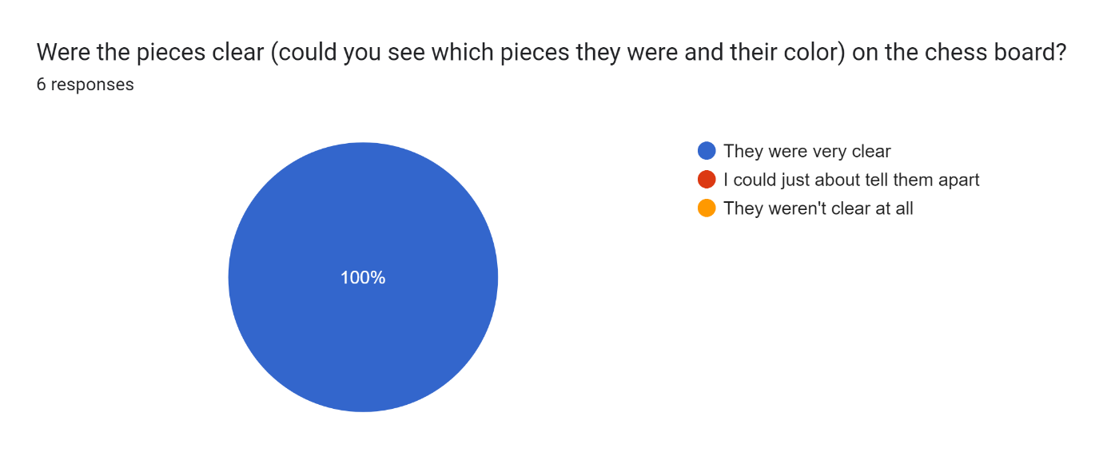

This response shows that the cream and brown colours used for the board, combined with the text shadow were able to contrast the pieces against the board. This made them very clear to users. This is evidence that contributes to my achieving my usability goals of making my program Easy to Learn as I made the GUI as clear as possible. 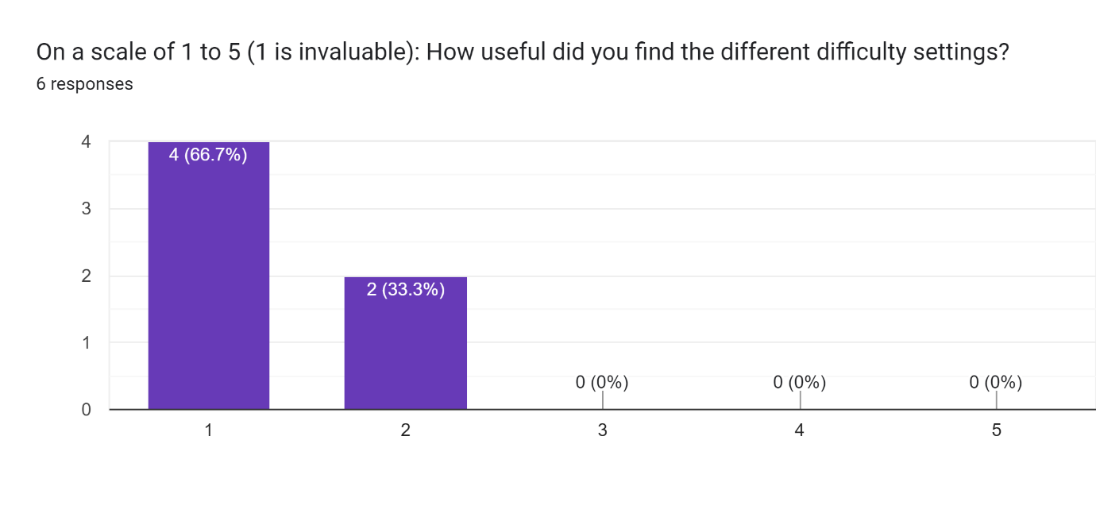

This shows that having a range of different difficulty settings is a feature that is appreciated by casual chess players (the stakeholder / target niche). This allows people to play an easy of challenging game of chess, whatever their level. It is likely that the main issue that some people had with the difficulty setting was that each additional difficulty took longer to decide the computer’s move. This is evidence that contributes to my achieving my usability goals of making my program Effective as it shows that it met my stakeholders needs well.

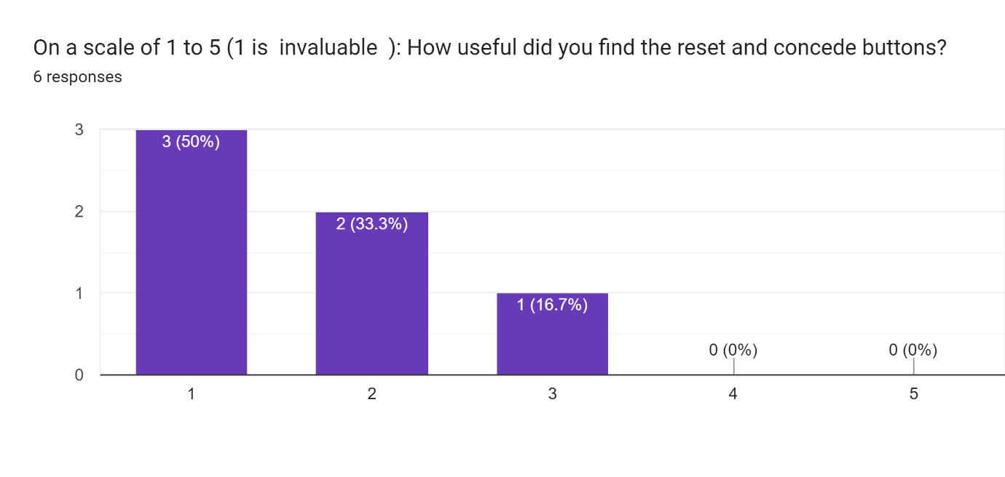

This shows that the ability to reset the games was also appreciated. It seems that some people didn’t see a use for the concede game button. This is evidence that contributes to my achieving my usability goals of making my program Effective as it shows that it met my stakeholders needs well.

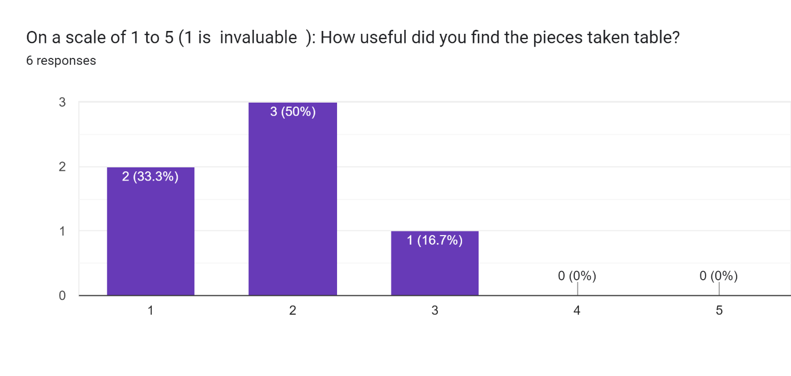

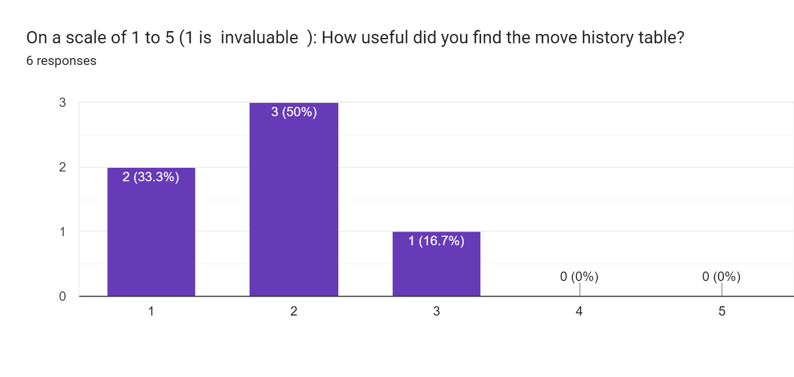

These results suggest that people had some issues with these tables. It is likely that the fact that they had to know to scroll down contributed to this. In addition the lack of chess squares ladled on the board (e.g. so that the user could easily find the square B5) means that some player cannot make full use of the information in the move history table. This is evidence that contributes to my achieving my usability goals of making my program Effective as it shows that it met my stakeholders needs well.

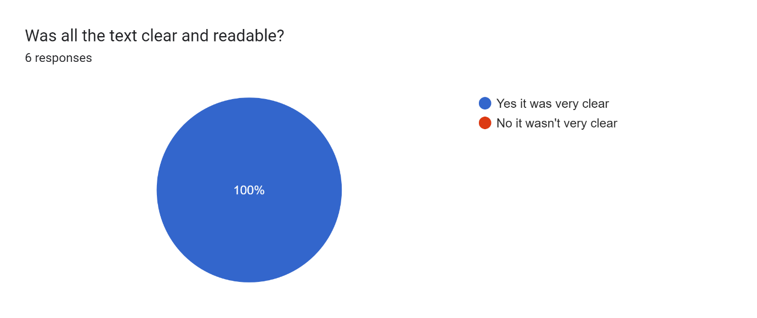

This is very encouraging. It shows that efforts to maximise contrast and make font sized big enough have allowed users to clearly see what is going on. This is evidence that contributes to my achieving my usability goals of making my program Easy to Learn by making its contents as clear as possible.

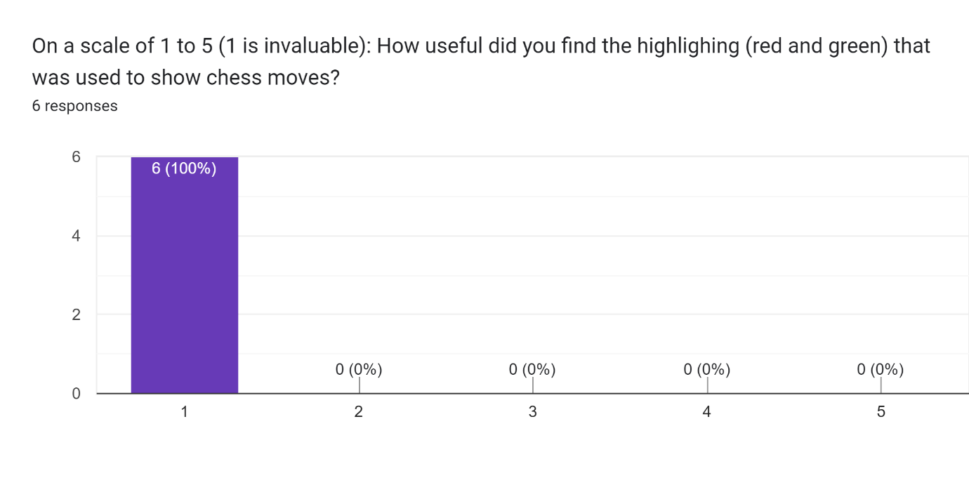This shows that the highlighting is by far the most popular feature. Users seemed to like how it made moving pieces intuitive. It also helps new players who are not yet aware of where all the pieces can move. The use of highlighting to show the computer move seemed to also be appreciated as it drew the user’s eye and made the computer’s move clearer. This is evidence that contributes to my achieving my usability goals of making my program Effective and Easy to Learn as it shows that it met my stakeholders needs (e.g. clarifying legal moves) and that it helped make the website outputs as clear as possible (e.g. clearly showing the computer move).

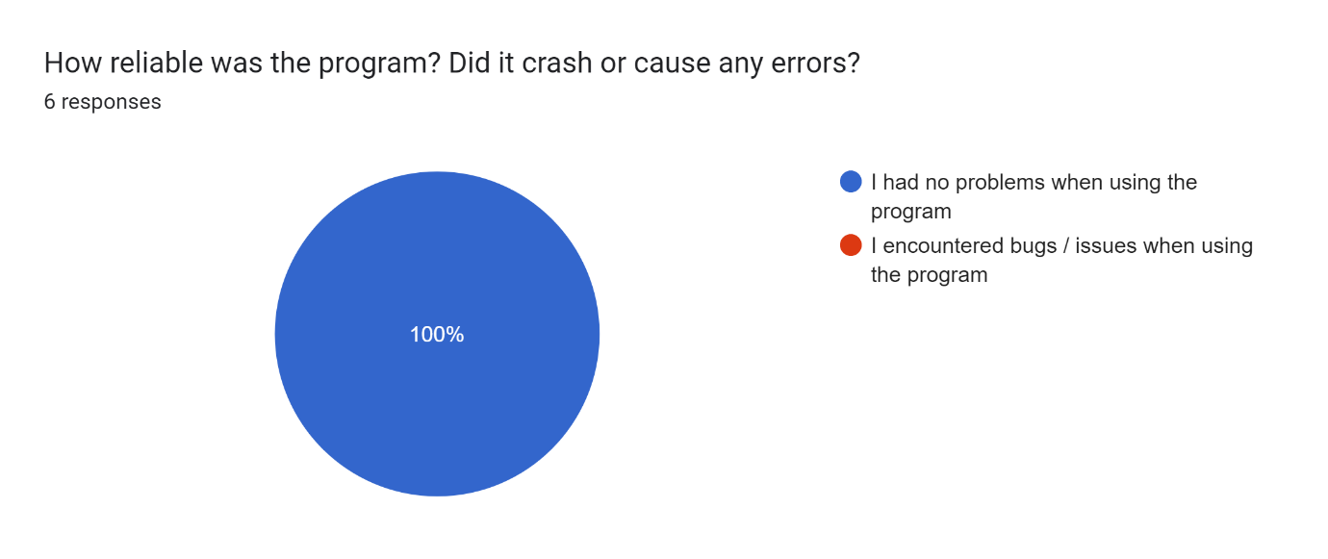

This shows that my testing and validation has paid off as the program is now very robust. None of the users had issues where the program crashed. This is in line with the results of my post development testing. This is evidence that contributes to my achieving my usability goals of making my program Error Tolerant.

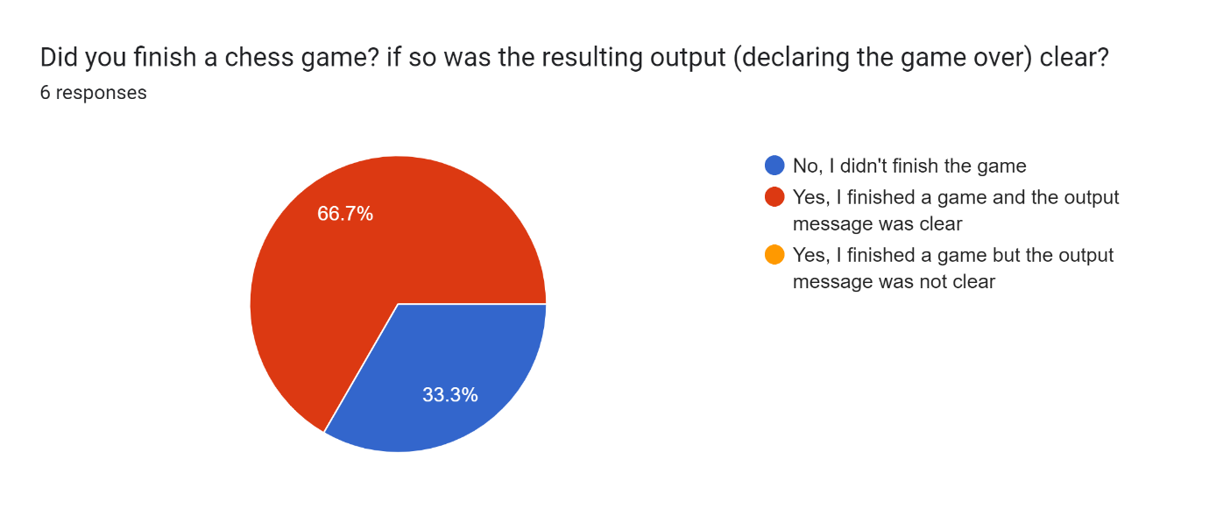

As many of the stakeholders were only able to test the program for a limited time, some were not able to fully finish a chess game. However the 4 who were able indicated that they felt that the resulting message and the disables board was clear and intuitive. This is evidence that contributes to my achieving my usability goals of making my program Easy to use and Engaging. This is because many of those sampled were engaged enough to finish a game. In addition they found the produced output clear.

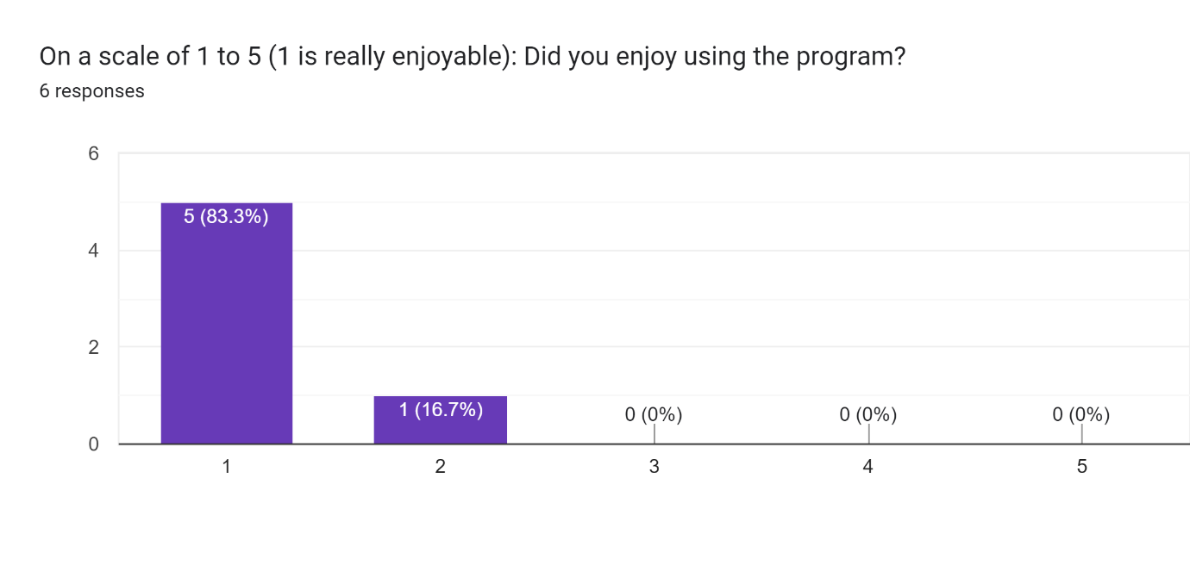

This feedback is very encouraging. It shows that I was able to meet my stakeholders main need: entertainment. All of my stakeholders enjoyed that game. This indicates that the game meets the needs of casual chess players well. This is evidence that contributes to my achieving my usability goals of making my program Effective and Engaging as it shows that it met my stakeholders need for entertainment well enough that they might want to play again.

Overall I believe that I have met each of the 5 aspect of usability that I identified in my design section. I believe the usability survey clearly shows that I have met the following objectives:

* Effective: as they indicated they founds its featured useful meaning it met stakeholders needs
* Easy to Lean: as they found the GUI clear and intuitive to use
* Engaging: the last question shows that they found the program engaging, the number of people that finished a chess game also shows that the program is engaging.
* Error Tolerant: My testing an validation must have worked as none of the users had issues with bugs, crashes of the website not loading

With regards to efficiency I believe that the fact that the website loaded up promptly and no lag was identified for all those sampled shows that the website was Efficient. While the long times needed to complete some of the high difficulty searches are not ideal, I feel that my effort to improve the minimax function has made the program much more Efficient.

Therefore I believe that my final solution met all 5 of my targets for usability. While no user interface is perfect, I feel that my efforts have paid of in creating a highly usable and clear end product.

**In future development** I will review the features that were not as successful and well received in this usability survey. I will review the need for reset and concede buttons as many users didn’t use them. This may mean that I remove them entirely or move them so they are not as front and centre in the website layout. In addition I have found that the move history and pieces taken tables were not a useful to my users as they could have been. In future I could improve the usability and user experience, specifically the easy to learn part, by making these tables smaller and more compact. Perhaps I could use a popup to allow users to reduce the space they take up if the user doesn’t find them beneficial.

## Breakdown of success criteria (what has been achieved):

|  |  |  |  |  |  |
| --- | --- | --- | --- | --- | --- |
| **Number** | **Feature name** | **Importance** | **Achieved** | **Evidence** | **Evaluation** |
| 1 | Difficulty settings | essential | Fully | Post development test 1 (and also test 6) | I used radio buttons to input the difficulty settings. I created 7 different difficulties that affected how long the AI had to explore the decision tree. I felt this was important as casual chess players could vary in skill and may not always want a challenge. |
| 2 | Validation client side | Essential | Fully | Post development test 2 (and also test 3) | As soon as the website opens, the computer waits for the user’s move. The user is always white and has unlimited time to think about their moves. |
| 3 | Validation client side | Essential | Fully | Post development test 3 (and also test 2) | I used both client and server side validation to ensure only the right player can make a move at any given point in the game |
| 4 | Validation client side | Essential | Fully | Post development test 4 | I showed how the highlights showed that the user couldn’t make some moves. I then showed that any inputs what tried to make these invalid moves were ignored |
| 5 | Intuitive Move Input with dot markings | High priority | Fully | Post development test 5 | I implemented this feature fully and it was well received by users. It makes it clear where the user can and can’t move a piece. It also helps users who are not that familiar with the game of chess. |
| 6 | Graphically show the move | Essential | Fully | Post development test 5 | Once the move is inputted, the new board state is shown to the user (with their piece moved to the new square). There is a purposeful delay before the computer move is added to ensure that I don’t have too much happening at once. This lets me clearly show the user that their move has been implemented |
| 7 | Computer Move output | Essential | Fully | Post development test 5 | The computer is able to move the black pieces on the board to successfully act as an opponent to the user. |
| 8 | Highlighting | High priority | Fully | Post development test 5 | Highlighting for a short time shows what piece the computer is moving and where the piece is going. Stakeholders found this feature helped them see exactly what move the computer had made. |
| 9 | Chess engine mid game | Essential | Fully | Post development test 6 | The Chess AI was able to make “smart” decisions when it was able to sufficiently search the tree. This allowed it to avoid losing its pieces and to take my valuable pieces |
| 10 | Chess engine late game | Essential | Fully | Post development test 7 | The Chess AI is able to pursue checkmate in the late game, once it already had a significant piece advantage. This help the user experience as there AI opponent is really trying to win. This should make the game more interesting. |
| 11 | Alert after each move for check | Essential | Fully | Post development test 4 | I made use of a large title to show which users turn it was as well as to make it clear, when a player was in check. I believe this provided some necessary direction to users (about whose turn is was). |
| 12 | Proper recognition of game over and its properties | Essential | Fully | Post development test 7 | I again used the main title element to output to the users that the game was over. I also disabled the board. This allowed users to still see all the pieces, without being able to move them. |
| 13 | Chess engine aware of different game over outcomes | Essential | Fully | Post development test 7 | It is able so successfully decide to pursue winning by checkmate over taking valuable pieces. It will also avoid losing by checkmate at all cost. It is aware of stalemate (normal and 3 repeat stalemates). It will try to avoid a stalemate when it is winning and cause one when it is losing |
| 14 | Undo button for last user move | Low priority | Not Implemented |  | This would have been a nice feature as it could have helped users who miss-clicked. In the end I already planned to implement so many other features which meant this feature would only be implemented if I had time to spare. |
| 15 | Log of history of moves in game | Ideal / desirable | Fully | Post development test 8 | This feature works fully. It logs the user’s and computer’s moves in a table. This includes whenever a piece is taken. The feature could be improved by adding numbers and letters down the side of the chess board to allow new players to locate squares that it refers to. |
| 16 | Step back through log | Low priority |  |  | This functionality would have required significant time to implement as additional complexity would have to be added to both the front end and the backend. |
| 17 | Fast and reliable connection between front and backend | Essential | Fully | Post development test 9 | The server and client browser are connected by WebSocket connections which hare extremely fast due to using a direct TCP/IP connection. This meant that the final product didn’t feature any lagging. |
| 18 | Allowing users to login & sign up | Low priority | Not implemented |  | This feature would have required huge amount of additional work. I would have needed to update the database; front end and backend validation; made a new python module to handle users and make significant changes to the user interface to allow for a login system. As I was able to implement a save game feature without users, it hardly seemed worth the steep time and opportunity code |
| 19 | Reloading unfinished game | Ideal / Desirable | Fully | Post development test 9 | This functionality was added using cookies and a database. I am proud of this feature as I think that it is technically impressive and very useful. |
| 20 | Puzzles | Low priority | Not implemented |  | This feature was written of early in the design process for being too much work. |
| 21 | Draughts | Last add, very low priority | Not implemented |  | This feature was written of early in the design process for being too much work and deviating from chess |
| 22 | Allow users to start with a custom game layout | Low priority | Not implemented |  | This would have been a nice feature to add. I could have allowed the user to be black and go second. I think that overall if makes sense for the user to go first as the computer has many advantages (such as looking at move possible board states). As such, I don’t think that much was lost in not implementing this feature |
| 23 | Leader board and trophy system | **After interview I no longer want to implement this (lowest possible priority)** | **Not implemented** |  | I wrote this feature off early in the analysis section. I believe that the idea of a leader board is more suited to competitive players than casual players. |
| 24 | Accessibility through website | Essential | Fully | I cite the usability interview and questionnaire as evidence as they show that the website is clear and intuitive | I aimed to ensure that the layout of the page and color, size and font of the text were as clear as possible. I prioritised this over aesthetics (hence the background color is white). I think that maximising clarity will benefit all stakeholders and the programs usability as a whole. I particularly think that it will benefit older and less tech-savvy stakeholders. |
| 25 | Mobile access | Desirable | Partially | Post development test 9 | I think that the efforts I did make to achieve this feature were still important. The final product should work well enough on most aspect ratios. This should allow the elderly who struggle to use PCs to play on tablets. This should also allow people on the go to play on their phones.  **In future development** I could modify the CSS and JavaScript to create a more intricate system to change the layout of the website for different aspect rations. This should mean that the website will be compatible with more devices. This would allow this success criteria item to be achieved in future. |
| 26 | Efficient adversarial AI | Highly desirable | Fully | See detailed explanation of improvements in prototype 3 (such as parallelisation).  The use of parallelisation and database cache was shown in post development test 6 | I am proud of my effort here. While I still am not able to quickly perform a depth 3 search, I brought the time needed to perform a depth 2 search of the stating positions from around 25 second to 12 seconds. I think that making depth 2 more possible is important as this lets the computer apply game theory to anticipate the user and make interesting decisions (like when we saw it avoid the trap). |
| 27 | The AI adversary feels as organic and real as possible | Highly desirable | Fully | Post development test 6 | I think that allow with making depth 2 searches more possible, and use of a database allowed allows the chess AI to learn make the AI a move real and dynamic opponent that is more fun to play against. |
| 28 | Validation of users move | Essential | Fully | Post development test 2 | I added both client and server side validation to ensure that the user couldn’t make an invalid move. |
| 29 | Valid computer move | Essential | Fully | Post development test 3 | I added checks within my code to catch erroneous and invalid moves made by the minimax algorithm and prevent them reaching the user and causing unexpected behaviour. |
| 30 | Pieces Taken output | Desirable | Fully | Post development test 8 | I added this feature as a way for users to see at a glance who is winning. This can be helpful information that a casual player might want. |
| 31 | Restart game button | Essential | Fully | Post development test 8 | The restart button allows the user to play a fresh new chess game. This can be done when the game is ongoing or when it is over. This allows users to start again if they want to (for example if they lose their queen). |
| 32 | Concede game button | Essential | Fully | Post development test 8 | The idea of this button was that it could stop the game progressing while still allowing the user to see all the pieces and the move history. This would stop the computer’s move coming through and changing the board state. Some players may also want the ability to concede (as they can in a real chess game). |

## Limitations and Maintenance:

This program is only a prototype and has various limitations that could get in the way of it being fully deployed. These include limitations of the program itself and difficulties in maintaining the system at scale.

### Limitations with the program itself include:

* One of the main limitations of the program is that the database is currently all stored withing one file. This would pose scalability problems if the program were to be used by many people. The solution would be to use a more scalable database system. For instance, the database could be implemented using a cloud based system such as AWS. This would make the database far more scalable and able to hold many more unfinished games
* Another limitation is that I didn’t implement all the move of chess. I did implement pawn promotion but didn’t implement moves like En Passant and castling. If this chess program were to become as popular as some of its competitors like Lichess, it would need to have these moves implemented.
* Exponential time complexity O(2^n) of the minimax search algorithm limits the depth to which the decision tree can be searched. This functional caps the difficulty of the chess AI. A different technique (e.g. machine learning rather that heuristics) would need to be used to create a chess AI like stockfish that can challenge expert and pro chess players. I have tried to work to maximise the challenge by improving the efficiency of my minimax function.

### As part of maintenance, certain issues may arise:

* For one, the database may accumulate to many unfinished games. While each one is only around 4KB of binary data, this could slow that database and present an unnecessary cost if it got out of hand in future.
* Another issue is that the database may gather so many cached results that is has a very strong opening at all difficulties. This could erode the concept of difficulty settings and prove a problem for new players.
* One issue that a future maintenance team would have to deal with would be technical debt. This describes the cost of committing to a given system, language, protocol or framework. In the future, Flask or WebSocket or SQL-Alchemy could become depreciated frameworks that are no longer supported. This would make maintaining the system more difficult and costly. New errors could be created from a no longer maintained framework or users trying to use the program in a way for which it wasn’t designed (e.g. with a new type of browser that the website isn’t set up for)
* Another difficulty for a future maintenance team would be quick and dirty fixes to problems. These are fixes that do not address the root cause of the problem and instead aim to prevent the problem from having a negative effect. This could be seen as bad practice as problems that are swept under the rug are allowed to build up. I only added 1 such fix in the form of my fix to the erroneous minimax result encountered in testing in prototype 3. In this case I made such a fix as the problem was complex to solve and I had limited time available. If I had added many such fixes to the program (I didn’t) this could make maintenance difficult. This is because it adds clutter and additional complexity to the code. It also makes it more likely that future changes will be difficult as they will cause man of these temporary fixes to fail.

### Some of the key ways in which this chess program could be improved:

* I could create a help feature to make the pram move usable for stakeholders that are not as tech-savvy or for users that are confused about what to do.
* I could have added the login system (success criteria item 18) to the program. This would have allowed users to save their games to their profile, allowing them to continue the game on any device. This could have also allowed for other features like a leader board (success criteria item 23)
* I could have added more complex moves including castling and En Passant (I did add pawn promotion to prototype 3). This would allow a user to play a full game of chess with all the proper rules. This would also prevent them needing to change their game plan (e.g. many chess players plan to castle).
* I could implement the stakeholder feedback about the user interface. Specifically I could make better use of the white space that is either side of the chess board in landscape. I could also add a note or arrow to indicate that there is additional content (the difficulty settings, moves history and pieces taken table) if you scroll down.

# Appendix:

## Sources:

(I have directly sighted some sights for a diagram or pieces of information already in this document)

|  |  |  |
| --- | --- | --- |
| URL | How I used the source | Date |
| <https://www.chessprogramming.org/Simplified_Evaluation_Function> | I used the pieces matrices from this website to make my static evaluation function (heuristic used) | October 2022 |
| <https://stackoverflow.com/> | I used this source to help me understand how to debug an issue that someone else had also had. The answer system could usually directly answer my question or direct me to another source that could help. | August 2022 till the end |
| <https://www.w3schools.com/> | I used this website to help me with HTML, CSS and JavaScript | Since August 2022 till the end |
| <https://youtu.be/STjW3eH0Cik> | I used this lecture to help me understand the minimax algorithm and how you might go about improving it | August 2022 |
| <https://youtu.be/l-hh51ncgDI> | I used this video to help me understand how alpha beta pruning works and to get a better understanding of the minimax algorithm | August 2022 |
| <https://youtube.com/playlist?list=PL4cUxeGkcC9hYYGbV60Vq3IXYNfDk8At1> | I used these tutorials to help me understand how to use the VUE js framework (not used in final product) | December 2022 |
| <https://cdnjs.cloudflare.com/> | I used Cloudflare to access a free copy of the WebSocket and crypto (used for hash function) library for use in my webpage. I copied the following script tags directly from the website:      <script src="https://cdnjs.cloudflare.com/ajax/libs/socket.io/4.5.1/socket.io.js"          integrity="sha512-9mpsATI0KClwt+xVZfbcf2lJ8IFBAwsubJ6mI3rtULwyM3fBmQFzj0It4tGqxLOGQwGfJdk/G+fANnxfq9/cew=="          crossorigin="anonymous" referrerpolicy="no-referrer"></script>      <script src="https://cdnjs.cloudflare.com/ajax/libs/crypto-js/4.1.1/crypto-js.min.js"          integrity="sha512-E8QSvWZ0eCLGk4km3hxSsNmGWbLtSCSUcewDQPQWZF6pEU8GlT8a5fF32wOl1i8ftdMhssTrF/OhyGWwonTcXA=="          crossorigin="anonymous" referrerpolicy="no-referrer"></script> | Since August 2022 |
| <https://nodejs.org/en> | I used this site to download the node runtime so that I could install Vue.js | December 2022 |
| <https://vuejs.org/guide/quick-start.html#creating-a-vue-application> | I used this site to provide additional sources for how to make a Vue.js app | December 2022 |
| <https://mermaid.live/> | I used this online editor and mermaid code to make some of my diagrams | January 2023 |
| <https://drawio-app.com/> | I used the free version of this app to make some of the diagrams | October 2022 |
| <https://sourceforge.net/projects/freeplane/> | I used Freeplane to make some of the diagrams | October 2022 |
| <https://www.tutorialspoint.com/javascript/index.htm> | I used some of these tutorials for reference when creating the JavaScript code | September 2022 |
| <https://www.sqlalchemy.org/> | I used the official source for documentation of the SQL-Alchemy library | January 2022 |
| <https://marshmallow.readthedocs.io/en/stable/> | I used the official source for documentation of the Marshmallow library | January 2022 |
| <https://flask.palletsprojects.com/en/2.2.x/> | I used the official source for documentation of the Flask library | January 2022 |
| <https://flask-socketio.readthedocs.io/> | I used the official source for documentation of the flask-socketio library | January 2022 |

## Interview Transcript: Interview with Roger:

Interviewer (me): Hi Roger, thank you for agreeing to speak with me about your needs for a chess app. Before we dive into the details, I'd like to ask how often you play chess and how you usually play it.

Roger: I play chess semi-regularly, usually a few times a week. It's a hobby that I enjoy during my free time. As for how I play, I primarily use my phone and an app called Lichess. It's convenient for me to have chess accessible on my phone whenever I have a spare moment.

Interviewer (me): That's great to know, what you like about Lichess?

Roger: One of the things I like is the ability to choose the difficulty level. It's great because it caters to players of different skill levels, allowing everyone to play at their preferred challenge level. Plus, it's nice to have the option of making the game easier or harder based on my mood.

Interviewer (me): That's interesting. What else stands out to you about Lichess?

Roger: The interface is very user-friendly, which I appreciate. I find it much easier to move the pieces by dragging and dropping or clicking, rather than having to type in the moves. It feels more intuitive and convenient. Additionally, Lichess has these satisfying sounds when you make a move or capture a piece, which I find quite attractive.

Interviewer (me): Sounds like Lichess has some appealing features. Anything else that you particularly like?

Roger: Yes, I also appreciate how the moves are recorded and visually highlighted. It's helpful to see the last move and have a list of all the moves made in the game. Plus, similar to chess.com, I can step back through the moves if I want to review the game. It's a feature that I find really useful.

Interviewer (me): Before our conversation, I took a look at Lichess myself and noticed some similarities to chess.com. Do you think there's a convention followed in terms of design and features?

Roger: Absolutely! The interface and features of Lichess do resemble chess.com quite a bit. It seems like there's a convention in place when it comes to the design and functionality of chess platforms. This makes it easier for me when I want to start using a new chess app as the graphics and layout are similar.

Interviewer (me): You mentioned earlier that Lichess allows for two users to play against each other online, but you're more interested in playing against the computer. Could you tell me more about that?

Roger: Yes, I prefer playing against the computer on Lichess. One of the features I really like is the high level of configurability. For example, I can change the colours of the board to something like brown and cream, and I can choose to play as white or black. It even allows me to configure the starting positions of the pieces. This flexibility lets me play variations of chess, sometimes even with an unfair advantage against the strongest AI. For instance, I can have extra pawns or remove the opponent's queen.

Interviewer (me): That sounds like a fun way to customize the game. Did you mention any other features that you liked or would like to see?

Roger: Yes, one feature I find missing on chess.com, but Lichess has, is an undo button. It's really useful for casual players like me who occasionally make mistakes or miss clicks. I know it's a bit like cheating, but players can always choose not to use it if they prefer.

Interviewer (me): Interesting, could I now ask about other features. I thought it would be a useful feature if a chess app could save the game after each move. This way, if the website is closed or there's a loss of Wi-Fi connection, the game can be continued when the user logs back in. Is this something you're aware of on Lichess?

Roger: Actually, no, I wasn't aware of such a feature on Lichess. But it would be really helpful, especially in situations where I need to pause a game or encounter technical issues. Being able to continue from where I left off would definitely enhance the user experience.

Interviewer (me): I see. On a different note, what are your thoughts on having a trophy reward system for winning matches or a leader board for ranking players?

Roger: Personally, I don't think a trophy reward system or leader board would interest me. As a casual player, my focus is more on enjoying the game and challenging myself rather than competing for rewards or rankings. However, I can see how it might appeal to more competitive players who are seeking that kind of recognition.

Interviewer (me): That's a valid point. Lastly, what do you think about the inclusion of a move clock or timer in the game?

Roger: I believe the move clock or timer should be optional. While some players may enjoy the tension and strategic element it adds to the game, I personally prefer having the time to fully consider each move. For me, it's more about the relaxed and thoughtful gameplay. I think having the option to enable or disable the move clock would cater to different preferences and player types.

Interviewer (me): That makes sense. Oh, one more thing you mentioned earlier: you prefer difficulty settings to be discrete rather than continuous, right?

Roger: Yes, that's correct. I think having discrete difficulty settings, like different levels to choose from, is preferable. It allows users to ensure they are playing at the desired difficulty and provides a clearer sense of progression and challenge.

Interviewer (me): Thank you for sharing your thoughts and insights, Roger. Your feedback and perspective on Lichess have been valuable.

Roger: You're welcome! I'm glad I could contribute. It was a pleasure discussing my experience with you.

Interviewer (me): Thank you once again for your time. Have a great day!

Roger: You too! Goodbye!